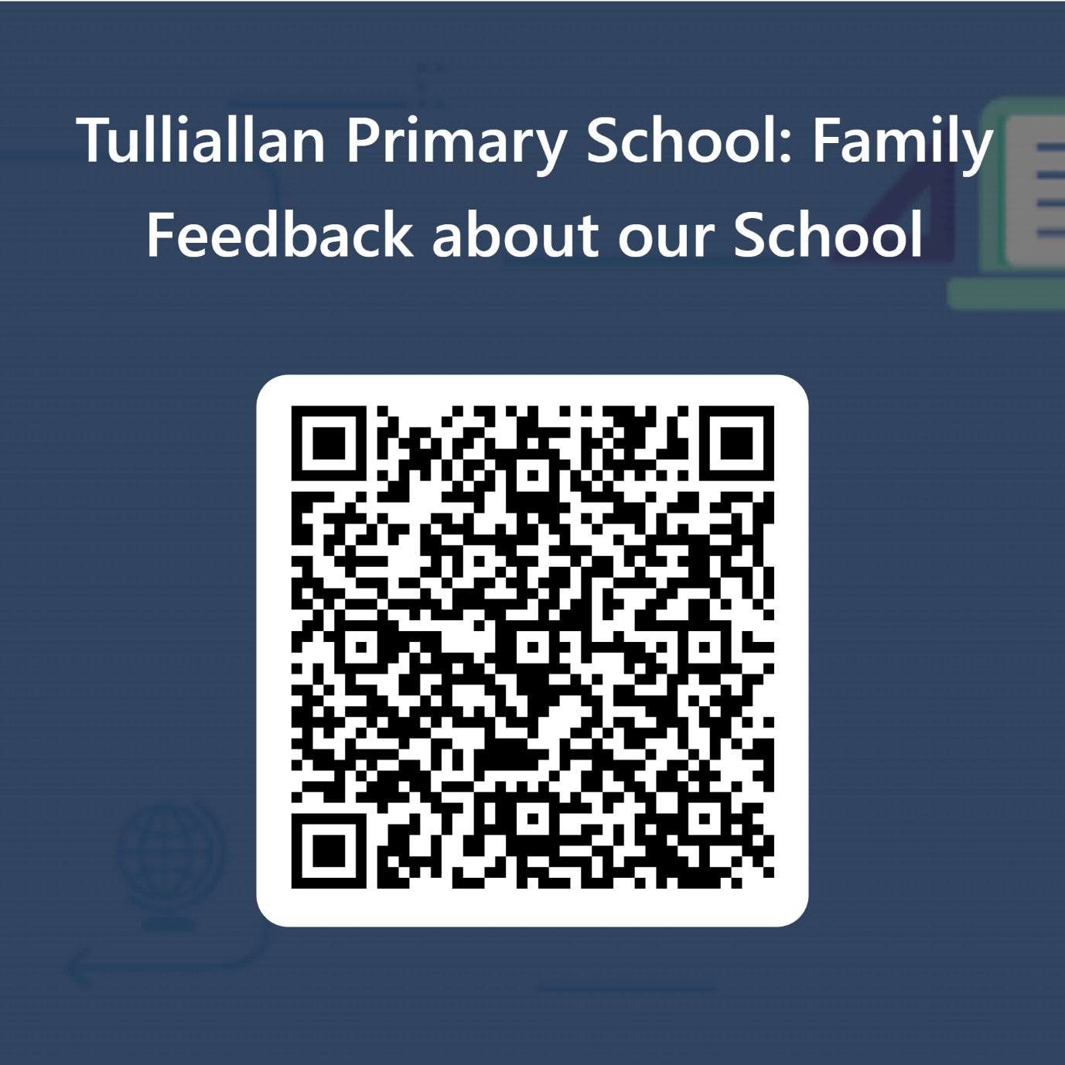

To help us make sure we are providing the best learning experiences, support, and challenge for our children, it is important to find out how our families feel about our school. This helps us to:

- Find out what we are doing well and what we could do better
- Decide which areas to priorities when developing our school improvement plan
- Make sure we are meeting the needs of you and your child/children

Please click on the QR Code above and take a couple of minutes to answer the questions and share your thoughts with us.

