Thursday 3rd November is Outdoor Classroom Day. Here is some information from the Outdoor Classroom website:

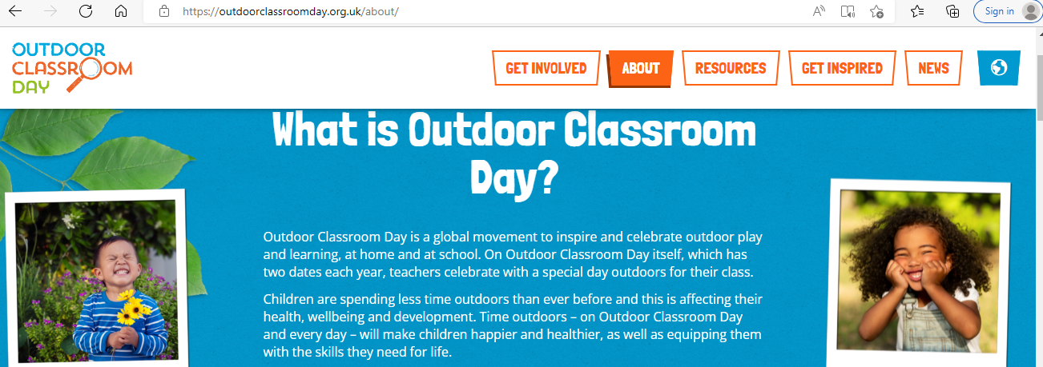

All children should come to school dressed in outdoor learning clothing. We will be spending a large part of the day learning outdoors in the playground and/or local area. Please make sure your child brings suitable footwear (wellies or boots might be useful if you have them), warm clothes, and waterproof jackets (waterproof trousers too if you have them available).

Thank you

