Dear Parent/Carer 5th September 2022
We are asking for your support in improving whole school attendance and punctuality.
During the COVID pandemic it was necessary for children and families to isolate if they or a close contact tested positive. That is not now the case and it is essential that we build back up on our previous positive attendance rates.
The impact upon children’s education through lost learning and socialisation with friends is huge. At a time when so much education has been disrupted it is vital that we make every school minute count. Ensuring that your child is in school and on time everyday helps prevent them from falling behind with their learning and helps to maintain friendships.
Our attendance rate last session was 92.8% and we are hoping, with your support, to increase this to 94.4% by the end of this school year.
To help us reach this target there are things you can do to improve your child’s attendance:
- If your child is unwell and you are unsure whether to send them to school, the NHS advice site can help (https://www.nhs.uk/live-well/is-my-child-too-ill-for-school/) or contact the office to seek advice on whether or not they should come into school
- Avoid taking any holidays during term times
- Speak to school staff with any concerns that you feel are preventing your child from attending school
- Most importantly, talk to your child about the importance of them being in school and let them know how important you feel it is.
The table below provides an example of the impact of lost learning through pupil absence:
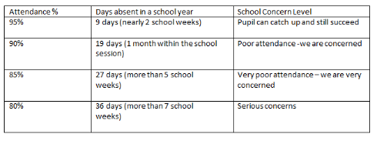
Punctuality is also highly important. Pupils who arrive late to school are not only losing learning but can also feel awkward about going into class late causing them further stress or anxiety. Pupils do not like being late into school and we see how upsetting it can be for them. We want to prevent this and we would rather a pupil be late than not come to school at all on that day.

The table below provides an example of the impact of lost learning through pupil lateness.
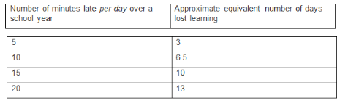
To help get your child to school on time there are some things you can try:
- Have everything you/your child needs for school prepared the night before. Encourage them to get what they need ready.
- Ensure that your child goes to bed at a reasonable time for their age so they are not too tired to get up in the morning.
- Ensure your child has a good night’s sleep by minimising their use of devices such as phones at night.
- Have a consistent night-time routine for your child.
- Set an alarm to allow plenty of time for your morning routine in getting to school on time.
Thank you for your support. We know that by working together we can improve attendance and punctuality at Tulliallan Primary.

N Bow
Acting Headteacher

