WELCOME TO EARLY LEARNING AND CHILDCARE AT

TREETOP FAMILY NURTURE CENTRE


Treetop Family Nurture Centre

Hillend Road Granville Way
Inverkeithing Rosyth
KY11 1PL KY11 2HP

01383 602376 01383 602150
Meet our Senior Leadership Team:

Headteacher: Rachel Marshall
Depute Head of Centre: Elizabeth Hunter
Rebecca Logan
Principal Teacher: Andrea Stark

Inverkeithing
Senior Early Years Officer: Lorna McGuigan

Senior Early Years Officer: Alina Kaczmarczyk

SEYO (Family Worker): Shona Wilson
Samantha Rayner
Rosyth

Senior Early Years Officer: Linda Downie

Senior Early Years Officer: Ann Hunter

At Treetop we aim to provide a secure happy stimulating environment for children to learn from. We want them to have fun and will support them as they need it. We will encourage them to become independent and know how to care for themselves as much as they can. We complement our work with children by supporting families and offering parent groups.


At Treetop Children and Families Come First!

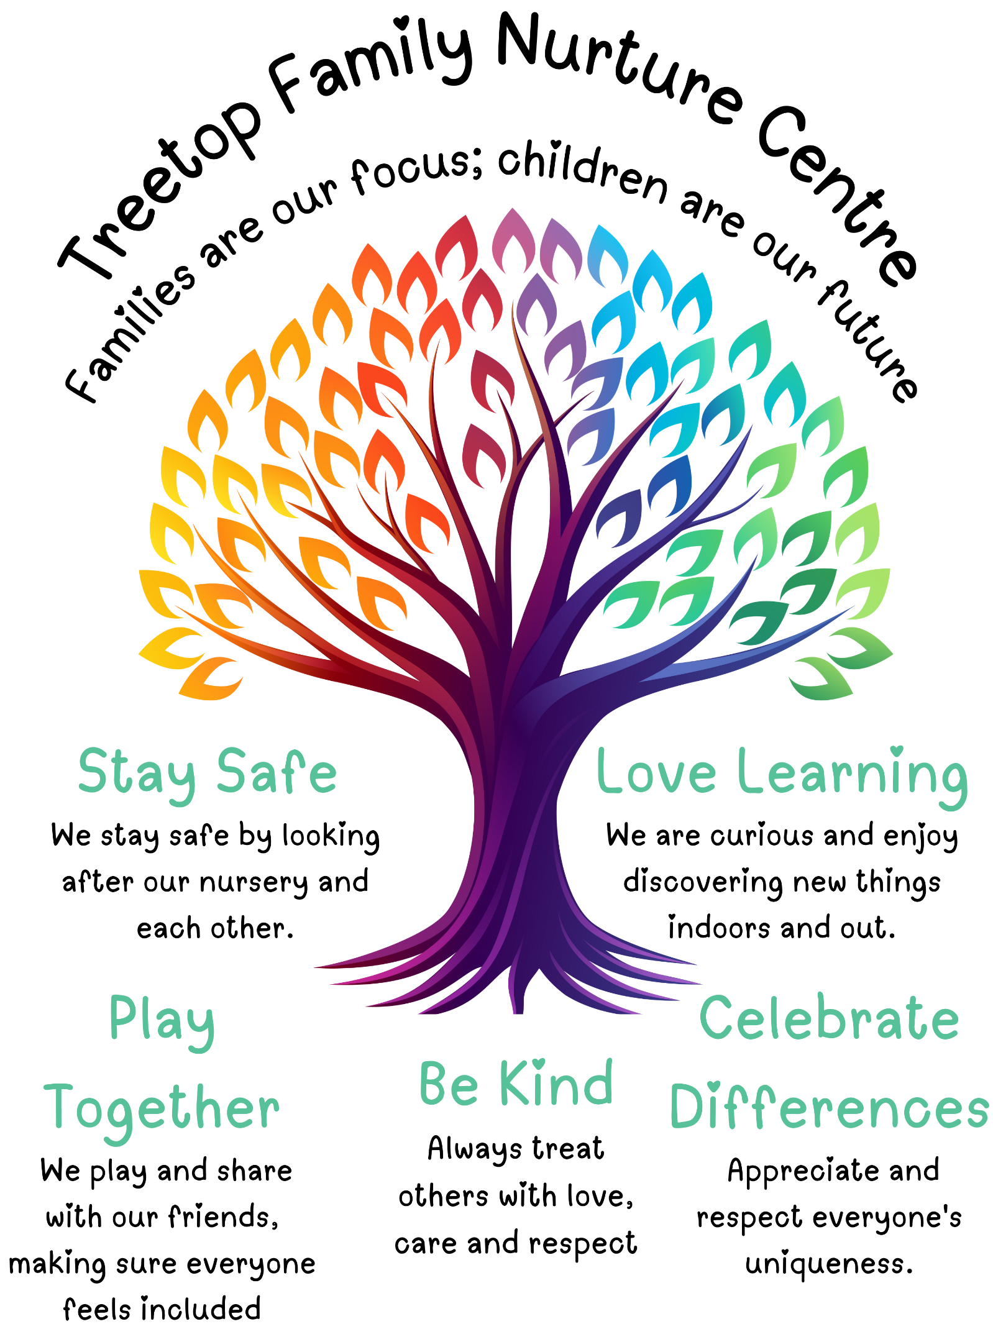

Before your child starts
Please talk about what they may expect – We have 3 “Early Bird” visits, holiday visits, a phone call from your child’s keyworker in addition to this booklet and a SWAY which hosts a wealth of information. It is a good idea to look at the SWAY with your child, particularly if there is a gap between their visits and start date (summer holidays for example) as there are lots of pictures to remind them of nursery and open up discussion .

Keyworkers
All children have key workers who try to get to know both you and your child. Please feel free to approach your child’s keyworker about anything you are unsure about.

Times
Treetop Inverkeithing

Session times are:
09:00-15:00 term time (39 weeks)

Treetop Rosyth
Session times are:

09:00-15:00 term time (39 weeks)

AM 0800-1240 or PM 1320-1800 (49 weeks)
OR
Mon, Tues 0800-1800 Wed 0752-1240 or
Wed 1320-1808 Thurs, Fri 0800-1800
(46 weeks)

Settling In
Parents/carers are welcome to stay at nursery with their child to support a smooth transition. This is often a different length of time for each individual child. Your child’s keyworker will work with you and advise you.

What do children do at nursery?

- Learn through play

- Learn how to play with other children

- Learn how to listen and communicate with other adults

- We follow the Early Level Curriculum for Excellence. This is the curriculum followed by children in Scottish Schools throughout their time in school.


What are Personal Learning Journeys (PLJs)?

- This a record of your child’s learning at nursery.

- When your child starts here the keyworkers will tell you how you can add to contribute to the PLJ folder.

- You will be invited to have parent chats, so you can hear about how your child has settled and how we can work together with your child to share successes and plan next steps for learning.

PLJs and Parent Chats are face to face but can be supported online and through phone calls/discussions.

Clothing
We would advise you to dress your child in old, comfortable clothes for coming to Nursery, so they can run about easily and it won’t matter if they get these covered in paint, glue or mud.

Please also bring at least one spare set of clothes to Nursery so we have a change of clothing should your child get wet in the water tray or have an accident. All clothing should be labelled with your child’s name.

We recommend trainers, or boots/wellies for the winter, to allow the children to safely enjoy physical play outdoors. Indoor shoes are also required as shoes and socks can become wet or muddy from outdoor play.

Please bring a coat for your child as we try to get out to play even if the weather is not very good. Waterproofs are also recommended.

Nursery Snack
All children are offered a snack during their session.
This is normally something like fruit, toast, cheese & crackers with milk or water to drink and adheres to Setting The Table Guidelines

Please let us know if your child has specific dietary requirements or allergies.

Lunch
For those children staying for lunch these are free and a choice of hot or cold lunch is available. We follow ‘Setting the Table’ documentation to ensure our children receive a healthy diet.

Menus are shared with parents to support choices.

Attendance
If your child is not attending Nursery due to illness, family days, holidays, appointments then please let us know as soon as possible by calling the main office at:
Inverkeithing: 01383 602376
Rosyth: 01383 602150

We are required to follow a Fife Council procedure for all absences.

Holidays
Nursery is closed to all children on In-Service Days and Public Holidays.

Inverkeithing:
Our provision offers term-time 9-3 sessions and as such follows the school holiday calendar for Fife.
Some children may be offered additional time in the holiday period. This is normally arranged in collaboration with nursery, parents/carers and other professionals.

Rosyth:
Children accessing the AM/PM sessions in the 49-week model have 1-week holiday at Christmas, plus in-service and public holidays.

Children accessing our 2 ½ day sessions in our 46-week model have 1 week at Christmas, 1 week at Easter and 2 weeks in summer, plus in-service and public holidays.

9-3 sessions follow the school holiday calendar for Fife.

Dates and reminders are included in our termly newsletters.

Illness
We encourage the children to practise good hand hygiene and infection control measures are followed by staff.
Should you feel your child has something contagious then please do not send them into Nursery and contact us to let us know why they are ill.

If your child has had sickness and/or diarrhoea then they will not be fit to return to Nursery until 48 hours following their last bout. Infection control is at the back of this booklet.

Sun Awareness
We work a Sun Awareness policy at Treetop that means that

Children should:
- Wear a sunhat when outside – legionnaire if possible
- Wear clothing covering the shoulders and arms
- Be outside for limited periods when sunny between 11.00-15.00 if UV index dictates
- Wear appropriate sunscreen
- Be encouraged to play in the shade and take frequent liquids

Parents/carers please apply sun cream to your child prior to coming into nursery. Staff will reapply during the full day session with nursery sun cream
If your child has sensitive skin, you may wish to supply your own sunscreen. Please label the bottle clearly and speak to a staff member.

Headlice
From time to time, we may have lice in the Nursery. Please get into a routine of checking your child’s hair regularly. Your child can continue to attend nursery with head lice however we ask you let us know and start treatment (we recommend a bone comb through wet, conditioned hair).

Accidents
If your child has a minor accident in nursery we will treat them with any necessary first aid and advise you of the accident. Nursery staff will phone to inform you at the time of the accident if there has been any head or face bumps.
We keep a record of all accidents. Parents are asked to sign the record to confirm they have been informed of the accident and can also have a copy of the form if they wish.
If a child has a major accident in our care, we will contact you and emergency services. Please make sure we have an up-to-date contact for both yourself and your emergency contact in case we cannot reach you.



Parents

Treetop encourages parents to have regular contact with staff. Our staff are always happy to discuss how your child is getting on in nursery and we are available if you need some support or advice.

We run a programme of parent’s groups, activities and learning sessions throughout the year.



Stay and Play Visits
You are welcome to stay and play for part of your child’s session. This gives you the opportunity to share in your child’s experiences.

Forest/Beach Kindergarten
Children will take part in outdoor learning sessions to the forest and beach. We will use areas within walking distance where possible.
We welcome parents to come along and spend time with their child.

Local Visits
Children often go out for a walk in the local area e.g. library, care home, shops, orchard, playing field. We welcome parent support at these times.

Volunteering
Can you help support the work at Treetop by becoming a volunteer?
If you can share your talents and time we will be grateful.
We always welcome volunteers on our woods trips and other outings, speak to your nursery room team.

Child Protection
All children and young people in Fife have the right to be cared for and protected. We all have a part to play to ensure that you are safe and your needs are met. Here in Fife, we believe that “child protection is everyone’s job and everyone’s responsibility”. Your welfare is very important to us all and we take that very seriously.

Should a child inform us or show signs that they are at risk from harm then we have a duty to report our concerns to either Social Work or Fife Police. This may be done without parental consent, please know this is being done to ensure the safety of all our children and families.

Elizabeth Hunter is our Child Protection Co-ordinator.
Rachel Marshall Depute Child Protection Co-ordinator.

Our SEYOs are also depute child protection trained:
Inverkeithing: Shona Wilson, Lorna McGuigan, Alina Kackmarczyk
Rosyth: Linda Downie and Ann Hunter

Social Work Contact Centre:- 03451 551 503.
E-mail- sw.contactctr@fife.gov.uk

Concerns and Complaints

If you have any concerns or complaints, please speak to your child’s keyworker or our Senior EYOs in the first instance.

Parents can also speak to management at any time. A member of the management team will be available to help. Please let staff know or contact us by phoning the nursery on
Inverkeithing: 01383 602376
Rosyth: 01383 602150

Or emailing our nursery at Inverkeithingnur.enquiries@fife.gov.uk

Where to find us:

Treetop Family Nurture Centre
Hillend Road Granville Way
Inverkeithing Rosyth
KY11 1PL KY11 2 HP

01383 602376 01383 602150

To keep up with our latest news & information:

Follow us: www.facebook.com/TreetopFamily

Our website is on blogs.glowscotland.org.uk and can be reached using the code:

bit.ly/treetopfnc

Scan this QR code with your smartphone to be taken straight to our main Facebook page.

Facebook | 

Infection Control
The information contained in the booklet was issued by the Department of Health and Department of Education.

Infection or symptoms | Recommended Exclusion | Comments
1. Rashes/ skin infections
Athlete’s foot. | None. | Not serious infection child should be treated.
Chickenpox (Varicella Zoster). | Until all vesicles have crusted over (usually 5 days). | Pregnant staff should seek advice from their GP if they have no history of having the illness.
Cold sores (herpes simplex). | None. | Avoid kissing and contact with the sore.
German measles (rubella). | 7 days before rash and 7 days after. | Preventable by vaccination (MMR x 2 doses). Pregnant staff should seek prompt advice from their GP.
Hand Foot and Mouth (coxsackie). | None. | If a large number of children affected contact HPT. Exclusion may be considered in some circumstances.
Impetigo (Streptococcal Group A skin infection). | Until lesions are crusted or healed or 48 hours after starting antibiotics. | Antibiotics reduce the infectious period.
Measles. | 4 days from onset of rash. | Preventable by immunisation. (MMR x 2 doses). Pregnant staff should seek prompt advice from their GP.
Ringworm. | Not usually required unless extensive. | Treatment is required.
Scabies. | Until first treatment has been completed. | 2 treatments are required including treatment for household and close contacts.
Scarlet fever. | Child can return 24 hours after starting appropriate antibiotic treatment. | Antibiotic treatment is recommended for the affected child.
Slapped cheek/fifth disease. Parvovirus B19. | None (once rash has developed). | Pregnant contacts of a case should consult their GP.
Shingles. | Exclude only if rash is weeping and cannot be covered. | Can cause chickenpox in those who are not immune, ie have not had chickenpox. It is spread by very close contact and touch.
Warts and verrucae. | None. | Verrucae should be covered in swimming pools, gymnasiums and changing rooms.
2. Diarrhoea and vomiting illness
Diarrhoea and/or vomiting. | 48 hours from last episode of diarrhoea or vomiting.
E. coli O157 STEC Typhoid and paratyphoid (enteric fever) Shigella (dysentery). | Should be excluded for 48 hours from the last episode of diarrhoea for E. coli 0157.  Further exclusion may be required for some children until they are no longer excreting. Exclusion is also variable for enteric fever and dysentery. HPT will advise. | Further exclusion is required for children aged 5 years or younger and those who have difficulty in adhering to hygiene practices.
Cryptosporidiosis. | Exclude for 48 hours from the last episode of diarrhoea. | Exclusion from swimming is advisable for 2 weeks after the diarrhoea has settled.
3. Respiratory infections
Flu (influenza). | Until recovered. | If an outbreak/cluster occurs, consult your local HPT.
Tuberculosis. | Advised by HPT on individual cases. | Only pulmonary (lung) TB is infectious to others. Needs close, prolonged contact to spread.
Whooping cough (pertussis). | 48 hours from starting antibiotic treatment, or 21 days from onset of illness if no antibiotic treatment. | Preventable by vaccination. After treatment, non-infectious coughing may continue for many weeks.
4. Other infections
Conjunctivitis. | None. | If an outbreak/cluster occurs, consult your local HPT.
Diphtheria. | Exclusion is essential.  Always consult your local HPT. | Family contacts must be excluded until cleared to return by your local HPT. Preventable by vaccination.
Glandular fever | None.
Head lice | None. | Treatment is recommended only in cases where live lice have been seen.
Hepatitis A | Exclude until 7 days after onset of jaundice (or 7 days after symptom onset if no jaundice).
Hepatitis B, C, HIV/AIDS. | None. | Hepatitis B and C and HIV are bloodborne viruses that are not infectious through casual contact.
Meningococcal meningitis/ septicaemia. | Until recovered. | Meningitis ACWY and B are preventable by vaccination.  There is no reason to exclude siblings or other close contacts of a case.
Meningitis due to other bacteria. | Until recovered. | Hib and pneumococcal meningitis are preventable by vaccination. There is no reason to exclude siblings or other close contacts of a case.
Meningitis viral | None | Milder illness. There is no reason to exclude siblings and other close contacts of a case. Contact tracing is not required.
MRSA | None. | Good hand hygiene and environmental cleaning.
Mumps | Exclude child for 5 days after onset of swelling. | Preventable by vaccination (MMR x2 doses).
Threadworms | None. | Treatment is recommended for the child and household contacts.
Tonsillitis | None. | There are many causes, but most cases are due to viruses and do not need an antibiotic.

