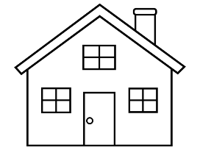
Learning at Home
Here are some of the things I enjoy doing at home
to help me learn as I grow up.

My parent/carer help me record these in my PLJ.

Date: | Short description of activity/experience & learning:  (you may want to add a photo or draw a picture to show what you have been learning)

