TREETOP FAMILY NURTURE CENTRE

HOME LEARNING ADVICE
Issue 5

Over the coming weeks we wish to support you with ideas on how you can support your child’s continued learning at home.

In this bulletin Fife Early Years Team have produced some suggestions on how to keep learning going at home.

THE IMPORTANCE OF PLAY
Play is how our youngest children’s learning and development. It will be very important that time is made within a day for quality play experiences.

Playing alongside your child at times during the day is going to have the maximum impact. This will provide them with the security and comfort that they will require over the coming weeks, but it will also help you have fun together.

Play enables children to develop a range of skills including communication, problem solving, imagination, co-operation etc.

It can take place indoors or outdoors.

The following web links may provide further information and practical ideas.

https://www.playscotland.org/parents-families/

https://education.gov.scot/parentzone/learning-at-home/learning-through-play/

ONLINE RESOURCES
Suggested resources and links have been included below to support learning and development.

As with any online resource, parental guidance and supervision is recommended to ensure children are accessing these in a safe and appropriate manner.

The Gruffalo by Julie Donaldson - Read by Alan Mandel 7 min 35

https://www.youtube.com/watch?v=s8sUPpPc8Ws

Here are some suggestions to use with this story.

Literacy
- Talk about any new words the children are hearing to develop their vocabulary.
- Can you find out who wrote the story?
- What happened first….mouse met a snake or the mouse met an owl?
- What colour are the Gruffalo’s prickles on his back?
- Try and retell the story in your own words.
- Draw some pictures related to the story.
- Act out parts of the story. For example, the mouse meeting the owl and the then the snake.
- Pick out and talk about the rhyming words. Can you think of other rhyming words?

Numeracy/Maths
- How many claws does the Gruffalo have?
- Which animal is the biggest?
- How many animals in total does the mouse meet?

Health and Wellbeing
- In the story, how does the mouse keep himself safe from the animals?
- How do you keep yourself safe when you’re out for a walk?
- What types of animals might you meet in the forest? What would be dangerous?

RHYME TIME

A Little mouse sat in my chair

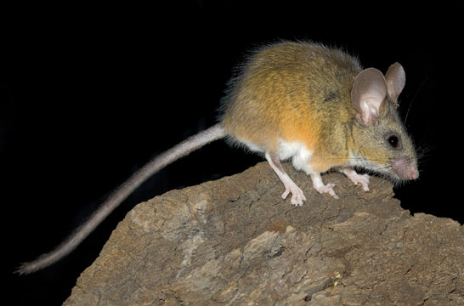
A little mouse sat in my chair,

When the cat said, ‘Miaow’,

He ran right up the stair.

A little cat sat on my knee,

When the dog said, ‘Woof’,

He ran right up the tree.

A little dog sat down by me.

When the duck said, ‘Quack’,

He bounced onto my knee.

- Can you say the rhyme together?
- Which words rhyme in the poem?
- Can you act out the poem?

