TREETOP FAMILY NURTURE CENTRE

HOME LEARNING ADVICE
Issue 7

Over the coming weeks we wish to support you with ideas on how you can support your child’s continued learning at home.

In this bulletin our Treetop Team have produced some suggestions on how to keep learning going at home.

THE IMPORTANCE OF PLAY
Play is how our youngest children’s learning and development. It will be very important that time is made within a day for quality play experiences.

Playing alongside your child at times during the day is going to have the maximum impact. This will provide them with the security and comfort that they will require over the coming weeks, but it will also help you have fun together.

Play enables children to develop a range of skills including communication, problem solving, imagination, co-operation etc.

It can take place indoors or outdoors.

The following web links may provide further information and practical ideas.

https://www.playscotland.org/parents-families/

https://education.gov.scot/parentzone/learning-at-home/learning-through-play/

ONLINE RESOURCES
Suggested resources and links have been included below to support learning and development.

As with any online resource, parental guidance and supervision is recommended to ensure children are accessing these in a safe and appropriate manner.

Freddy and the Fairy

by Julie Donaldson and Karen George (for age 4-5)

With your child watch and listen to the following story being read aloud on Youtube.

https://www.youtube.com/watch?v=P2BTo6rDtnk

https://www.booktrust.org.uk/book/f/freddie-and-the-fairy/

Here are some follow suggestions to use with this story.

Literacy
- Can you hear the rhyming words? Can you guess the rhyming word before it’s read?
- Think of new animal rhymes and some funny ones too:
Dog – Clog
Frog – Log
Cat – Mat
Llama – Pyjama
Parrots – Carrots

- Draw the pet that would wish for. Do you think Bessie-Bell would give you the right one? Draw what she might give you.

Numeracy
- Which animal do you think is Freddie’s biggest pet? The smallest?
- Guess how many pets there are? Can you count them? How many dogs does Freddy have?

Health and Well Being
- In the story do you think Bessie-Belle is happy or sad?
- Why do you think she is sad?
- Have you ever felt like that?
- How would you be a kind friend and help Bessie-Belle? Could you try sign language too? Trying signing Dog, Cat and Mouse.
ACTIVITY TIME

- Can you make your own wand like Bessie- Belle’s? You could use sticks and leaves.
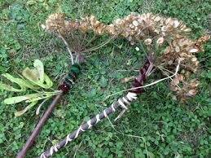

- Try learning some signs for different animals.

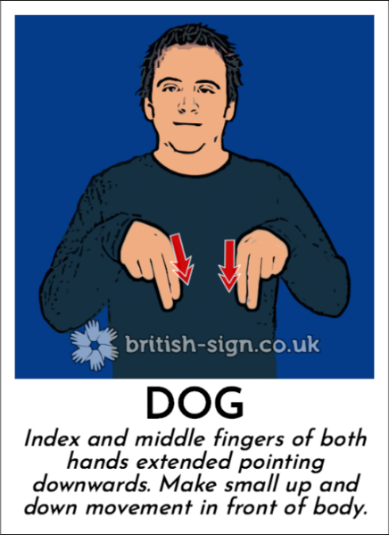
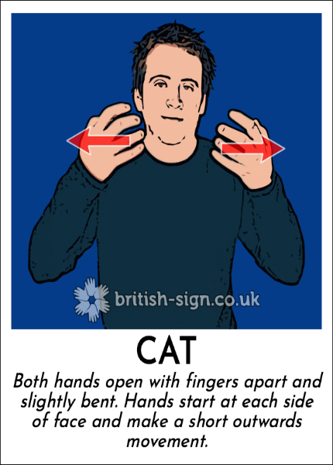
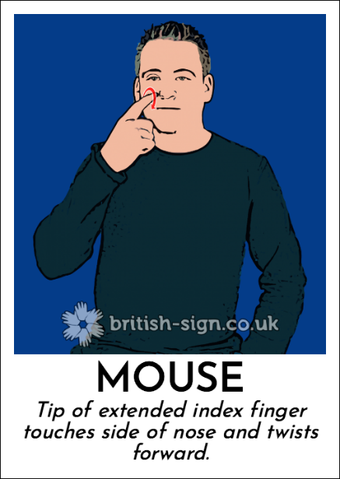

Don’t forget to share your home learning times with us.

Take a photo and email it to us at:
inverkeithingnur.enquiries@fife.gov.uk

By sending us in your photos you are agreeing that we can then post them on our website or social media page to help you keep connected with your friends.

