TREETOP FAMILY NURTURE CENTRE

HOME LEARNING ADVICE
Issue 10

Over the coming weeks we wish to support you with ideas on how you can support your child’s continued learning at home.

In this bulletin our Treetop Team have produced some suggestions on how to keep learning going at home.

THE IMPORTANCE OF PLAY
Play is how our youngest children’s learning and development. It will be very important that time is made within a day for quality play experiences.

Playing alongside your child at times during the day is going to have the maximum impact. This will provide them with the security and comfort that they will require over the coming weeks, but it will also help you have fun together.

Play enables children to develop a range of skills including communication, problem solving, imagination, co-operation etc.

It can take place indoors or outdoors.

The following web links may provide further information and practical ideas.

https://www.playscotland.org/parents-families/

https://education.gov.scot/parentzone/learning-at-home/learning-through-play/

ONLINE RESOURCES
Suggested resources and links have been included below to support learning and development.

As with any online resource, parental guidance and supervision is recommended to ensure children are accessing these in a safe and appropriate manner.

We’re Going on A Bear Hunt
by Michael Rosen

With your child watch and listen to the following story being read aloud on Youtube.

https://www.youtube.com/watch?v=0gyI6ykDwds

Here are some follow suggestions to use with this story.

Literacy
- Can you identify the descriptive words being used in this story? For example, “Ozzy mud” or “swishy swashy” as they go through the grass
- What are the different obstacles in the story? Can you act them out? for example pretending you’re in a swirling snowstorm
- What words is the author saying that describes positional language?
- Can you join in with the line “we’re going on a bear hunt, we’re going to catch a big one, what a beautiful day, we’re not scared”

Maths/Numeracy
- How many obstacles did they have to go through before they found the bear?
- How did they describe size of the bear?
- Can you count the different features on the bear that they see? How did they describe them?
- Can you describe the characters in the book? Who is the tallest? Who is the shortest? What colour of hair do they have? Are they all the same?

Health and Wellbeing
- How did they feel when they saw the bear?
- How was the weather in the story? Was it the same throughout the story?
- What are the different feelings in the story?
- Do you have any materials in your house that you can create your own sensory activities to go along with your story? For example, salt in a bottle to make a snowstorm
- Retell the story by acting it out together.

RHYME TIME
Five Little Bears  (Counting up)  One little bear  Wondering what to do  Along came another  Then there were two!  Two little bears  Climbing up a tree  Along came another  Then there were three!  Three little bears  Ate an apple core  Along came another  Then there were four!  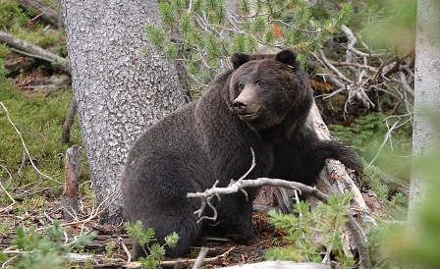  Four little honey bears  Found honey in a hive  Along came another  Then there were five! | Five Little Bears  (Counting down)  Five little bears  Heard a loud roar  One ran away  Then there were four!  Four little bears  Climbing up a tree  One slid down  Then there were three!  Three little bears  Deciding what to do  One fell asleep  Then there were two!  Two little bears  Having lots of fun  One went home  Then there was one!  One little bear  Feeling all alone  Ran to his mother  Then there were none!

Don’t forget to share your home learning times with us.

Take a photo and email it to us at:
inverkeithingnur.enquiries@fife.gov.uk

By sending us in your photos you are agreeing that we can then post them on our website or social media page to help you keep connected with your friends.

