TREETOP FAMILY NURTURE CENTRE

HOME LEARNING ADVICE
Issue 8

Over the coming weeks we wish to support you with ideas on how you can support your child’s continued learning at home.

In this bulletin our Treetop Team have produced some suggestions on how to keep learning going at home.

THE IMPORTANCE OF PLAY
Play is how our youngest children’s learning and development. It will be very important that time is made within a day for quality play experiences.

Playing alongside your child at times during the day is going to have the maximum impact. This will provide them with the security and comfort that they will require over the coming weeks, but it will also help you have fun together.

Play enables children to develop a range of skills including communication, problem solving, imagination, co-operation etc.

It can take place indoors or outdoors.

The following web links may provide further information and practical ideas.

https://www.playscotland.org/parents-families/

https://education.gov.scot/parentzone/learning-at-home/learning-through-play/

ONLINE RESOURCES
Suggested resources and links have been included below to support learning and development.

As with any online resource, parental guidance and supervision is recommended to ensure children are accessing these in a safe and appropriate manner.

The Smartest Giant in Town by
Julia Donaldson and Axel Scheffler

With your child watch and listen to the following story being read aloud on Youtube.

https://youtu.be/cfiPrA8E3qE

Here are some follow suggestions to use with this story.

Literacy
- What does an author do?
- What is the illustrator’s job?
- What was your favourite part of the story?
- can you create your own character for the story? Who would you be? What would you do?
- Can you find any rhyming words in the story?

Maths/Numeracy
- How many items of clothes made up George’s smart new outfit?
- Which do you think is longer – The giraffe’s neck or his new scarf?
- How many mice do you think can live in their new shoe house?
- How many different people did George meet on his walk?

Health and Wellbeing
- How do you think the goat feels when he gets his new sail?
- Why should the fox not sleep in a wet sleeping bag?
- How do you think George feels when he finds out the clothes shop is shut?
- Do you think George is the kindest giant in town? What can you do to show kindness to others?

RHYME TIME

Your tie is a scarf for a cold giraffe,
Your shirt’s on a boat as a sail for a goat,
Your shoe is a house for a little white mouse,
One of your socks is a bed for a fox,
Your belt helped a dog who was crossing a bog,
So… here is a crown to go with your sandals and gown,
For the kindest giant in town.

- Can you find all the rhyming words?
- Can you say the rhyme together?
- Can you illustrate the rhyme?

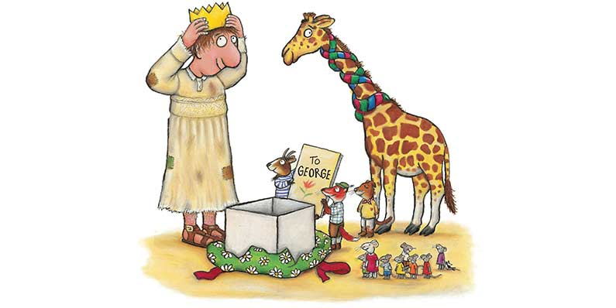

Don’t forget to share your home learning times with us.

Take a photo and email it to us at:
inverkeithingnur.enquiries@fife.gov.uk

By sending us in your photos you are agreeing that we can then post them on our website or social media page to help you keep connected with your friends.

