TREETOP FAMILY NURTURE CENTRE

HOME LEARNING ADVICE
Issue 4

Over the coming weeks we wish to support you with ideas on how you can support your child’s continued learning at home.

In this bulletin Fife Early Years Team have produced some suggestions on how to keep learning going at home.

THE IMPORTANCE OF PLAY
Play is how our youngest children’s learning and development. It will be very important that time is made within a day for quality play experiences.

Playing alongside your child at times during the day is going to have the maximum impact. This will provide them with the security and comfort that they will require over the coming weeks, but it will also help you have fun together.

Play enables children to develop a range of skills including communication, problem solving, imagination, co-operation etc.

It can take place indoors or outdoors.

The following web links may provide further information and practical ideas.

https://www.playscotland.org/parents-families/

https://education.gov.scot/parentzone/learning-at-home/learning-through-play/

ONLINE RESOURCES
Suggested resources and links have been included below to support learning and development.

As with any online resource, parental guidance and supervision is recommended to ensure children are accessing these in a safe and appropriate manner.

Hairy Maclary from Donaldson’s Dairy by Lynley Dodd

https://www.booktrust.org.uk/books-and-reading/have-some-fun/storybooks-and-games/hairy-maclary/

Here are some suggestions to use with this story.

Literacy
- Talk about any new words the children are hearing to develop their vocabulary.
- Can you join in with the line ‘and Hairy Maclary from Donaldson’s Dairy’ every time you hear it?
- Look at the pictures. Can you describe what each character looks like?
- Try and retell the story in your own words.
- Draw your favourite part of the story.
- Act out parts of the story. For example, the dogs all walking along…and then they meet Scarface Claw!
- Pick out and talk about the rhyming words. Can you think of other rhyming words?
- Try saying the dog’s names and clapping the syllables in them.

Numeracy/Maths
- How many dogs are there altogether?
- Which dog does Hairy Maclary meet first? Which dog does her meet next?
- Which dog does he meet last?
- Look for the door numbers. Which number does each dog live at?
- Are the numbers getting bigger or smaller as the story goes on?
- Which dog is the biggest? Which dog is the smallest?

Health and Wellbeing
- In the story, how did the dogs feel when they met Scarface Claw?
- How do you think Scarface Claw was feeling?
- Have you ever felt like that? What happened to make you feel like that?
- How does Hairy Maclary feel at the end of the story?

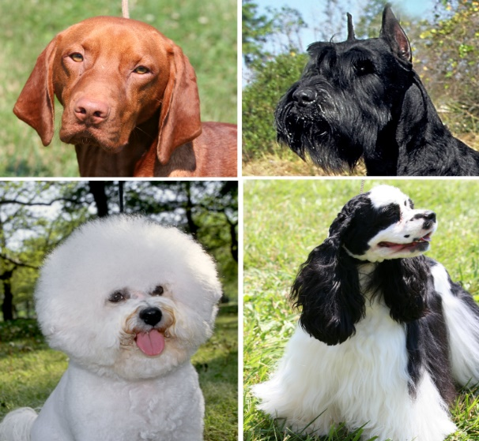
RHYME TIME

Puppy Dog, Puppy Dog

Puppy dog, puppy dog,

Wag your tail.

Puppy dog, puppy dog,

Let out a wail.

Puppy dog, puppy dog,

Jump for a bone.

Puppy dog, puppy dog,

Run on home!

- Can you say the rhyme together?
- Which words rhyme in the poem?
- Can you act the rhyme out?

