Touch School and Nursery

Standards and Quality Report Session 2022 -2023

Achieving Excellence and Equity Achieving Excellence and Equity

Context
Setting/School Roll (including ELC/ASC)

Session 2022/2023:
10 classes with an overall roll of 256 at June 2023 (48% identify as female and 52% as male). Of these:
2% are Young Carers
4% have English as an Additional language
11% have parents in Armed Forces (present or past)
2% are care experienced
37% have additional support needs

3 ELC (nursery) playrooms with an overall roll of 65 at June 2023. This is a term time only nursery operating 9am – 3pm.

School was built in 1970 and extensively refurbished between 2016 and 2018, with a 4 classroom extension finished in 2021. The nursery extension was built shortly after the school opened and was refurbished and extended to a third playroom between 2020 and 2022. The final part of the refurbishment will take place over the summer of 2023.
The school and nursery benefit from a wide variety of additional indoor and outdoor spaces
Outdoors: quad, wildlife garden, tarmac playgrounds, blaze pitch, fenced grass area, secure outdoor areas for nursery and P1-P3/4 classes.
Indoors; music room, gym /assembly /dining room, stage, ICT suite, library, spare classrooms which are used to support proprioceptive experiences, additional play and self-regulation support, LS base, nurture nook and break out spaces.

Our school and nursery vision is ‘Touch School and Nursery, A Community with Learning at its Heart: Built on on Connection and Relationships.’ This was last reviewed with all stakeholders in 2023. We have four school values: Honesty, Aspiration, Respect and Kindness. Everything we do and say is based on these values. Children, families and staff are all well aware of these values and our actions relating to these.
Our aims are:
- To provide an ethos where everyone in our school community is valued and happy as their wellbeing needs are met and their learning is supported and challenged.
- To ensure children develop across the four capacities (Successful Learner, Confident Individual, Responsible Citizen and Effective Contributor) and live our school and nursery values.
- To equip our learners with the skills, knowledge and attitudes (Aim high, Persevere, Reflect and Adapt, Wonder, problem Solve, Link Learning and Engage) for learning, life and work.
- To provide an equity of experience and opportunity to ensure all learners are able to fulfill their potential.
- To raise attaiment and narrow the attainment gap.

FME | 29%
SIMD Profile for establishment | 52% live in SIMd 1-2, 18% in SIMd 3-8 and 30% in SIMd 9-10
Attendance 89.98% | Authorised Absences | 5.71% | Unauthorised Absences | 4.3%
Exclusion (%)
Attainment Scotland Fund Allocation (PEF and SAC) | £78,840

School Improvement Priority Session 2022 – 2023

Priority 1 – All staff know how to keep children safe and their responsibilities within safeguarding and child protection by June 2023.

NIF Priority  Improvement in Children’s health and wellbeing  NIF Driver  Practitioner professionalism |  |  | HGIOS 4 Quality Indicators  2.1 Safe-Guarding and Child protection  3.1 Ensuring wellbeing equality and inclusion  Sub QIs – theme indicated  2.7 – development and promotion of partnerships  2.2 skills for learning, life and work  1.3 implementing improvement and change
Has this priority been:  (please highlight) | Fully  Achieved |  |  | Partially  achieved | x | Continued into next session
Progress:
- We audited our Child Protection procedures and practices and formulated a plan

- A programme of professional learning over two Inservice days took place
    - Female Genital Mutilation
    - The Promise
    - Care categories
    - Safeguarding and reposing to concerns
    - PREVENT – E-learning
    - Domestic abuse
    - Physical Intervention
    - Attendance links to Safeguarding
    - Reminders regarding neglect, social media and electronic media use, adult allegations
- Children engaged in learning experiences in class, with specialists and through assemblies
    - Keeping safe – online, drugs, alcohol and smoking, sexual abuse
    - Achievements
- Policies and Frameworks were reviewed and updated
    - Child Protection
    - Health – RSHP
    - Achievements

Impact:
All staff reported knowing who the Child Protection Co-ordinator and Depute Co-ordinator was following the August inset day
All staff reported knowing where to find a Care and Welfare form and what to do if they had a care and welfare / child protection concern, following both the August and February Insets.
40% of staff reported completing a care and Welfare form the previous session and of those, all stated they had received feedback after submitting this.
Almost all (91%) staff reported they were confident or very confident in supporting those who are or have experienced domestic abuse, from a baseline of 39% prior to the February Inset training.
All concerns (care and welfare and CP) have been reported using the agreed school procedures and done so in a timeous manner.
A few pupils have been added to and removed from the CP register this year, meaning the overall number has remained broadly similar to the previous year. A few pupils have both been added to and removed from our list of Children currently on a Compulsory Supervision Order.

This demonstrates our staff training. Policies and procedures are ensuring children are kept safe with reference to Safeguarding and CP procedures.
Next Steps:

- Parent input on online safety
- Equalities policy
- Anti-bullying will feature in 2023-2024 School Improvement Plan

Priority 2 – 75% of pupils in P4 will attain First Level Writing by June 2023 and 75% of pupils in P5 will be on track by June 2023 to achieve second level in writing by the end of P7
NIF Priority  Improvement in attainment, closing the attainment gap  NIF Driver  Practitioner professionalism |  |  | HGIOS 4 Quality Indicators  2.3 Learning, teaching and assessment  3.2 Raising attainment  Sub QIs – theme indicated  1.1 ensuring impact on learners’ successes and achievements  1.3 implementing improvements and change  2.4 removal of potential barriers to learning
Has this priority been:  (Please highlight) | Fully  Achieved |  |  | Partially  achieved |  | Continued into next session | x
Progress:

- P4 and P5 class were targeted to be involved in the QI writing programme due to the attainment risks within these classes
- Class teachers and a member of the senior leadership team engaged in training around QI methodology and the ‘writing bundle’
- Assessment information was analysed using a pareto to inform focussed targets
- The writing bundle was implemented at least 4 times per week. This included sharing data with the children.
- Children’s views were sought
- Staff observed each other teach and implement the bundle to ensure consistency
- Staff engaged in professional dialogue as part of the project and with members of our Learning Partnership
- Teachers involved in the QI writing project shared their experience of the project and methodology with other members of staff
- Children shared their writing with each other and with their parents
- Parent Workshop on writing
- Shared Start where parents had the opportunity to see their children and / or engage in writing with their child

Although the priority centred around two classes the opportunity to look at our writing approaches and progression across the whole school was taken

- Piloting use of Pobble in P6/7 and P7
- Fife Writing Pack shared as part of professional learning input
- Pupil target sheets / mats put into practice
- Writing genre framework developed and implemented from Jan 2023
- Parent Workshop on writing attended by adults
- Shared Start followed Writing Workshop allowing these adults to be involved in writing with or supporting their child in the writing process
Impact:
Overall 62% of pupils in P4 attained first level Writing.
Of the 32 pupils in the P4 class who were in the QI writing targeted class 66% attained First Level Writing.
Initial Pareto showed the areas of focus
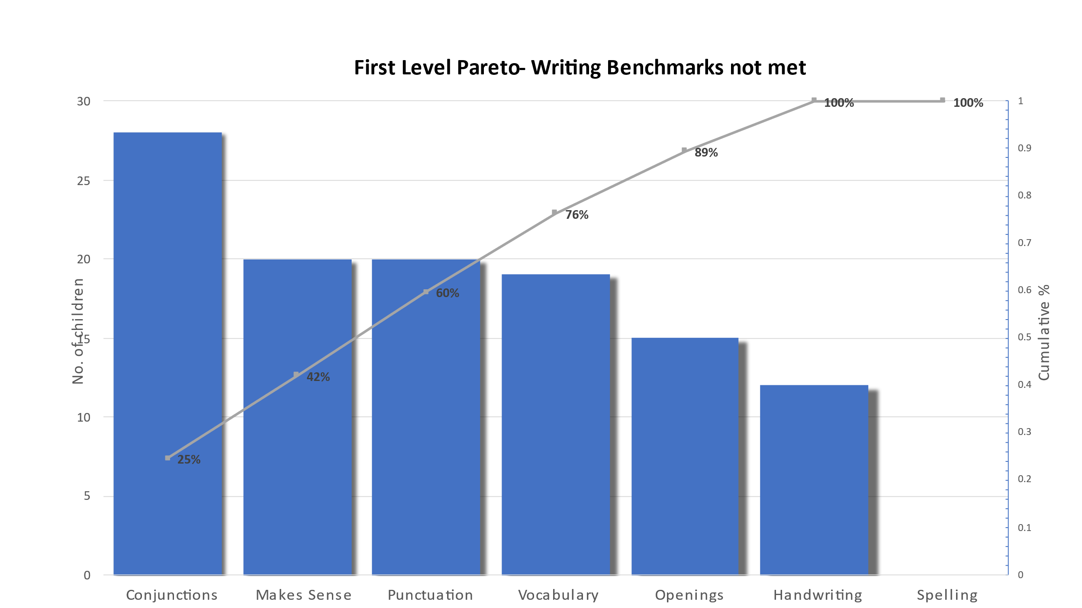

Progress towards the aims were recorded on a run chart daily and percentages shared with the children
Aim1- by 12th Dec 2022 73% of the P4 class will achieve at least 3 correctly punctuated sentences in their writing (capital letter and full stop) from a baseline of 36%
Aim 2 – by 12th February 2023 73% of the P4 class will achieve at least 3 correctly punctuated sentences 9capital letter and full stop) with at least two connectives (and, but, because, so) from a baseline of 32%
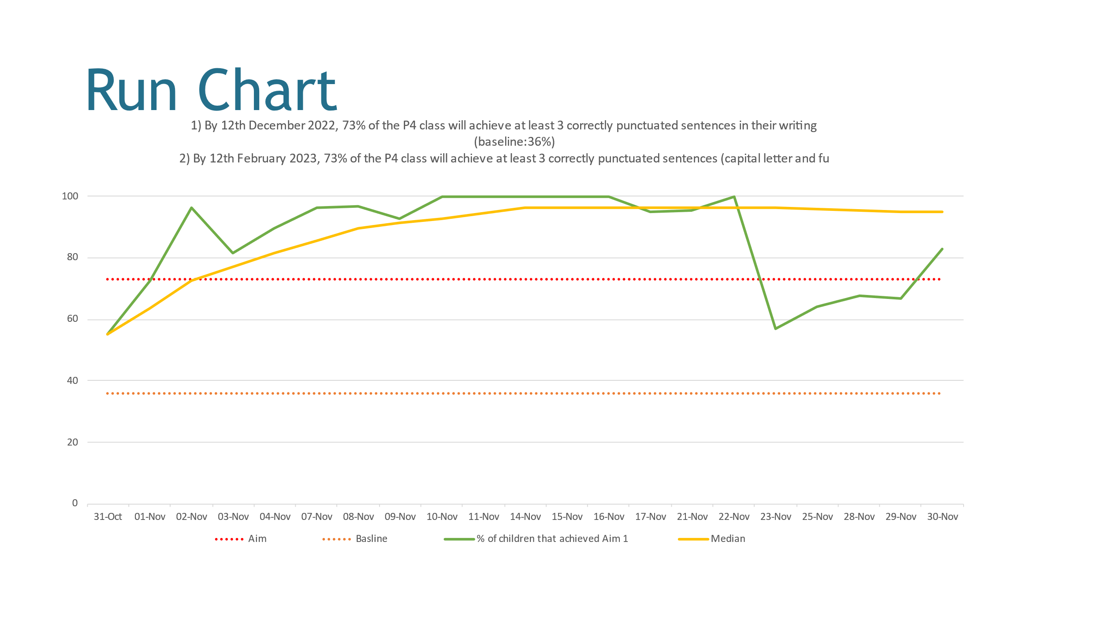
Almost all children reported a positive change in their attitudes towards writing by February 2023:
- I like to write about different topics for shorter times
- Surprising when we get the percentages
- I am curious about what we are writing about – it is good to write about different things every day
- When we get successful sentences it is amazing
- Knowing our % is exciting
- We try hard to beat our score

67% of pupils in P5 are on track for attaining Second level writing by the end of P7.
Of the 26 pupils in the P5 class 65% are on track for attaining Second Level by the end of P7, with 27% ahead of pace.
Initial pareto used to inform initial aim:
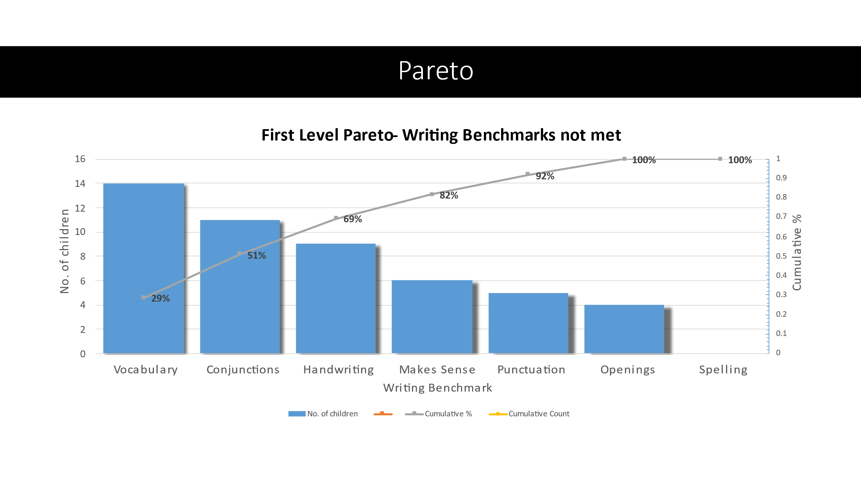
.
Through professional dialogue it was agreed the use of conjunctions needed to be the first aim: By 12th December 2022, 96% of P5 will write at least 3 sentences, each with a connective, in their independent writing (49%)

Aim 2: By 20th January 2023, 72% of P5 will include 3 sentences, each with a connective, and 3 'ambitious words' in their independent writing. (24% 2 sentences, each with a connective, and 1 'ambitious word'.)

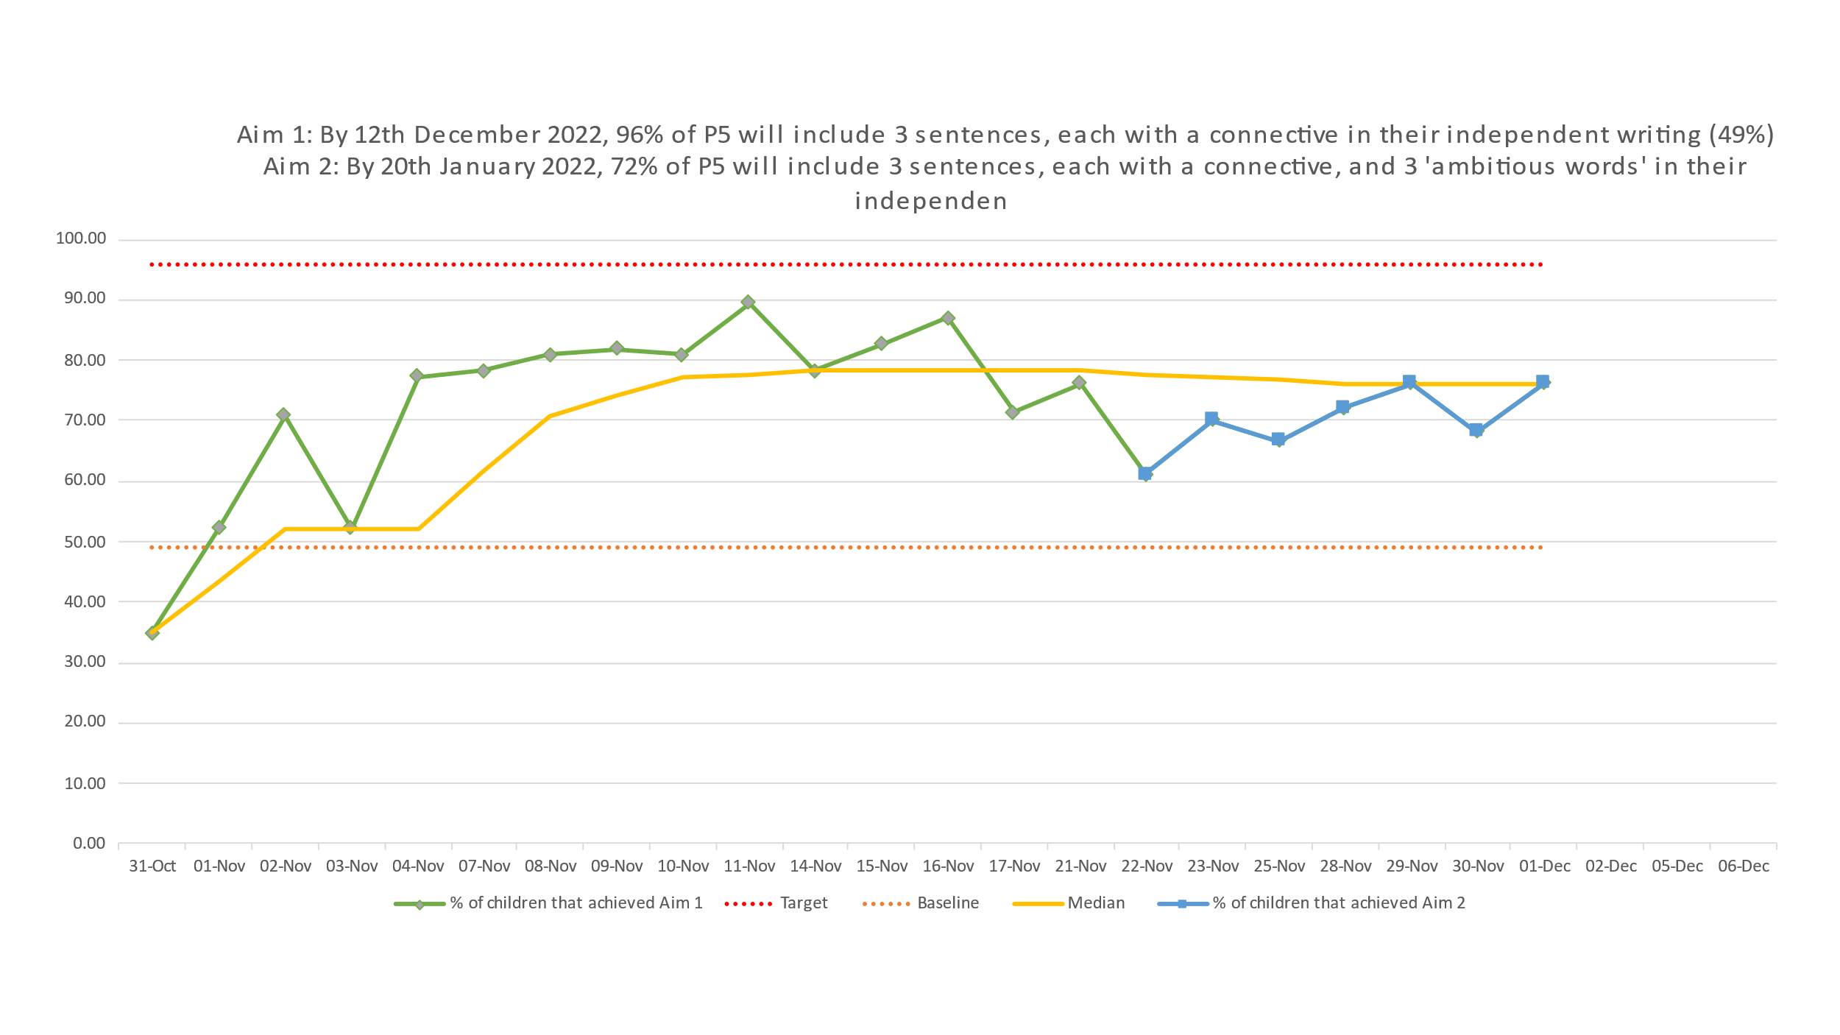
Pupils were asked When your teacher says, ‘we are going to write today,’ what goes through your mind?
- I wonder what we’re going to write about?
- Yes!
- I’m excited for this!
- Excited!
- Happy
- Is it going to be hard?
- Oh no, not writing again!
- I feel a bit worried about this

Professional dialogue during learning Partnership evidenced high quality professional dialogue with all staff in the QI writing programme who demonstrated professionalism, commitment and collegiality. They had a good understanding of the project and its impact. Children were able to share their writing and were enthusiastic about their writing experiences. They understood what they were working towards.
Next Steps:

- Due to changes in staffing we will need to train more staff on the QI methodology to maintain our status quo
- A plan for taking forward the methodology into reading and potentially other areas and other classes needs to be put in place
- The writing genre programme needs to be embedded 9 this is 6 months in to a 3 year programme. Ideas for relevant and real writing experiences needs to be added.

These next steps will be part of a literacy improvement priority for session 2023- 2024.

Priority 3 – Almost all children experience a consistent approach from all staff by June 2023
NIF Priority  Improvement in attainment, closing the attainment gap  NIF Driver  Practitioner professionalism |  |  | HGIOS 4 Quality Indicators  2.3 Learning, teaching and assessment  Sub QIs – theme indicated  1.3 Developing and shared vision, values and aims relevant to the school and community  2.2 rationale and design  3.1 wellbeing  1.2 professional engagement and collegiate working
Has this priority been:  (please highlight) | Fully  Achieved | x |  | Partially  achieved |  | Continued into next session
Progress:
- Vision, Values and aims consultations took place with all stakeholders
- Vision, Values and Aims were updated in line with the consultation
- School leadership team undertook professional learning on Curriculum Rationale and Curriculum Design
- Professional learning dialogue with staff team
- Consultation with parents and children on the experiences they feel a child should have in school before they leave P7
- Teachers plan a visit or visitor each term (or equivalent of 4 or more over the year)
- New planning formats piloted for session 22/23
- Leads for specific areas identified and given remit for sharing information:
- Mrs Bond - 1+2 languages
- Mrs Rennie – Cost of the School Day and Welfare Reform
- Mrs Montgomery – Assessment lead
- Mrs Wilson QAMSO
- Achievement Framework reviewed
- Library organised and put into operation
- Additional Support needs referral and support framework reviewed and updated
- Universal Supports professional learning and implemented in classes. Area for focus during Learning Partnership visit. Professional dialogue at Planning meetings.
- Four part lesson model with priority on feedback and plenary assessed through observation and Learning Partnership focus – staff individual action plans from this; reassessed at end of the year
- Pupil views on what makes a good learner and a good teacher – staff drew up individual action plans for this and the pupil views were repeated at the end of the year to evidence impact
- Pupil focus groups on unstuck strategies – individual class action plans following this.
- Pupil focus groups on Children’s Rights – individual action plans following this

Impact:
- In Term 1 pupil focus groups (random sampling of every 4th child on the register) also showed the 4 part lesson model was well embedded and routinely used across the curriculum in almost all curriculum areas. Of the children involved in the pupil focus groups most had a good understanding of learning intentions and learning strategies; the majority understood success criteria and the use of feedback. Only a few understood the purpose of the plenary. This is in line with classroom observations. All teachers put in place individualised plans for their class formed from the results of their classroom observation feedback and pupil focus group results on what made a good learner and a good teacher. Discussions with pupils and observations in classes during Learning Partnership visits in Term 3 showed 4 part model was evident in all classes, although the full board was not completed in all classes. LI and SC were the areas children were most able to talk about. Children in a few classes were able to talk readily with a good understanding of all 4 parts of the model. Children were clear this was used in most areas of the curriculum. By the end of Term 4 classroom visits and pupil focus groups showed improvements in the use of feedback and the linking of this to success criteria. Teachers were using a greater range of strategies and ensuring time was ring fenced to support more meaningful plenaries.
- All staff are aware of the vision, values and aims and are actively working to embed these within the life of the school
- Almost all classes have increased numbers of children showing an understanding of Children’s Rights
- All classes have worked on learning and using ‘unstuck strategies’. Direct reference to these were observed in classes during classroom visits
- Evidenced during the learning partnership visit, the majority of classes, organised and stimulating learning environments with differentiated learning and universal supports was evidenced. Children were engaged in their learning and teachers were sensitive to the needs of their children.
- All classes (almost all children) have participated in a visit or visitor each term (or equivalent i.e. 4 or more over the course of the year) as a result of the parent consultation on experiences for children before they leave P7. This resulted in the positive engagement of almost all pupils during the experiences.

Next Steps:

- Posters throughout the school need to be updated in line with the reviewed vision, values and aims
- Implement changes to planning formats as agreed from end of session review
- Increase number of school excursions to widen children’s experiences and support engagement

Nursery Improvement Priority Session 2022 – 2023

Priority 1 – All children with additional support needs in nursery will make good progress in their learning by May 2023

NIF Priority  Improvement in attainment, Improvement in health and wellbeing  NIF Driver  practitioner professionalism, assessment of children’s progress |  |  | HGIOELC Quality Indicators  2.4 Personalised Support  3.2 Securing children’s progress  3.1 Ensuring wellbeing, equality and inclusion  Sub QIs – theme indicated  1.1 – ensuring impact of success for children and families  1.2 – professional engagement and collegiate working  1.4 - Building and sustaining a professional team  2.2 - skills for life and learning  2.3 - learning and engagement, quality of interactions
Has this priority been:  (please highlight) | Fully  Achieved |  |  | Partially  achieved | x | Continued into next session
Progress:
Professional Learning
ASD from Educational Psychology
Signalong – sway. We had tried to establish a cluster signalong network, unfortunately staff absences both in our service and across other services made this difficult.
Support from SALT for individual needs – in particular use of Core Books to support communication and whole communication methods
All staff trained on e-LIPS

Professional Dialogue
Strategies to support individuals

Consultation with stakeholders
Consultations with parents, other professionals and staff during planning for children with additional needs
Impact:
All staff reported they knew which children in their playroom had additional support needs and the strategies in place to support these children
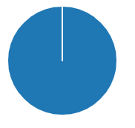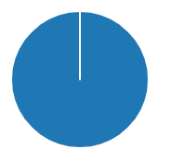
All staff who were keyworkers for children with additonal support needs and on a Child’s Plan were involved in review meetings, creating assessment profiles, setting and reviewing targets.
85% of staff felt that the strategies for chidlren with additonal support needs wre used consistently across all staff in the playroom. Observations of staff using agreed strategies showed there were varying degrees of confidence using a few strategies with a few chidlren, but most of the time, most staff were using the agreed strategies. Care Inspectorate noted partnership working with other services and staff using strategeis advised by specialist services to provide individualised support.
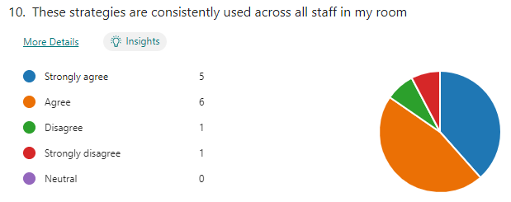

We asked children with additional support needs what they enjoyed in nursery and how their experience could be improved. In a minority of cases this was done through non-verbal means – by interpreting children’s gestures, actions, eye gazes etc to give voice to their views. All of the children could identify things in nursery they enjoyed. Across the group the children identified 18 different areas or aspects of nursey they enjoyed – these were mostly particular to them. However the majority of the children viewed the outdoor area as a favourite, which was in keeping with the wider view of all children in the nursery. Stories / books, sand, friends and toothbrushing were also selected by 29%. Finding out what the children wanted to improve their experience, was a more difficult concept with 43% giving no response. Of those that did respond, responses tended to be of an individual nature, with having more of the same resources being mentioned by all of those that responded.

We asked parents their views during and at the end of review / Child’s Plan meetings. All parents felt they had been fully involved in sharing strategies, reviewing of plans, their child’s profile and agreed targets. All children had made progress with their targets, although not all targets were fully met. Care Inspection report noted parents had opportunities to discuss their child’s individual needs and received regular updates on their children’s learning.

Monitoring of SeeSaw journals and for preschool children end of year reports, shoed staff knew their children well, achievements were recognised, and children had a wide range of experiences.

The majority of children with additional support needs were ready to start Primary 1 at Early Progressing in reading, writing and number. E-LIPS data breaks down the literacy /communication data for children of nursery age, looking at doing, understanding and saying. 40% of the children had moved from ‘red’ to ‘green’ in all 3 areas over their nursery experience;.20% had moved from red to amber in saying; 20% had moved from red to amber in understanding.
Next Steps:
- Signalong network
- Training materials for ASD and Signalong to be added to induction training for new staff
- De-escalation on next Improvement Plan
- Imaginative ways to hear children’s voice – particularly those with ASN

Priority 2 – All Children and parents will have a consistency of experience across all 3 nursery rooms by April 2023
NIF Priority  Closing the gap between the most and least disadvantaged children and young people  NIF Driver  Practitioner professionalism, Parental Engagement |  |  | HGIOELC Quality Indicators  1.4 Leadership and management of practitioners  1.5 Management of resources to promote equity  2.3 Learning, teaching and assessment  2.5 Family Learning  Sub QIs – theme indicated  2.7 – engagement of parents and carers in the life of the setting  2.4 – removal of barriers to learning  2.2 - Pedagogy and play  1.3 – implementing improvement and change
Has this priority been:  (please highlight) | Fully  Achieved |  |  | Partially  achieved | x | Continued into next session
Progress:
- Induction process for new staff – this is an ongoing programme over the first year using the national induction model
- All new staff have a peer mentor
- Regular (weekly) meetings across all 3 rooms to look at areas where there were known inconsistencies (entry to nursery routine, mealtimes) expectations and procedures were discussed, agreed and written down. A monitoring sheet to measure impact was written at the same time and used to monitor progress towards consistency – this can be used for self, peer and management monitoring
- Stay and Play sessions for parents
- Lending library and Book bugs sessions – available to all families on a rotation
- Forest training delivered to all staff currently employed in November 2022 – training took place in the area nursery will visit
- Community visits for groups of children

Impact:
All nursery staff reported understanding and feeling confident or very confident in their role.
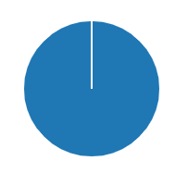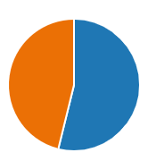
Observations of staff show almost all sounding and looking confident in their interactions with children. Children’s needs were responded to quickly and staff were highly responsive. This was also seen during our Care Inspectorate visit.
Most staff (85%) reported all staff in their playroom were aware of expectations., this included being involved in learning walls 85%, writing observations 92%, 85% involved in planning, 77% setting up learning experiences.
Almost all (92%) of staff felt they worked together effectively.

85% of staff felt children had consistent experiences across all three playrooms the majority of the time or more.
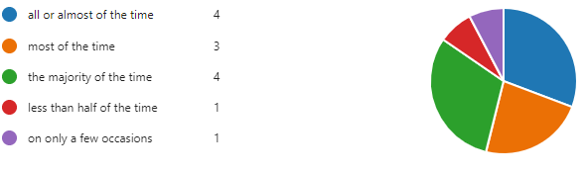
Observations of pupil experiences across all playrooms and in the outdoor area showed very similar levels of support, environment and staff interactions. As small differences were noted these will continue to
We recognise that staff absences, including long term absences ad time waiting for new members of staff had an impact on our ability to make as rapid progress as we would have liked and to maintain progress within a constantly changing team.

A Learning Partnership externally validated our evaluations noting the cohesion across the three rooms and the welcoming and beautiful environment, which was well organised and thought out, with resources which were accessible to children. High quality resources and meaningful play opportunities were also noted by the Care Inspectorate, who also noted how children’s interests were developed through skilful staff interactions. (We talk more about our Learning Partnership and Care Inspectorate findings later in this report.)

Through child focus groups, children told us their views on nursery – the things they enjoyed the most and things that could make nursery even better. Almost all areas of nursery were mentioned by one or more children. This is supported by staff observations which show a wide range of areas being used on a daily basis. Monitoring visits to playrooms also showed staff responsiveness to children’s ideas and requests. Almost all observed requests were actioned within a few minutes.
In particular children told us they enjoyed the outdoor area (50% mentioned this as a favourite). Sand inside and outdoors was also a popular choice with this being mentioned by 39% of children asked. Dough and playing with friends were also mentioned by 28% and 22% of children. Children most often identified more of current resources such as cars or getting back out resources they had earlier in the year (36%) as areas to improve; interestingly 11% of children also mentioned lunches – wanting to have the same lunch available each day.

Almost all children in nursery were working on Early progressing ready for entry to Primary 1, for reading, writing and number. Most children were working at this level for listening and talking.
Next Steps:

- As part of induction make increasing responsibilities clear both to new staff and existing staff, so that there is not a miss match in expectations
- All new priorities - continue to write up policies with clear expectations and create monitoring tools at the same time to ensure consistency – encourage use of monitoring tools for self and peer evaluation and feedback

Attainment of Children and Young People
Stage | Reading | Writing | Listening and Talking | Numeracy
P1 | 85% | 67% | 85% | 89%
P4 | 57% | 62% | 87% | 62%
P7 | 76% | 73% | 83% | 73%

Overall Attainment for 2022- 2023
 | Literacy | Numeracy
P1 | 79% | 89%
P4 | 68.6% | 62%
P7 | 77% | 73%

Literacy |  | Numeracy
Stretch Target | Actual | Stretch Target | Actual
76.8% | 74.2% | 80.8% | 72%

Reading
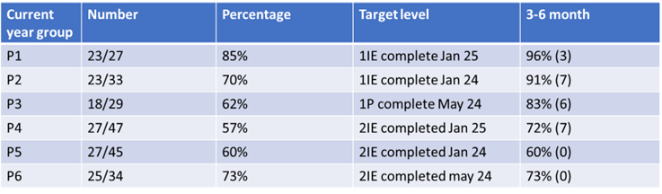

Writing
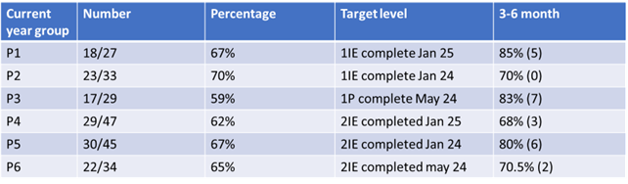

Numeracy

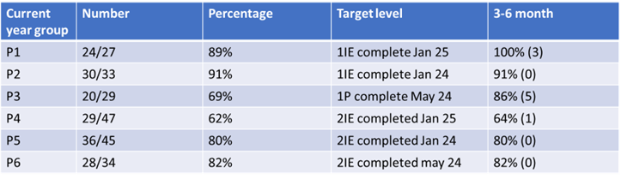

Evidence of significant wider achievements
P1-7 all pupils record their in school and out of school achievements in their individual Achievement Booklet. This is organised by the 4 capacities and cross referenced to our school values and learning words. This supports teachers in planning experiences for all pupils to achieve across the capacities. Achievements are recognised and celebrated through assemblies, a system of awards and certificates, SeeSaw journals and school newsletter sways.

The achievements of all children in nursery are recorded in their SeeSaw journals, allowing partnership and celebration of achievements between nursery and home. Children are encouraged to share their achievements with their peers through ‘Show and tell’ and sharing their journals.

Confident Individuals
Almost all pupils in P5 engaged in the YMI guitar or song writing projects. The song writing group produced 3 songs related to their IDL, which they sung for the wider school and parents.
Almost all pupils in school learned about and engaged in activities around a healthy lifestyle through health and Sport Week – this involved a wide range of taster sessions from local clubs (basketball, American football, shinty, boxing, Enjoy-a-ball, athletics, cricket, bowling and netball)
Almost all pupils in P4 engaged in the Schools Massage Programme to support their learning of wellbeing strategies
A few pupils in P7 were selected to represent the school at the Rotary Quiz, where they showed ambition and resilience during both the competition and preparation for the event
A few pupils in P5-7 represented the school at a variety of local sporting events. In all cases the children showed good sportsmanship, aspiration, teamwork and perseverance. This allowed them to take second place at the Dunfermline and West Fife Sports Council Hockey Festival and fourth place at the West Fife Cricket Festival

Responsible Citizens
Almost all pupils contributed to the creation and use of their class charter – increasing their understanding of Children’s Rights and how these can be realised. This was extended to Global Goals in a minority of classes
Almost all children in P5, P5/6, P6/7 and P7 learned about the democratic process through visits from the Scottish parliament and engaging in Political party elections for their class
Almost all children in nursery learned about being responsible during a visit from the police
Almost all children in P2/3, P3/4 and P5 learned about the role of our local church in our community
Almost all children in P2/3, P3/4, P4 and P4/5 learned about the elements that make up our local community and engaged in walks around our community
Almost all pupils in school and nursery learned about Scottish culture through a range of Scottish experiences – food tasting, poetry, dancing, artwork, Scots language and assemblies
All children in the nursery are learning to participate responsibly and increase their independence through lunch ordering and mealtime routines
Almost all pupils in P6/7, P5/6, P5, P4/5 and P4 learned about looking after animals and behaving responsibly through visits from the Peacock Rescue centre and/ or Dogs Trust. The majority of pupils developed skills in solving problems around dog stereotypes.

Successful Learners
Almost all children further developed their communication skills by asking questions, listening to presentations and engaging in discussion with visitors e.g. Generation Science visit – Day and Night, Peahen rescue and lifecycle, Dog’s Trust, Scottish Parliament, Police etc
Almost all children in P6/7 and P7 learned about skills for life and work through their visit to East End Stadium
Almost all children in P6/7 and P7 developed skills in using technology and understating science through their visit from the Royal Navy and WHS STEM Ambassadors
Almost all children in P5 and P5/6 developed food technology skills and skills for life through a visit to WHS Home Economics department to engage in practical cooking
Almost all children in nursery engaged in book bug sessions to support their literacy and communication skills

Effective Contributors
Almost all pupils in P5 developed an enterprising attitude and learned skills in teamwork whilst engaging in their Bee fundraiser
Almost all children in nursery participated in a reading fundraising challenge which supported their developing literacy, positive attitudes towards reading and enterprising attitudes
All pupils had the opportunity to be involved in planning and delivering a special service or assembly for the school and their parents.

Feedback from External Scrutiny
Learning Partnership/Extended Learning Partnership
School – key strengths
- Initial discussion with leadership team set the purpose of the visit and gave a clear indication of self-evaluation and the journey so far in each area
- 4 part model was evident in all classes, although the full board was not completed in all classes. LI and SC were the areas children were most able to talk about. Children in a few classes were able to talk readily with a good understanding of all 4 parts of the model. Children were clear this was used in most areas of the curriculum.
- In the majority of classes, organised and stimulating learning environments with differentiated learning and universal supports was evidenced. Children were engaged in their learning and teachers were sensitive to the needs of their children.
- Clear routines evident in all classes P1-P3/4 as children moved between teaching time with the teacher, child initiated and adult initiated experiences, including in the outdoor areas.
- High quality professional dialogue with all staff in the QI writing programme who demonstrated professionalism, commitment and collegiality. They had a good understanding of the project and its impact. Children were able to share their writing and were enthusiastic about their writing experiences. They understood what they were working towards.
- Well-structured and accessible play based learning.
- Agreed universal supports in place in most classes

Development needs / Agreed actions (red- not started, amber – some progress made, green – completed)

- 4 part lesson model board and pack for hall and music room to support this being visible to children across the whole curriculum.
- Individual feedback to be given to staff so that this can be included within their individual plans to improve (along with leadership teams obs, peer obs and pupil focus groups carried out by peer)
- Staff meetings and Development Time to be rotated around classrooms with time given for staff to look around and each staff member share their room – this will start with the classes which have been evaluated as having very good / interesting practice to share.
- Use of peer mentors to support less experienced staff with their classroom environment.
- Support for Learning / Leadership team support for specific classes with regard to differentiation and universal supports.
- Share QI writing practice and improvement methodologies – this has already started incidentally.

Nursery – key strengths
- All rooms were beautiful, well organised, well presented and thought out, with resources and activities accessible to children
- Each room was different but there was cohesion across the rooms
- The indoor and outdoor learning environments provided rich experiences for children with plenty of opportunities for literacy and numeracy learning
- All children were engaged.
- Staff were caring, nurturing, engaged with children during their play and extended their learning.
- Most staff were able to share their practice
- Most learning walls were of a high quality, where the learning journey was evident and at a height which enabled it to be accessible to children.

Development needs / Agreed actions (red- not started, amber – some progress made, green – completed)

- Review PLJ practice
- Review outdoor area supervision
- Share practice on learning walls across all 3 rooms
- Set expectations on use of high boards in the nursery which cannot be used for Learning Walls.

Care Inspectorate - Strengths and Areas for Improvement
QI 1.1 Nurturing care and support – very good
Children were happy, settled and having fun
Children experienced nurturing care which supported wellbeing
Staff were kind, engaged with children respectfully, taking time to listen and respond at the children’s level
Children had opportunities to reflect on their play and learning
Parents had opportunities to discuss their child’s individual needs and received regular updates on their child’s learning
Children’s achievements were recognised
Partnership working, including staff use of strategies advised by specialist services, to provide individualised support
Calm and relaxing atmosphere for eating
Staff use of best practice guidance for eating
Child ownership of mealtime experience, promoting independence and life skills

QI 1.3 Play and Learning – very good
Children meaningfully involved in leading their own play, in both spontaneous and planned experiences
Daily routines provided in a way which allowed choice to end play and engage in activities
High quality resources which offered children rich and meaningful play and learning activities across all playrooms
Children highly engaged in their play.
Children’s interests developed through skilful staff interactions

Next steps:
finalise ways to include planning and tracking children’s next steps in learning

QI 2.2 Children experience high quality facilities – very good
Setting was welcoming, clean and inviting with furniture and resources of a high quality both indoors and outdoors
Strong sense that children matter
Children had the opportunity to engage in risky play with staff using a risk benefit approach to assessing risk and ensuring safety
Staff created a very positive learning environment with purposeful areas and quiet, nurturing spaces
Outdoor play valued and children had the opportunity to experience learning and fun in different weather conditions
Environment was safe and healthy with appropriate infection control measures in place

QI 3.1 Quality assurance and improvements are well led - good
Children benefited from a child centred approach to play and learning
Staff felt valued and supported by the leadership team
Distributed leadership model supported individual staff members to share skills and knowledge
Staff were reflective and keen to continue their individual and service practice
Policies were reviewed, updated and implemented using best practice guidance
Children benefitted from a knowledgeable and committed staff team
Self-evaluation maintained and improved the quality of care, play and learning

Next steps:
Review medication forms to ensure these are being used as intended
Continue to consult with parents and children on service improvements, regularly

QI 4.3 Staff deployment – very good
Children benefited from a service that valued their rights to play and have fun through quality interactions, positive relationships and high quality provision
Staff met together regularly to discuss individual children, best practice and to plan a breadth of experiences, ensuring their practice was reflective and consistent in meeting children’s needs
New staff were supported through a continuous induction programme
Staff communicate across playrooms to ensure children’s needs were responded to in a timely manner, whilst ensuring ratios were kept

There were no outstanding requirements or areas of improvement.
There were no upheld complaints.

PEF Evaluation/Impact
Targeted Interventions

Progress:
- Individualised support and identification of barriers to attendance through daily phone calls to parents of the targeted group of pupils on days when children did not attend. This encouraged families to bring children to school even if they were late, supported parents to make decisions over whether or not a child was too unwell to attend, and gave practical advice around children who were not doing as their parent asked.
Subsequent groups of individuals were identified through normal attendance monitoring and were added to the list of 13 when attendance dropped below 80%.
- Family worker joined the staff team in January 2023. Through the analysis of data a group of parents were identified who wanted support to aid attendance. In most cases this included families where parental health, children’s age and living outwith the catchment area were all working together to create attendance barriers. The aim of the group was to facilitate a network of parents who could eventually support each other.
- Breakfast Club, supported by PSA to allow a soft start for pupils who need this

Impact:
1.This initially saw a positive impact, with the majority of parents bringing their child to school after a phonecall. However over time parents were less likely to engage and in cases did not respond to phone calls or other messages.

data point 21 – no calls made, or record taken
data point 23 Inset

2.The barriers faced by almost all of the parents within this group meant attending in a group setting was not possible – work arrangements or health issues. Individual support, including home visits, was put in place for one family where attendance had fallen below 50%. Three families from this group are actively seeking housing within the catchment area to support their child’s attendance.

By June 2023 the original group of 13’s average attendance was 72% which was a marginal gain from their average attendance of 70% the previous year. However, 23% of the group managed to increase their attendance to over 80%. This attendance rate should also be viewed within the overall context of attendance this year and our general trend in attendance over time. Between session 2017 -2018 and session 2021 -2022 our attendance has remained fairly stable at between 93 and 95%. A stretch target of 93% was set for this session (2022- 2023). The overall attendance this session is 90%. We are aware that with a background of sporadic industrial action many families were placed in difficult situations around childcare, and which often meant school wasn’t seen as a priority on weeks when children were only required to attend on 2 or 3 days.

Next Steps:
Family Worker to continue working with individual families to support them with solutions to improve attendance. Where attendance remains a serious concern, alternatives around supporting children’s learning need to be addressed.

Intervention 2
By April 2023 those targeted pupils will be returning home learning most of the time.

Progress:
This target was not progressed as consultation showed original barriers to home learning were no longer present.
Main barrier which continued was timing around homework – individualised agreements were made with families as to when homework would be returned.

Impact:

Next Steps:

Intervention 3
By June 2023, all identified pupils for nurture intervention (16 pupil) will have improved wellbeing, their barriers to learning will have been reduced.

Progress:

make up of the 16 children was updated to those most in need during T1 (change of class dynamics supported some children without further support strategies; 3 new children to school were added to the targeted group)

- Two groups of children were identified for support using Lego therapy to help improve their turn-taking, sharing, teamwork, social interactions, problem solving and communication skills. Children participated for one Lego therapy session each week, over 6 weeks, giving them practice at 3 main roles: engineer (using plans to describe a construction and the bricks needed to build it); supplier (finding the bricks described by the engineer and giving these to the builder); builder (uses the verbal instructions from the engineer and the bricks given by the supplier to assemble the construction). One group also learned the role of the director (role normally taken on by the adult facilitator – keeping everyone on task and supporting appropriate behaviour).
- Resources for sensory boxes purchased for all classrooms, to be used as part of a universal strategy
- Proactive Management Plans in place and reviewed regularly
- A range of proprioceptive strategies were taught and added to children’s plans. PSA time was given to support this.

Impact:

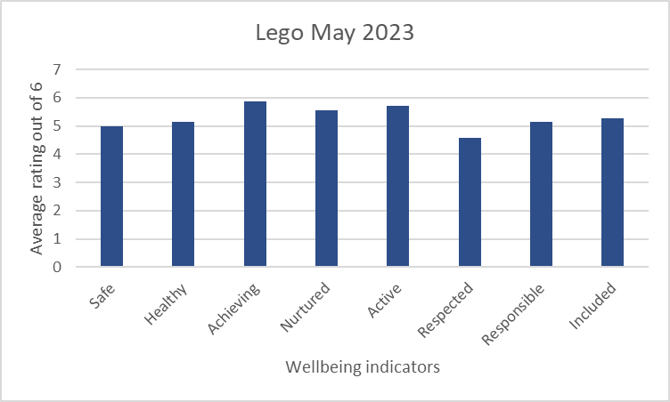
- Lego Therapy
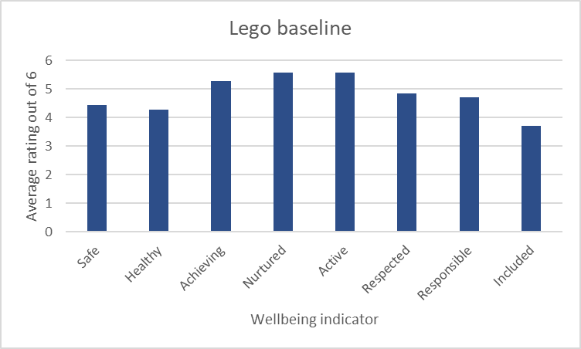

In 87% of the Wellbeing Indicators children reported an increase in their wellbeing; respected showed a small decline from an average rating of 4.8 to 4.5. The most noticeable increase in average rating was Included which rose from an average rating of 3.7 to 5.3.

Children commented:
- I liked socialising. I liked the humour, that it was calm, makes me self-aware
- I liked the Lego; it was fun with friends
- I liked the Lego it was fun. I liked the job roles
- I liked the team building
- I liked the Lego. I loved the engineer role. I disliked not getting people to listen to me, and people doing jobs which were not theirs
- I like Lego. I loved being the engineer. I did not like being bullied* (bullied comment was made in reference to the other 2 pupils in the group trying to tell the individual in the group not to take over and if they noticed he was doing something ‘wrong’ telling him ‘No, this way’

All of the children expressed enjoyment in using the Lego as a tool to support their learning.
The adult facilitating and observing the groups noted that the majority of children in the group of 3 improved their descriptive language and communication skills over the 6 week period. She also noted that all of the children in the group of 4 who also looked at the Director role were able to make insightful observations on the working of the group, supporting their understanding and development of teamwork.

- Sensory box of resources in place and used in all classes. Most children report using items from the box at some point to aid concentration and calming
- 25% of the targeted group have a PAMP. These show fluctuating levels of success and are reviewed often to ensure successful strategies are maximised and all adults involved with an individual are using consistent approaches. PAMP is working very well for 25%, with very few instances of unsafe behaviour.
- Proprioceptive activities added to 81% of the group’s individual plans to support regulation – this is supported by PSAs for 37% of the group until children are able to use these independently. 31% of the group are using these strategies mainly independently.
- Attainment for targeted 16 children: Most children are on track in reading and numeracy. The majority are on track in writing and listening and talking. Most children have either accelerated (44%) or kept the same (38%) rate of progress as in previous years. 19% of children have slowed their progress and are at risk or are currently off track.
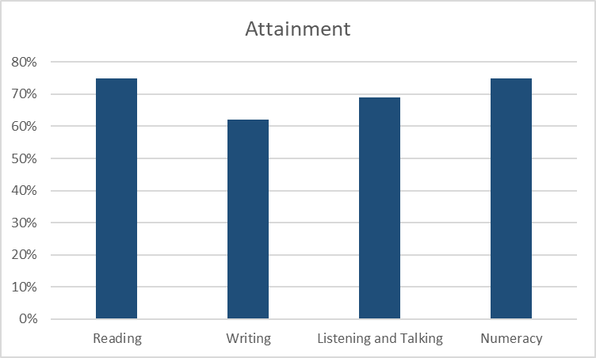

- Attendance for targeted 16 children: 25% of children in this targeted group have an attendance rate of 95% or better. Most of the children (75%) have an attendance of 80% or more. In 6% attendance has fallen to around 50%
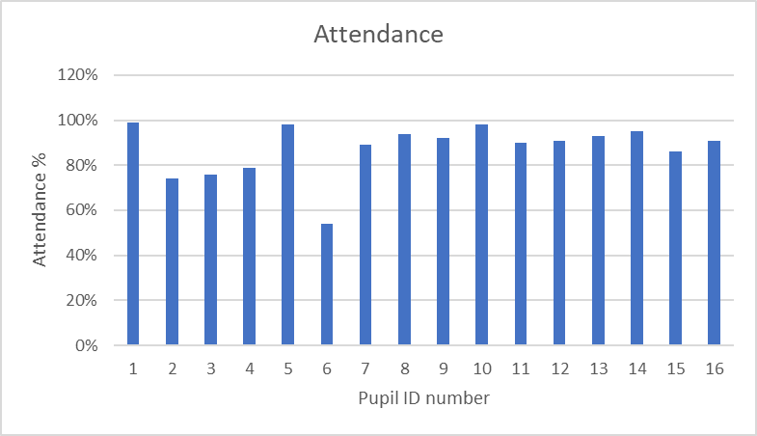

Next Steps:
- Link with de-escalation work on the SIP for session 2023 2024
- Cluster work to share most successful strategies for Regulate, Relate and Reason (Bruce Perry)
- Produce school / cluster book of strategies and professional reading / learning

Targeted Interventions
Intervention 4
By June 2023, all identified pupils for anxiety intervention (13 pupil) will have improved wellbeing, their barriers to engagement in learning will have reduced

Progress:
- A Family Support Worker was put in place from January 2023, working 2 days per week over the full year.
- Decider Skills run in 2 groups for a total of 6 pupils – programme teaches 12 decider life skills (STOPP, It will Pass, Right Now, Name the Emotion, Opposite Action, Fact or Opinion, Self-care, Values, Listen, Respect, Crystal Clear and Reflect) for proactive mental health for children (and adults). Two skills are taught each week over 6 weeks.
- Three Kitbag groups were run in small groups for 6 weeks.
- Massage in Schools programme was run for 6 weeks in P4 class led by our family Worker 2 days per week and supported by the class teacher on the remaining days. All classes within the school then had a taster session of the programme during Health week.

Impact:
2. Decider Skills
Children who participated in the Decider Skills groups were asked to self-rate using the Wellbeing indicators at the beginning and end of the input. They were also asked to comment on their feelings and attitudes towards being involved in the group.

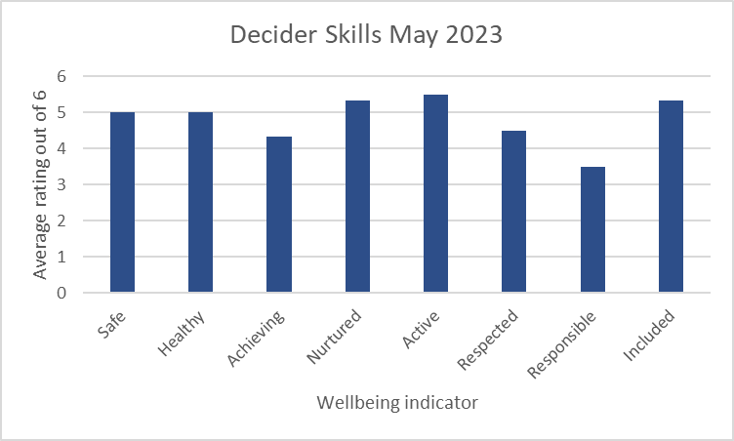
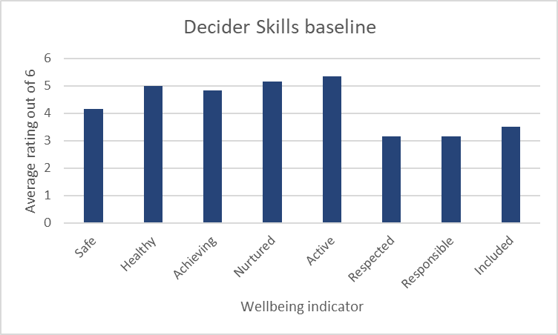
The average rating increased or stayed the same in 87% of the wellbeing indicators, however Achieving showed a slight decrease from an average rating of 4.8 to 4.3. The most noticeable rises were in Safe (4.1 to 5), Respected (3.2 to 4.5) and included (3.5 to 5.3).

Children commented:
- I liked that you respect us’
- I didn’t like when it was on a Thursday, but it changed
- I didn’t like it when we missed gym before on a Thursday
- I did not like when the group was on a Thursday
- I liked everything about the group.
- I liked decorating the cookies, time out of class, making the obstacle course, the weird words, and talking.

Most children’s ratings improved in most wellbeing indicators. We recognise that these ratings are a snapshot in time and can often be influenced by how a person is feeling at that particular time.
The majority of children expressed dislike of the original timing of the group. This was quickly changed by the adult who was able to respond to the views of the children.

3. Kitbag
Children who participated in the Kitbag groups were asked to rate their wellbeing using the wellbeing Indicators. They were also asked to make a comment on their feelings and attitudes towards their involvement in the group.
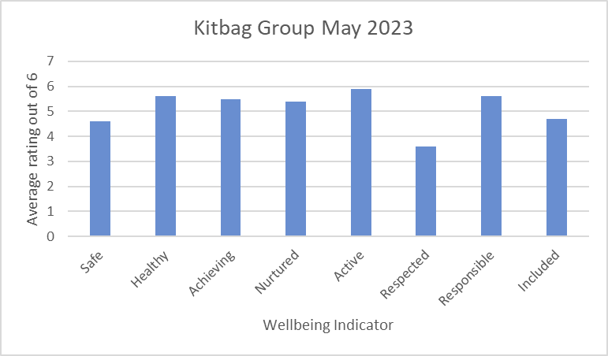

The average rating out of 6 increased in 66% of the wellbeing indicators, this was most noticeable in Healthy (increase from 5- 5.6) and Achieving (increase from 4.6- 5.5) and Responsible (increase from 4.8 to 5.6)

Children commented:
- I like coming to the group because I feel safe about talking about things and I would like to have people who I feel safe to talk to, and it helps my anxiety because I am allowed to bring my putty as well
- This helps me a lot, but I still need to do it to help me.
- I didn’t like not feeling comfortable at the table with sharing stuff with the group. I would feel more comfortable with my friend and liked people
- I like it when we lie on the floor (mindfulness). In the future can it just be me by myself? I did not like being in a group.
- I like my friends in the group, the group is nice,
- I liked that everyone was passionate about it, funny, nice, I liked the kitbag cards, the mindfulness and the cosy corner.
- it makes me calm, I like the Cosy Corner, the kitbag cards, puppets and oils’
- I liked getting to know about other people’s day, getting time to rest, and Wolfie and Robin in kitbag
- I would like to add pillows maybe’
- I liked that it was fun, nice, peaceful, relaxing, mindful. I liked the puppets.

All of the children valued time dedicated to learning strategies to help them with their wellbeing. Almost all also valued having the undivided attention of a caring adult.
The groups had been divided by gender which seemed to work well and supported children in talking about how they felt. This worked particularly well with the group of boys. However the group of 6 girls seemed to split into 2 friendship groups with most of the girls (5) commenting that they didn’t always feel comfortable talking about some issues in front of those they did not consider part of their friendship group and 1 who wanted to do the work on their own with an adult.

4.Massage in Schools Programme
Almost all (91%) of children in the target class reported they would like to continue the massage programme, with the majority saying they would actively promote this at home.

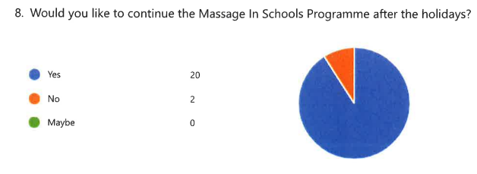

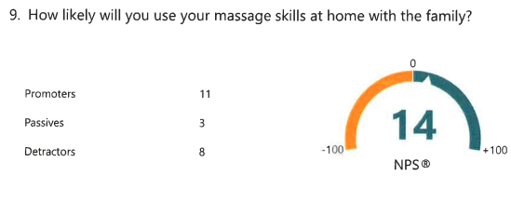

Almost all (95%) gave the programme 4 or 5 stars (out of 5).

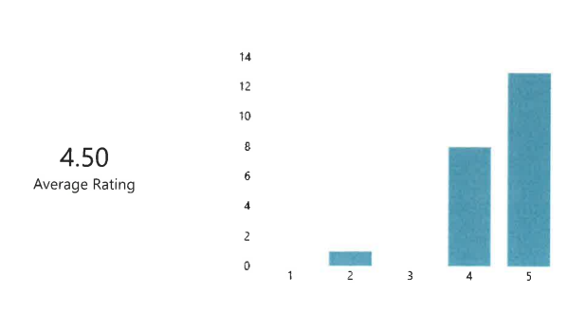

During the programme the class teacher anecdotally noted almost all children looked forward to participating and showed high levels of engagement during the activity. They showed very good partner skills, and the teacher noted a big difference in the kindness levels towards each other in class. As the massage activity usually took place after lunch it supported the children to calm any playground issues and helped a minority of children to self-regulate when they would normally seek adult support. The activity provided a good transition between the playground and the start of the afternoon lessons. The class appeared calmer and more relaxed following the sessions.

Next Steps:
- Children need a greater degree of ownership including choice of group membership, location and timing if they are to get maximum impact from additional groups.
- There is the potential for those who have been involved in small group kitbag sessions to teach others in class and support small groups in class to run their own groups, however, there continues to be the need for the support of a caring adult who can give a group their undivided attention.
- Massage in Schools Programme to be further developed – Sway created this year to be shared
- Decider Skills programme to be further developed across more pupil groups

NIF Quality Indicators (HGIOS 4) School Self- Evaluation
Quality Indicator | 2020 -2021 | 2021- 2022 | 2022-2023 | Inspection Evaluation  (Since August 2022)
1.3 Leadership of change | Very good | Good | Good | NA
2.3 Learning, teaching and assessment | Good | Good | Good | NA
3.1 Ensuring wellbeing, equity and inclusion | Very good | Very good | Good | NA
3.2 Raising attainment and achievement | Good | Good | Good | NA

NIF Quality Indicators (HGIOS ELC) Early Years Self- Evaluation (Nursery)
Quality Indicator | 2020 -2021 | 2021- 2022 | 2022-2023 | Inspection Evaluation  (Since August 2022)
1.3 Leadership of change | Good | Good | Good | NA
2.3 Learning, teaching and assessment | Good | Good | Very good | NA
3.1 Ensuring wellbeing, equity and inclusion | Very Good | Very Good | Very Good | NA
3.2 Securing children’s progress | Good | Good | Good | NA

Care Inspectorate (within last 3 years) | Grade (if applicable)
 | 2020 -2021 | 2021- 2022 | 2022-2023
Quality of care and support | NA | NA | Very good
Quality of environment | NA | NA | Very good
Quality of staffing | NA | NA | Very good
Quality of leadership and management | NA | NA | Good

Headteacher Katrina Miller June 2023

