Touch School and Nursery


Touch Primary and Nursery
A Community with Learning at its Heart

Site Traffic Management Plan

Reviewed Feb 2023

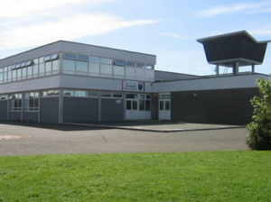
Contents

Section

- Introduction
- Layout / Access
- Pedestrians
- Pupils / Students
- Staff
- Visitors
- Servicing / Deliveries
- Contract Hire Services
- Disabled Access
- Out with the School Grounds
- Management Practices

1. Introduction

This document has been prepared to inform and instruct employees, pupils, parents and others who come onto the site, including visitors (both pedestrians and people in vehicles), about the site rules concerning pedestrian and vehicle separation.

Touch School and Nursery takes the health and safety of all site users very seriously. It is therefore, imperative that individuals take care, exercise caution when in the school grounds or within the vicinity of the school grounds and follow instructions to avoid risk of injury. If there are any concerns about traffic safety, they should be reported to the school management team.

We urge all site users to read this document carefully and act in accordance with the instructions contained therein. The instructions constitute site rules. Pupils in breach of the site rules may be subject to disciplinary action.

Copies of this document are available to school staff, pupils, parents and carers. Copies are also available from reception and on the school website:
https://blogs.glowscotland.org.uk/fi/touchprimary/

The document will be reviewed annually and awareness raised regularly through parental events and newsletters, class talks and assemblies.

For further information, please contact:

Katrina Miller (Headteacher) 01383 602438
Touchps.enquiries@fife.gov.uk

2. School Layout / Access

Parking for kitchen deliveries

Carpark for staff and visitors
Main entrance

Gravel Pitch
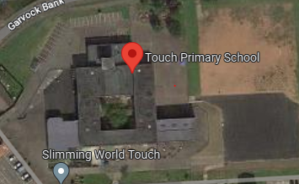

playgrounds

Alternative parking for parents and visitors – Vine Church

Alternative parking for parents and visitors - layby
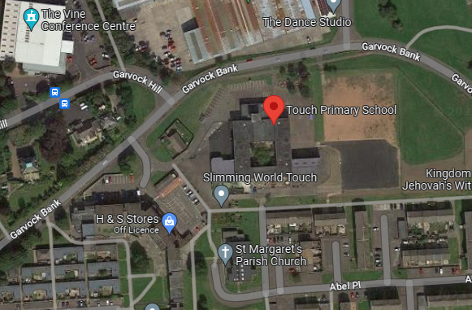

Alternative parking for parents and visitors

Alternative parking for parents and visitors – St Margaret’s Church

3. Pedestrians

There is a pavement around the perimeter of the school and pedestrians should make sure that they use this safely and avoid spilling onto the road.

Pedestrians should only access the school from the designated entry points only. There is no pedestrian access via the driveway.

4. Pupils

It is very important that pupils set a good example to others, particularly in the spirit of being a safe school. There are a number of site related areas pupils should be aware of:
- Pupils should be particularly aware that entry into the school grounds via vehicular access points - school carpark and driveway - is forbidden. Whilst this may seem a quick way into the school, it is a breach of the school rules and compromises personal safety and the safety of others.
- Pupils found to be climbing over railings or walls, not following staff instructions in relation to the site, or not adhering to the contents of this plan will be in breach of the school rules and may be subject to disciplinary action.
  - When using the footpaths – walk! This will avoid accidents and will make you more aware of what is happening around you.
  - Pupils may access the school grounds via the gravel pitch.
  - Pupils should make their way around the school playground to their entry door – access across the carpark is not permitted.

Drop Off

There is no designated on site drop off for pupils other than for those attending with disabled access needs. No vehicle should be accessing the car parks for this purpose, without express permission.

5. Staff

There is one car park within the school grounds and this is strictly for the use of visitors and school staff. Drivers should proceed slowly (maximum speed of 10mph) within the car parks at all times.

Staff are expected to act responsibly on the site when parking and accessing the school building. This includes parking which does not obstruct access to the building for other users, obstruction of emergency vehicle access by parking on the driveway and the consideration towards other users in gaining access to their vehicles.

6. Visitors

Visitors are welcome to park in the school grounds. The car parks are often busy, visitors should only park in available designated bays, and on no account park on the driveway as this may cause an obstruction to emergency vehicles. Drivers should note the maximum speed within the school grounds is 10mph.

Alternative parking is available in the surrounding area, but if you are unfamiliar with the area, please make sure that you do not block residential driveways or park where this could cause an obstruction.

Access into the school is only permitted from the main entrance on Garvock Bank. Visitors need to press the security buzzer located outside the main office. All visitors must report to reception and sign in before going anywhere in the school. On departure, visitors should sign out at reception and leave the building by the main entrance door.

If visitors need any advice on access or parking before their visit, please call the school reception on 01383 602438.

7. Servicing / Deliveries

Drivers of service vehicles (if they have not been on the site before or obtained instruction in advance) should report to the reception desk in the main building to advise the nature of their visit and get clarification on where they can park. Drivers may be issued with a copy of this plan for reference or simply be advised of the site rules in relation to the area they are parking at the time. Drivers should note the maximum speed within the school grounds is 10mph.

Where the contractor is on site to carry out works by prior arrangement, please call the school reception on 01383 602438 in advance to agree the most suitable parking location.

Delivery drivers may park outside the school kitchen area.
Contractors working within the school should use the parking bays in the carpark, on no account should the driveway be used to park. If access to other locations is needed drivers must park their vehicle and check with reception – on no account should drivers drive into the playground or across the grass or gravel pitch area until authorised to do so – to ensure their own personal safety and the safety of children and staff who may be using the playground areas. Keys for the bollard, to gain access to the playground, can be found in reception.

Drivers should be aware that they are working in a school environment - exercise extreme caution and be vigilant when carrying out vehicle manoeuvres in any part of the school grounds. Particular care should be taken on entry to the driveway as this is a tight bend and a crossing point for children at peak times.

On no account may vehicles be driven in areas where children are present eg.playground.

8. Contract Hire Services

Contracted vehicle drivers (including taxis and minibuses) will have specific instructions given to them through Transportation & Environmental Services as part of the terms of the contract. These vehicles may park in the school carpark in a parking bay or at the gate at the end of the carpark. Drivers should note the maximum speed within the school grounds is 10mph.The driver / escort should make their way to reception to escort the child being collected or dropped off. Children are not permitted to access the carpark on their own. Taxi /minibus organised through transportation may also use the layby directly outside the main gate for the drop ff r collection of children,

9. Disabled Access

Pedestrian access is primarily via the main front entrance. There is a disabled access ramp at the front entrance.

Parking
There is a disabled bay in the school car park – this is clearly marked. Drivers should note the maximum speed within the school grounds is 10mph. There is also a parking layby outside the gate of the main entrance which is also suitable for disabled access, although this is not a designated disabled parking bay. If visitors, staff or pupils require information on access or any other considerations, they should contact the school reception in the first instance on 01383 602438.

10. Outwith the School Grounds

The school accepts that parking near the school is not easy. It is important that the school is a good neighbour to local residents. Parents/Carers are encouraged not to park near the school and allow their children to walk the remaining distance if they drop them off further away. However, there are parking areas within the vicinity of the school – parking behind the shops in Mercer Place; parking at St Margaret’s Church and parking at the Vine Church (the school have made arrangements with both churches for the use of their carparks at peak times within school ie. around 9am and as school finishes at 3.05pm).

Parking indiscriminately, parking outwith bays in the carparks above, parking on pedestrian crossing points, mounting pavements, double parking, stopping on any yellow lines, parking on the gravel pitch, obstructing access points to streets and driveways and parking near junctions causes danger to pupils and other road users. Accidents can arise if views are obstructed or pedestrians have to negotiate between parked vehicles. In addition, the roads can become congested which results in frustration and delays to services and ongoing journeys.

Please act responsibly by parking as far away from the school as possible to keep the pupils at Touch School and Nursery, local residents and other road users safe.

11. Management Practices

Key to the ongoing monitoring of the plan is the role of school managers and other staff. All staff have a responsibility to make sure that they are acting in such a way as to not compromise the health and safety of themselves or others.

Monitoring of compliance against this plan

The School Management Team will carry out intermittent site inspections to view practices. These inspections along with all other actions and communications in respect to the Traffic Management Plan will be recorded on a designated spreadsheet and school management log. These records will be retained for a minimum of 12 months. High Visibility clothing should be worn during site inspections.

Where issues arise with vehicular access, taxi/minibus drivers and staffing, these will be dealt with or escalated by the Headteacher. The School Management Team and will be responsible addressing the conduct of all pupils.

Non-compliance

If there are concerns or incidents that constitute non-compliance these will be recorded by those monitoring the site and appropriate action will be taken. This includes possible disciplinary action and reports going to Contractor or Service management which may result in investigative action. On days where there is no monitoring carried out and there is an instance of non compliance, these should be escalated immediately to the School Management Team who will make a record and take appropriate action. Staff should maintain their own personal safety at all times – if there are any instances of verbal, physical or attempted physical abuse the staff member should walk away and contact a member of the management team. This will be notified to the headteacher for appropriate action, which may involve the police.

