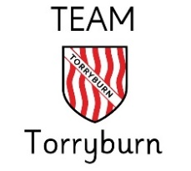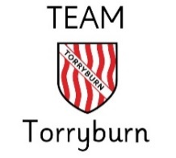Primary 4/5

**Ready**

**Respectful**

**Safe**

**Kindess**

**Honesty**

**Hardworking**

Oct-Dec 2024

This term we will be learning about …

**Health & Wellbeing (Including PE)**

* Improving Personal Fitness-Circuit Training
* Yoga
* Rights Respecting Schools-UNCRC Rights Article 16
* Emotion Works
* Connecting Kindness in P4/5

**Literacy & Languages**

**‘Literacy across Learning’**

* Reading – Reading comprehension through class novel (Kensuke’s Kingdom’ by Michael Morpurgo)
* Guided Reading-Strategy focus-Questioning
* Reading for information/Non-fiction texts
* Writing- Poetry, Fact-Files, Connectives, Book Reviews
* Listening & Talking – finding and using information/reporting to others
* Modern Languages – French: Giving name & age, Numbers to 30, Days of the Week, Christmas

**Numeracy & Mathematics**

* Time
* Measurement
* Multiplication- Using and applying strategies
* ‘Times Table All Stars’
* 4 Operations – Continued/Development

**Expressive Arts (Including Dance)**

Music & Dance

* Dance, Music & Instruments across cultures
* Singing – Awareness of audience and skills for voice projection

Art

* Topic Inspired Art using a variety of materials.
* Christmas Craft/Calendar

Drama

* Create a short drama improvisation from a given stimulus

**Religious & Moral Education**

* Practices & Traditions
* Christianity (Christmas focus)
* Religions across continents

**Technologies**

* Glow- PowerPoint- Topic link-Country
* Communication via technology
* Internet Safety (link to Article 16)
* Programming (Microbit)
* Reliability of online sources

**Message from the teachers**

* Mrs Forrest: All day Monday, Wednesday 9-10, 11-11.20 & 1.20-3, All day Thursday & Friday.

Mr Graham: Tuesday & Wednesday 11.20-12.40

* We will continue to share learning and class activities on Seesaw. Keep an eye out for updates written by the class.
* Thank you for your continued support, we are excited for another fantastic term of learning and growth.

**Wider Life of the School**

* P5 Violin Group
* Buddies with P3/4
* Assembly-4 Capacity Awards
* Mathematician, Artist, Writer and Reader of the month

**Social Subjects and Sciences**

**Topic** – ‘World Explorers’- Geography

* Location of Continents/Countries/Flags
* Analysis of geographical maps
* Physical Features of continents
* Languages/People/Culture across the world
* Forces - transport