Torbain Nursery

….. where we nurture and grow the creative thinkers of the future!

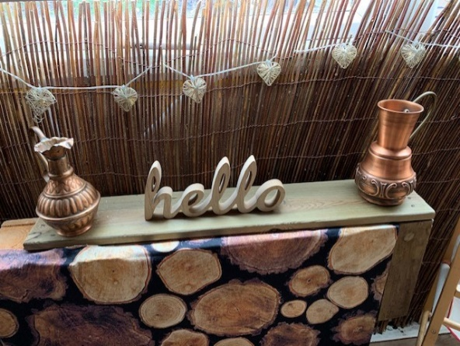

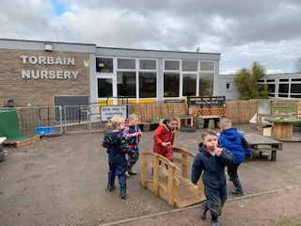 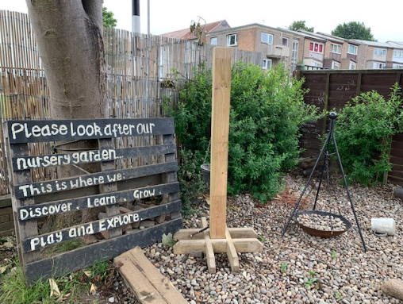

**Nursery Information**

As you may not be too sure of what your child will face at nursery, we hope this booklet will answer some of your questions and help you and your child prepare for this future adventure

**Torbain Nursery/ELC**



We are an Early Learning and Childcare setting registered to take 89 children from 9:00am-3:00pm. All areas of the nursery are available to all children, indoors and out. We believe children have the right to the best possible childhood and young, active learners need to widen their experiences and learning in all areas of development. We want the best for every child and our motto is...

**TRY PARTICIPATE SUCCEED**

The values we promote throughout the nursery and school are

**Friendship Fairness Respect Honesty**

Our aims are:

* **To cater for the needs of all children to enable them to reach their full potential**
* **To provide a nurturing, safe, calm environment, where everyone – child or adult is welcomed and valued**
* **To provide natural open-ended and authentic resources which engage, challenge and inspire children**
* **To provide children with opportunities to face challenges in a supportive environment, helping them to learn to assess and manage risks for themselves**
* **To provide opportunities for children to develop the skills of resilience, independence and self-regulation of their emotions**
* **To provide a diverse and cultural environment that promotes respect and tolerance**
* **To provide opportunities for children to become successful learners, effective contributors, confident individuals and responsible citizens**
* **To ensure that children’s voices are at the heart of our practice**
* **To foster a love for outdoors, no matter the weather**
* **To foster curiosity and stimulate imagination and creativity in all children**
* **To ensure and support parents and families to be partners in their child’s learning**
* **To ensure staff are highly skilled, reflective practitioners, who are models of life-long learning**



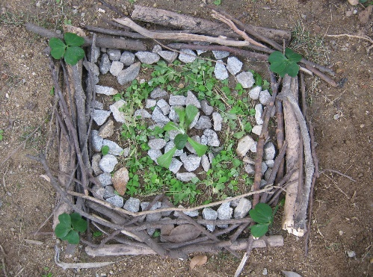 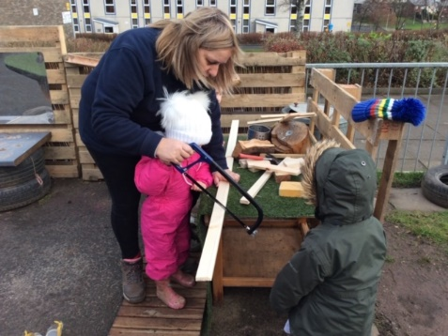

**Effective Partnerships and Communication**

Effective communication is vital to the success of any partnership and it is particularly important that you regularly check the digital ways we use to share key information.

  

We will share information through

* An app called SEESAW – nursery staff will support you to download this when your child starts
* Primary School App for parents also keeps you informed of school and nursery information, INCLUDING HOLIDAYS AND NURSERY CLOSURE DAYS
* Twitter - @TorbainPS
* Termly newsletters
* Text Messaging Service – due to cost, this is used for important texts only

**Nursery Closure Procedures**

* Very occasionally, the nursery is unable to open, due to severe weather conditions or unforeseen circumstances. It is vital that parents sign up to Fife Council’s closure alert system. Using this, you can receive an alert message as a text message to your mobile phone or by e-mail if the nursery is closed. To sign up please go to [www.fifedirect.org.uk](http://www.fifedirect.org.uk)
* In the unlikely event that the nursery has to be evacuated, the children would be transferred to the main building of the school or to Torbain church.

**The Nursery Curriculum**



**‘Play is the highest form of human development.’**

(Froebel, 1826)

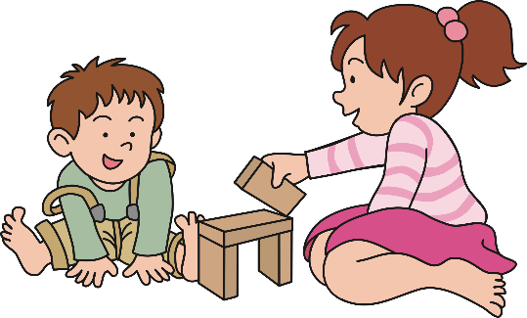

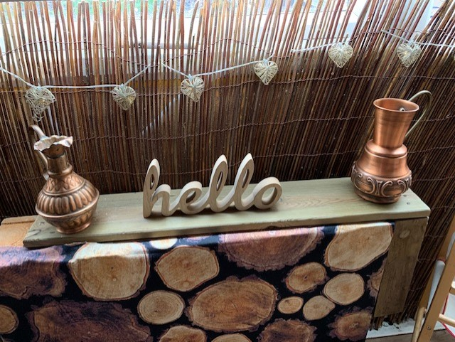 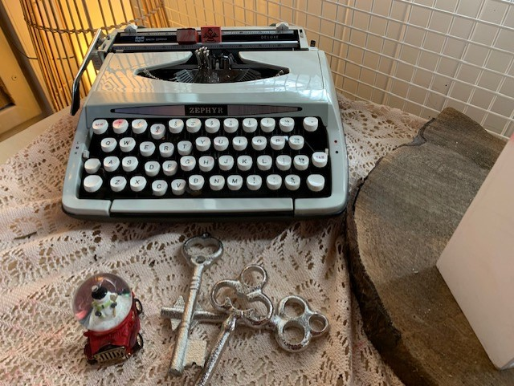

You may notice that our nursery environment looks a bit different to what you might expect, due to our philosophy of using primarily open ended, natural objects, rather than plastic pre-made toys. This is to encourage the children to be creative and imaginative. We often use real objects, which encourages the children to self- assess risk and take care of the things around them.

The Early Level of Curriculum for Excellence spans pre-school and Primary 1 and it is designed to meet the needs of most children from 3 years old to the end of Primary 1, promoting better continuity and progression of learning from nursery into school. It is flexible, promoting real-life learning and focuses on the needs of every child.

Curriculum for Excellence gives prominence to play, particularly across the early level and we use a child-centred play pedagogy approach, allowing children time to explore and make sense of the world around them, whilst developing the right balance between child-initiated, adult initiated and adult-directed learning. We value play and we take time to observe the children playing, in order to then deepen or extend their learning.

We believe in equal opportunities for all children and consider all nursery activities suitable for boys and girls. We also feel it is important that from a young age children have access to resources that will help them learn about families and cultures other than their own and to value these too.

We are proud to have achieved Level 2 as part of the Rights Respecting School initiative recognised by UNICEF, as well as having our third Eco Flag and being a Fairtrade Nursery and School.

Our nursery rooms are all open plan and the children are encouraged to have free flow between the rooms and the nursery garden. Due to this, staff will move between rooms and so you may find different faces welcoming you at the door on different days. Please be assured, your child will still see their Key Worker throughout the day as they move through the nursery.

# Settling In

We are delighted to be able to welcome families back into Torbain. We are continuing to look at ways to ensure everyone feels safe and secure now that there are more adults coming back into the nursery setting. The nursery staff will be on hand to welcome your child into nursery and help them to feel safe and secure in their new nursery environment. This can happen quickly with some children, and with others it can take a much longer time. Please do not worry if your child is taking longer to settle than some others – this is normal with young children. Sharing key information about favourite toys/books at the beginning can be a big help.

Initially it is better for the children to spend a shorter, happier time in nursery than for them to spend a lot of time unhappy and asking to go home. Our experience is that gradually increasing the length of nursery time the children are in nursery works best. This is done on an individual basis, in agreement between nursery staff and parents. Nursery hours are flexible, although children must be picked up by 3:00pm to allow staff to complete their planning, preparation and professional development tasks.

**Drop off and Pick up**

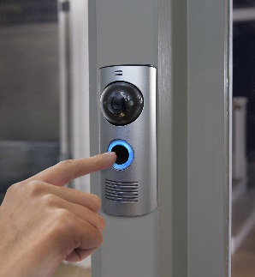

Drop off

The only drop off point from 9.00am-9.30am will be the nursery gates at the front of the Infant Building. A member of staff will register your child here and let them into the nursery.

From 9.30am please use the nursery buzzer which is at the main door of the Infant Building. A member of staff will buzz you in and you can accompany your child to the cloakroom area. Please ensure you have spoken to a member of staff, who will register your child before leaving through the garden exit.

Pick-up

As pick-up is less busy please enter the nursery through the main door by pressing the buzzer and head to the cloakroom area to meet your child.

PLEASE ENSURE YOU CLOSE THE NURSERY DOOR LEADING TO THE CLOAKROOM OR GATES LEADING TO THE GARDEN TO KEEP ALL OF OUR CHILDREN SAFE AND SECURE.

**Attendance at Nursery**



Although, attendance is not compulsory, if you have accepted a nursery place in a Fife Council nursery, unless your child is ill, regular attendance is expected as it is vital to ensure that your child is making the expected progress through the Early Level of the curriculum, which continues into Primary 1. Most children also find it easier to establish and maintain friendships and develop resilience, perseverance and independence skills if they attend nursery on a regular basis.

If your child is unable to attend nursery please **phone (01592 583656)** or send a text message to our “**Absence Text Number” (07860 004 849)** letting the infant office know what is wrong. We adhere to the Fife Council Attendance Policy, copies of which are available from the nursery staff.

**Illness**

If your child is ill, it is important that they do not return to nursery until they are completely better. This is to prevent infections and illnesses spreading to others. The NHS has guidance on a range of infections/viruses, regarding the recommended time that child should not attend nursery and this guidance is displayed on the nursery notice boards. We would ask for your cooperation in this matter to help prevent the spread of illness.

One of the main points regards diarrhoea and/or vomiting. The guidance states

**Children with diarrhoea and/or vomiting should be excluded until they have had no symptoms for 48hours.** *(NHS Dec’11)*

**There is new guidance surrounding any child or adult exhibiting COVID-19 symptoms and this guidance will be strictly adhered to.**

**Independence Skills**

**Toileting**

The majority of children are toilet trained or almost toilet trained by the age of 3 and when they start nursery, staff will initially go with them to remind them what to do and show them where to wash their hands thus getting into good habits. Later on, when they (and we) are confident, they can go on their own. Please discuss with the Key Worker if your child is not yet independent regarding cleaning themselves after using the toilet or getting their clothing back to normal before leaving the toilet. It is very important to respect children’s privacy and to encourage them to see themselves as having a right to privacy, so the less we have to help the better. Toileting ‘accidents’ do sometimes happen and staff will change and reassure your child, but we do not have ‘lie- down’ changing facilities within the nursery toilets. In line with council guidance, children must be changed whilst they are standing.

If your child is not yet fully toilet trained, we will work with you and your child’s health visitor to ensure that they receive the best support to become independent as quickly as possible. Guidance from the Institute of Health Visiting is available from the nursery.

**Dressing**

As nursery is a place where children are being encouraged to experiment in all areas including painting, glueing and other messy activities please dress your child in old, easy to wash clothes.



For safety reasons, slip on gym shoes are ideal footwear as children use physical apparatus in nursery and attend gym. Jewellery is not recommended at any time .

#### There will be many times throughout the day when children will need to change shoes, or put coats on to go out to play. Encouraging your child to be able to dress themselves independently helps them to feel confident – staff will always be available to assist, but again the emphasis is on encouraging independence. Can your child put his/her coat on? Do buttons and zips? Please consider this carefully when you are dressing your child for nursery.

**Health and Well-Being**

**Emotional Wellbeing- Being Considerate and Sharing**

Your child will be one of a larger group of children and will learn from these children as well as the adults. For this reason we spend time encouraging the right learning environment, showing that we care about each child, listening and respecting their views and ideas. We help the children to do this with each other and to consider the feelings of others, sharing, being tolerant and resolving difficulties, concerns or disagreements through discussion. Making children more aware of other people and their needs is a big help in making the nursery experience easier and more valuable. Giving children some independence and responsibility quite early on is a good start.

**Enhanced Hand Washing and Respiratory Hygiene**



There are arrangements for enhanced hand and respiratory hygiene by adults and children in the setting in line with government COVID-19 guidelines. Children and staff will wash their hands with soap and water for 20 seconds frequently.

Handwashing will be encouraged

* On arrival at the nursery
* Before and after eating
* After toileting
* At regular intervals throughout the day
* When moving between different areas of the nursery, including from inside to outside and vice versa
* Children will be encouraged not to touch their face, and to use a tissue or elbow to cough and sneeze and dispose of tissues appropriately
* Children will be encouraged to wipe their own noses independently – we would

greatly appreciate if you could provide a box of tissues each term for use

within the nursery.

## **Snack**

****We encourage the children to make healthy choices in life. Water is available at all times for children to drink and some of the provision for snack is fruit and milk, which is provided by Fife Council. To cover the cost of other snack items, we ask you to make a voluntary contribution of £1.50 per week (Monday if possible) or if you would rather pay by term, this is possible and would be appreciated. There are four terms in the year. This money is also used to buy small additional resources, related to children’s interests.

**Lunch**

The children can bring in a cold packed lunch from home (we are not able to heat any food up) or order a lunch from the kitchen. Home packed lunches are served in the nursery rooms, as well as the cold lunch option from the school lunch menu. If you wish your child to have the hot option for lunch, please order it, by letting the member of nursery staff know at drop off. Please ensure that your child is able to use cutlery fairly independently, as we are unable to give direct 1-1 support at the moment.

**Toothbrushing - Childsmile**

Our Childsmile toothbrushing is up and running again. Children are encouraged to brush their teeth – with support form their Key Worker. If you DO NOT wish your child to participate in toothbrushing at nursery please speak to your child’s Key Worker.

**Outdoor Learning**

***“The best classroom and the richest cupboard is roofed only by the sky”***

*(Margaret McMillan)*

An important aspect of a child’s physical development and well-being is outdoor play. We have a lovely nursery garden and school grounds, which we use daily. It is widely recognised that children should experience outdoor play throughout the year, come rain or shine! We would be grateful if children could have a pair of wellingtons to be kept in nursery at all times, and to come to nursery each day, dressed appropriately for the weather and to get dirty!! In the summer, when hopefully, we have some warm weather, it is important that the children wear a hat and sunscreen to protect them from the sun. We ask that sunscreen is applied by parents in the morning and staff will support children to top up in the afternoon. We have nursery sunscreen and if you DO NOT wish your child to use this please speak with their Key Worker.

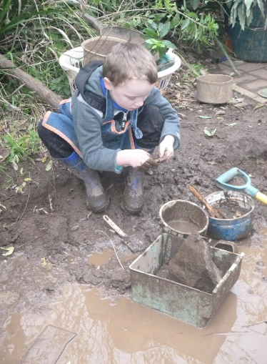 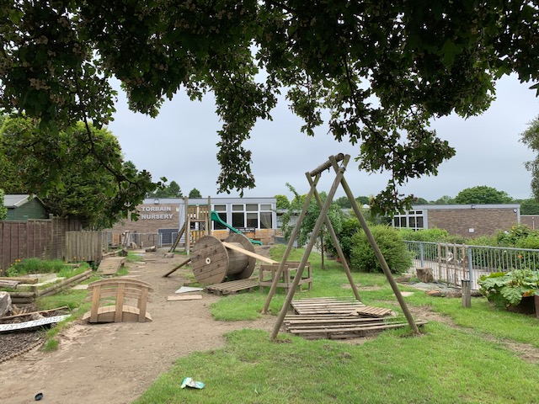

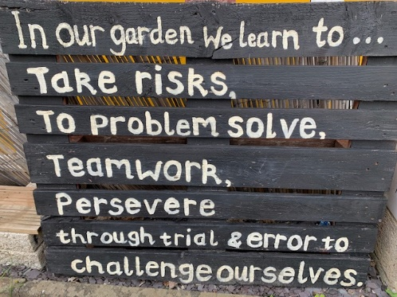

As part of outdoor learning the children will also get the opportunity to experience Nature Kindergarten (in Raith Woods) and Beach Kindergarten (Pathhead Sands).

**Children’s Learning**



Your child’s progress will be recorded through on-going observations led by one member of staff (the Key Worker) who will pay particular attention to your child and his/her development and progress. Your child’s key development successes will be recorded in their PLJ (Personal Learning Journey) folder. This is a partnership document with lots of opportunities, within it, for you to share the learning your child is doing at home.

Remember that children are often troubled or behave in a different way if circumstances change. It is helpful if you could let us know of significant changes at home or any ‘special’ circumstances concerning your child. Similarly within nursery we will inform you of changes in behaviour etc. There will be regular opportunities to discuss your child’s learning through planned phone chats, but please contact your child’s Key Worker if you have any concerns at all.

**Family Learning**

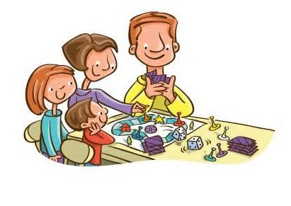

Families and Nursery working together will ensure the best experience for your child and we hope you will take part in and enjoy the many opportunities to share your child’s time in nursery. Whilst the PLJ is the key documentation in the partnership, there are many Family Learning Experiences which focus on working with families to improve learning and achievement for children.

Family Learning opportunities will take place throughout the year. Information regarding these sessions will be shared via Seesaw.

**Getting It Right For Every Child** **(GIRFEC) and Child Protection**

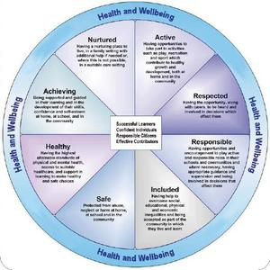

As part of GIRFEC, every child in Scotland should have access to professionals who ensure that everything is in place for them to have the best possible start in life. Until your child starts school, your child has a Health Visitor, who we can liaise with, if support is required. We can also request assistance from our Speech and Language Therapist or our Educational Psychologist. Other professionals will be contacted only if you have given your permission, except in the case of Child Protection issues. We have a duty of care to all the children in our nursery and if we have concerns that any child is at risk of harm, we have a responsibility to pass this on to the appropriate agency, and we do not need to seek your permission in this instance. We have a policy on Child Protection, a copy of which is given to you. Mrs Bruce, the HT is our Child Protection Coordinator and Mrs Tollick, DHT, is the Depute Child Protection Coordinator. Copies are also available from the office. Further information on GIRFEC can be found on our School Website.

**Children’s Safety**



Please help us by adhering to the following safety rules and ensuring your child is aware of them also:

* You must park outwith the school grounds when dropping off and picking up children - please make sure all family members are aware of this.
* Do not walk through the staff car park
* Only adults should press the entry/exit buttons and only use the allotted access and exit doors.
* Always inform staff when you drop off, who will be collecting your child – if this changes unexpectedly please phone the Infant Building Office to let us know.
* Always ensure that it is always a responsible adult (over 16) who brings and collects your child from nursery.
* Keep us informed immediately if your contact details change – particularly mobile phone numbers - we must be able to contact you in an emergency.

We are a Fife Council nursery/ELC and we adhere to their policies and procedures. We are also regulated by the Care Inspectorate. We hope that you and your child have a happy time at Torbain nursery. However, if you have a concern or complaint about an aspect of the nursery, please in the first instance, speak to your child’s Key Worker, Miss Lorna Hillmansen the Nursery Teacher or Mrs Joanna Houston and Mrs Susan Tollick, the Depute Headteacher’s who will deal with your queries and concerns in a sympathetic and confidential manner. If you wish, Mrs Caroline Bruce, the Headteacher, is also available.

If you wish, you may also contact:

Early Years Team

5th Floor South

Rothesay House

Rothesay Place

KY7 5PQ

Telephone 03451 55 55 55 442 073

Care Inspectorate Headquarters

Compass House

11 Riverside Drive

Dundee

DD1 4NY

Telephone: 01382 207100

Website: www.careinspectorate.com

Email: enquiries@careinspectorate.com

**Once all the children are settled there will be opportunities to help and share your child’s nursery experience in lots of different ways. We welcome and value your support and look forward to working with you.**

Joanna Houston and Susan Tollick

Depute Headteacher’s (Early Years)

**Useful Numbers**

Infant Building 01592 583656

Absence Text Number 0786 0004 849