Strathkinness Primary
School Travel Plan



Headteacher: Mrs Kate Balsillie

School address: 3 Church Road
Strathkinness
KY16 9XR

Telephone No: 01334 659442
Social Media/Website: Website



Contents Page

3: 1.0 WHY HAVE A SCHOOL TRAVEL PLAN

3.: 2.0 BENEFITS OF HAVING A SCHOOL TRAVEL PLAN

4: 3.0 Current Travel Habits

3.1 Family Questionnaire Data

9: 3.2 Staff Questionnaire Data

11: 4.0 ROUTE AUDIT OF KEY ROUTES TO SCHOOL

4.1 Access Arrangements

12: 5.0 ACTION PLAN

14: 6.0 MONITORING AND EVALUATION

15: 7.0 DISTRIBUTION OF SCHOOL TRAVEL PLAN

16: APPENDIX 1 – ROUTE AUDIT REPORT
1.0 Why have a school travel plan

School-related traffic congestion and the risks congestion poses to the safety of the pupils, teachers, parents, residents, and motorists in and around school locations is a significant problem in communities around Fife.

The most obvious cause of traffic congestion around our schools is vehicles, and the biggest source of those vehicles is parents’ dropping off and picking up their children from school.

Statistics highlight that 1 in 4 cars during the hours of 8:30 to 9:15 and 2:30 to 3:15 is primary school traffic.

Our annual Hands Up Survey highlights that 23%, that’s 5562 primary school children are driven to the school gate each day with a further 17% opting to Park and Stride. That is an additional 4111 pupils being driven in and around the school streets.

Fife Council’s Road and Transportation Service are working with schools in Fife to develop School Travel Plans and support Junior Road Safety Officers to develop campaigns such as Walking Buses, Park n Stride sites, Parking Pledges, available routes to school maps, delivery of Bikeability as well as looking at any engineering works that may be required to make active travel to school your first choice of travel.

2.0 BENEFITS OF HAVING A SCHOOL TRAVEL PLAN?

The benefits of encouraging active travel are clear and a school travel plan can ensure that your school has a long–term vision with aid to support Junior Road Safety Officers with delivering campaigns to;-

- Improve health and well-being by reducing harmful emissions and increasing activity levels.
- Improve safety through engineering measures and increasing road safety education.
- Improve access and opportunity by developing pupils’ skills for safe and independent travel.
- Improve the environment by reducing pollution and CO2 emissions.
- Gain school accreditations such as Fresh Air Frankie STP Awards, Active School Award Eco School Award, Cycle Friendly School Award
- Have access to additional funding and support.

All work associated with School Travel Planning has been designed to fit into the Curriculum for Excellence.

3.0 CURRENT TRAVEL HABITS

Each year all Fife schools undertake the Hands Up Survey which gives a true reflection of how pupils are travelling to school and the latest results show that 56% of pupils are actively travelling to school with a further 36% being driven and the rest via school transport.

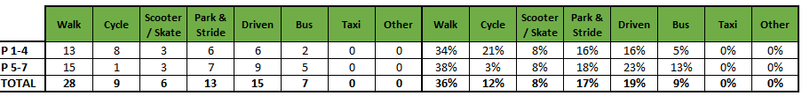

3.1 Family Questionnaire

20 families answered the school travel plan online questionnaire, and the results are detailed in the graphs and text below.

How do you normally travel to and from school?
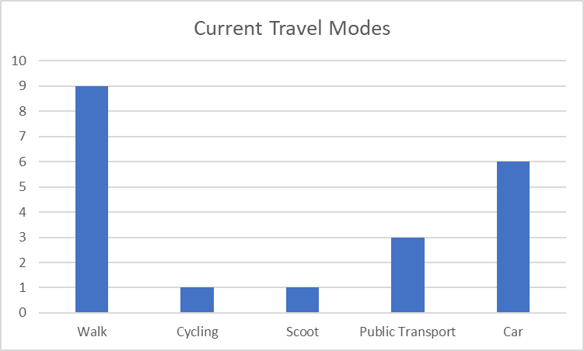

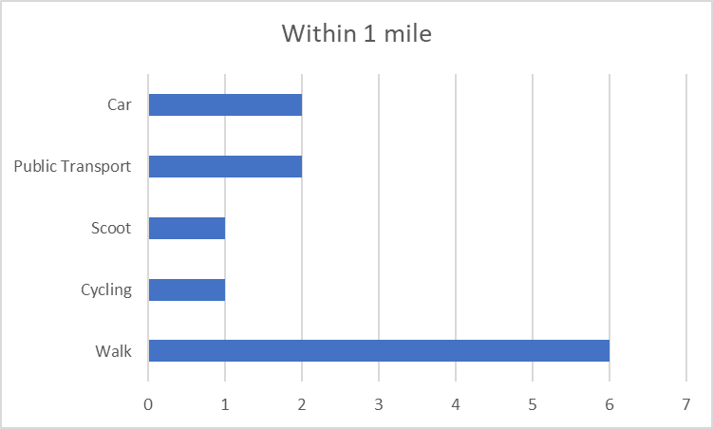

Those parents who are already actively travelling to school were asked if they would like to volunteer to help the school set up a walking bus, one parent said yes.

All parents who stated that they drive to school were asked if they would consider using a Park and Stride Site away from the school gate to help with congestion and the majority said yes as long as it was within a 5 minute walk to the school.

Those parents were then asked what could they do to help with safety concerns with regards to parking around the school gate?

- Park further away
- Park according to school travel plan
- I have to drop off a child at another school/nursery first
- School crossing patrol

Parents were then asked if they wanted to add anything else about their journey to school only 2 parents answered that lived out of catchment and said that there is nothing they can really do about the mode of transport they use to school.

3.2 Staff Questionnaire

How far do you travel for work?

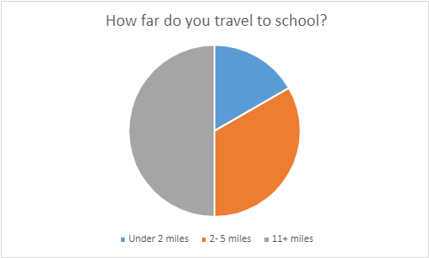

Staff were also asked if they would like to consider car sharing and of those who answered 4 stated yes.
They were also asked if they would like to undertake Bikeability training to deliver cycling in school and 3 said yes.

When asked what would encourage them to consider an alternative mode of transport to work, they replied.

- Bus takes at least three times as long to do the journey and is inconvenient. No other option.
- Perhaps when my own children are older and I don’t need to be home quickly for childcare pick ups at various locations for various after school clubs, I would have more flexibility.
- Electric charge point at school/village
- Not having to carry so much! Also very steep hill to get home!
- A cycle path.

Finally, when asked are there any improvements you could make to your journey to ensure the routes to school are less congested?

- Park considerately a safe distance from school or use the Church playground.

4.0 MAPPING WORK AND ROUTE AUDIT

A mapping exercise was carried out within the school to identify the routes pupils travelled. These were then analysed and then categorised as active travel routes (green) and vehicular routes (red).

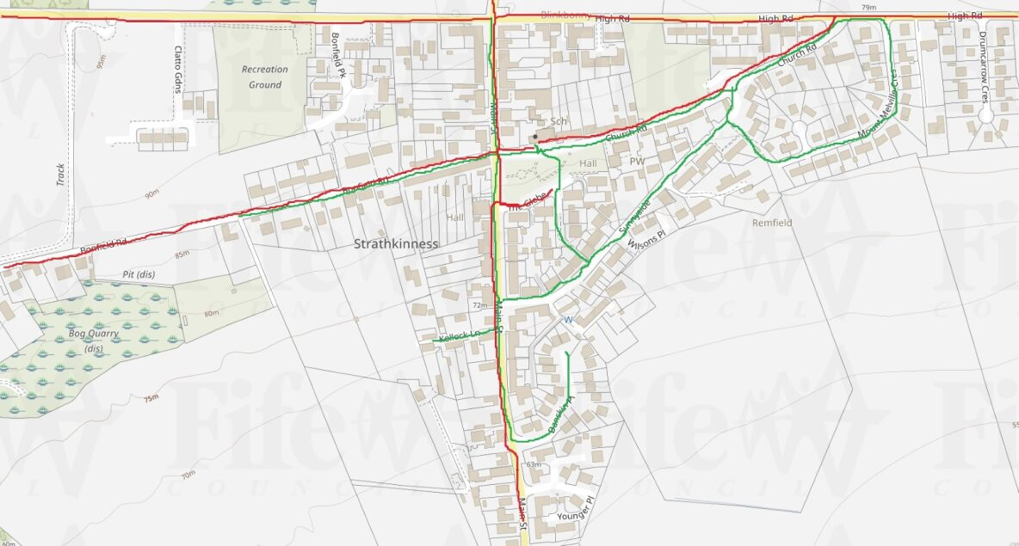

4.1 Access Arrangements

There are two entrances onto school grounds. The first gives pedestrians access from Church Road to the playground and the second allows vehicular access.

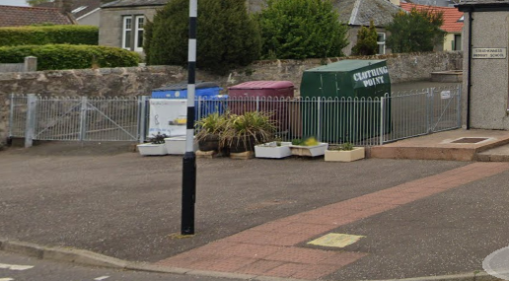

The schools main reception is around the back of the building.

5.0 ACTION PLAN

Action | Solution | Action Owner
Promote School Travel Plan | - Upload plan to website and social media pages  - Create a JRSO notice board or story board  - Create articles for school newsletters, social media, and assemblies,  - Keep the school travel plan team updated on all work carried out to include in the Fresh Air Frankie termly newsletter. | School
Travel Tracker | - Update the travel tracker every day | School
Local and National Campaigns | Term 1  Week 1 Hands up Survey Active Travel  Week 2 Cycling Competition  Week 3 Bike Week  Week 4 Interschool Active Travel Challenge  Term 2  Week Launch #dontparkhere Campaign  Week 2 Parking Letter to Parents  Week 3 Road Safety Week  Week 4 Be Bright Be Seen Competition  Term 3  Create an active travel leaflet for the new starts that can be included in the school induction pack.  Sustrans Big Walk and Wheel  Term 4  Week 1 Walk to School Week  Week 2 Scoot to School Week  Week 3 Active Travel Treasure Hunt  Week 4 Bike to School Week | School  School/Travel Plan Team
Reduce congestion | Consider developing the following:- Parking Pledge  Park N Stride Site  Walking Bus | School/Travel Plan Team
Bikeability | Deliver Bikeability | School/Bikeability Team
Awards | Work towards gaining the Fresh Air Frankie School Travel Plan and  Active Schools Award | School/Travel Plan Team

6.0 MONITORING & EVALUATION
The JRSO will continue to meet periodically to monitor progress.
Specific progress will be monitored by participation in the “Hands Up Travel Tally” each year and a repeat of the full travel survey will take place in 2027. The school’s ongoing commitment to travel planning will be publicised in the school handbook, the school newsletters, the Parent’s notice board and through assemblies.

7.0 DISTRIBUTION OF SCHOOL TRAVEL PLAN
The following bodies will receive a copy of the School Travel Plan:
• Fife Council Roads and Transportation via the Travel Plan Team
• Fife Council Education Service
• Fife Council School Estates Team
• Parent Partnership
• Active Schools
• Copies will also be made available to the parents from the School Office and via
the school information site.

Route Audit

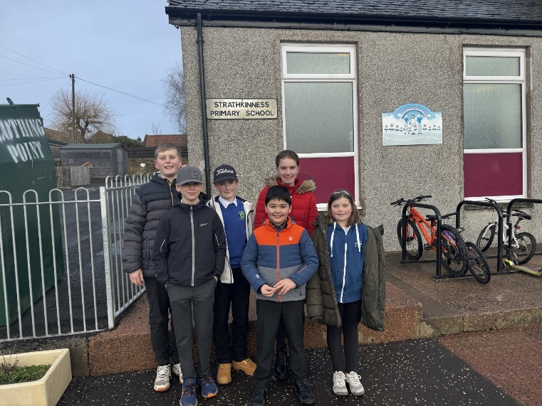

1. INTRODUCTION

1.1 This report results from a Safety Audit, undertaken on 25 January 2024, of key routes taken by children attending Strathkinness Primary School at the request of the school.

1.2 The audit team consists of:

- Trudy Brown – Travel Plan Coordinator (Sustainable Transport & Parking)
- Kate Balsillie – Headteacher at Strathkinness Primary
- 6 pupil from Strathkinness Primary

1.3 The school is situated on Church Road. Church Road forms part of a 20mph zone and is part of the adopted public road network.

1.4 The routes audited were Church Road, The Glebe, Sunnyside and pedestrianised path to The Glebe, Main Street, Danskin Place, Bonfield Road, Bonfield Park and High Road.

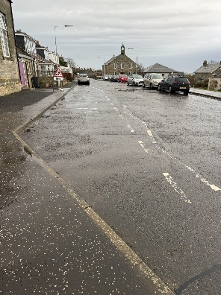

2. ROUTES AUDITED

2.1 Church Road

Issue
Congestion is an issue at drop off and pick up. Parents are parking in the school bus stop and on the white zigzag controlled parking area.

Recommendation
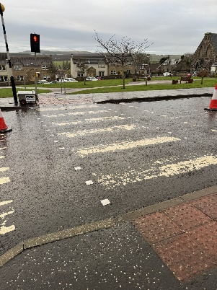
Repaint school bus stop markings, zebra crossing and white zigzags.

Action
Referred to traffic management to action.

2.2 The Glebe

Issue
The Glebe is a residential area south of church road, where there are ample parking spaces that could be used as a drop off area for pupils, however these do appear to be residential spaces.

Recommendation
Highlight this as a park and stride site to parents as there is good connecting pathways to the zebra crossing leading to the school. Making this an ideal drop of point to ease congestion at school gates.
The pupils in the school could maybe write a letter to residents in the first instance to ask if they would mind.

Action
School campaign to write to residents to see if this could be a park and stride site am and pm.
Information out to parents to encourage using this as a drop off and pick up point.

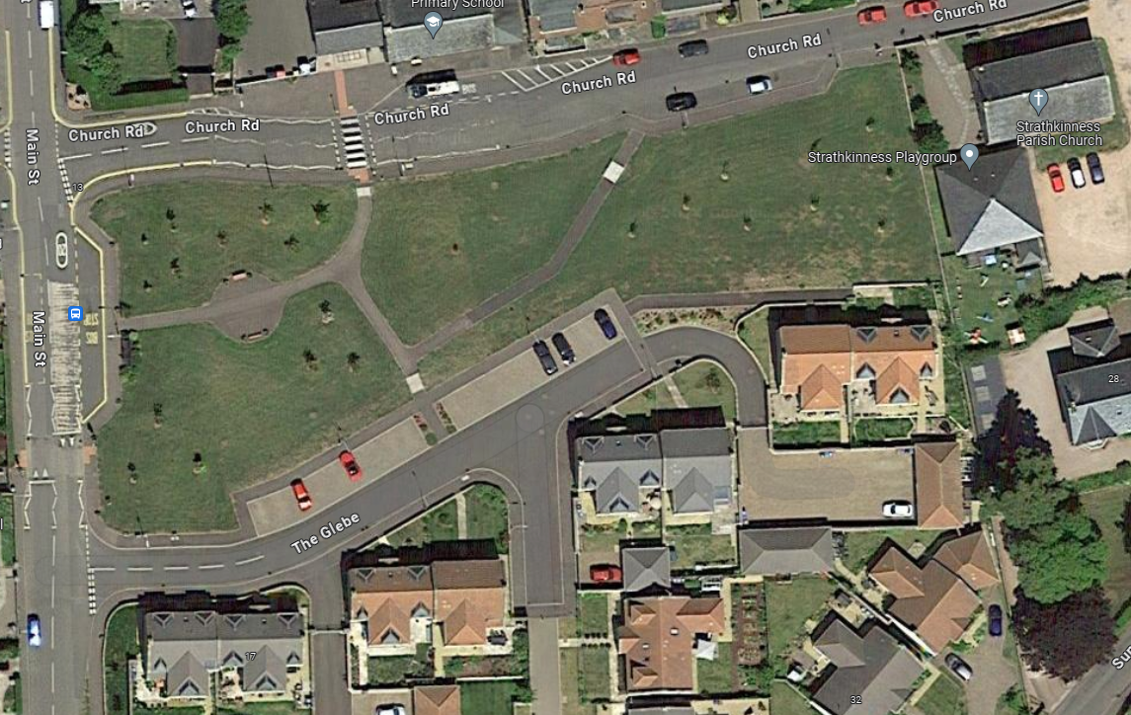

2.3 Sunnyside

Issue
No issues were raised on Sunnyside and the Pedestrianised access to The Glebe makes a good walking route for children to travel avoiding the busy main road. The children did observe that they need to be more vigilant for cars reversing out of driveways.

2.4 Main Street

Issue
Main Street is a busy route through the village, with HGV’s and Tractors using it. Residents also park on Main Street, meaning that cars often have to give way to oncoming traffic.

Recommendation
Pupils to be made aware of road safety when walking on a busy route and crossing roads.

Action
School pupils who attended the Route Audit could do a Road Safety campaign and deliver it to the rest of the school at an assembly.

2.5 Danskin Place

Issue
No issues were raised on Danskin Place. This is a residential cul-de-sac. Children did observe that there are a lot of driveways and that they need to stay vigilant when crossing.

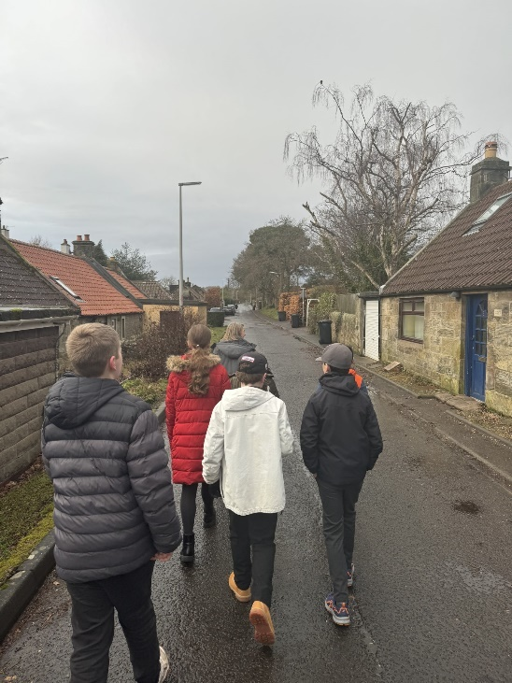
2.6 Bonfield Road

Issue
Bonfield road is an old track road with very little pathways. Pedestrians are forced to walk on the road.

Recommendation
Pupils to be made aware of road safety when walking on a busy route and crossing roads.

Action
School pupils who attended the Route Audit could do a Road Safety campaign and deliver it to the rest of the school at an assembly.

2.7 Bonfield Park and High Road

Issue
Bonfield Park is a residential area and no issues were raised here. There is a good network of paths. A new housing developments is being built west of Bonfield Park, which could increase traffic flow going forward.

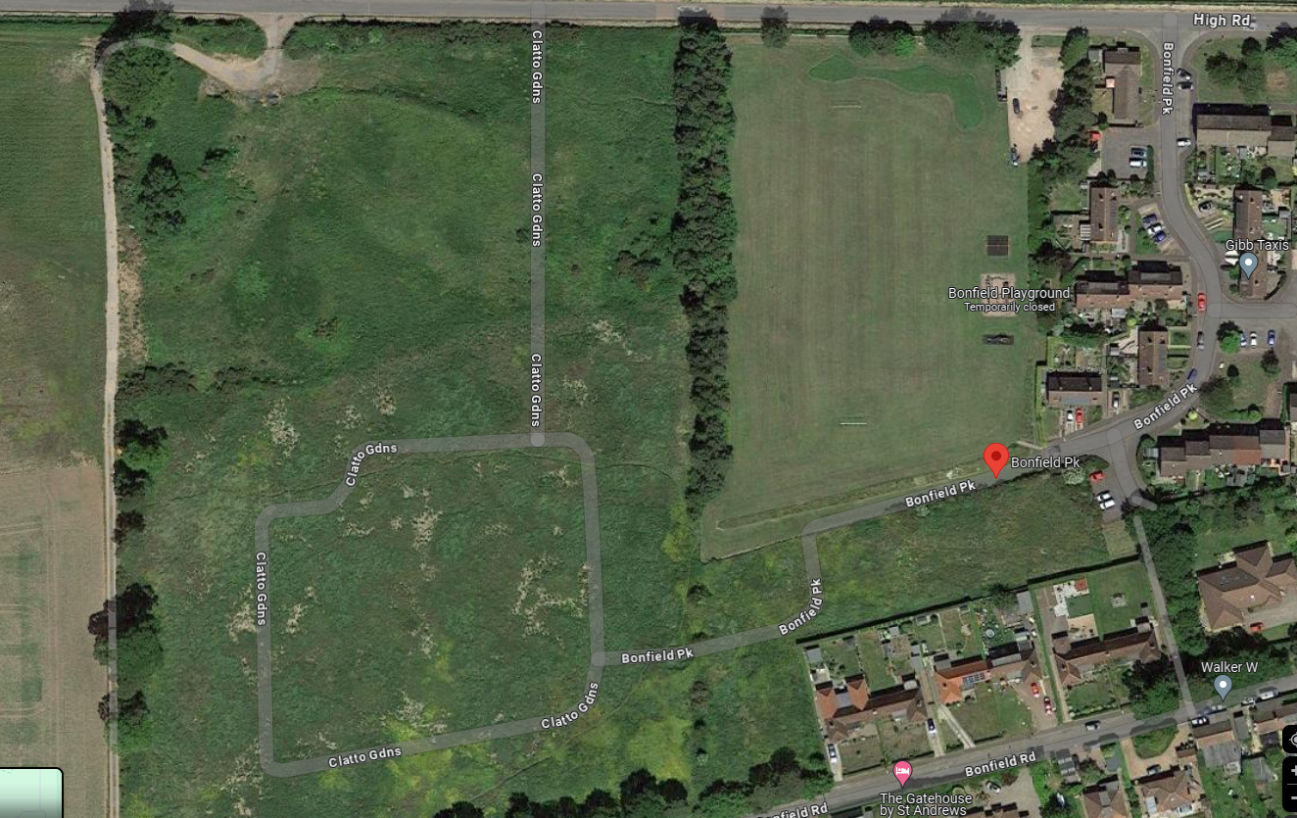
Housing development

High Road is a 20mph however this leads on to a 60mph speed limit, therefor children must remain vigilant when cars are coming in to the village as they may not reduce their speed. A carpark was considered as a Park & Stride site, however due to its location and distance from the school, this would not be suitable.

3.0 Summary

The condition of routes around Strathkinness Primary School are good. Identifying safe routes and promoting these as part of the Travel Plan is essential to improve safety and encourage sustainable travel, which will also help educate pupils in road safety.

