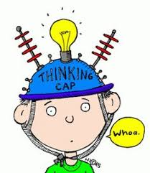
P5 Overview of learning
Session 2021-2022
Term 4

These are some of the things we are focusing on this term.

Curricular area | Teaching focus
Literacy and English  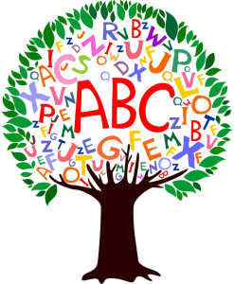 | Independent Reading – reading and comprehension groups.  Reading for Understanding - Comprehension skills.  Reading for Enjoyment - Library books and class novel (Shadowsmith – Ross MacKenzie)  Daily opportunities in class.  Spelling and grammar – homophones, similes, adverbs, connectives and dictionary work.  Writing - creating a variety of texts with increasingly complex ideas, structure and vocabulary  Handwriting – recapping letter formation and simple joins.
Numeracy and maths  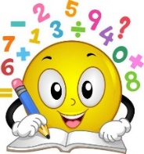 | - Time  - Multiplication and division.  - Measure  - Information Handling.  - Fractions, decimals and %.
Health and wellbeing | - Athletics – run, jump and throw.  - Fitness.  - Health and Wellbeing –Food and Health  - Relationships, sexual health and parenthood
Other curricular areas | - Topic – Ancient Rome
 | - Technology- typing skills; coding; individual Sways.
 | - Music- Youth Music Initiative – Voice Gym
 | - Art –with Mrs Gillan.
 | - French and Spanish.

