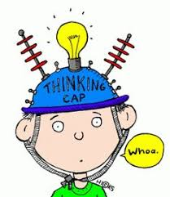
P1/2 Overview of learning
Session 2021/22
Term 4
These are some of the things we are focusing on this term.

Curricular area | Teaching focus
Literacy and English  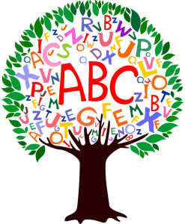 | Reading:  - Reading for understanding - Comprehension skills  - Progressing at our own level through the school reading schemes, using these books at home and in school.  Listening & Talking:  - Learning to listen for information and instructions.  - Learning to talk about our experiences in group situations.  Spelling – understanding spelling rules and using these in our spelling. (P2)  Phonics – Jolly phonics/blending (P1/2)  Writing – Working at our own level we will be:  - Practise forming letters correctly.  - Practise fine motor skills through finger gym games and activities.  - Using emergent writing to express our ideas.  - Sizing all letters appropriately.  - To use capital letters, finger spaces and full stops correctly. (P2)  - lengthening sentences using ‘and’ and starting to use other conjunctions. (P2)
Numeracy and maths | Working at our own level we will be:  - Reading, ordering and forming numbers to 20 (P1) to 100 (P2).  - Counting forwards and backwards to 20 and beyond (p1).  - Counting on in 1’s from a given number.  - Using the maths language before/after, greater/smaller and less/more (P1 & P2).  - Number Bonds to make 10.  - Adding and subtracting within 10 (P1) and 20 (P2).  - Verbalise and recognise numbers to 100 by counting on and back in 1s (P2).  - Identifying odd and even numbers.  - Shape, Position and Movement  - Investigating and sorting shapes, simple directions and positions, symmetry (P1)  - Exploring 2D and 3D shapes, symmetry, describing position, directional language (P2)
Health and wellbeing | - Athletics, skills for sports day, orienteering skills  - Food and health  - Relationships, Sexual Health and Parenthood – families and friendships, we are all unique and special, our bodies, feelings and making choices and looking after living things
Other curricular areas | - Science - Our bodies – learning about our skeleton, heart, digestion and skin.  - Lifecycles of plants and animals.
 | - Technology – Exploring materials and ways to design and construct models
- French: - greeting each other in French every day.
- numbers to 10.
- body

- RME:
- Explore a range of places and buildings that are special for religious believers
- Outdoor Learning:
- Loose parts play.
- Visits to the Community gardens

Here are some of the ways you can help

At home | With us in school | Out and about
-Helping at home by supporting the learning of our phonic sounds and reading.  - counting in 1s, 2s, 5s, 10s. |  | -Look at house numbers – are they odd or even?  -Refer to clocks, calendars and timetables as you go about your day- can you find any timetables as you are out and about?
Remind children to wear PE kits for Mondays and Fridays.

Homework will be handed out on a Thursday and handed in on a Monday.

