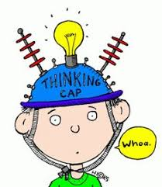
P5/6 Overview of learning
Session 2021-2022
Term 3

These are some of the things we are focusing on this term.

Curricular area | Teaching focus
Literacy and English  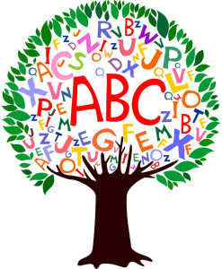 | Independent Reading – literacy circles. Daily opportunities in class.  Reading for Understanding - Comprehension skills. Reading and decoding Scots stories.  Reading for Enjoyment - Library books (library bus? and in school). Class novel (The Eejits – The Twits in Scots).  Spelling and grammar – homophones; prefixes and suffixes, possession (apostrophes), root words and origins, dictionary work.  Writing - using a variety of formats – descriptions, information reports, letters, recounts, recipes and narrative.  Handwriting – recapping letter formation and simple joins.
Numeracy and maths | - Money.  - Multiplication and division.  - Mental maths strategies – variety of areas but specific focus on multiplication and division.  - Problem solving- focus on deciphering word problems.  - Fractions, decimals and %.
Health and wellbeing | - Passing and moving, ball skills through a variety of sports.  - Co-operation and working in groups.  - Hockey - stick skills, ball control, games and accuracy.  - Health and Wellbeing – Emotion Works; Food and Health
Other curricular areas | - Planet Earth – plants and seeds; inheritance. (After Feb break).
 | - Technology- computer skills; coding; individual Sways.
 | - Music- Scottish songs; singing in unison and in parts; listening to different styles of music.
 | - RME – Judaism (World Religion); Chinese New Year
 | - Art - Scottish focus.
 | - French and Spanish.

Here are some of the ways you can help

At home | With us in school | Out and about
Practice time tables as often as possible! Topmarks has several good games including Hit the Button. | Help out at an after school club – get in touch if you would like to do this. | We are having a Scottish focus in literacy until Feb break - any opportunity to explore our heritage would be beneficial.
Keep encouraging reading to build an extended vocabulary that your child will be able to apply to their written work. | If anyone would like to come in to talk about their job, this would be great- please be in touch with us to arrange. | Growing something easy at home in Spring, either in a pot or in the garden is a good practical way to learn.

