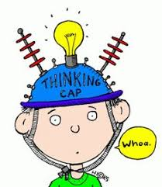
P1/2 Overview of Learning
Session 2021/22
Term 3
These are some of the things we are focusing on in term 3.

Curricular area | Teaching focus
Literacy and English  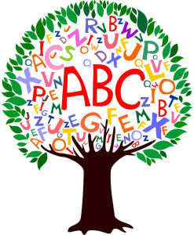 | Reading:  - Sharing and reading stories as a class.  - learning letter sounds and beginning to blend three letter words (P1).  - Progressing at our own level through the school reading schemes, using these books at home and in school.  Listening & Talking:  - Choosing, learning and reciting a Scottish poem  - As others recite poems, learning when and how to listen  Spelling – Continuing to learn spelling rules and patterns and use these in our writing. (P2)  Learning common tricky words (P1 & P2)  Phonics – Continuing to learn new Jolly phonics sounds and revise those previously learnt. Blending sounds to form words (P1/2)  Writing – Working at our own level we will:  - Practise forming letters correctly.  - Practise fine motor skills through finger gym games and activities.  - Use emergent writing to express our ideas.  - Size all letters appropriately.  - Use capital letters, finger spaces and full stops correctly. (P2)  - Start sentences in a variety of ways and lengthen sentences using different conjunctions. (P2)  - Recount writing.  - To express preferences and opinions.
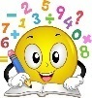  Numeracy and maths | Working at our own level we will be:  - Reading, ordering and forming numbers to 20 (P1) to 100 (P2).  - Counting forwards and backwards to 10 and beyond (p1).  - Counting on in 1’s from a given number. (P1)  - Using the maths language before/after, greater/smaller and less/more (P1 & P2).  - Bonding verbally to 10 (P2)  - Adding and subtracting within 20 (P2)  - Verbalise and recognise numbers to 100 by counting on and back in 1s (P2).  - Sequencing and ordering numbers to 100 (P2).  - Using time related vocabulary (P1 & P2)  - Recognising, talking about and using timetables, calendars, timers and clocks (P1 & P2)  - Awareness of money and recognising coins (P1) making money amounts (P2).  - Creating timelines relating to events in lives and weekly and daily routines (P1 & P2)  - Problem solve using measures of time (P2)  - Estimate and calculate durations (P2)
Health and wellbeing | - Gymnastics  - Ball skills – throwing, catching and kicking  - How exercise affects our bodies  - Emotion Works – An emotional wellbeing programme to help children understand their emotions through a range of activities.
Other curricular areas | - As usual, this term we will be exploring various topics. We will be responsive to the children’s interests as shown through their play and discussions. Topics may last a few days, a week or longer and will provide contexts for learning in the areas of expressive arts, social studies, science, maths, technology and health & well-being. This term’s focus is Scotland and currently we are looking at learning more about St. Andrews.
 | - Computing Science: Programming and de-bugging using Bee-Bots.
 | - French: Colours and the weather
 | - Art: Scottish artists
 | - RME: Using the theme of belonging to link to groups we belong to. Considering religious groups that people belong to and what this means.
- Outdoor Learning:
- Loose parts play.
- Walks to the Community gardens and around the village.

Here are some of the ways you can help

At home | With us in school | Out and about
Helping at home by supporting the learning of our phonic sounds and reading.  Talking about days of the week, months of the year and seasons. |  | Look and discuss numbers – door numbers (even/odd), speed signs, car registration plates.
Remind children to wear PE kits for Mondays and Fridays.  Homework will be handed out on a Thursday and returned to school on a Monday. |  | Looking at prices and discussing money whilst shopping.

