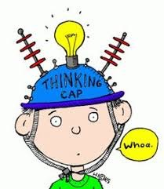
P6/7 Overview of learning
Session 2019/20,
Term 1/2

These are some of the things we are focusing on this term.

Curricular area | Teaching focus
Literacy and English | Reading  ‘short reads’ trios to explore a variety of texts weekly that link to our writing and ‘long reads’ (reading groups) to continued to developed our skills as a balanced reader.  Decoding: focus on key words related to genre of text or our topic and spelling rules that help us to understand the words meaning.  Fluency and phrasing: opportunities to read a variety of texts aloud and discuss the use of punctation, writing techniques and their impact on how we read texts.  Comprehension: Focus on literal, inferential and evaluative tasks for a variety of texts.  Writing  Linked closely with our learning during weekly ‘short reads’ tasks we will focus on letter writing, applications forms and personal statements, creative writing and poetry.  Listening and talking  Across our learning we will be developing our skills in giving constructive feedback based on a variety of success criteria for different tasks (for example, pieces of writing, information posters and short drama performances).
Numeracy and maths | - Revisiting and developing our knowledge of place value, estimation and rounding  - Developing our skills in using the four operations in more complex problem solving questions  - Continue to practice our mental maths skills for quick recall of times tables and division facts  - Properties of 2D and 3D shapes
Health and wellbeing | - Performance markers in fitness (HR, effort, repetitions, time)  - Team games with a focus on good communication, sportsmanships and sports specific skills.  - Mental health and wellbeing and how we can support others  - Use of the 5 point scale to discuss how we feel and what can help us
Other curricular areas | - Social studies: Our topic will be a comparison of WW1 and WW2. We will look at the main causes and chronology of each war, develop our historical skills in evaluating primary and secondary sources and then work in groups to research, compare and share our findings about a key aspect of war (for example, technology used, transportation, different jobs etc.)
- Modern languages: We will be developing our knowledge of both French and Spanish over this term
- Expressive arts: Developing our skills and knowledge of different artistic, drama and musical techniques.
- Science and technology: Developing our skills in using digital technology to communicate our ideas and learning (class and individual SWAYs)
- RME: extend our knowledge of different world religions, festivals and celebrations and consider how values impact actions.

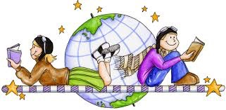
Here are some of the ways you can help

At home | With us in school | Out and about
Encourage reading of and discussion of a variety of texts e.g. fiction and non-fiction books, comics and child-friendly news magazines. | Share any family links or local knowledge about WW1/WW2 - through class teams, GLOW email or by contacting the school office. | Discuss 2D and 3D shapes in the environment - what are they called, how have they been used and why?
Keep practising times tables, division facts and quick numeracy problems. | Remind children to come dressed for gym Tuesday and Wednesday (weather permitting our Wednesday gym slot will be outdoors) | Discuss local WW1/WW2 history and family links with family, friends, neighbours.
Use and talk about the 5 ways of wellbeing (Take notice, connect, be active, give and keeping learning). | Regularly check class teams and our whole class SWAY (link to follow) and talk about what we have been doing in our learning. | Look out for and discuss different ways digital technology is used to share information (signs, screens, interactive displays..)

