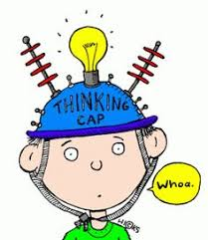
P5/6 Overview of learning
Session 2021/22
Term 1/2

These are some of the things we are focusing on this term.

Curricular area | Teaching focus
Literacy and English  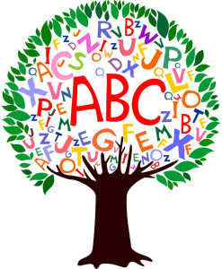 | Independent Reading - Oxford Reading Tree, Infact books and novels  Reading for understanding - Comprehension skills and Book Detectives  Reading for Enjoyment - Library books  Spelling – understanding spelling rules and using these in our spelling. Using a dictionary to check spelling of tricky words.  Writing – focusing on adjectives, tenses and powerful verbs.  Imaginative, recounts and report writing.  Using “The Great Kapok Tree” as a book study.  Grammar  Handwriting – cursive practise  Comprehension – reading for understanding
Numeracy and maths  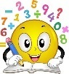 | - Place value, times tables, addition and subtraction, problem solving  - Angles, compass work and co-ordinates  - 2D and 3D shape  Mental Maths: working on our timetables
Health and wellbeing | - Team Games  - Emotional and social wellbeing - exploring feelings and friendships  - Food and the Consumer
Other curricular areas | - Topic - Tropical Rain Forest and Sustainability
 | - ICT – individual Sway, keyboard skills
 | - French / Spanish
 | - RME: Beliefs / Values and Christmas
- Drama – topic related
- Art – topic related
- Music – singing in a range of styles; topic related

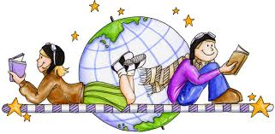
Here are some of the ways you can help

At home | With us in school | Out and about
Helping with homework by orally testing pupils on spelling words and times tables, and listening to their reading aloud. | You are welcome to share knowledge and skills on our topic. | Identify 3D shapes in the environment, use money and look at directions on a map when travelling.
Get your child involved with the recycling at home. |  | Look at food packaging labels and discuss how the product may have got to Scotland.
Look at maps, programmes and books dealing with current environmental affairs. | Helping out or run an after-school club (when allowed). | Visit local museums and exhibitions.

