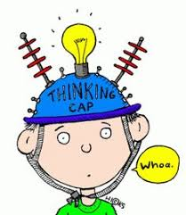
P1/2 Overview of learning
Session 2021/22
Term 1/2
These are some of the things we are focusing on in terms 1 and 2.

Curricular area | Teaching focus
Literacy and English  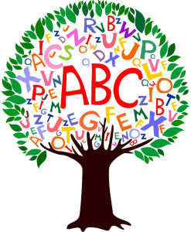 | Reading:  - Sharing and reading stories as a class.  - learning letter sounds and beginning to read three letter words (P1).  - Progressing at our own level through the school reading schemes, using these books at home and in school.  Listening & Talking:  - Learning to listen for information and instructions.  - Learning to talk about our experiences in group situations.  Spelling – understanding spelling rules and using these in our spelling. (P2)  Phonics – Jolly phonics/blending (P1/2)  Writing – Working at our own level we will be:  - Practise forming letters correctly.  - Practise fine motor skills through finger gym games and activities.  - Using emergent writing to express our ideas.  - Sizing all letters appropriately.  - To use capital letters, finger spaces and full stops correctly. (P2)  - lengthening sentences using ‘and’ and starting to use other conjunctions. (P2)
Numeracy and maths | Working at our own level we will be:  - Reading, ordering and forming numbers to 10 (P1) to 20 (P2).  - Counting forwards and backwards to 10 and beyond (p1).  - Counting on in 1’s from a given number. (P1)  - Using the maths language before/after, greater/smaller and less/more (P1 & P2).  - Bonding verbally to 10 (P2)  - Adding and subtracting within 10 (P2)  - Verbalise and recognise numbers to 100 by counting on and back in 1s (P2).  - Sequencing and ordering numbers to 100 (P2).  - Information Handling.  - Measure
Health and wellbeing | - Games: this will help with learning to move well, share space, listen carefully, control our bodies and be part of a team.  - Catching and throwing  - Recognising that we all experience a variety of thoughts and emotions that affect how we feel and behave and learning ways to manage them.
Other curricular areas | - This term we will be exploring various topics. We will be responsive to the children’s interests as shown through their play and discussions. Topics may last a few days, a week or longer and will provide contexts for learning in the areas of expressive arts, social studies, science, maths, technology and health & well-being. Currently we are going to look at ……...
- ICT – recognise different types of technology such as iPad, cameras, and netbooks.
- Learn how to use applications on the iPad to help us with our learning.
- French:
– We will learn simple greetings and how to say our names.
- RME:
- Explore how people show that they care for others and link this with our own life and family.
- Outdoor Learning:
- Loose parts play.
- Visits to the Community gardens.

Here are some of the ways you can help

At home | With us in school | Out and about
Helping at home by supporting the learning of our phonic sounds and reading. |  | Look and discuss numbers – door numbers, speed signs, car registration plates.
Remind children to wear PE kits for Wednesdays and Fridays.

Homework will be handed out on a Thursday and returned to school on a Monday.

