|  |
| --- |
| **Strathallan Primary School and Nursery** **Standards and Quality Report – June 2023**  ***Achieving Excellence and Equity*** |

|  |  |  |  |  |  |  |  |  |  |  |  |  |  |  |  |  |  |  |  |  |  |  |  |  |  |  |  |  |  |  |
| --- | --- | --- | --- | --- | --- | --- | --- | --- | --- | --- | --- | --- | --- | --- | --- | --- | --- | --- | --- | --- | --- | --- | --- | --- | --- | --- | --- | --- | --- | --- |
| **Context**   |  |  |  |  |  | | --- | --- | --- | --- | --- | | **Setting/School Roll (including ELC/ASC)** | **343** | | | | | **FME** | **8%** | | | | | **SIMD Profile for establishment** |  | | | | | **Attendance (%) 93.3%** | **Authorised** | **5.03%** | **Unauthorised** | **1.66%** | | **Exclusion (%)** | **0%** | | | | | **Attainment Scotland Fund Allocation (PEF and SAC)** | **£25, 72** | | | |   **Context**  Strathallan Primary School and Nursery opened in January 2007. The school is situated to the west of Kirkcaldy within an affluent housing estate and is part of the Balwearie High School cluster.   * Our FME is 8% and our current school roll is 343 pupils with capacity for 60 children within our nursery.   **School**   * The school has 13 classrooms with 11 classes this session, in use. All 13 classrooms are used as two non-class contact teachers use rooms. Our teaching staff consists of Headteacher, 2 Depute Head Teachers, 10 fte class teachers, 4 fte part-time class teachers and 1 Support for Learning teacher. * We have 4 PSAs (full and part-time) and 1 classroom support assistant who are committed to enhancing children's learning. * Strathallan is an inclusive and nurturing school, promoting equality, diversity, opportunity, respect and achievement for all. * All pupils experience the broad general Curriculum for Excellence through high quality learning, teaching and assessment both indoors and through good use of outdoor spaces including the local forest. We aim to meet the needs of all learners through a variety of meaningful, differentiated tasks and activities which are suited to each child. * We link curricular areas to the wider world of work in order to equip our young people with the skills necessary for their future. * We have a house system into which each child is allocated a place. Tokens can be earned and awards achieved throughout the year and house competitions are arranged at points across the year to ensure children feel connected to their house. * We have excellent support from our parents/carers, with whom we communicate in as many different ways such as our school app, groupcall and most importantly through Seesaw. Using seesaw keeps our parents informed on day to day learning for their children and it is widely regarded as a very useful communication tool by parents. * We link with a variety of outside agencies, whose support we greatly value; these include Balwearie High School, other local secondary schools, other cluster primary schools, private nurseries, local businesses, Health, Social Work, Educational Psychologist, FACST, S.A.L.T, O.T, Active Schools, local councillors, Police Scotland and the minister from Abbotshall Church. * The school building hosts an Out of School Club from 3.05 p.m.- 6.00 p.m. each evening.   **Early Learning and Childcare Setting**   * Strathallan Nursery can accommodate 60 children on a 9.00 a.m.- 3.05 p.m. basis offering flexible nursery placement. The teaching allocation is 0.5 peripatetic. The Nursery is an integral part of our school and we strive to ensure that all children are fully included in our whole school vision and ethos, attending learning opportunities, assemblies, events and participating in concerts.   **Vision, Values, Aims**   * Mr Murray was appointed Headteacher in December 2022 and decided to look closely at the schools vision values and aims through consultation with parents, children and partners. Our vision remains **“inspiring the future**”. * Our school values have changed with a focus now on **CARE – Caring, Achieving, Respect and Equity. An example of the parent questionnaire in relation to this is below.**      * **Our school aims: Strathallan PS and Nursery will work together with all stakeholders to ensure all our children are afforded the opportunity to become successful learners, confident individuals, responsible citizens, and effective contributors. We will provide a safe, nurturing and supportive environment in which all children, families and staff are equal and respected. We will strive to deliver the very best learning opportunities and support our pupils to understand environmental and cultural issues. We will always encourage children to do their best and reach their full potential.** |

|  |  |  |  |  |  |  |  |
| --- | --- | --- | --- | --- | --- | --- | --- |
| **Improvement Priority Session 2022 – 2023** | | | | | | | |
| **Priority 1 –** To improve our school culture, ethos and environment by ensuring all stakeholders understand our shared beliefs, attitudes, values and aims for all children through building strong relationships between school staff, students and families. | | | | | | | |
| NIF Priority: Improvement in children and young people’s health & wellbeing. Improvement in attainment and achievement, Assessment of children and young person’s progress.  NIF Driver  School and ELC improvement, | | | HGIOS 4 Quality Indicators  HGIOELC Quality Indicators  QI – 1.1 Self Evaluation for Self Improvement  1.3 Leadership of change  3.1 Ensuring Wellbeing, equality and Inclusion | | | | |
| Has this priority been:  (please highlight) | Fully  Achieved | Yes | | Partially  achieved |  | Continued into next session | CR |
|  | |
| **Progress:**  As a new Headteacher to Strathallan my priority was to ascertain from all stakeholders their views on the current strengths of the school and the areas that needed improved. It was very clear from staff and parents that the ethos of the school had suffered and was weak. There were relationship issues between staff and there was a disconnect with parents and the community. Staff felt that behaviour in the school was having a significant impact on the learning and teaching and therefore outcomes for the children in the school were not as positive as they might be. A decision was made to have a strong focus in this area and move away from a previously created priority that staff felt they had little input to.  One of our school improvement priorities became: “To improve our school culture, ethos and environment by ensuring all stakeholders understand our shared beliefs, attitudes, values and aims for all children through building strong relationships between school staff, students and families.”   * All stakeholders have been consulted and have contributed to our newly created Curriculum Rationale. The evidence from all stakeholders is held and as a staff we now need to establish how we want to present this so that it is clear and concise for children, parents, carers and staff alike. More detail around this can be found in next steps for this priority.      * Parental engagement sessions took place in September 2022 to gain viewpoints and opinions on the direction of the school. This information was collated and was used to form two new priorities for the school. * Microsoft Forms was used to questionnaire ALL pupils, parents, staff and partners on the direction for the school. Questions that would support us to develop a Curriculum Rationale were used. These included: What makes Strathallan unique, what our core values should be and what parents/children felt were priorities for learning. * All pupils took part in an online exercise to answer questions about their views on the school and how they are treated within the school by staff and other pupils. Questions ranged from asking about bullying, being treated fairly, being encouraged to do their best and if they felt they were listened to and supported in the school. (P7 example below)      * A working party was set up including teaching staff, senior leaders, support staff and parents to look closely at the relationships and behaviour within our school and to develop a whole school policy for improving relationships and behaviour across the school. The policy has now been created and is being implemented across the school. Click the image below to view the policy in full.      * A pupil version of the relationships and behaviour policy has been created and will be shared in August 2023 so that all children are clear on expectations. Children were involved through questionnaires and will take ownership of the policy. * A number of staff attended “Trauma Informed Practice” training in November and then cascaded this training to the wider staff. The learning from this training was considered and helped to shape the Relationships and Behaviour flowchart and policy. * At our Learning Partnership in November 2022, colleagues and parents were asked to observe and give feedback on their observations/experiences specific to relationships, behaviour and ethos of the school. A report was then created on their findings and again this was used to help shape the relationships and behaviour policy. Details of the strengths and next steps identified can be found later in this report. * Staff attended “De-escalation” training offered by Fife Educational Psychology Service in February 2023. They then cascaded the key elements of this to ALL staff and this was then considered and included in the creation of our whole school relationship and behaviour policy and flow chart. * A revamp of the “House system” within the school became a focus and through collegiate working during staff meetings changes were made. All children are allocated to houses and the system was improved to include who house competitions and prizes to motivate and engage pupils and provide them with a sense of belonging. | | | | | | | |
| **Impact:**   * A curriculum rationale has been developed and core values have been established having consulted with all stakeholders. All children were consulted, and the core values of CARE (Caring, Achieving, Respect and Equality) are discussed each week at assembly and within classes. Almost all children can talk about these values and as a result there is a better understanding of how we want children to conduct themselves in school. Seemis latest pastoral notes indicate that there is a reduction in poor behaviour choices in the playground and around the school in general and questionnaire data around bullying and feeling safe is positive. * Almost all Pupils have shown in responses to their online questionnaires that they feel listened to and that they have someone within the school whom they can talk to if they feel they need to. See screenshot above. * A relationships and behaviour policy is now in place and a flowchart showing steps to take to de-escalate and deal with poor behaviour choices of pupils. All staff have had an input to this document and views from parents and children have also been considered. A focus on three behaviour choices was piloted in the first instance. These were based on the Paul Dix approach and were 1) Smart Walking, 2) Tidy Cloakrooms, and 3) Showing good manners and respect to all. SLT and almost all teachers have indicated that they have seen improvements in behaviour compared to last session. * All staff are now better informed about “Trauma Informed Practice and are better equipped to understand certain behaviours from children who have suffered trauma. Key staff (5 members) are equipped with the skills considered as advanced in this area and are very able to support colleagues when needed. Almost all children within our school who have suffered trauma are supported using the guidance and training from the “Trauma Informed Practice” model. * The learning partnership observations and comments in November gave teaching staff informative feedback on their learning and teaching. SLT then used this information at observations in term 3. There is evidence from these observations that most teachers plan lessons using a 4 part model and that pupil engagement is high for most learners. * Relationships between pupils and teachers has improved for almost all learners as a result of work carried out by the relationships and behaviour working party and it’s roll out of strategies and policy to wider staff teams. * All staff have had input on “De-Escalation” methodology and are now more aware now of how to use these strategies within their own classes and/or remit. All support staff are more confident in how to de-escalate situations that arise, and teaching staff are also more skilled in this area and as a result staff are using more strategies to support children in the class and playground. * All children have benefited from the revamp in “House” focus and through recent discussions with classes there is strong evidence to suggest that pupils value their house and want to contribute to the success of their house. House captains speak highly about it’s importance and make efforts to encourage their house members at assembly and other events. The recent sports day was very successful and children worked hard as a team within their house in order to gain points. Children are looking forward to finding out who has won the overall “House” prize. Children were also very involved in discussions around what behaviours should warrant house points and what a worthwhile reward/prize would be for their “House”. Children have developed teamwork skills and captains and vice captains have improved leadership skills. | | | | | | | |
| **Next Steps:**   * To finalise the Strathallan Curriculum Rationale and place into a format that is clear and concise for all stakeholders using the evidence gathered. This is very likely to be a short film with pupils, parents and staff voice captured. There is also a collective desire to create an “anthem” that can be sung at times to motivate all stakeholders. (August/September 2023) * Continue to roll out relationships policy and share pupil version with all pupils in August 2023. * Provide input for new teachers (two Probationer Teachers) on “Trauma Informed Practices” and “De-Escalation” and continue to promote these strategies through revisiting at in-service days and collegiate sessions. * Act on Learning Partnership feedback for next session, mainly around ensuring a consistent approach across the school on differentiation and meeting ALL learners needs. | | | | | | | |

|  |  |  |  |  |  |  |  |  |
| --- | --- | --- | --- | --- | --- | --- | --- | --- |
| **Improvement Priority Session 2022 – 2023** | | | | | | | | |
| **Focused Priority**: To improve attainment, achievement and wellbeing through improved learner participation, pupil voice and strengthened links with our wider school community including parents/carers, partners and beyond. (Rebuild of school community) | | | | | | | | |
| NIF Priority: Improvement in attainment, particularly in literacy and numeracy and Improvement in children and young people's health and wellbeing  NIF Driver  Parental/carer involvement and engagement School and ELC leadership | | | HGIOS 4 Quality Indicators  HGIOELC Quality Indicators  QI – 1.3 Leadership of Change  2.2 – Curriculum (Pupil Experiences)  2.5 – Family Learning  2.7 - Partnerships | | | | | |
| Has this priority been:  (Please highlight) | Fully  Achieved | Yes | | Partially  achieved | Yes | Continued into next session | Yes | |
|  | |
| **Progress:**   * A working party was set up to create and oversee our PVG initiative (Pupil Voice Groups) and it was planned that these groups would then meet on a 3 week cycle to discuss ways in which the school could re-engage with the families and community as this was identified as a weakness and something that was missing from the school. The groups were: Digital Schools Team, Rights Respecting School Committee, Eco Committee, Playground Committee, Learning Council, Community Committee and Health and Wellbeing Committee. Every child in the school was assigned to a pupil voice group. * Throughout the year, on a 3 week cycle the groups have met, discussed, and planned initiatives and opportunities and implemented these. They then reported back at points over the course of the year at assembly and through visiting classes to present. * All teaching staff and PSA staff were assigned to a pupil voice group to lead and support the children and to plan initiatives relating to their group goals. * Soft starts and soft finishes began in September 2022 after not featuring for over 2 years due to the pandemic and other circumstances. All parents in the school had opportunities to be welcomed back into the school and to observe/support their child. * Seesaw has been revamped and used consistently throughout the school as a communication tool to share learning and progress and to involve parents in that journey. Parents have been given input on the use of seesaw. * SLT and the Parent Council set up a two pronged strategy to reconnect parents and the community to the school as this was identified as a an area for improvement. Two groups were created and led by SLT and members of the parent teacher council. These were a “Community” groups and a “fundraising” group. Events such as Macmillan Coffee morning, Soft Starts, Christmas and Summer Fayres, internet safety training for parents and sports days gave parents more opportunities to be part of the life and ethos of the school.   A hand holding a cup of coffee  Description automatically generated   * Many events have taken place throughout the course of the year designed to provide opportunities for parents and carers and the wider community to engage with the school. This was a clear priority of parents and staff and had been identified as a weakness through engagements sessions and questionnaires. Recent questionnaires indicated that this is much improved and that parents feel they are more involved in the life and ethos of the school. * A new website has been created with areas for pupils, parents and partners to showcase their work. The website has a build in communication portal that allows parents to stay informed and to contribute to decisions made by the school. The calendar app has allowed parents to plan and be more involved in the life of the school. * Involvement in the community was identifies as a priority from staff and parents in August. Children had missed many opportunities that their peers in other local primary school participated in. As a result of this, we ensured that our school created a football team, netball team, coding club, gardening group, bike ability class amongst other initiatives. Strathallan also took part in cluster events and Kirkcaldy/Fife wide initiatives that they hadn’t done for a number of years. These included Rotary Quiz and Burns Quiz. * All parents, carers and family members were asked if they had particular skills in order to support the school. Sensory music sessions, reading support and sports were all delivered to our young people as a result. * Children at all stages have been asked about the direction of the school and have participated in many opportunities to express their views. These include the pupils voice groups, class charters and other decisions when teachers plan for topics etc. * Questionnaires have been used to gather data from parents and children about their involvement in the life of the school. An initial questionnaire was used in September 2022 and a similar questionnaire used in June 23 to ascertain the value added as a result of our work. | | | | | | | | |
| **Impact:**   * All children within the school have benefited from being part of a PVG group. The groups included- Digital Schools Team, Rights Respecting School Committee, Eco Committee, Playground Committee, Learning Council, Community Committee and Health and Wellbeing Committee. A survey was carried out to gather opinions from children about pupil voice and almost all children feel they have a voice and are listened to. This has increased since the same questions were asked in September. All children understand the importance of the Environment and UNRC through regular assemblies and pupil voice groups. * All children have participated in pupil voice groups and contributed to school improvements. The improvement priority to ensure we reconnect with the wider community and enhance pupil voice has been successful and there is a range of evidence of both the experiences and the impact on children’s learning, wellbeing and the reconnection with the community. A link can be found further in the document with a list of the events that have taken place with comments from children and parents. Most children across the school developed skills in collaboration, communication, teamwork and some children developed their leadership skills. * Parents, Carers and wider family members have had many opportunities this year to participate in the ethos and life of the school. Soft starts, soft finishes and workshops have allowed parents and carers the opportunity to understand more fully the way in which Literacy and Numeracy is taught. As a result, parents are better equipped to support their children at home. This is particularly evident in the infant classes of P1 – P3. * Feedback from parents, carers and wider families about the range of opportunities to come into school has been very positive. The opportunities such as “Coffee, Chat and Connect, Christmas and Summer Fayre, Soft Starts and workshops have meant that parents and the wider community feel closer to the school and more informed about the daily life and ethos of the school. All children have benefitted through participating in wider achievement opportunities and there is an increased sense of pride when children talk about their school and it’s involvement in these events. Feedback at Parent Teacher Council meetings has been positive about these improvements. Through pupil questionnaires in the upper classes of P4 – P7, it is clear that almost all pupils feel that the schools involvement with the community is an improvement. * Some children have benefitted from being involved in a range of sporting events, including cluster football competitions, netball and running. Almost all of these children mention that they feel a sense of pride representing their school and that they are happy being involved in cluster events as previously they had not participated. * Most parents speak highly about the school’s use of seesaw although there is a need to ensure that this is consistent across all classes as a next step. Most Parents engage well with seesaw and as a result are more involved in their child’s learning and are more able to support them. * The new school website is seeing more traffic of parents, carers and family members and is allowing them to keep more informed about events. Parents, carers, and family members are positive in their feedback about this. The impact on children and families is a better connection between school and home. | | | | | | | | |
| **Next Steps: (Maintenance priority)**   * Ensure consistency in the use of Seesaw as a communication tool by providing further input to new teachers and to those teachers who have requested support. Monitor this and continue to ask for parental feedback at parents’ nights and through questionnaires. * Make adjustments to Pupil Voice Groups to reduce the size of these and consider other ways in which to involve all young people to ensure they have pupil voice and are listened to. * Develop school website with parental input and create a calendar of events section with opportunities for parents and carers and wider family to attend. * Continue to provide pupils with opportunities to represent their school at cluster and community events such as cross country running, football, netball, rotary quiz and Burns Speakers Competition. Children indicated through SLT discussions that they wanted to be part of these events and had missed out in previous years.  |  |  |  |  |  |  |  |  | | --- | --- | --- | --- | --- | --- | --- | --- | | **Improvement Priority Session 2022 – 2023**  (Duplicate section to reflect number of priorities from 2022- 2023 improvement plan) | | | | | | | | | **NURSERY SPECIFIC PRIORITY**  Fully engage in the guidance from Realising the ambition and use in their practice. | | | | | | | | | NIF Priority  NIF Driver | | | HGIOELC Quality Indicators  QI 1.1, 2.2, 2.3 | | | | | | Has this priority been:  (please highlight) | Fully  Achieved |  | | Partially  achieved |  | Continued into next session |  | | **Progress:**  During in-service days and development sessions, the nursery team has engaged in:   * Self-evaluation and reflection of current practice * Professional reading – Realising the Ambition document and related Education Scotland video overviews * Professional dialogue and debate   Through engaging with the document and challenge questions, the team has reviewed and improved practice in relation to quality learning spaces, interactions and experiences. | | | | | | | | | **Impact:**  **Quality Learning Spaces**  The garden doors are open daily from 9.30am to 2.30am, except for lunchtimes. The garden is used well and the majority of children are interacting with peers from both rooms. Observations of significant learning are being recorded and tracked. This informs planning. The team continue to take inspiration from the Curiosity Approach; this is happening naturally now so team no longer needing photographic evidence. Learning spaces continue to evolve, depending on children’s interests. Daily responsive planning is embedded and weekly planning is done as a team with all members contributing to any changes. There is regular use of forest and school facilities, e.g., library, gym, grass area. Parent helpers are supporting forest visits. The majority of children are enthusiastic about going to the forest. The lunch area is a more welcoming, homely environment. The majority of children have become more independent and will sit with different people. Messy play is going well. Most children will now ask if they wish to make playdough or slime and most are experimenting with different paints. The home corners are well used by the majority of children, with appropriate role play. Writing and drawing spaces are very busy, with most children engaging in the learning opportunities on offer. Most children are able to recognise their name on their pebble  **Quality Interactions**  There are positive relationships between staff and children. The children are happy and settled and almost all are confident in approaching staff. The staff engage in welcoming conversations and most children will share news and engage in show and tell. The feedback from settling in questionnaires was mostly positive. Many children are engaging with floor books, including writing, drawing, helping to add pictures and recalling learning. Pupil voice opportunities include discussions around snack choice and gym activities. P7 buddies have been reintroduced; this is helping N5 children with the transition to P1. Positive relationships and communication with parents/carers continue to develop and improve, and parents/carer are coming into nursery more often; this had been impacted by Covid restrictions. Parents/carers are happy to talk to staff about their children, in person at drop off/collection times, by phone or via Seesaw. Face-to-face Parent Chats have resumed within the setting and are well attended. Several parents have participated in nursery events, including forest, Bookbug and PEEP. Many parents participated in soft starts/finishes, particularly in Terms 1 and 2. Most parents/carers are engaging/ interacting with Seesaw in relation to their child’s learning. Information is being shared with parents/carers via Seesaw, the School App, newsletters and Groupcall, as well as paper letters and flyers. There has been increased involvement of partner agencies and professionals in review meetings. HV are again coming into the setting to observe the children and attend meetings. ASN targets/next steps are reviewed/set during meetings.  **Quality Experiences**  The children have had opportunities to participate in forest and park visits, indoor/ outdoor gym sessions and Book Bug. Almost all children engaged in forest visits with good interaction, persevering and challenging themselves. Many children are using equipment appropriately during park visits, learning to share and relating experiences to home. In gym, many children are choosing their own experiences and risk assessing their use of large apparatus. Most children who engage in Bookbug sessions participate well, with good listening and following of instructions. Some N5 children and family members have engaged in PEEP sessions in Term 4, these have proven successful however, due to staffing, preparation time for EYOs was limited. Most of the children have been able to share their learning experiences with family members during soft starts/finishes. Lunch times offer more self-service opportunities. EYO observations indicate that most children are becoming more independent and more confident in self-help skills. Most children are choosing their seats and interacting in conversations with friends. All N5 children have engaged in transition activities, including Play on Pedals, classroom visits, milk and story times, tour of school, loose parts play, playground sessions, activities with their P7 buddy and meet the teacher activities. Feedback on this has been positive, with most children presenting as settled and comfortable with the transition to P1. Soft starts/finishes, sports day, nursery graduation and our Daffodil Tea provided opportunities for the children, their families and EYOs to come together as a community and benefit from shared experiences.  Quality observations of significant learning support daily responsive planning and the planning of intentional promotions. Learning is recorded and tracked within PLJs, which are frequently updated. Parents are encouraged to engage with PLJs and to share home learning activities. Floor books provide evidence of learning, with many children contributing to these. | | | | | | | | | **Next Steps:**  **Quality Learning Spaces**   * Review the learning environment/provision in garden * Plan regular audits of core provision   **Quality Interactions**   * Extend opportunities for the children to learn from other members of the school community, e.g., invite visitors into nursery in relation to the World of Work. * Extend the links between N5 and P1 throughout session, not just during transition activities. * Introduce Cuppa Chats before/after soft starts/finishes to strengthen relationships with parents/carers. * Share Seesaw policy with parents, once finalised, so expectations around communication are clarified. * Devise a system for children to select lunch choices independently.   **Quality Experiences**   * Introduce new games to extend learning in gym. * Develop pupil voice opportunities in relation to lunches, encourage quiet voices at lunch times and increase awareness of food waste/recycling. * Reduce frequency of soft start/finish sessions to increase engagement from families, as many parents find it difficult to attend multiple sessions due work commitments. * Continue to review N5 to P1 transition activities annually to ensure these are relevant to the current children, e.g., transition teddy no longer relevant. | | | | | | | | | | | | | | | | |
| **Attainment of Children and Young People (Primary and Secondary)** | | | | | | | | |
| |  |  |  |  |  | | --- | --- | --- | --- | --- | | **Stage** | **Reading** | **Writing** | **Listening and Talking** | **Numeracy** | | **P1** | **85%** | **85%** | **89%** | **75%** | | **P4** | **83%** | **72%** | **89%** | **74%** | | **P7** | **84%** | **73%** | **92%** | **88%** |  |  |  |  | | --- | --- | --- | | **Overall Attainment for 2023 - 2024** | | | |  | **Literacy** | **Numeracy** | | **P1** | **86%** | **75%** | | **P4** | **81%** | **74%** | | **P7** | **83%** | **88%** |  |  |  |  |  | | --- | --- | --- | --- | | **Literacy** | | **Numeracy** | | | **Stretch Target** | **Actual** | **Stretch Target** | **Actual** | | **77%** | **83%** | **81%** | **80%** |   **Evaluative statement of attainment over time.**  **Primary 1**   |  |  |  |  |  |  | | --- | --- | --- | --- | --- | --- | | **CFE Achieved at Appropriate Level** | **2018-2019** | **2019-2020** | **2020-2021** | **2021-2022** | **2022-2023** | |  | **Primary 1** | **Primary 1** | **Primary 1** | **Primary 1** | **Primary 1** | | **Numeracy and Maths** | **73.5%** | **83.7%** | **87.8%** | **95.3%** | **75%** | | **Reading** | **71.4%** | **55.1%** | **80.5%** | **83.7%** | **85%** | | **Writing** | **61.2%** | **53.1%** | **80.5%** | **81.4%** | **85%** | | **Listening and Talking** | **85.7%** | **73.5%** | **80.5%** | **95.3%** | **89%** |   **P1 Literacy**  By the end of Primary 1 most children achieved in all three areas of Literacy including Reading, Writing and Talking and Listening. Most children in Primary 1 have exceeded the Fife and National expectations for reading, writing and talking and listening.  All children have made good progress from their prior levels of attainment in Literacy and English as shown in our follow base assessments which showed good value added.  **P1 Numeracy**  Most children in Primary 1 have achieved the expected level of Early Numeracy and Maths although this percentage is down from the previous few years. Further investigation into the data has helped us understand the reasons for this including a few children who have not yet achieved have a recognised additional support need.  **Primary 4**   |  |  |  |  |  |  | | --- | --- | --- | --- | --- | --- | | **CFE Achieved at Appropriate Level** | **2018-2019** | **2019-2020** | **2020-2021** | **2021-2022** | **2022-2023** | |  | **Primary 4** | **Primary 4** | **Primary 4** | **Primary 4** | **Primary 4** | | **Numeracy and Maths** | **51.8%** | **45.2%** | **74.4%** | **76.2%** | **74%** | | **Reading** | **64.3%** | **61.9.2%** | **76.9%** | **76.2%** | **83%** | | **Writing** | **50.0%** | **45.2%** | **79.5%** | **61.9%** | **72%** | | **Listening and Talking** | **67.9%** | **76.2%** | **92.3%** | **97.6%** | **89%** |   **P4 Literacy**  By the end of Primary 4 most children achieved in all three areas of Literacy including Reading, Writing and Talking and Listening. Most children in Primary 4 have exceeded the Fife and National expectations for reading, writing and talking and listening and have achieved First Level.  All children have made good progress from their prior levels of attainment in Literacy and English as shown in our NSA assessments which showed good value added from their previous achievements.  **P4 Numeracy**  Most children in Primary 4 have achieved the expected level of First Level Numeracy.  There has been a slight drop in the attainment of numeracy and mathematics from last year. Having investigated further and looked closely at the cohort, there are clear reasons for the drop in attainment that don’t relate to the schools approach to numeracy and mathematics.  **Primary 7**   |  |  |  |  |  |  | | --- | --- | --- | --- | --- | --- | | **CFE Achieved at Appropriate Level** | **2018-2019** | **2019-2020** | **2020-2021** | **2021-2022** | **2022-2023** | |  | **Primary 7** | **Primary 7** | **Primary 7** | **Primary 7** | **Primary 7** | | **Numeracy and Maths** | **69.4%** | **55.1%** | **58.2%** | **72.0%** | **88%** | | **Reading** | **69.4%** | **49.0%** | **78.2%** | **86.0%** | **84%** | | **Writing** | **71.4%** | **49.0%** | **60.0%** | **74.0%** | **73%** | | **Listening and Talking** | **79.6%** | **49.0%** | **90.9%** | **88.0%** | **92%** |   Overall, attainment in literacy and English is good. Most children achieve CfE levels as expected at Second level. Most children achieve national expected levels of attainment at second levels in listening and talking, reading, writing and numeracy/mathematics. | | | | | | | | |
| **Evidence of significant wider achievements** | | | | | | | |
| **School**   * Seesaw has been rolled out across the school to all classes and have kept parents/ carers / pupils aware of daily developments in our school community. * All pupils have had their first school trip since prior to 2029. Trips were planned and included many educational visits such as “Money on the Mound Museum”, Dynamic Earth and Sky academy amongst others. All pupils attended their school trip and the school funded those families who requested support and the school part funded all other trips to ensure there was a low cost to families. * Some children have represented their school in sporting activities in the cluster such as football competitions and netball competitions. The school were not involved in cluster events such as this since 2019. * All classes have had Soft Starts and Soft Finishes each term to ensure parents are given an opportunity to visit their child’s classroom setting and to engage with their child’s learning * Children have been trained in Bikeability at Primary 5, Primary 6 and Primary 7. Children from P3 who were unable to cycle were given cycling starter lessons and most can now ride a bike. * Several school clubs including football training, netball have been set up for P5, P6 and P7. These are lunchtime clubs and afterschool clubs. This is the first time such clubs have been available in the school for 4 years. * P7 pupils were involved in two enterprise projects during the year. All P7s planned the Macmillan Coffee morning and were involved in a Dragon’s Den style Enterprise Initiative in Term 4. All pupils were involved in baking, selling, designing, banking and many other skills. The feedback from pupils and parents was very positive. * Although it was not a specific school improvement priority, a OneNote system has been developed in order to move all planning, assessment, evidence and timetables online. Teachers have embraced this and it will have improve the transition of learning for all learners in the school from class to class.   **ELC**   * Parents/carers have been welcomed back into the setting now that restrictions have been lifted * Parents/carers are happy to talk to staff about their children, in person at drop off/collection times, by phone or via Seesaw * Face-to-face Parent Chats have resumed within the setting and are well attended * Several parents have participated in nursery events, including forest and Bookbug * Many parents participated in soft starts/finishes * Most parents/carers are engaging/interacting with Seesaw in relation to their child’s learning * Information is being shared with parents/carers via Seesaw, the School App, newsletters and Groupcall, as well as paper letters and flyers   From participating in the following events children have developed a variety of skills for learning, life and work, including leadership, communication, creativity and problem solving. | | | | | | | |
| **Learning Partnership/Extended Learning Partnership/Subject Review/3.1 Review/DAS Review Strengths and Areas for Improvement** | | | | | | | |
| As part of our ongoing improvement journey we always look to moderate and welcome the views of others. On the 16th November 2022 we welcomed a number of professional colleagues to our school including our Education Manager and some other Headteachers and Deputes. We also invited parents and pupils to give their views on the school’s performance. These views, together with the observations of professional colleagues provided us evidence of the success of our journey and also some next steps to consider as we moved through the rest of the school session of 2022-2023. Strengths and next steps are detailed below.  **Outcome/Strengths identified:**   * Throughout the school there was a very positive and welcoming atmosphere and relationships between teachers and children was strong. * All lessons were well planned. * Across all classes almost all children knew what they were learning and how to be successful. * Learning intentions were shared with children in all classes and children were able to talk about what they were learning. * Learning environments were well organised, appropriate and stimulating for children’s learning. * In all lessons there was good use of resources to support the learning and engage learners. * In all lessons there was a high level of pupil engagement and in almost all lessons there were creative approaches to teaching. * Digital technology was used to support teaching in all classes. Where appropriate children also had the opportunity to use technology to support their learning. * A variety of curricular subjects were observed including science and our 1+2 language Spanish. There was also good evidence of 1+2 languages in most classes. * There was evidence of inclusion of children with additional support needs in all classes and pupil support assistants were said to be well utilised. * Children spoke very highly about the school during their focus group discussion. They articulated that they felt listened to and valued. Children knew the term “pupil voice” and spoke about ways in which they could contribute to the ethos and life of the school. * Staff were positive about communication and mentioned that they felt this had improved significantly this session. * Staff also mentioned that they felt more involved in decision making through a collegiate approach and felt valued. * Parents were positive about the changes in the school and also had shared ideas/comments from other parents for next steps below.   **Areas for Improvement/Planned Next Steps**   * Success criteria was not consistently co-created and or spoken about it all classes. A next step is to work on ALL classes sharing and co-creating success criteria effectively. * It was identified that not all classroom wall displayed had supports that matched children’s ability. * Although inclusion was spoken about in a very positive way, a next is to consider “inclusion in learning” and not just inclusion. * Parents felt that there was an inconsistency in the approach to homework and would like to see this addressed. * Differentiation was not apparent in all classroom lessons although it was clear in most. There is a need for ALL teachers to plan for ALL children including more able and those who require support. * In most lessons observed there was a good level of challenge to engage learners but in two lessons Learning Partners noted that some children were more able than the task/activity they were working on. | | | | | | | |
| **PEF Evaluation/Impact** | | | | | | | |
| **Targeted Interventions** | | | | | | | |
| **Progress**  Purchase of Assessments   * The purchase of INCAS assessments provided good evidence and a support for class teachers to sit alongside their teacher judgement in assessing overall attainment. In a few targeted classes this was used twice to track the value added over the course of the year. * Following the assessments, consultation with teaching staff took place to identify gaps in attainment and to create support packages for these children. * Regular meetings between SLT, SFL with PSA staff took place to ensure the right supports were in place for the right children. * PSA hours increased to support individuals in class - PSAs are used to support learning and teaching across the school and adding further “people time” to support teachers has worked well. Teachers feedback has been that this is extremely valuable in allowing smaller groups of children to have more input either by the class teacher or by our PSA staff. * PSAs have been trained and now have used kitbag to support the social & emotional needs of pupils. * PSA staff are skilled in knowing children and families and are essential in identifying concerns and issues around children’s wellbeing, particularly vulnerable children. | | | | | | | |
| **Impact:**   * Individual results were assessed, and next steps were identified, ensuring that decisions taken around the child’s learning were based on robust information. * Most teachers / parents / carers have noted a positive impact on the behaviours of children. PSA’s · Kit bag sessions have been running throughout and it appears that these are having a positive impact on the children involved. * 3 Children who would not have been able to access the curriculum have been supported and as a result they have made good progress and remained in school. * Kitbag sessions have been used throughout the school year and have been successful in supporting pupils. Pupils speak highly of the sessions they are involved in and feel listened to and supported by PSA staff. | | | | | | | |

**Parent Teacher Council Work 2022-2023**

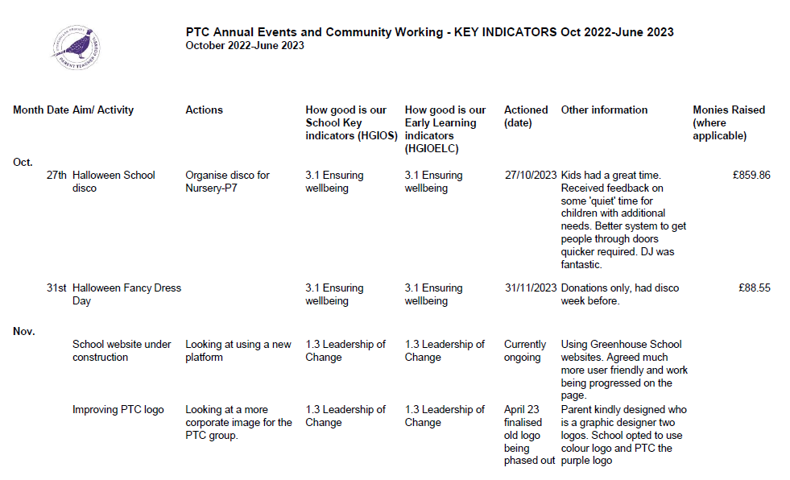

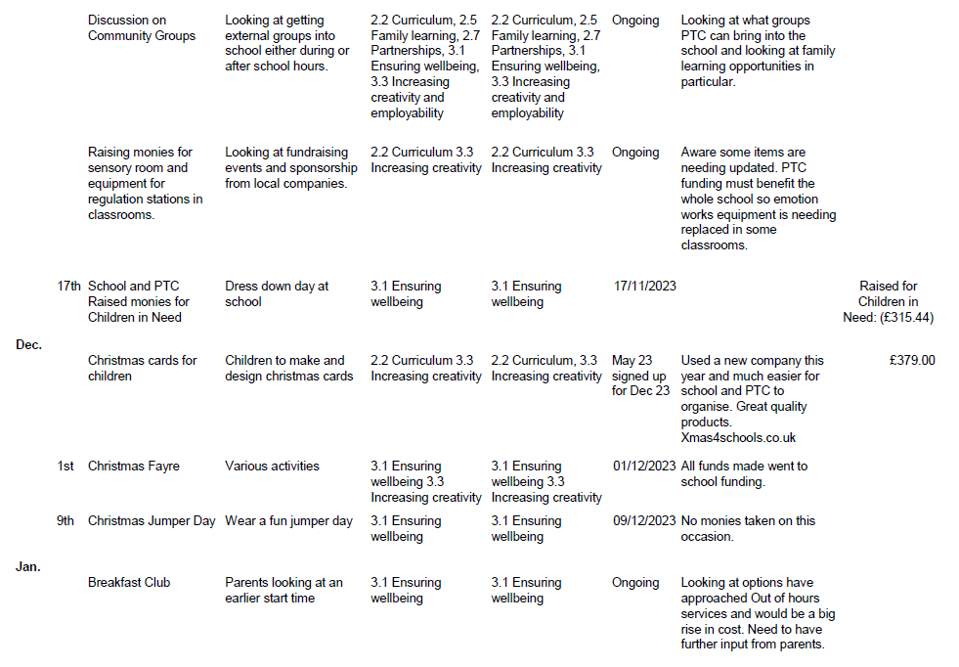

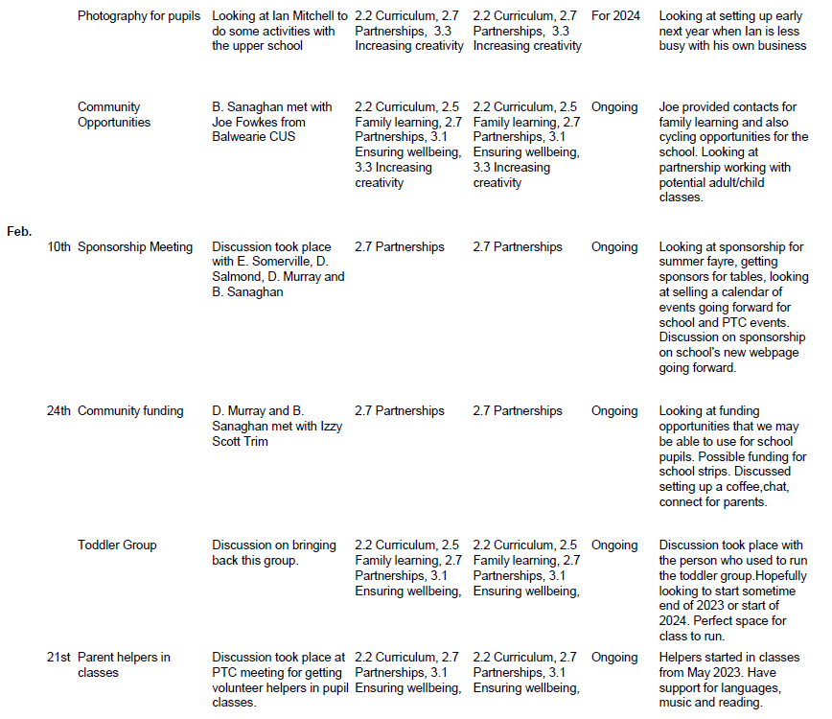

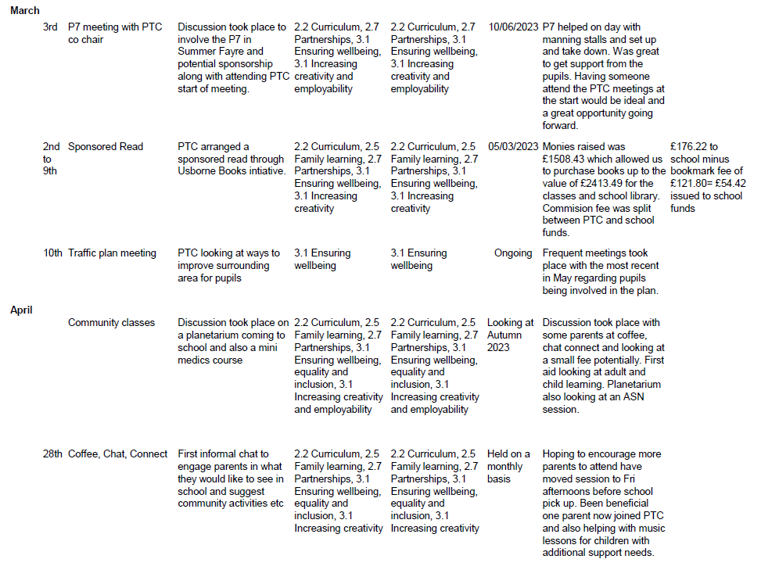

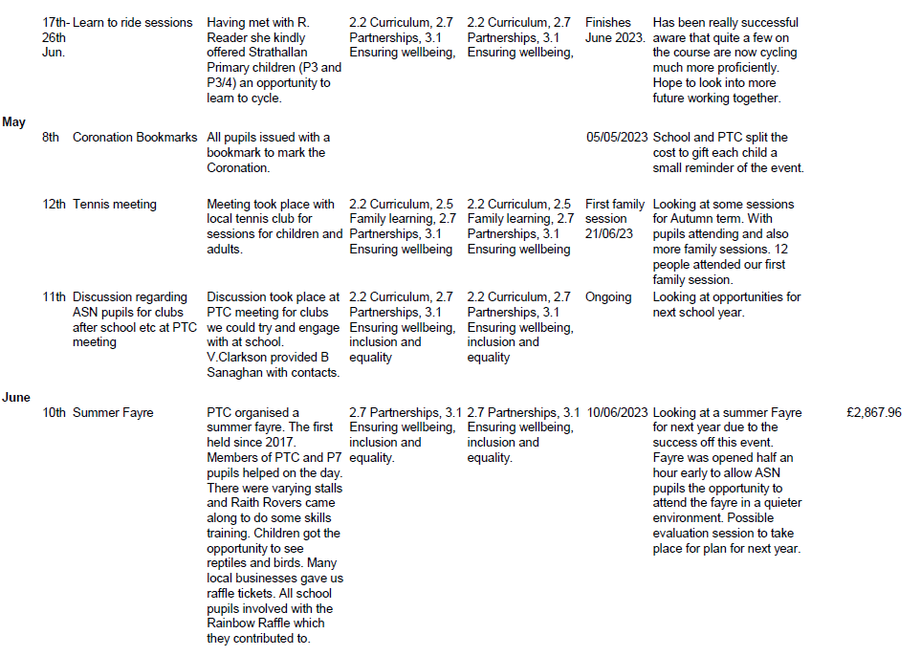

**School/Setting Name ________________________________________________**

|  |  |  |  |  |
| --- | --- | --- | --- | --- |
| **NIF Quality Indicators (HGIOS 4) School Self- Evaluation** | | | | |
| **Quality Indicator** | **2020 -2021** | **2021- 2022** | **2022-2023** | **Inspection Evaluation**  *(since August 2022)* |
| **1.3 Leadership of change** | Good | Good | Good |  |
| **2.3 Learning, teaching and assessment** | Good | Good | Good |  |
| **3.1 Ensuring wellbeing, equity and inclusion** | Very Good | Good | Good |  |
| **3.2 Raising attainment and achievement** | Good | Good | Good |  |

|  |  |  |  |  |
| --- | --- | --- | --- | --- |
| **NIF Quality Indicators (HGIOS ELC) Early Years Self- Evaluation (Nursery)** | | | | |
| **Quality Indicator** | **2020 -2021** | **2021- 2022** | **2022-2023** | **Inspection Evaluation**  *(since August 2022)* |
| **1.3 Leadership of change** | Satisfactory | Satisfactory | Satisfactory |  |
| **2.3 Learning, teaching and assessment** | Satisfactory | Satisfactory | Good |  |
| **3.1 Ensuring wellbeing, equity and inclusion** | Satisfactory | Satisfactory | Good |  |
| **3.2 Securing children’s progress** | Satisfactory | Satisfactory | Good |  |

|  |  |  |  |
| --- | --- | --- | --- |
| **Care Inspectorate (within last 3 years)** | **Grade (if applicable)** | | |
|  | **2020 -2021** | **2021- 2022** | **2022-2023** |
| **Quality of care and support** |  |  |  |
| **Quality of environment** |  |  |  |
| **Quality of staffing** |  |  |  |
| **Quality of leadership and management** |  |  |  |

**Headteacher: Mr Drew Murray**

|  |  |  |  |  |  |
| --- | --- | --- | --- | --- | --- |
| **National Improvement Framework Priority:**  Raised Attainment across Literacy | | | | | |
| **Focused Priority**: Increase the number of children achieving expected stage-related outcomes in Literacy | | | | | |
| **HGIOS4 Quality Indicators** | | | **HGIOELC Quality Indicators** | | |
| QI 1.2 Leadership of Learning; QI 2.3 Learning, Teaching & Assessment; QI 3.2 Raising Attainment & Achievement | | |  | | |
| **Expected Impact** | **Strategic Actions Planned** | **Responsibilities** | | **Measure of Success**  ***(Triangulation of Evidence/QI Methodology)*** | **Timescales** |
| **Writing**  All staff have a clear stretch aim for raising writing attainment in their class. This focus on making improvements at class level leads to targeted support for individual children and close monitoring of their progress.  All children working within Early and at the beginning of 1st level are able to see the relevance of written texts in our daily lives through a literacy-rich environment and develop their reading and writing skills as they engage in purposeful play.  All children from P1 – 7 will be able to talk about the key features of different text types (appropriate to age and stage) and identify what they are doing well in their writing and their own next steps. This will ensure that children can write confidently across genres for a variety of purposes.  All teachers from P1-7 will provide explicit instruction in, and hiqh-quality feedback linked to, grammar and punctuation (at the editing stage for P3-7) This will ensure that all children from P1-7 will be able to talk about their writing tools confidently and apply grammar and punctuation in their writing.  All P1-7 teachers will have a shared understanding of, and be confident in gathering, high quality assessment evidence to support achievement of a level in literacy. This ensures that children are being reported at the correct attainment level and appropriate next steps are identified.  **Talking and Listening**  Assessment of Talking and listening will be a focus for all teachers. Talking and Listening will be more thoroughly assessed than in previous years using benchmarks and assessing in different contexts. Children will be more accurately assessed in talking and listening and will have better opportunities to show they have the L+T skills required for their particular level. | * Stretch targets set for every class and shared in August. * Develop literacy-rich play environment (P1-2) * Teachers in P1 – 2/3 will work with EYOs to develop further the play environment, providing meaningful contexts for writing across all areas of the classroom. * Training session with Marion Cochrane to look at “PM” Writing linked with Fife Assessment for Writing. * Teachers to refer to these when co-creating success criteria and providing high-quality feedback to children based on text-type features. Teachers will build children’s capacity to peer and self-assess against clear genre criteria. * Teachers will also use visuals to support use of writing tools and provide opportunities for editing and receiving feedback based on tools for writing, e.g. punctuation. * Pupil Support Assistant will take part in the training. This will ensure consistency in supporting key children. * In writing, teachers will work with stage partners, wider staff across the school and cluster to discuss, plan and evaluate each stage of the moderation cycle.   Teachers will moderate/discuss talking and listening assessments and different contexts for T+L.  Collegiate sessions will be timetabled to allow staff to assess and moderate T+L. Professional dialogue opportunities during staff meetings will allow staff to look closer at T+L benchmarks and assessments. | SLT to create and share stretch targets and discuss attainment gaps from previous year.  Class teachers to ensure targeted support and close monitoring of progress  Class teachers  Marion Cochrane  SLT, all teachers, PSAs.  Class teachers  Class teachers  Support staff  Class teachers/SLT  SLT/Class teachers | | * Progress of each class towards stretch targets (% increase in attainment at each stage) * Evidence of planning being used to support writing drafts in jotters * Daily opportunities in all classes for children to regularly engage with a range of quality fiction and non-fiction texts * Learning environment monitoring. * Gathered high-quality observations/assessment evidence to ensure that teaching is directed to adequately support and challenge all learners. * Staff moderation of writing across stages and schools * Observations of support staff employing a wide range of supports when helping children * Tracking discussions * Evidence in jotters and OneNote. * Pupil voice * Cfe Declarations * BASE/NSA analysis * Gathering of parent and pupil views at points during the session. * Support staff to meet at points with class teachers to discuss specific identified children. * Moderation discussions at points during the school year. | August 2023  August/September 2023 and then ongoing checks  August 2023  4 times throughout school session  Fortnightly Pupil voice sessions  November 2023  March 2024  4 Times across the school year  October 2023  April 2024 |
| **Ongoing Evaluation** | | | | | |
| **This should be updated as part of on-going cycle of self-evaluation** | | | | | |

|  |  |  |  |  |  |
| --- | --- | --- | --- | --- | --- |
| **National Improvement Framework Priority:**  Improvement in children and young people’s health & wellbeing. Improvement in attainment and achievement  Assessment of children and young person’s progress (Driver) | | | | | |
| **Focused Priority**: Assessment and moderation at class stages, across levels and by looking outwards to work with colleagues in our Learning Partnership and Cluster. *To ensure teachers and support staff are using high quality assessment to securely declare pupil levels and predicted levels.* | | | | | |
| **HGIOS4 Quality Indicators** | | | **HGIOELC Quality Indicators** | | |
| QI 1.1, 2.1, 2.4, 3.1 | | | QI 1.1, 2.1, 2.4, 3.1 | | |
| **Expected Impact** | **Strategic Actions Planned** | **Responsibilities** | | **Measure of Success**  ***(Triangulation of Evidence/QI Methodology)*** | **Timescales** |
| All Teachers will have robust, detailed data on learners’ attainment in Literacy and Numeracy through using a variety of high quality assessments. The impact of this will be increased confidence in the use of planning for assessment and will increase pace for most learners.  Almost all children will progress from previous levels of attainment and meet our current stretch targets in Literacy and Numeracy.  Children will access a curriculum that is relevant and progressive, raises attainment from prior levels and closes attainment gaps.  Teachers will have a range of summative assessment data that can be used to support professional judgements together with their ongoing planned assessment. This will increase confidence in staff that levels are robust at P1, P4 and P7 and that predications are accurate and manageable.  Staff will become more skilled in ensuring that assessment is planned for and is moderated at points during the course of the year.  As a result, children will be more accurately assessed, pace of learning increased/interventions put in place to support quicker to ensure ALL children make appropriate progress. | A class teacher has already taken on the role of Assessment and Moderation Coordinator and has attended training. Assessment and moderation will be a focus for August Inservice day and collegiate meetings throughout the year.  Robust planning and tracking meetings scheduled throughout the year focussing on High quality assessment  Collegiate sessions will be timetabled to include moderation cycle opportunities with a focus on Literacy. Writing moderation will take place each term including opportunities to work with colleagues within the cluster and Learning Partnerships.  Staff will begin to use assessment criteria in talking and listening both within the classroom setting and in outdoor learning at the woods.  Teachers will have input on the use of the new Fife writing assessment materials and will begin to use these at the start of the new session. Review of this will take place at points during collegiate sessions throughout the year.  Online assessments will be purchased for all classes to support professional judgements.  Single word spelling test will be used throughout school.  NSA tests at P1, P4 and P7  Class teacher enrolled on Assessment and moderation training and will take lead in school. Lead practitioner will cascade to all teaching staff.  Links made with cluster schools to seek out moderation opportunities. | Class teacher  SLT  Teaching staff  SLT  Cluster PT  All teaching staff  All teaching staff    Fiona Smart  LS and SLT  LS and SLT  Louise Barron and SLT  SLT/Teaching Staff | | Examples of High Quality assessment will be a feature in planning and tracking discussions and teachers will be asked to bring examples. Increased confidence in teachers predicting levels and confirming levels.  Evaluations and notes from Planning and Tracking meetings will show good evidence of high quality assessment materials used.  Learning Partnership Focus  Attainment data including standardised assessments.  Discussions during planning and tracking meetings which are recorded on OneNote.  Learning Partnership focus looking at evidence in range of jotters. (On track, ahead and behind)  Staff feedback on assessment and moderation.  Scrutiny of attainment data.  Agreed standards with cluster colleagues around meeting benchmarks to achieve a level or predicted level. | August 2023  And ongoing collegiate sessions timetabled.  September 2023, December 2023, March 2024 and May 2024  Every 4th Staff meeting  November 2023  March 2024  September 2023, December 2023, March 2024 and May 2024  August 2023  September 2023, January 2024 and March/April 2024  November 2023  March 2024 |
| **Ongoing Evaluation** | | | | | |
| **This should be updated as part of on-going cycle of self-evaluation** | | | | | |

|  |  |  |  |  |  |
| --- | --- | --- | --- | --- | --- |
| **National Improvement Framework Priority:** | | | | | |
| 1. **Focused Priority**:  **Raising Attainment in Literacy through the introduction of WFL skills and Helicopter stories.** 2. **Review and extend outdoor learning opportunities** 3. **Develop and extend the opportunities for children to use technology across the curriculum.** | | | | | |
| **HGIOS4 Quality Indicators** | | | **HGIOELC Quality Indicators** | | |
| QI 1.1, 2.1, 2.4, 3.1 | | | QI 1.1, 2.1, 2.4, 3.1 | | |
| **Expected Impact** | **Strategic Actions Planned** | **Responsibilities** | | **Measure of Success**  ***(Triangulation of Evidence/QI Methodology)*** | **Timescales** |
| **Raising Attainment in Literacy through the introduction of WFL skills and Helicopter stories.**  Expected Impact:  Almost all N5 children to have achieved EIE by December 2023  The team will have a shared understanding of WFL skills and be able to apply related approaches within all aspects of play, across the curriculum.  The team will have a shared understanding of Helicopter stories, and the related approaches,  and be able to use these effectively to enhance the children's communication and language development.  There will be evidence of consistent approaches and high-quality practice within the setting.  **Review and extend outdoor learning opportunities.**   The team will have an enhanced knowledge and understanding of current guidance and expectations in relation to outdoor learning opportunities.  There will be a shared understanding of what the setting is trying to achieve through the outdoor learning opportunities on offer.  There will be a shared understanding of what high quality practice looks like in relation to the children's outdoor learning experiences and interactions  There will be evidence of consistent approaches and high-quality practice within the setting.  **Develop and Extend the opportunities for children to use technology across the curriculum.**  The team will have an enhanced knowledge and understanding of current guidance and expectations in relation to using technology across the curriculum.  There will be a shared understanding of what high quality practice looks like in relation to the use of technology.  Almost all children will engage with technology and achieve their expected Es and Os by end of May 2024. | Self-evaluation and reflection of current practice  In-service and development session training  Professional dialogue and debate  Introduction of skills within practice - planned implementation once staff confident in approaches  The team will use their knowledge and understanding when planning, observing and assessing literacy skills.  The team will continue to review and develop approaches to ensure consistency throughout the setting.  Professional reading, learning , dialogue and opportunities to look outward to other ELCs.  The team will work collaboratively to engage with 'My Active World' (Care Inspectorate) and 'Out to Play' (Education Scotland).  This will include:  Self-evaluation/audit of current practice and provision, including nursery garden provision  In-service and development session training  Professional dialogue and debate  The team will use their enhanced knowledge and understanding when planning, observing and assessing the learning opportunities for our children.  The team will continue to review the outdoor learning provision to ensure high quality provision and that all children have equitable access to the learning opportunities on offer.  Audit of current practice and provision  Professional reading - 'What Digital Learning Might Look Like' (Education Scotland)  Professional learning - [DigiLearnScot](https://blogs.glowscotland.org.uk/glowblogs/digilearn/)  Professional dialogue and debate  Creation of action plan with 1 or 2 agreed actions, based on audit and enhanced knowledge of expectations  Implementation of action(s)  The team will use their knowledge and understanding when planning, observing and assessing the use of digital technology.  The team will continue to review and develop strategies/resources, in line with agreed action(s).  Opportunities to visit other early years establishments. | Nursery Teacher - leader  EYOs  DHT  Nursery Teacher - leader  EYOs  DHT  Nursery Teacher - leader  EYOs  DHT   * + - * Nursery Teacher - leader       * EYOs       * DHT | | Evidence from SLT and PNT observations:   * learning environment – indoors and outdoors * interactions * Seesaw posts   Evidence from PLJ observations and CfE trackers  PNT/SLT planning and tracking meetings  Evidence from staff self-evaluation  E-LIPS  Evidence from SLT and PNT observations:   * learning environment – indoors and outdoors * interactions * Seesaw posts   Evidence from PLJ observations and CfE trackers  PNT/SLT planning and tracking meetings  Evidence from staff self-evaluation  E-LIPS  Evidence from SLT and PNT observations:   * learning environment – indoors and outdoors * interactions * Seesaw posts   Evidence from PLJ observations and CfE trackers  PNT/SLT planning and tracking meetings  Evidence from staff self-evaluation  E-LIPS  Wide range of evidence collected through – Pupil questionnaires and at nursery events. | October 2023  October to May 2024  January to March 2024 |
| **Ongoing Evaluation** | | | | | |
| **This should be updated as part of on-going cycle of self-evaluation** | | | | | |

**Appendix C Session 2023- 2024 Improvement Plan – PEF Plan Examples**

|  |  |  |  |
| --- | --- | --- | --- |
| **Attainment Fund Rationale**  Raise attainment in Literacy (Reading and Writing for specific learners identified as behind in their attainment. Focus on disadvantaged children off track and other off track learners. | | **Amount of Fund £25,725** | |
|  | | | |
| **Expected Impact** | **Interventions Planned** | **Measure of Success**  ***(Triangulation of Evidence/QI Methodology)*** | **Impact on learners**  **Ongoing evaluation Dec/June** |
| **Priority 1**  Literacy levels in writing will increase for P4 and P7 from 73 and 74 percent to 80%.  **Priority 2**  Children who have been identified as 1 year behind their chronological age will make gains in the reading and this will reduce over the course of the year. | PEF funding will be used to release an experienced teacher who has been working with Fife pedagogy on writing. She will work specifically with identified groups of learners at times team teaching and at other times with small group interventions.  Pupil Support Assistant will be timetabled to support teachers during writing lessons specifically. An increase in PSA hours is planned using PEF funding as detailed  Parental workshops will be led by writing teacher for ALL children although further meetings will be arranged to support parents of children who are behind in their attainment for literacy.  Children who have a reading age of more than 1 year behind that of their chronological age will be identified and targeted for reading intervention using Nessy  Fortnightly meetings between SLT and support for learning to analyse the data provided by Nessy and track progress of identified children. | Teacher writing assessments.  Support staff will use their additional one hour to meet with class teachers at points during the term to discuss writing and targeted children.  Feedback from Parent Questionnaires will be gathered.  Nessy Data will show progress made and this will be closely monitored by SLT and Support for Learning. |  |

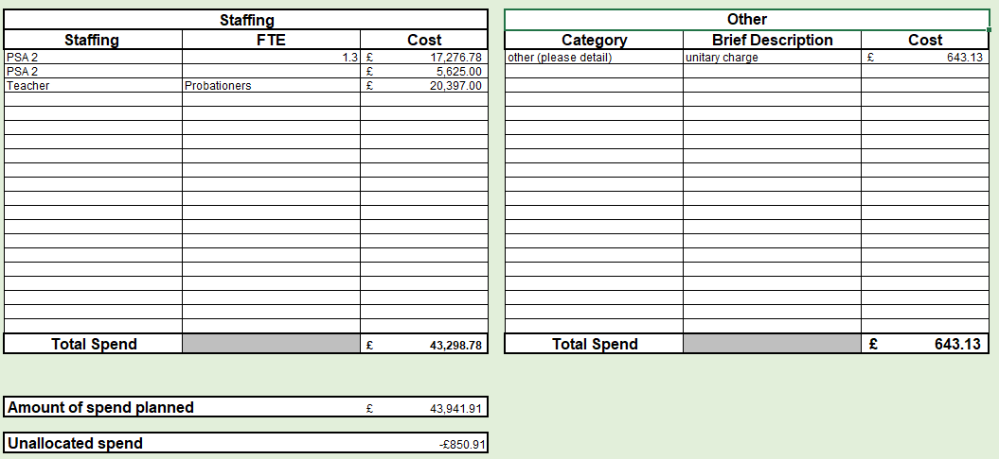

**Appendix F**

**Measure of Success – QI Methodology**

Quality improvement is about**giving the people closest to issues affecting outcomes the time, permission, skills and resources they need to solve them.** It involves a systematic and coordinated approach to solving a problem using specific methods and tools with the aim of bringing about a measurable improvement.

A few suggested approaches to consider are :

|  |  |  |
| --- | --- | --- |
| **Approach** | **Description** | **Visual** |
| Model for Improvement | Rapid cycle process involving Plan, Do Study, Act (PDSA) cycles to test the effects of small changes, make them and ultimately spread the effective changes through the system if they have the desired effect. | A visual diagram of a Plan-Do-Study-Act (PDSA) Cycle | Download Scientific  Diagram |
| Visible Learning – Impact Cycle | Gather and consider/analyse evidence/data to determine a focus, introduce an idea or element to your practice and measure the impact that it has based on evidence. | Education Sciences | Free Full-Text | Implementing High-Leverage Influences  from the Visible Learning Synthesis: Six Supporting Conditions | HTML |
| Practitioner Enquiry/professional Enquiry Process |  | The Flow Inquiry of Practitioner Enquiry | Download Scientific Diagram |