# Generated image

**Fresh Air Frankie’s**

**School Travel Plan**

School: St Leonards Primary School

Headteacher: Kirsty Muir

School address: St. Leonards Street, Dunfermline, KY11 3AL

Telephone No: 01383 602434

Social Media/Website: [Website](https://blogs.glowscotland.org.uk/fi/stleonardspsdunfermline/)

**Contents Page**

**3: 1.0 WHY HAVE A SCHOOL TRAVEL PLAN**

**3.: 2.0 BENEFITS OF HAVING A SCHOOL TRAVEL PLAN**

**4: 3.0 Current Travel Habits**

**3.1 Family Questionnaire Data**

**8:** **4.0** **ROUTE AUDIT OF KEY ROUTES TO SCHOOL**

**4.1 Access Arrangements**

**12:** **5.0** **ACTION PLAN**

**13:** **6.0** **MONITORING AND EVALUATION**

**13:** **7.0** **DISTRIBUTION OF SCHOOL TRAVEL PLAN**

**1.0** **Why have a school travel plan**

School-related traffic congestion and the risks congestion pose to the safety of the pupils, teachers, parents, residents, and motorists in and around school locations is a significant problem in communities around Fife.

The most obvious cause of traffic congestion around our schools is vehicles, and the biggest source of those vehicles is parents’ dropping off and picking up their children from school.

Statistics highlight that 1 in 4 cars during the hours of 8:30 to 9:15 and 2:30 to 3:15 is primary school traffic.

Encouraging active travel—such as walking, cycling, or scooting to school—offers children a healthier, more energising start to their day. It helps improve physical fitness, boosts mood and concentration, and reduces traffic congestion and pollution around school gates, making the environment safer for everyone.

Fife Council’s Road and Transportation Service are working with schools in Fife to develop School Travel Plans; a practical framework to promote sustainable travel and address barriers families may face by supporting Frankies Active Campaigners Team (FACT) to lead activities, raise awareness, and celebrate progress. These initiatives empower children to take pride in their choices and inspire others to get moving – making active travel a positive part of everyday school life.

**2.0** **BENEFITS OF HAVING A SCHOOL TRAVEL PLAN?**

The benefits of encouraging active travel are clear and a school travel plan can ensure that your school has a long–term vision with aid to support your FACT group with delivering campaigns that will;-

* Improve health and well-being by reducing harmful emissions and increasing activity levels.
* Improve safety through engineering measures and increasing road safety education.
* Improve access and opportunity by developing pupils’ skills for safe and independent travel.
* Improve the environment by reducing pollution and CO2 emissions.
* Gain school accreditations such as Fresh Air Frankie STP Awards, Active School Award and Eco Schools.

All work associated with School Travel Planning has been designed to fit into the Curriculum for Excellence.

**3.0**  **CURRENT TRAVEL HABITS**

Each year all Fife schools undertake the hands up survey which gives a true reflection of how pupils are travelling to school, and the 2024/25 results show that 58% of pupils are actively travelling to school. However, with over 36% still being driven to school the school must remind parents of their responsibilities around the school gate.

The school are unable to commit to creating a FACT group at this time but will consider this for the future.

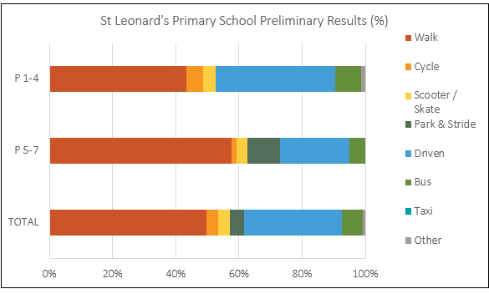

**3.1 Family Questionnaire**

The school created their own questionnaire, and the following diagrams highlight the data received from those families who took part.

**How does your child/children normally travel to school?**

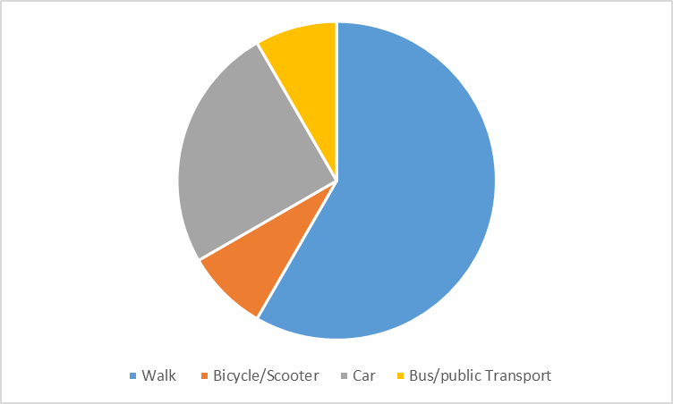

**If you selected car, please indicate your reasons for driving your child to school and/or nursery.**

* Work commitments
* Work commitments; Distance from the school/nursery; My son goes to school club and is picked up others, so we use both walking and transport
* My and my child's health conditions
* Disability
* Ensuring the safety of my child/children
* Distance from the school/nursery
* Distance from the school/nursery
* Ensuring the safety of my child/children
* Distance from the school/nursery
* Work commitments
* Ensuring the safety of my child/children
* Distance from the school/nursery
* Work commitments
* Convenience; Ensuring the safety of my child/children

**What would improve your child's journey to school or nursery**

The majority of those who answered this question stated that

* their journey would improve if they had increased designated parking/pick-up/drop-off points.
* Less traffic congestion
* Wider speed restrictions
* Improved and additional crossings
* Improved/additional walking paths and cycling paths

**Improved/additional walking paths and cycling paths.**

* The crossing between the school and bus garage is very busy in the morning with buses and cars going in and out of the junction.
* Main road at Hospital Hill
* The crossing with extra lollipop person
* St Leonard Place
* Jennie Rennies Road
* We are coming from Pitbauchlie Bank and honestly there is no crossing which changes in reasonable time from red to green after pressing the button. It only entices children to cross on red or they will be late from school if they wait until it finally swaps to green. There is not a single crossing over Queensferry Road that we can cross in one attempt. If you try to cross you always stuck in the middle between high traffic. To be honest it is highly unsafe. We would need maybe a pedestrian bridge
* The traffic lights crossing from Asda are frequently broken, this need replaced. The sun glare on the Asda side from January to August means many drivers pass through at green even when they are working. The next road leading to the bus station is also very busy, with many people taking the corner at speed getting annoyed with children crossing when they have not even indicated in good time.
* The opening to Dunfermline high on Jennie Rennie’s Road. High school traffic does NOT stop for children to cross there.
* Zebra crossing outside val-u-blinds or traffic lights . Disabled space.
* Both the double crossing on st Leonard’s street, and also the crossing outside of the primary school. Also the area outside of the pub, on st Leonard’s street where cars often drive on the pavement, park on the pavement, and drive out onto the school crossing. All these areas are very dangerous.
* Lolly pop lady at junction to bus station, kids run a cross road without looking and buses pulling in constantly
* Crossing at St Leonard’s Asda.
* Crossing officer at both sides of road opposite Kwik Fit
* St Leonard’s Street
* Hospital hill
* The crossing from the olive garden pub to the school side. There is no pedestrian crossing apart from the lollipop woman and when it’s super busy we have to cross the road further up as it’s so busy.
* In back of school

**If you have selected wider speed restriction area, please indicate where you feel this could be put in place.**

* Hospital hill. The speed of the traffic going up and down this road in the morning should be significantly reduced and flashing signs need to be installed before someone dies. I cross both crossings everyday and see people speeding every day!
* Hospital Hill to Asda
* At every crossing near school
* St Leonard Pl
* St Leonards Street
* Next to the school
* Any area around a school could be 10 mph, from Hospital Hill to Nethertown Broad Street.
* Main road
* All of St Leonard’s street must be speed reduced for safety at pick up and drop off times.
* Coming into bus station
* The whole of St Leonard’s street.
* From Asda up to traffic lights beside Everest should be 20 during school drop off and pick up times
* From Bothwell roundabout
* Dual carriageway hospital hill next to traffic lights
* Hospital hill
* In back of school

**Is there anything else you would like to tell us about your journey to school and nursery in relation to safety of travel.**

The crossing patrollers do a great job but without speed restrictions and possibly even speed cameras on this road it is not going to improve. I walk my children to school everyday as I don’t trust the cars on the road.

The traffic lights at the bus depot just along from the school are constantly breaking and this makes it unsafe to cross at times because they are not repaired quickly enough.

Overall I feel the school and crossing patrol are doing all they can. It is the busy road and speed that is more the issue. Speed restriction and making drivers more aware of children crossing the road I think will help.

You need to look and be alert for any car coming

There are a lot of risk around but mainly to educate students at school about safety and running across the street.

School buses make it harder to cross to get to school/Nursery on time, should be a crossing guard on Jennie Rennies Road, a lot of children and families cross there morning and night

It is highly unsafe due to the high traffic volume on Queensferry Road. It is just matter of time when it happens again

Cars mounting the pavement at the school gates continues to be an issue. Kids cannot be seen when crossing. People leaving the bus station and at times the school car park can be very frustrated and continue to push through rather than wait 2 minutes, this is even more of an issue when there are buses going in either direction.

I do not walk my child to school anymore as I do not feel safe doing so. There is drivers speeding, going through red lights, driving on the pavement, driving out onto the school crossing and parking dangerously. It’s a mess.

Crossing at St. Leonards Asda often isn’t working, extremelyunsafe for crossing with young children.

Even with pedestrian crossings our walking journey to school could be improved with reduced speed areas and lollipop people at crossings every day

The traffic lights to work near little Asda’s as when they are out it’s very dangerous.

From Asda traffic light people

During the winter months the council need to do better at gritting the pavement down at Leonard’s street

**3.2 Staff Questionnaire**

At the time of updating the travel plan a staff questionnaire was not completed.

**4.0 MAPPING WORK AND ROUTE AUDIT**

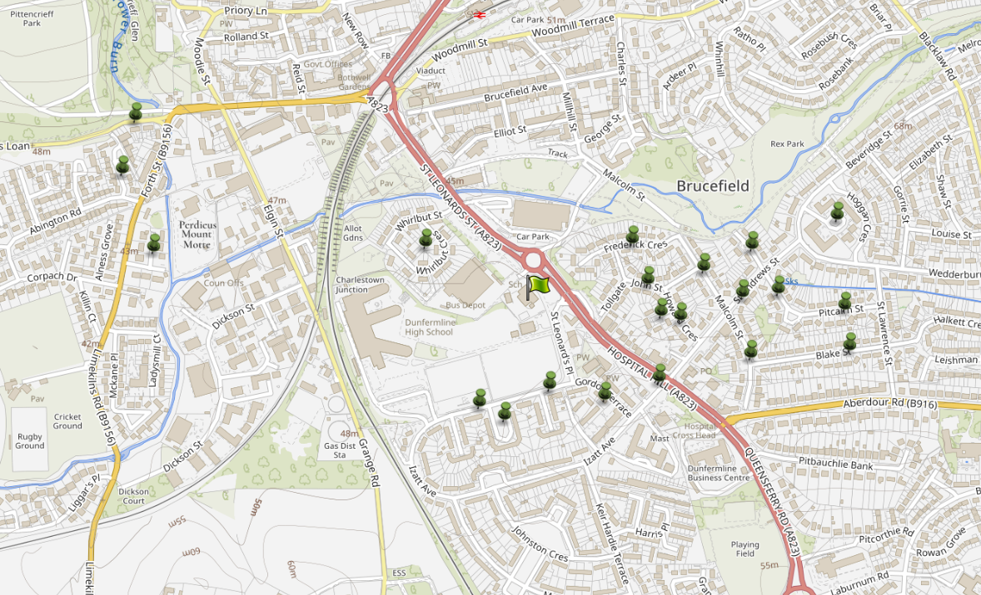By analysing the geographic distribution of pupil addresses who live within the catchment area, we identified key clusters and common travel corridors that assisted in creating a strategic map of routes that prioritise safety, accessibility and connectivity to the school using existing infrastructure.

**Route Audit Report: Catchment Area**

**Overview:**  
This audit assesses the pedestrian infrastructure and safety features along key routes to school within the residential area east of the school. The area benefits from wide pavements, adequate dropped kerbs, and traffic calming measures including 20 mph speed zones. This route includes a transition from the residential zone to a busier main distributor road with an increase in the speed limit.

**Key Findings:**

1. **Pavement Quality and Width:**
   * Pavements throughout the area are consistently wide, allowing for safe passage of children, parents, and mobility aid users.
   * Surfaces are generally smooth and well-maintained, with minimal trip hazards or obstructions.
2. **Dropped Kerbs and Crossing Points:**
   * Dropped kerbs are present at all major junctions and crossing points, supporting accessibility for wheelchairs, pushchairs, and visually impaired pedestrians.
   * Tactile paving is in place at most crossings, enhancing safety for visually impaired users.
3. **Traffic Calming and Speed Limits:**
   * The 20 mph speed limit is clearly signposted and contributes to a safer environment for school children.
   * Residential streets show evidence of traffic calming features such as speed humps and narrowed carriageways.
4. **Visibility and Lighting:**
   * Street lighting is adequate along main routes, ensuring visibility during early morning and late afternoon travel times.
   * Sightlines at junctions and crossings are generally clear, reducing the risk of vehicle-pedestrian conflict.
5. **Transition to Main Distributor Road (30 mph):**
   * One key route exits the 20 mph residential zone and joins a main distributor road with a 30 mph speed limit.
   * This road experiences higher traffic volumes and speeds, presenting increased risk to pedestrians.
   * Pavement width remains adequate and although crossing points are less frequent they are managed by signalised crossing points.
   * Visibility at junctions and crossing points are good.
6. **Signage and Wayfinding:**
   * On day of undertaking the online route audit no “school2 street signage was visible

**Conclusion:**

While the main distributor road is a necessary part of the school route network, it does presents significant safety and comfort concerns for families as outlined in the online questionnaire findings.

These concerns have been raised with Fife Council Traffic Management team for further investigations

Pupils who live out with catchment

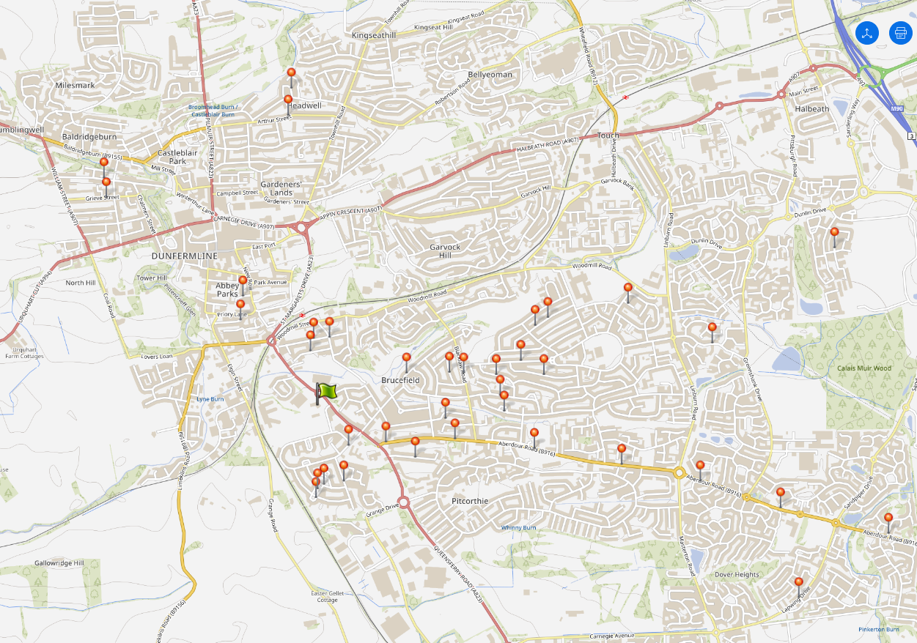

**Key Problems Identified:**

1. Increased Traffic Congestion:
   * Out-of-catchment journeys often involve longer travel distances, contributing to higher volumes of traffic around school gates.
   * This leads to congestion during peak times, affecting residents and other road users.
2. **Parking Pressure and Safety Risks:**
   * Limited parking near schools becomes overwhelmed, resulting in illegal or inconsiderate parking on pavements, junctions, and driveways.
   * This creates safety hazards for children walking or cycling and reduces visibility at crossings.
3. **Reduced Active Travel Participation:**
   * High volumes of car traffic discourage walking and cycling, particularly for families living within the catchment area.
   * The environment around the school becomes less welcoming and more stressful for those choosing active modes.
4. **Environmental Impact:**
   * Longer car journeys contribute to increased emissions and air pollution around schools.
   * Idling vehicles during drop-off and pick-up times exacerbate this issue, affecting children’s health.
5. **Undermining Local Travel Planning:**
   * School travel plans and active travel initiatives are less effective when a significant proportion of pupils arrive by car from outside the area.
   * It also complicates efforts to implement safety measures like walking or cycling buses.

**Conclusion**

While out-of-catchment enrolment is sometimes necessary, the associated car use presents significant challenges to safe and sustainable school travel. A coordinated approach involving schools, parents, and the school travel plan team is essential to mitigate these impacts and support active travel for all pupils. Parents have access to 2 main car parks across the road from the school which should be promoted as a Park N Stride site.

**4.1 Access Arrangements**

The school consists of two main buildings. The third building is a purpose-built nursery located in its own garden area. Controlled entry systems are in operation. There is a staff and visitor car park, which is accessed from St. Leonard’s Street with 20 designated spaces.

Yellow lines prohibit parking at the entrance to the car park and school. There is storage provision for bicycles and scooters within the school playground.

The school is adjacent to the dual carriageway at Hospital Hill and to St. Leonard’s Place which can become very congested at the beginning and end of the school day.

Children who travel to school by taxi are dropped off in the school car park.

The school bus parks in a designated place on St. Leonard’s Place.

**Parents dropping off pupils are asked to consider not parking on St. Leonard’s Place. They are asked to park further away from school and walk. Parents can use the public car park on the opposite side of Hospital Hill which has 24 spaces or park in the nearby Asda Car Park.**

**5.0** **PROPOSED** **ACTION PLAN**

|  |  |  |
| --- | --- | --- |
| **Action** | **Solution** | **Action Owner** |
| Promote School Travel Plan | * Upload plan to website and social media pages. * Create a FACT notice board. * Upload generic social media posts throughout each term. * Keep the school travel plan team updated on all work carried out by completing your FACT floor book. | School |
| Fresh Air Frankie Awards Campaigns | **Term 1**  Hands up Survey Active Travel  FACT Assembly about Active Travel Month  Send out generic Social Media Posts  Active Travel Month (distribute and collect Fresh Air Frankie  Travel Passports)    T**erm 2**  Launch #dontparkhere Campaign  FACT Assembly  Send out generic Social Media Posts  Road Safety Week  T**erm 3**  Frankie’s Step into Spring Campaign  FACT Assembly  Big Walk and Wheel    T**erm 4**  FACT Assembly about Active Travel Month  Send out generic Social Media Posts  Active Travel Month (distribute and collect Fresh Air Frankie  Travel Passports) | School – full details held within your FACT folder |
| Reduce congestion | Consider developing the following:-  Parking Pledge  Walking Bus  Campaigns to increase active travel to school. | School – full details held within your FACT folder |
| Bikeability | Deliver Level 2 Bikeability and apply for Cycle Friendly School Award | School/Bikeability |
|  |  |  |
| Annual Active Travel Award | Top 3 schools that can showcase the largest increase in Active Travel to School will be crowned champions. Data will be collated from the HUSS and our own travel tracker. | School/Travel Plan Team |

**6.0 MONITORING & EVALUATION**

At the time of updating the travel plan the HT stated that due to shortages of staff that the school would not be setting up a FACT group and carry out the work proposed in the action plan above. Specific progress will be monitored by participation in the “Hands Up Travel Tally” each year and a repeat of the full travel survey will take place in 2031/32.

However, it is suggested that the school’s commitments to reminding parents about their responsibilities while doing the school run and that pupil safety around the school gate is a priority.

**7.0 DISTRIBUTION OF SCHOOL TRAVEL PLAN**

The following bodies will receive a copy of the School Travel Plan:

• Fife Council Sustainable Transport and Travel via the Travel Plan Team

• Fife Council Education Service

• Parent Partnership

• Copies will also be made available to the parents from the School Office and via

the school information sites.