Be READY TO LEARN by:  - Showing the 5 Listening Skills  - Have Everything I Need  - Using ‘One Voice’  - Be Safe | 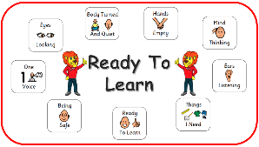
Go OVER and ABOVE by:  - Always being Ready to Learn  - Aspiring to be an  Outstanding Leo Learner | 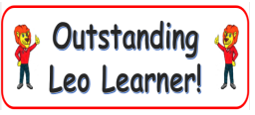
KEEP IT GREEN by:  - Making good choices | 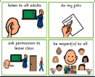
Positive Relationships Policy
St Leonard’s Primary School
Updated 2023-2024

All children at St Leonard’s should:

If children are NOT Ready to Learn (or not Keeping it Green), they are encouraged to:
STOP AND THINK  - Reflect on your choices to help you be Ready to Learn | 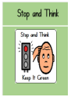
Take TIME TO THINK  - 5 minutes to think about your choices (in class/at ‘quiet’ area or at break time) to allow you to be Ready To Learn | 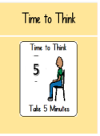
Take TIME TO TALK  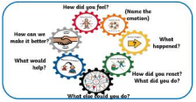  - At break time, using the Restorative Discussion framework | 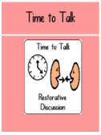

3 Times to Talks = a call home by Class Teacher.
If this continues, SLT arrange a meeting with parent/carer to discuss next steps.

