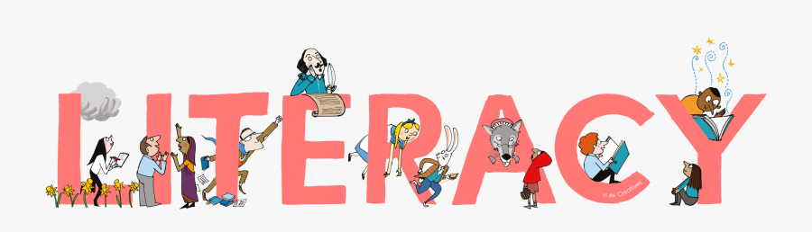
P5 Home Learning
Literacy

Spelling  Silent letters  https://www.youtube.com/watch?v=ss9r236LRcw  Task 1:  Using a book of your choice to try and find words with silent letters. Is there one ‘silent letter’ that is more common than the others.  Task 2:  Write 5 sentences using some of your words. Try and use more than one in each sentence.  Each sentence must include a connective e.g. but, and, although, so, however, therefore | Reading  Who is Roald Dahl?  Task 1:  Find out about Roald Dahl  by visiting his official website.  https://www.roalddahl.com/roald-dahl/about  Task 2:  Research as many facts as you can about Roald Dahl and present these in one of the following ways:  PowerPoint  Fact file  Poster  Task 3:  Design a new cover for one of his books.  Include an eye-catching illustration, title, author and blurb.  Use google images to give you ideas. | Handwriting  Size and height of letters  Task 1:  Roald Dahl created many wonderful characters.  Find the names of 10 characters.  Carefully write these character names making sure each name starts with a capital letter and all letters are the correct height.  Task 2:  Copy out and illustrate one of Roald Dahl’s or one of his character’s inspirational quotes.  e.g :  A little nonsense now and then is relished by the wisest men. (Willy Wonka)  If you have good thoughts they will shine out of your face like sunbeams and you will always look lovely.  (Roald Dahl)  Illustrate your quote. | Grammar  Adjectives  Watch this video clip to remind yourself what adjectives are:  https://www.youtube.com/watch?v=94cdAyyPj3Q  Task 1:  Remember:  - An adjective is a describing word.  - Adjectives give us more information about nouns.  - Adjectives make sentences more interesting.  Look out of your window. Write down 10 things you can see. Now choose an adjective(s) to give more information about the noun.  e.g. emerald green grass or golden rays of sunshine.  Task 2:  Write a paragraph describing one of Roald Dahl’s characters.  Use adjectives to describe the character’s appearance (what they look like) and personality (what kind of person they are). | Writing  Read all about it!    This Photo by Unknown Author is licensed under CC BY-NC  Task 1:  Watch an episode of this week’s Newsround, you will find it on the CBBC website.  Which story caught your attention? Can you write a newspaper report about it?  Remember:  - Eye catching headline  - Stick to the facts  - Use a report layout  - Include a quote from someone in the story  - Put in 1 or 2 pictures  Task 2:  Make up 5 interview questions for someone featured in one of the news stories you watched.  Include a brief description of what the news story was about as well as information about the person, including their name.

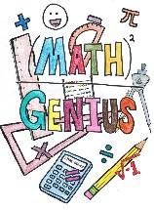
P5 Home Learning
Maths

Money  It’s Your Birthday!  Task 1:  Plan a party for you and your family. You have a budget of £30. Go online to your favourite supermarket and make a list of items for your shopping basket e.g. crisps, popcorn, juice, ice cream.  - Find the total of your basket.  - How much change from £30?  Task 2:  - Compare the cost from a different retailer. Is it any cheaper?  Challenge Task:  - Explain why is budgeting important? | Number Patterns  Task 1:  https://www.youtube.com/watch?v=d51bsZwPKVw&pp=QAA%3D  Find out how to work out the missing numbers in a sequence. Pause the video and work out the missing numbers. What is the rule?  Now try these:  Remember to write the rule  34, 42, 50, __ , 66, __, __  129, 121, __, 105, __, __  299, 304, 309, __, __, __  432, 428, 424, __, __, __  989, 999, __, 1019, ___, ___, ___  1754, 1764, __, __, 1794, __, __, __  3, 6, 12 , 24 __, __, __, __, __  4, 12, 26, __, __, __, __, __  Task 2  Create your own number sequences.  Write down the rule.  Task 3  Create your own missing number sequences. Give it to someone else to solve. Were they correct? | Measure  Fanatical About Film!  Task 1:  Look at the Odeon Cinema’s website.  Look at this week’s film showings. Write down the name of each film and it’s duration in minutes.  Now convert the minutes into hours and minutes.  e.g. 150 minutes = 2 hours and 30 minutes.  Task 2:  Choose one film with more than one showing. Calculate what time you would leave the cinema after each showing.  Challenge Task:  Convert the 24 hour start times into 12 hour times.  Remember to use am and pm. | Shape  3D Shapes  Task 1:  Learn about 3D shapes  https://www.youtube.com/watch?v=his3cU-kslc  Identify and describe 3D objects within your home and garden and explain why their properties match their function.  Task 2:  Design an alternative packaging for one of your identified objects, ensuring it is able to meet it’s required function. | Multiplication  Speed Test  Task 1:  Practise your most challenging times table by writing it down 3 times, saying it out loud 3 times, covering the answer and testing yourself.  Now set a timer for 1 minute and ask a family member to quiz you on your table non-stop until the time is up.  How many questions did you answer correctly?  Set the timer again and try to beat your total.  Task 2:  https://www.topmarks.co.uk/maths-games/hit-the-button  Google the Topmarks website online and try a game of Hit the Button with your most challenging table then with a mixture of all tables up to the 12 x table.




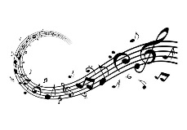

Music  Charlie and the Chocolate Factory  Task 1:  https://www.youtube.com/watch?v=wEAQkYE5dTk&list=PLPZa9eVNFzn_R5u_HF6hRHNkcybou9CBn  Click on the link to listen to the soundtrack to Charlie and the Chocolate factory.  Which song is your favourite and why?  Task 2:  Choose two of the songs that make you feel different emotions.  Explain the reasons for your choice.  Extra Challenge  Listen to your favourite song again. Name some of the instruments you can hear. | French  Your Family  Task 1:  https://www.youtube.com/watch?v=L5-3kpXaEi4  Watch the video to help you say the names of family members in French.  Draw your own family and label each person with their French title.  Task 2:  Watch the video again to practice phrases that include family members. | Science  All about Chocolate  Task 1:  https://www.youtube.com/watch?v=WV_FT9ACA4U  Find out as much as you can about chocolate by using the kink above.  You might need to watch the video a few times as there is a lot of information.  Describe the different processes chocolate goes through before it becomes a bar we can eat.  What do the percentages mean on the chocolate bar labels?  Task 2:  When we use chocolate in a recipe it can change state.  Solid to liquid by melting.  Powder to liquid by dissolving.  Find a recipe that includes chocolate changing state process.  Write down the recipe or even better have a go at making it and enjoy a tasty treat. | Art & Design  Drawing in the style of Quentin Blake  Task 1:  Quentin Blake illustrated nearly all of Roald Dahl’s books.  You can learn to draw in his style by following the tutorial below.  https://www.youtube.com/watch?v=aZJm6QXSOP4  Task 2:  Draw yourself as the winner of a sixth Golden Ticket in the style of Quentin Blake. | HWB  Fitness  Task 1:- (DAILY!)  Choose a different Joe Wicks workout to do with your family every day.  These workout can be found on YouTube by search for Joe Wicks workouts.  Task 2:- (DAILY!)  Walk, jog or cycle with your family.  Challenge yourself to increase your daily distance and improve your fitness and stamina  Task 3:  Help to plan a healthy snack or meal with your family.  Draw or photograph your delicious efforts.

