Achieving Excellence
and Equity
St John’s RC Primary School

Standards & Quality Report 2022-2023

School Improvement Plan
2023-2024
Shona Munro-sc

St John’s RC Primary School

Standards and Quality Report
Achieving Excellence and Equity

Context
Setting/School Roll  (including ELC/ASC) | 214  8 Classes
FME | 44
Attendance Stretch Target 94.4%  Actual Attendance 91.2% | Authorised | 5.63% | Unauthorised | 3.17%
Exclusion (%) | 0%
Attainment Scotland Fund Allocation (PEF and SAC) | £39 253

St. John’s RC Primary is a Roman Catholic denominational school located in the town of Rosyth. It has a roll of 214 pupils arranged in 8 classes within two open plan wings. The single storey school building opened in 1988 replacing the original school which was located beside our church at the Crossroads in Rosyth.
Our catchment area is wide and varied serving Rosyth, Inverkeithing, Hillend, Dalgety Bay, Aberdour, Limekilns and a growing area of the Dunfermline Eastern Expansion. Our SIMD data ranges from 2-10 averaging at SIMD 3.
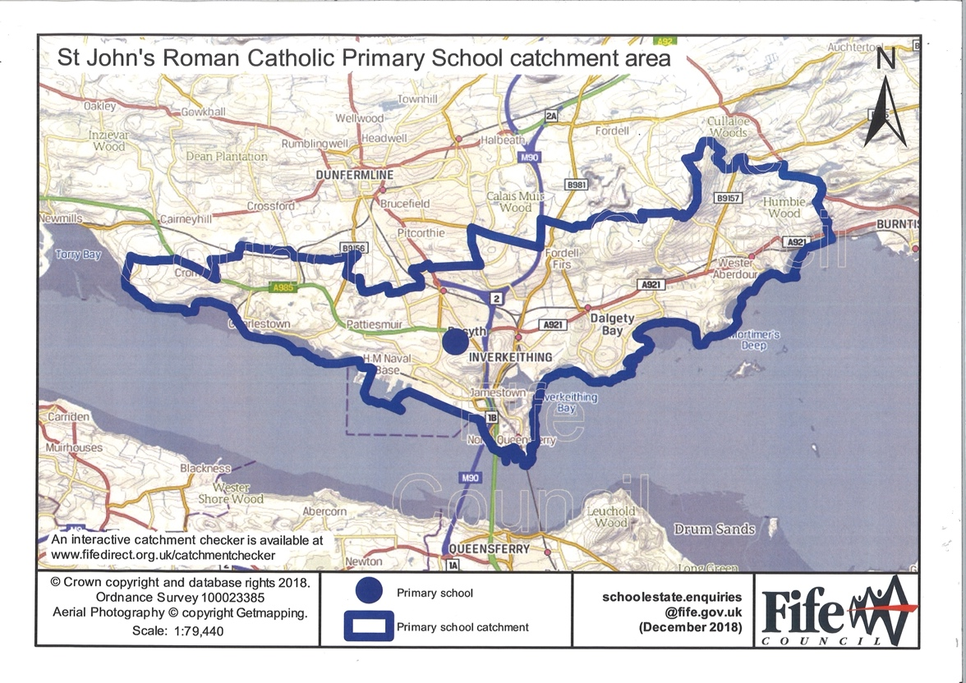

School Population 2022/2023
Number of Pupils 214
FME | 44 | 20.56%
SIMD 2 | 4 | 1.86%
SIMD 3 | 25 | 11.68%
ASN | 18 | 8.41%
EAL | 28 | 13.08%
Young Carers | 4 | 1.86%
Armed Forces | 11 | 5.14%
Minority Ethnic Population
54 pupils
White Other | 28 | 13.08%
BAME | 26 | 12.14%
Total | 54 | 25.22%
Roman Catholic Pupils
49 Pupils

22.89%

The senior management team consists of the Headteacher Mrs Munro and Principal Teacher Mrs Thomson. In addition to 8 class teachers, we have an ASN allocation of 0.5FTE, a NCCT allocation of 0.94 FTE, an additionality teacher of 0.6 FTE, one full-time PSA, two full-time PEF funded PSAs, one full-time PSA funded from school and PEF, one PSA with 20 hours funded from our Classroom Assistant budget , a woodwind instructor, 1 full time admin and 1 part time clerical assistant (9 hours), 1 janitor, 4 catering and two cleaning staff.
We are committed to working in partnership with all parents/carers and partners and have established strong communication links between home and school and the wider community.
The school roll for academic session 2022/23 was 214 pupils

Shared Vision, Values and Aims

We worked collaboratively with the St. John’s Community when we revised our Mission, Vision, Values and Aims in the academic session 2022/23.

Our St. John’s Mission Statement
At St. John’s we educate and encourage pupils to respect and show kindness to each other celebrating diversity, our faiths, and successes,

Our St. John’s Vision Statement
Inclusion is important at St. John’s.
We strive to make people feel loved, respected, safe and a part of our diverse school community.

The 5 core values for St. John’s school are:

FAITH RESPECT KINDNESS ACHIEVEMENT INCLUSION

These values are highlighted within each class charter and are regular features of our weekly Assemblies when Wonderful Workers and Stars of the Week are celebrated

We will:
- Provide a positive ethos in which everyone feels valued, putting the child at the centre of the curriculum.
- Conduct our business adhering to the Gospel Values of integrity, fairness, and trust; showing care and mutual respect that underpins our Roman Catholic ethos.
- Value diversity, promoting social inclusion, in an environment where everyone is welcome.
- Seek progress through partnership, working closely with people with whom we share a common purpose.

We are aiming to ensure excellence by building capacity in teachers, pupils, and partners to achieve:
- High quality teaching
- High quality learning
- High quality engagement
- Equity for all

School aims
- We aim to ensure that all children achieve their potential, and they are achieving as learners.
- As a staff, we aim to work collaboratively, share good practice, and are focused on improvement.
- We aim to work effectively with partners to ensure that we are a nurturing school focused on achievement and equity for all.

Improvement Priority Session 2022-2023
Focused Priority 1:
Professional learning to deepen understanding and increase awareness of the need to challenge conscious and unconscious bias through a shift in pedagogical approaches and practice. This will include an increased focus on UNCRC and the Wellbeing Indicators.
NIF Priority  Placing the human rights and needs of every child and young person at the centre of education.  NIF Driver  Teacher and practitioner professionalism |  |  |  | HGIOS 4 Quality Indicators  - Self-evaluation for self-improvement  - Leadership of learning  - Leadership of change  2.2 Curriculum
Has this priority been:  (please highlight) | Fully  Achieved |  | Partially  Achieved |  |  | Continued into next session
Progress:
- Professional learning accessed via the Teams SIP tile and discussed during staff meetings- particularly relevant Applying Critical Reflection to Teaching Race and Racism- Stephen Brookfield
- Staff group created class learning (UNCRC SWAY) which was shared with the whole school resulting in a whole school learning and teaching approach. Ideas also shared as to how to create a relevant display to promote Diversity, Equality, and Inclusion. Continual focus in all Assemblies
- NCCT teachers have been supporting learning around the Wellbeing Indicators that has been further developed by the CTs.
- Working shared document populated by the CTs and NCCTs with relevant learning as we start to create a pathway. - ongoing now to align with E&Os
- CTs and SLT looking at Literacy resources- Black History Month had a literacy focus with CTs choosing relevant texts for their stage. Links to websites to support the choosing of the texts shared by HT.
- HT participating in the LA Equality Working Group- ongoing
- Assemblies are shared via Twitter and on our website to allow our whole school community engage with the ongoing learning. Assemblies have a focus on Inclusion, Diversity and Equality aligning with the Gospel values and Roman Catholic teaching ever present within a faith-based school.
- The Pupil Voice Group were asked how they felt we should refer to the pupils from a Minority Ethnic background. They didn’t want anything that could be viewed as further isolation and chose the inclusive “St. John’s Family’.
Feedback from LP Pupil Focus Groups:
- ALL equal
- Everyone is fairly treated; we help each and no-one is left out.
- Clear understanding of inclusion and diversity and what it means and that it is a good thing to have diversity.
- Displays, resources and materials help them to evidence their learning – ‘fascinating to be different’.
- Inclusion is one of our school’s values.
- Learning is threaded through activities such as class novels, Black History Month, art through culture, class charter, prayer, literacy, weekly assemblies which highlight the range of ‘people’ that make up humanity.
- UNCRC articles are known across the school at appropriate levels.

Feedback from LP Staff Focus Groups:

- Staff shared the journey they had been on and how their practice had changed.
- More aware of the resources they use to ensure all children see themselves in their learning and have been ruthless about those they will now abandon.
- Professional reading and subsequent discussions made them aware of their own unconscious bias.
- All staff have engaged fully with the priorities taking ownership of how this will look within their own class setting- resources, books, displays in class and around the school.
- Diversity charters that include the pupil voice.
- Parental involvement through surveys and focus groups.
- Creation of pathway to ensure this work is ongoing and embedded.

Impact:

- Most children are engaging in dialogue around what is appropriate/not appropriate when discussing diversity and inclusion.
- Most children without being prompted are demonstrating their knowledge and understanding of diversity and inclusion in their learning (in Writing)
- Most children are aware of the importance of diversity and inclusion.
- Most children are naturally using skin tone pencils to represent the wide range of nationalities in our St John’s family.
- Most children are confident to call out racism when they witness it.
- Most children are aware of their rights and refer to them, most children know that they all have the same rights.
- All children have access to a wide range of diverse texts in their class libraries and through planned learning activities.
- Learning showcased to the wider community during Sharing the Learning session 17th May 2023.
Enjoyed hearing about the shared focus of school -Diversity and Inclusion.
P4 parent

Evidence of impact:
Love the learning about diversity.
P6 parent

Great to see learning about diversity- Well done
P6 parent

I find learning about equality and diversity important to me.
P4 pupil in jotter feedback sheet

N was a great tour guide. It is great to see all his fav. things he talks about to us. The way all the different cultures and skin tones in the class are celebrated is amazing!
P1 parent.

Email:
Hi Mrs Thomson, Mrs Munro,

Hope you are both well. Quick note to say that it was great to see the extensive work that the school has been doing with regards to inclusion and belonging whilst at Sharing the Learning last week. The way various children were openly discussing the skin tone colouring pencils they'd be using for their drawings as well as all the work previously done that adorned the walls.

We appreciate the work being done by the school and whilst we won't be around after this year, it's a positive thing knowing that lots of other children (regardless of their ethnicity), will benefit from it all.

Kind regards,

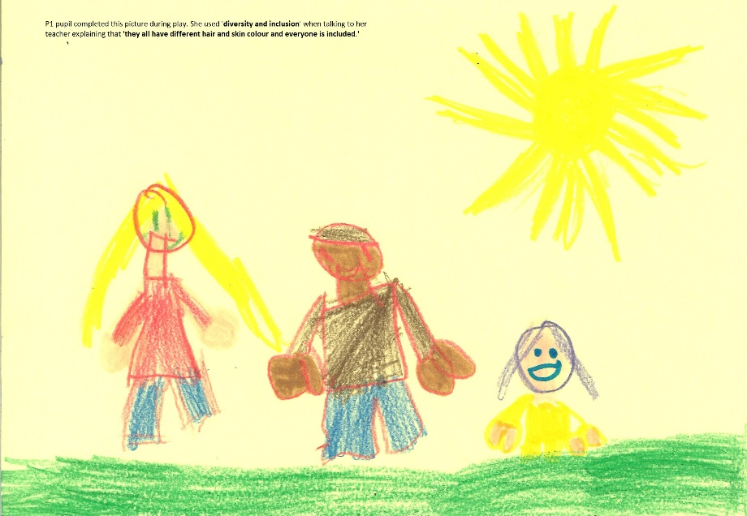

Next Steps:
Staff Perspective:
- This work will never be completed and will be an ongoing priority in the Academic session 2023/2024.
- Develop further to include other protected characteristics including gender, neurodiversity, religions.
- Work towards accreditation with UNCRC.
- Sharing our ongoing journey with the Probationer Service.
- Use and continue to populate our Learning Pathway aligning with bundled E&Os.
- Address the challenge of our Catholic faith and some aspects of diversity inclusive of the nine protected characteristics.
- Continue to engage and work with parents to ensure a collective voice is heard.
- Make links with a local school to work collaboratively and share good practice.
- Link with LP schools who are at the start of this priority journey.

Pupils Perspective:
- Continue to reinforce in all aspects of the curriculum RME, Social Subjects and beyond.
- Make sure our new P1 entrants and families are aware of this continued focus.
- Refresh displays throughout the year to ensure they are relevant.
- Extend the learning to include disabilities and wellbeing.

Improvement Priority Session 2022-2023
Focused Priority 2:
Co-create a new vision, mission, and further enhance current core values to encompass inclusion at all levels with a particular lens on the protected characteristics.

NIF Priority  Improvement in children and young people’s health and wellbeing  NIF Driver  Parent/carer involvement and engagement  School and ELC improvement  School and ELC leadership |  |  |  | HGIOS 4 Quality Indicators  1.3 Leadership of change  2.7 Partnerships  3.1 Ensuring wellbeing, equality and inclusion
Has this priority been:  (please highlight) | Fully  Achieved |  | Partially  Achieved |  |  | Continued into next session
Progress:
- It’s Good to be Green in School Fantastic Five launched August 2022. Diplayed in all class areas and throughout the school.
- Learning and Teaching started with a SWAY shared with all class with relevant Talking Points to understand the purpose of a Mission and Vision statements as well as values and aims.
- Data from Talking Points was collated and used as a starting point.
- Using data 4 Mission and Vision Statements were created and a whole school community consultation process started. Parents views were sought during Nov. Parent Interviews as this would ensure most voices were heard. All staff were also consulted.
- Finalised Mission and Vision statements were shared towards the end of Nov. 2022 with the whole school community.
- Mission, Vision, Values and Aims are continually referred to during assemblies tying in with the teaching of Jesus, our Faith and the Gospel Values which feed into whole class learning. Assemblies continue to be shared as SWAYS to allow all the staff team to be aware of the learning and teaching. - ongoing
- New Logo introduced in Jan 2023 to encompass inclusion.
- Staff team created a Digital Charter SWAY which was shared with all class to aid the creation of in-class digital charters. The purpose is to emphasise what it means to be a digitally responsible citizen. – ongoing through the Digital Literacy priority in 2023/2024.
- Renewing Equality and Anti-Bullying Policies working with staff, parents, and pupils. The Equality Policy has hyperlinks to the SWAY learning undertaken within the school to be share the learning and teaching that the pupils have undertaken. – ongoing- Consultation T4
- Parents had been consulted on how they would like to be involved:

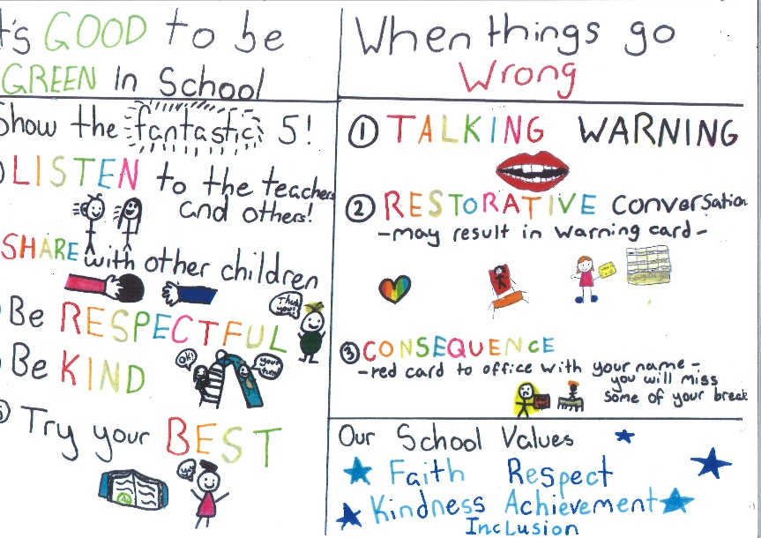

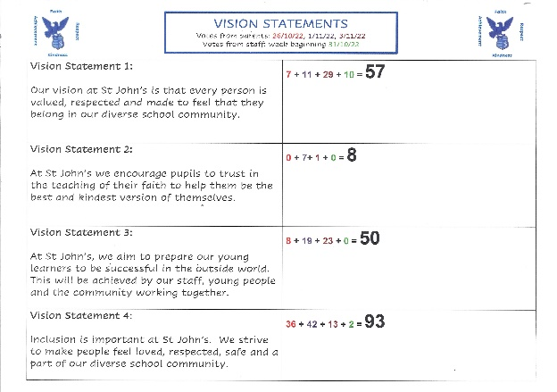
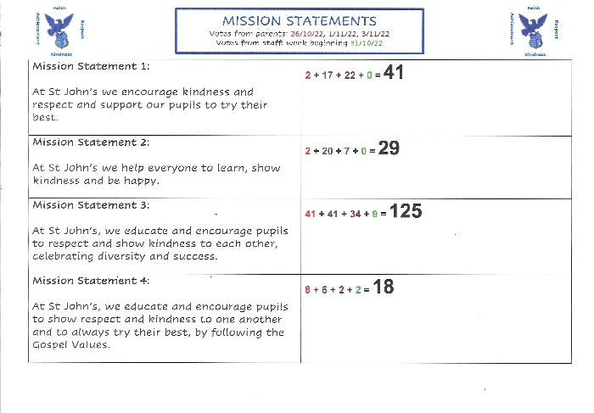

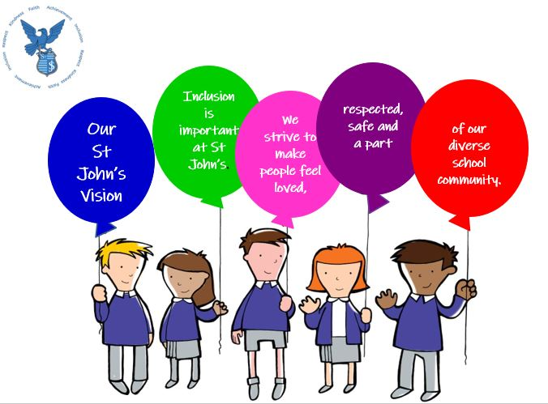
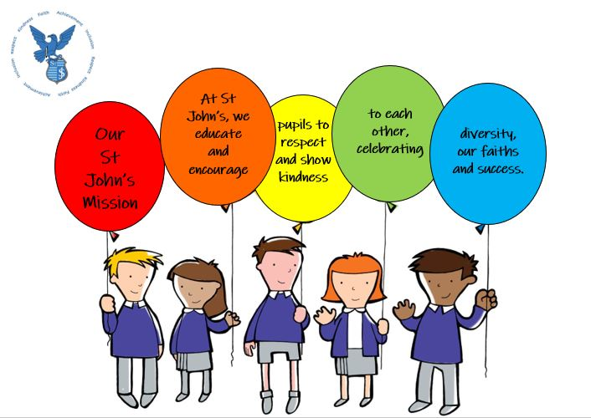

Impact:
- Most children are aware of our school values which encompasses inclusion.
- All classes have a Digital Charter on display and is referred to regularly.
- Most children can explain what it means to be safe online (appropriate to age and stage)
- Most children know the 3-step consequence system and accept when they have a red card consequence.
- Most children only require a talking warning or warning card before behaviour is turned around.

Next Steps:
- Share the policies with the whole school community following consultation with our parents.
- Discuss the policies with our pupils and how to re-imagine in appropriate child friendly language.
- This work will align with the work identified in Priority 1 to be continued into session 2023/24.
- Further develop Digital Charters with an emphasis on being responsible citizens. This will be included in the Digital Literacy Priority in academic session 2023/24.

Improvement Priority Session 2022 – 2023
Focused Priority 3:
To ensure high quality learning experiences for all pupils.
NIF Priority  Improvement in attainment, particularly in literacy and numeracy.  Closing the attainment gap between the most and least disadvantaged children and young people.  NIF Driver  Teacher and practitioner professionalism  Curriculum and assessment  School and ELC improvement |  |  |  | HGIOS 4 Quality Indicators  2.3 Learning, teaching, and assessment  1.3 Leadership of change  3.2 Raising attainment and achievement
Has this priority been:  (please highlight) | Fully  Achieved |  | Partially  Achieved |  |  | Continued into next session
Progress:
- Close link with Cluster Priority. PT leading on this.
- Linked to The Teaching Delusion 3 – Bruce Robertson
- Collection of data informed the area to take forward. Evaluative process to be repeated to measure impact. The feedback was on the whole positive however concerns around the effectiveness of the collegiate sessions were raised. Staff would prefer practical sessions to upskill and improve their own practice rather than being ‘talked at’. Having a choice of input to meet their own personal requirements was also highlighted. The opportunity to share expertise without the pressure of observations was also believed to be beneficial. This feedback will be acted upon both through our Digital Literacy Cluster and School Priorities in session 2023/2024.
- Collaborative Cluster Sessions led by DHTs and PTs. - (St. John’s input ‘Meeting Learner’s Needs)
- Working with our staff to create a Lesson Toolkit that ensure a consistency of approach throughout the school. Now to be accessed and used to inform practice.
- SLT created an audit tool to support the creation of positive and productive learning environment to ensure a consistent standard across the school. To be monitored to ensure the consistency that we are aiming for is apparent in ALL class environments.
- A focus at St. John’s was ensuring our pedagogies are culturally responsive and relevant to allow all our pupils see themselves within the curriculum. Development of Pathway - next step to incorporate relevant E & Os
- 4 members of staff working on writing using the Model for Improvement methodology- P2/3, P3/4, P5 and P7, making use of the Fife Writing Assessment Resources. This initiative is being led by our P7 teacher via the Assessment and Moderation team. - started in Term3
Progress on MfI
Challenging to commit to the marking system – too complicated for the children in infant and middle stages.
Placemats a successful tool to support children in their writing.
Children lost enthusiasm after a long period of time on one style of writing in the upper stages.
This feedback to be acted upon in session 2023/2024.

Impact:
- Most children can speak about their learning.
- All classes use the same learning ladder and learning pit – most children can say where were and where they are in their learning, and some can talk about their next steps.
- Most pupils can share the resources that help them learn.
- Most children can identify skills for learning, life, and work within lessons.
- Some children are referring to the skills in their reflective diary.
- Most children are keen to know what the learning intention is before the lesson begins.
- In some lessons ICT is used to support and challenge learners
- Across the school mini plenaries are used throughout lessons to check understanding
- Most children are active participants in co-creating the success criteria and use this to evaluate their learning throughout the lesson
- Almost all pupils are articulate and confident in talking about their learning and understanding of inclusion and diversity
Next Steps:
LP Feedback
- Ensure appropriate challenge and pace in all classes.
- Embed appropriate differentiation across the school through pedagogical approaches. i.e. whole class input moving to more individualised group learning to allow scaffolding to support all learners and challenge the more able.
- Make more use of WAGOLL to support scaffolding and challenge.
- Increase the pupil voice in displays.
- Embed AiFL strategies across the school.
- Ensure feedback is not generalised but specific to the success criteria.

- Following the feedback from our LP visit in March 2023 a focus for 2023/2024 will be to ensure appropriate challenge and differentiation with a particular focus on writing.
- Include a more robust programme of Assessment and Moderation linking in with the pilot by 4 members of our school team who made use of the Fife Writing Assessment Resources.
- Look to plan across stages within levels to ensure there is progression making use of the new planning format which includes E7Os and the Essential Indicators.
- Continue to develop the culturally responsive pedagogical pathway aligning the learning and teaching with CfE E&Os to ensure progression and relevance.

Attainment Information
The Scottish Government records CfE levels of pupils that have achieved a level at P1, P4 & P7. The grid below outlines the combined attainment levels for St. John’s RCPS in sessions 2019/20, 2020/21, 2021/22 and 2022/2023. These values demonstrate an increase within Reading but decreases in the other curricular areas.

Reading + 1.2% Writing – 1.5% L & T - 1.6% Numeracy - 5.2%
Data for P1, P4 & P7 combined
Academic Session | CfE Reading | CfE Writing | CfE Listening & Talking | CfE Maths
2019/2020 | 86.7% | 81.1% | 88.6% | 83.9%
2020/2021 | 85.5% | 87.5% | 84.6% | 83.6%
2021/2022 | 87.1% | 86.1% | 92% | 90%
2022/2023 | 88.3% | 84.6% | 90.6% | 84.8%

Although there are decreases from the previous academic year apart from reading, all show an increase from 2019 the last non-restricted academic year.

Attainment of a level data will need to be consistently monitored to ensure ongoing progress for all our learners. We will look carefully at the predicted dates and focus on the pupils who have been given extended periods for the achievement of their next stage of learning.

Our new school-based Records of Understanding will help us identify these pupils quickly.

We will adopt MfI, PDSA and Practitioner Enquiry models to ensure we are supporting these learners effectively.

Writing will be a whole school improvement priority throughout the 2023/2024 academic year.
Attainment Overview – June 2023

Stage | Reading | Writing | Listening and Talking | Numeracy
P1 | 89.6% | 82.7% | 89.6% | 82.7%
P4 | 82.7% | 79.3% | 86.2% | 86.2%
P7 | 92.8% | 84.6% | 94.8% | 89.7%
Whole school – June 2023 | 83.9% | 81.1% | 89.6% | 85.3%

Literacy |  |  | Numeracy
Stretch Target | Actual  P1/P4/P7  combined | Actual (Whole School) | Stretch Target | Actual  P1/P4/P7  combined | Actual (Whole School)
73.7% | 87.8% | 84.8% | 78.3% | 84.8% | 85.3%

CfE FME Attainment Data
Academic Session | CfE Reading | CfE Writing | CfE Numeracy
27 Pupils FME
2019/2020 | 70.3% | 70.3% | 74%
47 Pupils FME
2020/2021 | 83.9% | 78.7% | 63.8%
47 Pupils FME
2021/2022 | 85.1% | 80.8% | 91.4%
44 Pupils FME
2022/2023 | 61.3% | 56.8% | 68.1%
P1. P4, P7 combined- 16 Pupils FME
2022/2023 | 81.2% | 75% | 87.5%

From the table above the data shows a very different picture to 2021/2022. It is clear there is a great deal of additional work in the coming academic session to remove barriers. Staff will work towards supporting our FME pupils towards attainment of a level. The combined data for P1, P4 and P7 is more positive however data for the current P3 and P6 highlights the need for targeted support.

How are we working to address challenges / barriers to delivering National Improvement Framework Priorities?
To improve attainment, particularly in literacy & numeracy, we will continue to refresh our approaches to reading, writing, spelling and numeracy, based on what research tells us is best practice including delivering effective learning experiences digitally.

To improve children’s health & wellbeing we have continued to work with Child and Adult Mental Health partners to develop our understanding of how we best promote good mental health as well as having input from the Educational Phycologist team and ASIST to help us better understand ASD characteristics and how best to support these pupils within our own school setting.

We continue to develop our understanding of Adverse Childhood Experiences (ACEs) and offer small kitbag, Lego therapy and mindfulness activities and interventions for targeted groups and individual pupils to promote our children’s ability to talk about their wellbeing, emotions, and anxieties.
We have further developed a support nurture base for those pupils who, at times, find it challenging to access their learning within the class setting or find it difficult to regulate their behaviours. In session 2022/2023 we reassessed this provision to make it a restorative destination with clear activity and learning areas.

Our Relationship Policy has been continually monitored and improved with the pupils’ views being actioned as they felt the initial 5 steps where not appropriate. We now have 3 clear steps and the Fantastic Five ways of ‘How it’s Good to be Green in School’. A pupil version of the policy has been created and been shared with the wider school community as well as being displayed throughout the school.

Working towards closing the Attainment Gap between the Most and Least Disadvantaged Children and Young People we have used the data to inform and drive our decisions which has enabled us to be clearer about what changes are resulting in improvement. We will make better use of the Model for Improvement framework as a tool for teachers to employ to close any identified gaps. All our teachers will continue to plan small tests of change for specific targeted groups of pupils in each of our classes in literacy, numeracy, and wellbeing. Our adapted St. John’s RUs should significantly improve our identification of these pupils along with increased opportunities for planning and moderation across levels. Effective use of data from standardised assessment at P1, P4 and P7 will also support our declaration of achievement of a level at the expected rate.

Digital poverty has been identified as a barrier to attainment and we were able to provide those in need with a netbook to bridge that gap. Improving digital skills for both staff and pupils is an identified area for development in 2023/2024.
Evidence of significant wider achievements.

- In Term 1 all pupils engaged with Rookie Rockstars to deliver an energetic and engaging Inclusion/Diversity themed performance for our whole school community. These performances were during the school day and evening to allow as many families as possible be involved developing their communication and creativity skills.
- All pupils had the opportunity to further develop their performing skills through our P1-3/4 Christmas Nativity and P4-7 Christmas Concert and our whole school Scottish Celebrations in January, working collectively to bring our community together and further developing their confidence in presenting, collaborating and performance.
- P7 organised a hugely successful raffle for Macmillan Cancer Support working collaboratively whilst using their organisational skills.
- P6 have worked in partnership with the Parent Council to raise funds for our school through promoting our school community raffles. This activity helped them to develop their communication and collaborative skills as they worked as a team to organise the distribution of the prizes.
- Despite the challenges of this year, we continued to fund raise and highlight the work of various charities which included Poppy Appeal, Fairtrade, and SCIAF bringing alive the Gospel Values that are at the root of our Catholic’s Faith social teaching.
- During this academic year, our P4 -P7 learners have been given the opportunity to participate in Basketball, Badminton, Football and Mini Wimbledon Tournaments at local and cluster level promoting interpersonal and resilience skills.
- All classes have enjoyed visits to the Rosyth Orchard run by EATS Rosyth. This partnership will be ongoing in 2023/2024.
- Learning outdoors, health and wellbeing, physical activity, adventure education, team building, resilience, achievement and overcoming fears were developed during the P7 residential trip to Dounans with our St Columba cluster schools.
- As a denominational school, Roman Catholic pupils in P7 and P4 continued their Sacramental journey.
- In June 2023 pupils in P7 celebrated the Sacrament of Confirmation.
- In June 2023 pupils in P4 and P6 celebrated Sacrament of First Holy Communion.
- In November 2022 all pupils in P6 were enrolled into the Pope Francis Faith Award. This is a 2-year process which they will have completed by March of their P7 year.
- In June 2023 all pupils in P7 received their Pope Francis Faith Award.
- P1 -P3 pupils had the opportunity to participate in a variety of lunchtime activities run by our Sport’s Leaders.
- Breakfast and After School Clubs have been run by the teaching staff at St. John’s with no costs to parents.
- All classes were given budgets and made collective decisions about how they would like to celebrate St. John’s Day and the King’s Coronation ensuring each planned activity was collaborative and relevant to the stage and age of the learners. This gave ALL learners the opportunity to apply numerical learning from a budgeting standpoint as well as the importance of collaborating towards an agreement through their communication skills.
- In June 2023 all classes took responsibility to run a stall for the St John’s Crazy Day Sale raising £1022 for school funds. Each class used their organisational and communication skills, taking ownership of their particular stall as well as applying their literacy and numeracy skills through promoting their stalls and selling.
- Our active Parents council have contributed funds to allow all pupils have an educational trip as well as resources that enhance our work on Inclusion, Equality and Diversity.
- In June 2023 P7 produced a successful show which allowed them to develop real life skills including lighting, set design, props, promotion and performing. Other than the technical aspects associated with a show they also developed the interpersonal skills required to work as a team to support each other throughout the process.

Feedback from External Scrutiny
Learning Partnership
Overview of focus/format of Learning Partnership:
Focus QI: 2.3 Learning, Teaching and Assessment
- Theme 1: Learning and Engagement
- Theme 2 : Quality of teaching
Focus QI: 2.4 Personalised Support
- Theme 3 : Removal of potential barriers to learning
Focus QI: 3.1 Ensuring Wellbeing, Equality, and Inclusion
- Theme 3: Inclusion and Equality
The Learning Partnership visit consisted of class observations to evidence the quality of the learning and teaching provision across the school as well as a pupil focus group to discuss with the observer the impact of our whole school focus on inclusion and equality.

Strengths identified:
Observations: Learning, Teaching and Assessment/ Inclusion and Equality (In-class Focus Groups P1 -7)
- Calm purposeful learning environments.
- Vast majority of pupils engaged and motivated in their learning.
- In many class areas learning walls supported the learning activity observed.
- Class displays of a high quality.
- LI shared in all classes; most classes co-created their success criteria.
- Setting the context and ‘hooks’ to engage learners was evidenced across the school.
- Positive relationships between all staff and their pupils.
- Pupils could talk about their learning, where they were and next steps using the Learning Ladder. They shared the resources that help them learn and be successful.
- All pupils from the in-class focus groups could share their understanding of inclusion and diversity and what that means for them in their setting.
- Pupils spoke about how they are listened to and respected by all adults who help them solve any problems and support them in their learning and play.
- Pupils are articulate and confident in talking about their learning and their understanding of inclusion and diversity.
- They enjoy weekly assemblies that always have learning and teaching regarding wellbeing, inclusion, and equality as themes.

Staff Focus Groups – Inclusion and Equality
- Staff shared the journey they had been on and how their practice had changed.
- More aware of the resources they use to ensure all children see themselves in their learning and have been ruthless about those they will now abandon.
- Professional reading and subsequent discussions made them aware of their own unconscious bias.
- All staff have engaged fully with the priorities taking ownership of how this will look within their own class setting- resources, books, displays in class and around the school.
- Diversity charters that include the pupil voice.
- Parental involvement through surveys and focus groups.
- Creation of pathway to ensure this work is ongoing and embedded.

Pupil Focus Groups - Inclusion and Equality
- ALL equal
- Everyone is fairly treated, we help each and no-one is left out.
- Clear understanding of inclusion and diversity and what it means and that it is a good thing to have diversity.
- Displays, resources and materials help them to evidence their learning –‘fascinating to be different’.
- Inclusion is one of our school’s values.
- Learning is threaded through activities such as class novels, Black History Month, art through culture, class charter, prayer, literacy, weekly assemblies which highlight the range of ‘people’ that make up humanity.
- UNCRC articles are known across the school at appropriate levels.

Planned next steps:

Focus QIs: 2.3 Learning, Teaching and Assessment/ QI 2.4 Personalised Support
- Ensure appropriate challenge and pace in all classes.
- Embed appropriate differentiation across the school through pedagogical approaches. i.e. whole class input moving to more individualised group learning to allow scaffolding to support all learners and challenge the more able.
- Make more use of WAGOLL to support scaffolding and challenge.
- Increase the pupil voice in displays.
- Embed AiFL strategies across the school.
- Ensure feedback is not generalised but specific to the success criteria.

Focus QI: 3.1 Ensuring, Wellbeing , Equality and Inclusion
Staff
- Address the challenge of our Catholic Faith and some aspects of diversity inclusive of the nine protected characteristics.
- Engage and work with parents to ensure a collective voice is heard.
- Make a link with Kings Road Primary School to share good practice.
Pupils
- Continue to reinforce
- Make sure our new P1 entrants and families are aware of this continued focus.
- Refresh displays throughout the year to ensure they are relevant.
- Extend the learning to include disabilities and wellbeing.

Impact of Local/National resources within our setting (additionality of staffing)
Additionality in staffing (teaching/support)

Progress:
St John’s was allocated a 0.6 additionality teacher. We looked to further enhance our Support for Learning capacity and our NQT worked closely with our SfL colleague on the best ways to support identified pupils both academically and emotionally.

This member of staff stayed with us until the middle of March 2022 when she was offered a permanent full-time contract out with Fife. Following advice from our Business Manager we were able to utilise the remaining funds to employ a part time PSA to take over the nurturing aspect of this role.

Impact:
As the needs of pupils developed the focus for input was within our P1/2, P2/3, P3/4, P4, P5 and P7 classes. This involved in-class support to help them engage appropriately with the ongoing learning as well as nurture activities which have included successful Kit Bag and Lego Therapy sessions.

A more tailored approach for eight pupils with more complex additional needs was identified. All eight pupils are currently at varying stages along the neurodiversity pathway, one has recently received a diagnosis of ASD, two of these pupils have very complex needs due to ASD and require adult guidance for the entire school day.

The Support Base has been further developed through this academic year to provide learning opportunities to develop gross and fine motor control as well as social skills to build positive relationships.

Attainment Scotland Fund Evaluation (PEF) | PEF : £ 39,253
Progress:
Our funding is used exclusively on staffing to support learning and teaching of our vulnerable learners who have had trouble in accessing the curriculum to ensure we deliver an inclusive educational experience for all.

We fund PSAs and 0.2 of a probationer.

Impact:
The work and dedication of the entire PSA staff has greatly supported our school community throughout year. They have supported pupils with a range of ASN. At the start of this academic session some pupils were identified as requiring some support however as the year has progressed differing needs became evident, with four pupils requiring help to regulate their emotions requiring intensive adult support when they are in school.Their skills in Lego Therapy and Kit Bag have been integral to these learners’ ability to make positive progress.

We have created a Support Base for our PSA team which allows for collegiate learning. Following the additionality of an hour per fulltime PSA in Term 4, the team have agreed that they will work beyond their working day together for this hour which they use to plan and resource the learning, and teaching activities for the base.

This area along with the adjoining courtyard have become a nurturing hub for pupils who may experience emotional difficulties in the class or playground settings. Our aim with the emotional and behavioural needs of our learners was to support their engagement within their class learning areas and when this was proving challenging to place them in a safe, quiet space with designated adults who could help with their emotional regulation through games and restorative conversations. All targeted children have been supported in this way.

The PSAs continued to take ownership of this space working alongside our Support for Learning teacher and our Principal Teacher. Valued input from a colleague from Calaiswood has helped us in creating appropriate activities for two severely autistic pupils as well as those on the ASD pathway.

Throughout this period the SLT and SfL teacher have encouraged and supported these key members of staff realise their own skill set and build their confidence in taking initiatives forward.

Putting a small part of the budget to part funding a probationer allowed out PT to be out of class to ensure a positive, strong leadership team. However due to the initial continuing impact of COVID and the challenges in accessing Teaching Supply our PT spent a great deal of the year covering classes.

Academic priorities were to work with P4 and P5 class teachers to raise attainment in Reading and Writing.
There were 16 pupils identified as requiring additional input to support them to reach their expected learning milestones in reading. The intervention was successful for most of these learners. Four identified pupils will continue to require additional support.

There were 18 pupils identified as requiring additional input to support them reach their expected learning milestones in writing. The intervention was successful for most of these learners. Five identified pupils will continue to require additional support.

Next steps are:
- To work towards involving the pupils in creating their own action plans and discuss with them what works.
- Take advice and work with a colleague from one of our LP schools, Lynburn, who have enjoyed success with their work on Nurturing approaches: RRR- Regulate, Relate, Reasons: A Neurosequential Approach to Wellbeing developed by Emily Laranja
- Upskill our PSAs/Teaching Staff in the use of Clicker 8 (P2 – mid P5) and Chromebooks (Begin towards the end of P5 - P7) to support our identified pupils engage with the written curriculum.
- Further develop the spaces, which will be led by our PT, to create zones to further encourage engagement in age/stage of learning appropriate active and quiet activities with an emphasis on nurture and regulation of emotions.
- Co-create a charter with the pupils for this space.
- Timetable for learners across the school.

NIF Quality Indicators (HGIOS 4) School Self- Evaluation
St. John’s RC Primary School
Quality Indicator | 2020 – 2021 | 2021 - 2022 | 2022- 2023 | Inspection Evaluation  (within last 3 years)
1.3 Leadership of change | Very Good | Very Good | Very Good | NA
2.3 Learning, teaching and assessment | Good | Good | Good | NA
3.1 Ensuring wellbeing, equity and inclusion | Very Good | Very Good | Very Good | NA
3.2 Raising attainment and achievement | Good | Good | Good | NA

NIF Quality Indicators (HGIOS ELC) Early Years Self- Evaluation (Nursery)
Quality Indicator | 2020 – 2021 | 2021 - 2022 | 2022- 2023 | Inspection Evaluation  (within last 3 years)
1.3 Leadership of change | NA | NA | NA | NA
2.3 Learning, teaching and assessment | NA | NA | NA | NA
3.1 Ensuring wellbeing, equity and inclusion | NA | NA | NA | NA
3.2 Securing children’s progress | NA | NA | NA | NA

Care Inspectorate (within last 3 years) N/A | Grade (if applicable) N/A
 | 2019 - 2020 | 2020-2021 | 2021-2022
Quality of care and support
Quality of environment
Quality of staffing
Quality of leadership and management

Appendix B Session 2023 -2024 Improvement Plan

St. John’s School Improvement Plan
2023/2024

National Improvement Framework Priority:
Improvement in attainment, particularly in Literacy and Numeracy

National Improvement Framework Drivers:
Curriculum and Assessment/ School and ELC Improvement
Focused Priority 1:
Increase the number of children achieving expected stage-related outcomes in writing.

HGIOS4 Quality Indicators
QI 2.2 Curriculum
Other Relevant HGIOS4 Quality Indicators:
QI 1.2 Leadership of Learning
QI 2.3 Learning, Teaching & Assessment
QI 3.2 Raising Attainment & Achievement
Expected Impact | Strategic Actions Planned | Responsibilities | Measure of Success  (Triangulation of Evidence) | Timescales
All staff have a clear stretch aim for raising writing attainment in their class.  This focus on making improvements at class level leads to targeted support for individual children and close monitoring of their progress.  All children can use a variety of tools to help them plan and develop ideas for writing. This supports them to extend their ideas and communicate using structured written approaches.  All children working within Early and at the beginning of 1st level can see the relevance of written texts in our daily lives through a literacy-rich environment and develop their reading and writing skills as they engage in purposeful play.  Reading for enjoyment is firmly established as part of the culture of the school and links between reading and writing are used to support all children to develop their skills as writers.  Through staff professional learning & moderation, staff have increased confidence in approaches that are working effectively for individual children and supporting them to make very good progress as writers.  . | - Stretch targets set for every class through monitoring and tracking discussions as well as baseline data.  - ALL staff to make use of the St. John’s Environment Audit and Lesson Toolkits as well as the St. John’s standard for Meeting Learners Needs to support consistency of effective Learning and teaching across the school.  - ALL teaching staff to collaborate with the creation a Jotter Standard Toolkit to promote consistency of presentation and content across the school.  - Further develop a literacy play based environment.  (P1-2)  - Develop modelling of writing and use of planning tools, making explicit links between these and how they support writing.  - A planned progressive structure is in place to ensure that all children experience a range of genres and a consistency of experiences.  - Timetable visits to school library  - Develop close links with Rosyth library.  - Paired Reading with Lloyds Bank employees for identified pupils in P4-P7.  - ICT to support and enhance pupil outcomes in writing.  - All staff to be upskilled in the use of technology to promote independence for pupils who require a more individualised approach. First Level – Clicker 8 /Talking pens etc. Second Level – Microsoft word to match the tools used in HS.  - Further engage with Bruce Robertson’s Teaching Delusion 3 – Power Up Your Pedagogy with a particular focus on Part 3.  - Engage with LA ‘What’s in a Level- Developing Confidence in our Professional Judgement’.  - Stage planning across a level.  - Identified pupils who are not achieving to be highlighted, barriers identified and an individual/group CfE action plan to be devised.  - Pupils not achieving at expected rate to be included in a MfI/ PDSA/Practitioner Enquiry model to identify and overcome barriers.  - Support ALL staff’s professional learning around writing development & ways to support writing.  - Moderation & assessment of writing using Fife writing assessment pack taking onboard feedback from pilot group in academic session 2022/2023. | SLT/SfL/CTs  SLT/SfL/CTs  P1 and P2 CTs  SLT/SfL/CTs  PT  SfL colleague  HT/PT  SLT/SfL/CTs | - Progress of each class towards stretch targets to achieve a 7% increase of the combined whole school attainment data and a 5% increase of the combined P1, P4 and P7 attainment data.  - Learning environment supports the learning, is relevant, progressive and matches the current learning.  - Evidence of differentiation to ensure effective support for all learners. (Peer/SLT /LP/ Cluster HT Observations/Jotter Monitoring)  - Evidence of quality feedback linked to clear Success Criteria, that it has been accessed and acted upon. (Jotter Monitoring)  - Evidence of planning being used to support writing drafts in jotters.  - P3-7 children able to talk about how planning links to their writing.  - Daily opportunities in all classes for children to regularly engage with a range of quality fiction and non-fiction texts including texts that promote diversity and inclusion.  - Focus groups: Children able to identify techniques that good writers use through engagement with a range of quality texts.  - Children experience a wide range of genre and ICT opportunities as evidenced through class work.  - All teachers can identify their own developmental needs and work towards personal growth in their identified area.  - School adapted RU for all pupils across the Literacy Curriculum matched with the ‘essential indicators’ at each primary stage.  - Peer observations  - Observations of ALL staff employing a wide range of supports when helping children making it clear they know their learners well.  - Staff moderation of writing across stages, cluster schools and high school.  - Tracking discussions  - Attainment spreadsheet | From August 2023  From September 2023  From October 2023  From October 2023  From October 2023  From September 2023  January/February 2024  Initially engagement August 2023 and then regular in-put throughout the academic year.  Starting September 2023  October 2023 and then Termly  Term 2/3 - 2023/2024  Termly  Oct/Dec/April/June
Ongoing Evaluation
This should be updated as part of on-going cycle of self-evaluation

National Improvement Framework Priority:
Improvement in attainment, particularly in literacy and numeracy.
Closing the attainment gap between the most and least disadvantaged children.

National Improvement Framework Drivers:
Curriculum and assessment
Teacher’s Professionalism
Focused Priority 2: Linked with Cluster Priority
To ensure learning is enriched and supported by an effective use of digital technologies.

HGIOS4 Quality Indicators
QI 1.2 Leadership of Learning
QI 2.3 Learning, Teaching and Assessment
QI 3.2 Raising Attainment and Achievement
Other Relevant HGIOUS 4 Quality Indicators
QI 2.6 Transitions

Expected Impact | Strategic Actions Planned | Responsibilities | Measure of Success  (Triangulation of Evidence) | Timescales
All learners experience a broad and progressive ICT curriculum that enhances and supports learning and teaching.  Digital technologies are used to continue developing the Pupil Voice and Parental Engagement  All P6 & P7 learners will engage in a digital pilot to support transition.  Digital platforms, software and apps are used to support professional learning across the school/cluster.  Digital platforms, software and apps are used effectively to support engagement in learning and teaching across curricular areas. | - Engage with the new Fife Planning Formats to support progressive planning and the delivery of digital learning across the school.  - Organise devices to ensure effective learning and teaching both in and through ICT to embed digital skills across many curricular areas.  - Create a record of device allocation to monitor correct usage, identify recurring faults, encouraging staff and pupils to take ownership of maintaining each device appropriately.  - Create a Rules for Use for the ICT Suite.  - Enrol in Digital Schools Award, Scotland to promote, recognise and encourage a whole school approach in the use of digital technology in school.  - Further develop, enhance, and embed Digital Charters in ALL classes.  - Pupil Voice sought to ensure we are meeting the developmental needs of all our learners in Term 1, revisit in Term 4 to evaluate progress from their viewpoint and next steps.  - Pupils learn how to make use of FORMs to collect data.  - Engage with parents to identify family access and digital tools available to support continued learning at home.  - Consistent approach across the school of the use of online platforms to support home learning.  - P1-3/4 SeeSaw  - P4-7 Glow  - P6/P7 pupils to become skilled in the use of Chromebook technology to enhance transition to HS.  - P7s to be involved in digital transitions to learn about their new learning environment within the Dunfermline Learning Campus.  Professional learning  - Fife Digital Roadmap Strategy  - Seek out guidance and support to allow ALL staff maximise the potential and make the best use of devices, products available in Fife and in-school.  - Engage with Cyber Resilience and Internet Safety Programmes to allow our pupils to navigate this part of their lives safely and free from online bullying.  - Practitioner Skill Development  - Use of Clicker 8 and Microsoft Word to support pupils access the written curriculum with confidence.  - Leadership of Learning  - Sharing good practice across the school and cluster to further enhance the skills of ALL practitioners. | SLT/SfL/CTs/PSAs  PT  CTs through collaboration with their pupils  HT  ALL CTs/PSAs  (Support Base)  P3-P7  SLT  CTs  P6/P7 CTs  P7 CT/ Secondary School Colleagues  SLT/SfL/CTs/PSAs  SfL colleague  CT Digital leads within the school and across the cluster. | - Digital FORM audit tool to identify areas for personal development.  - Completed at intervals throughout the year as skills develop and need changes.  - Pupil questionnaires  - Parent consultation  - Pupils and families’ questionnaires  - Evidence from Peer/SLT discussions within school  - Evidence from Peer/SLT discussions within school and cluster.  - Evidence from Peer/SLT/LP and Cluster HT observations/visits.  - Evidence through Digital Class Charters  - Seek out and engage with partnership work out with the school as outlined in Fife’s Digital Roadmap Strategy.  - Attainment data/Tracking discussions  - Feedback from in-school and cluster sessions to ensure relevance. | August 2023  Begin August 2023 and to be continually monitored.  June/August 2023  August/September 2023-revisited regularly throughout the year to ensure relevance.  September 2023/May 2024  Sept/Oct Parent Interviews  Term 2 onwards  Questionnaire Term 4  September 2023 onwards  Dependant on the Transition Timetable.  To begin September 2023  September 2023  Begin September 2023  August Inservice day 2 and then ongoing  Oct/Dec 2023  March/May 2024  October/November Workshops  In-school Workshops x 4 (minimum) dependent on need.
Ongoing Evaluation
This should be updated as part of on-going cycle of self-evaluation

National Improvement Framework Priority:
Placing the human rights and needs of every child and young person at the centre of education.

National Improvement Framework Drivers:
Teacher and practitioner professionalism
Focused Priority 3:
Continued professional learning to challenge conscious and unconscious bias through a shift in pedagogical approaches and practice taking in to account our Roman Catholic faith.
HGIOS4 Quality Indicators
QI 1.1 Self-evaluation for self-improvement
QI 1.2 Leadership of learning
QI 1.4 Leadership of change
QI 2.2 Curriculum
QI 3.1 Ensuring wellbeing, equality, and inclusion
Expected Impact | Strategic Actions Planned | Responsibilities | Measure of Success  (Triangulation of Evidence) | Timescales
Staff will further develop their understanding and knowledge of the policy and theory that underpins equality which will influence their practice.  Further develop our anti-racism, and equality pathway that is promoted throughout the school to included other protected characteristics.  Embed this learning across the whole school learning community by matching with cross curricular E & Os with an emphasis on Health and Wellbeing and Social Studies.  Ensure learning is age and stage appropriate and aligns with our Roman Catholic Faith sensitively.  Core reading resources to have both fiction and non-fiction texts that have diversity, inclusion, and equality as strong themes allowing the pupils to see themselves reflected within the curriculum.  UNCRC Accreditation  Apply for Bronze and work towards Silver. | - Engage with the Equality Act of 2010 and what that means for us as educators.  https://www.equalityhumanrights.com/en/equality-act-2010/what-equality-act  - Make use of the Equality and Equity Toolkit (Connect)  https://education.gov.scot/media/cail41kg/equality-and-equity-toolkit-aug21.pdf  - Professional dialogues will be used as the strategic priority develops during staff meetings. This needs to be adaptable to change and what is seen as a priority following on from the data capture activities from their own pupils, our parents, and their own personal professional development requirements.  - A working document added to throughout the year(s) by the teachers at each stage to make sure age-appropriate content and to meet the changing demands of our school community.  - Engage with:  - Global Compact on Education- Phase 1  http://oiecinternational.com/wp-content/uploads/2021/05/GUIDE_COMPACT_ingles.pdf  - Equality and Inclusion learning and Teaching (Early, First and Second Levels)  https://sces.org.uk/equality-learning-and-teaching/  - Seven Catholic Social Teaching Principles  https://cafod.org.uk/pray/catholic-social-teaching  - Identification of key resources that will move forward Equality, Equity, and Inclusion agenda within our school.  - Access the forms, guides, and resources to support the accreditation process.  https://www.unicef.org.uk/rights-respecting-schools/getting-started/bronze/what-is-bronze/  https://www.unicef.org.uk/rights-respecting-schools/resources/teaching-resources/rrsa-forms-and-guides/silver-forms-guides/  - HT /whole school involvement in the LA equalities agenda.  - Connect with other schools.  - Sharing our journey with LP schools. | ALL staff will continue to be engaged in every aspect of this journey.  SLT/ALL Staff  HT/PT - weekly Assemblies.  NCCT colleagues through HWB learning.  CTs through Social Studies/RME/Literacy  SfL and SLT  HT /PT/CTs will continue to provide links to resources/titles/  materials that are age appropriate.  HT/PT  Sarah Else, Education Manager (Equity & Equalities) to lead.  HT/PT/CTs | - Evidence of understanding demonstrated through highlighted activities within forward /weekly/daily planning.  - Professional dialogues during whole staff meetings, PRD, and individual planning meetings that identify developmental needs and next steps making use of the Visible Learning – Impact Cycle  - Peer/SLT/LP and Cluster HT observations and focus group discussion including pupils and staff.  - Discussion points incorporated during Assemblies.  - Children’s learning shared via Assemblies demonstrating clear understanding.  - Evidenced within forward planning overviews.  - Class and School displays  - Class Charters  - Evidence within the Learning Pathways working document available to all via Glow.  - Achievement of Bronze :  Rights Committed.  - Clear evidence of work that support application process for Silver : Rights Aware  - Work to be shared via online platforms.  - Sharing our experiences with the Probationary Service. | Introduced during the Inservice Day 5 June 2023.  Continued throughout the academic year 2023/2024.  Staff meetings (throughout each term)  PRDs  Termly planning/tracking meetings  Continuing from 2022/2023 - will be ongoing throughout the year and beyond.  Starting August 2022  Resources available from the first year of this priority in 2022/2023.  Identify our school theme for Black History Month October 2023 and what resources will be required. (September 2023)  Begin August 2023  Throughout academic year 2023/2024  June 2023 for new academic session 2023/2024.
Ongoing Evaluation
This should be updated as part of on-going cycle of self-evaluation

Appendix C Session 2022 -2023 Improvement Plan – PEF Plan

Attainment Fund Rationale  Intervention1 : Raising attainment in Writing P 4 -7  Intervention 2 : Nurture and Wellbeing of pupils to allow them to engage appropriately with their learning and peers. |  | Amount of Fund £39 601
Writing attainment prediction dates for session 23/24 for P 4 -P7 shows that without intervention 16 identified pupils will not achieve their next stage of learning at the expected rate.
To support the emotional wellbeing of 9 identified Neurodiverse pupils from P3-7 who either have an ASD diagnosis or are awaiting further assessments to help them engage appropriately with all aspects of their learning at an appropriate level. (P1 unknown at this point)
Expected Impact | Interventions Planned |  | Measure of Success  (Triangulation of Evidence/QI Methodology) | Impact on learners  Ongoing evaluation Dec/June
Intervention 1  By June 2024 16 identified learners from P4 – P7 will be supported to meet their learning milestones within writing.  P4 – attain 1st Level by June 2024  P5- working confidently within 2ndIE  P6- moving to 2nd P in December 2023  P7 – attain 2nd Level by June 2024  Intervention 2  By June 2024, the identified pupils will have strategies to help them manage their behaviours, in some instances talk about their feelings, reducing any emotional barriers to learning. | - Baseline writing assessments to be completed with identified learners. Aug/Sept – Jan/Feb – May/June using digital technology.  - Phonics, Single Word Spelling Test and grammar assessments will be used to identify gaps and next steps.  - Identified learners will focus on core skills, which will be explicitly taught for a minimum of 6 weeks.  - Increased time will be allocated for writing on a weekly basis. Each pupil will complete meaningful writing activities daily and an extended writing piece each week. These will include clear success criteria.  - PT, SfL and PSA will support individuals as identified.  - Regular attainment meetings will identify the progress for the identified children (at least every 6 weeks).  - Greater use of digital technology will be utilised to support their progress.  - Staff and pupils to become skilled in the use of digital technologies to support this intervention. - P4- Mid P5: Clicker 8, Mid P5 - P7 Microsoft Word.  - Daily nurture sessions for identified pupils (2 age and stage appropriate groups) PSAs  - Twice weekly sessions to support fine and gross motor control development.  - Skills analysis completed for all pupils. PT/SfL teacher  - CIRCLE Participation Scale audits completed for each identified pupil termly. CT/PT/SfL.  - Individualised/group action plans created and evaluated termly. CT/PT/SfL/PSAs  - Strengths, difficulties, and individual plans adapted.  CT/PT/SfL/PSAs |  | - SfL, CT and PT will identify and collate potential barriers to writing success.  - Pupils identified via St. John’s RUs and Tracking Data  - Regular planning, assessment, and moderation discussions  - Attainment discussions/ records will identify trends and improvements.  - Analysis of standardised assessment- NSAs.  - Regular tracking meetings with SLT, SfL, and CTs as required.  - Attendance and engagement data will be gathered daily/weekly.  - Individual pupil targets will be created and monitored based on a range of data sources including CIRCLE participation scale, social environment, and structures /routines audits.  - Power BI data analysed along with standardised assessments CEM (P1), SNSA (P4 & P7)  - Identified pupils’ engagement in their learning will increase (age and stage dependent). | DEC:  DEC:

Appendix D – Pupil Equity Financial Plan Session 2022- 2023
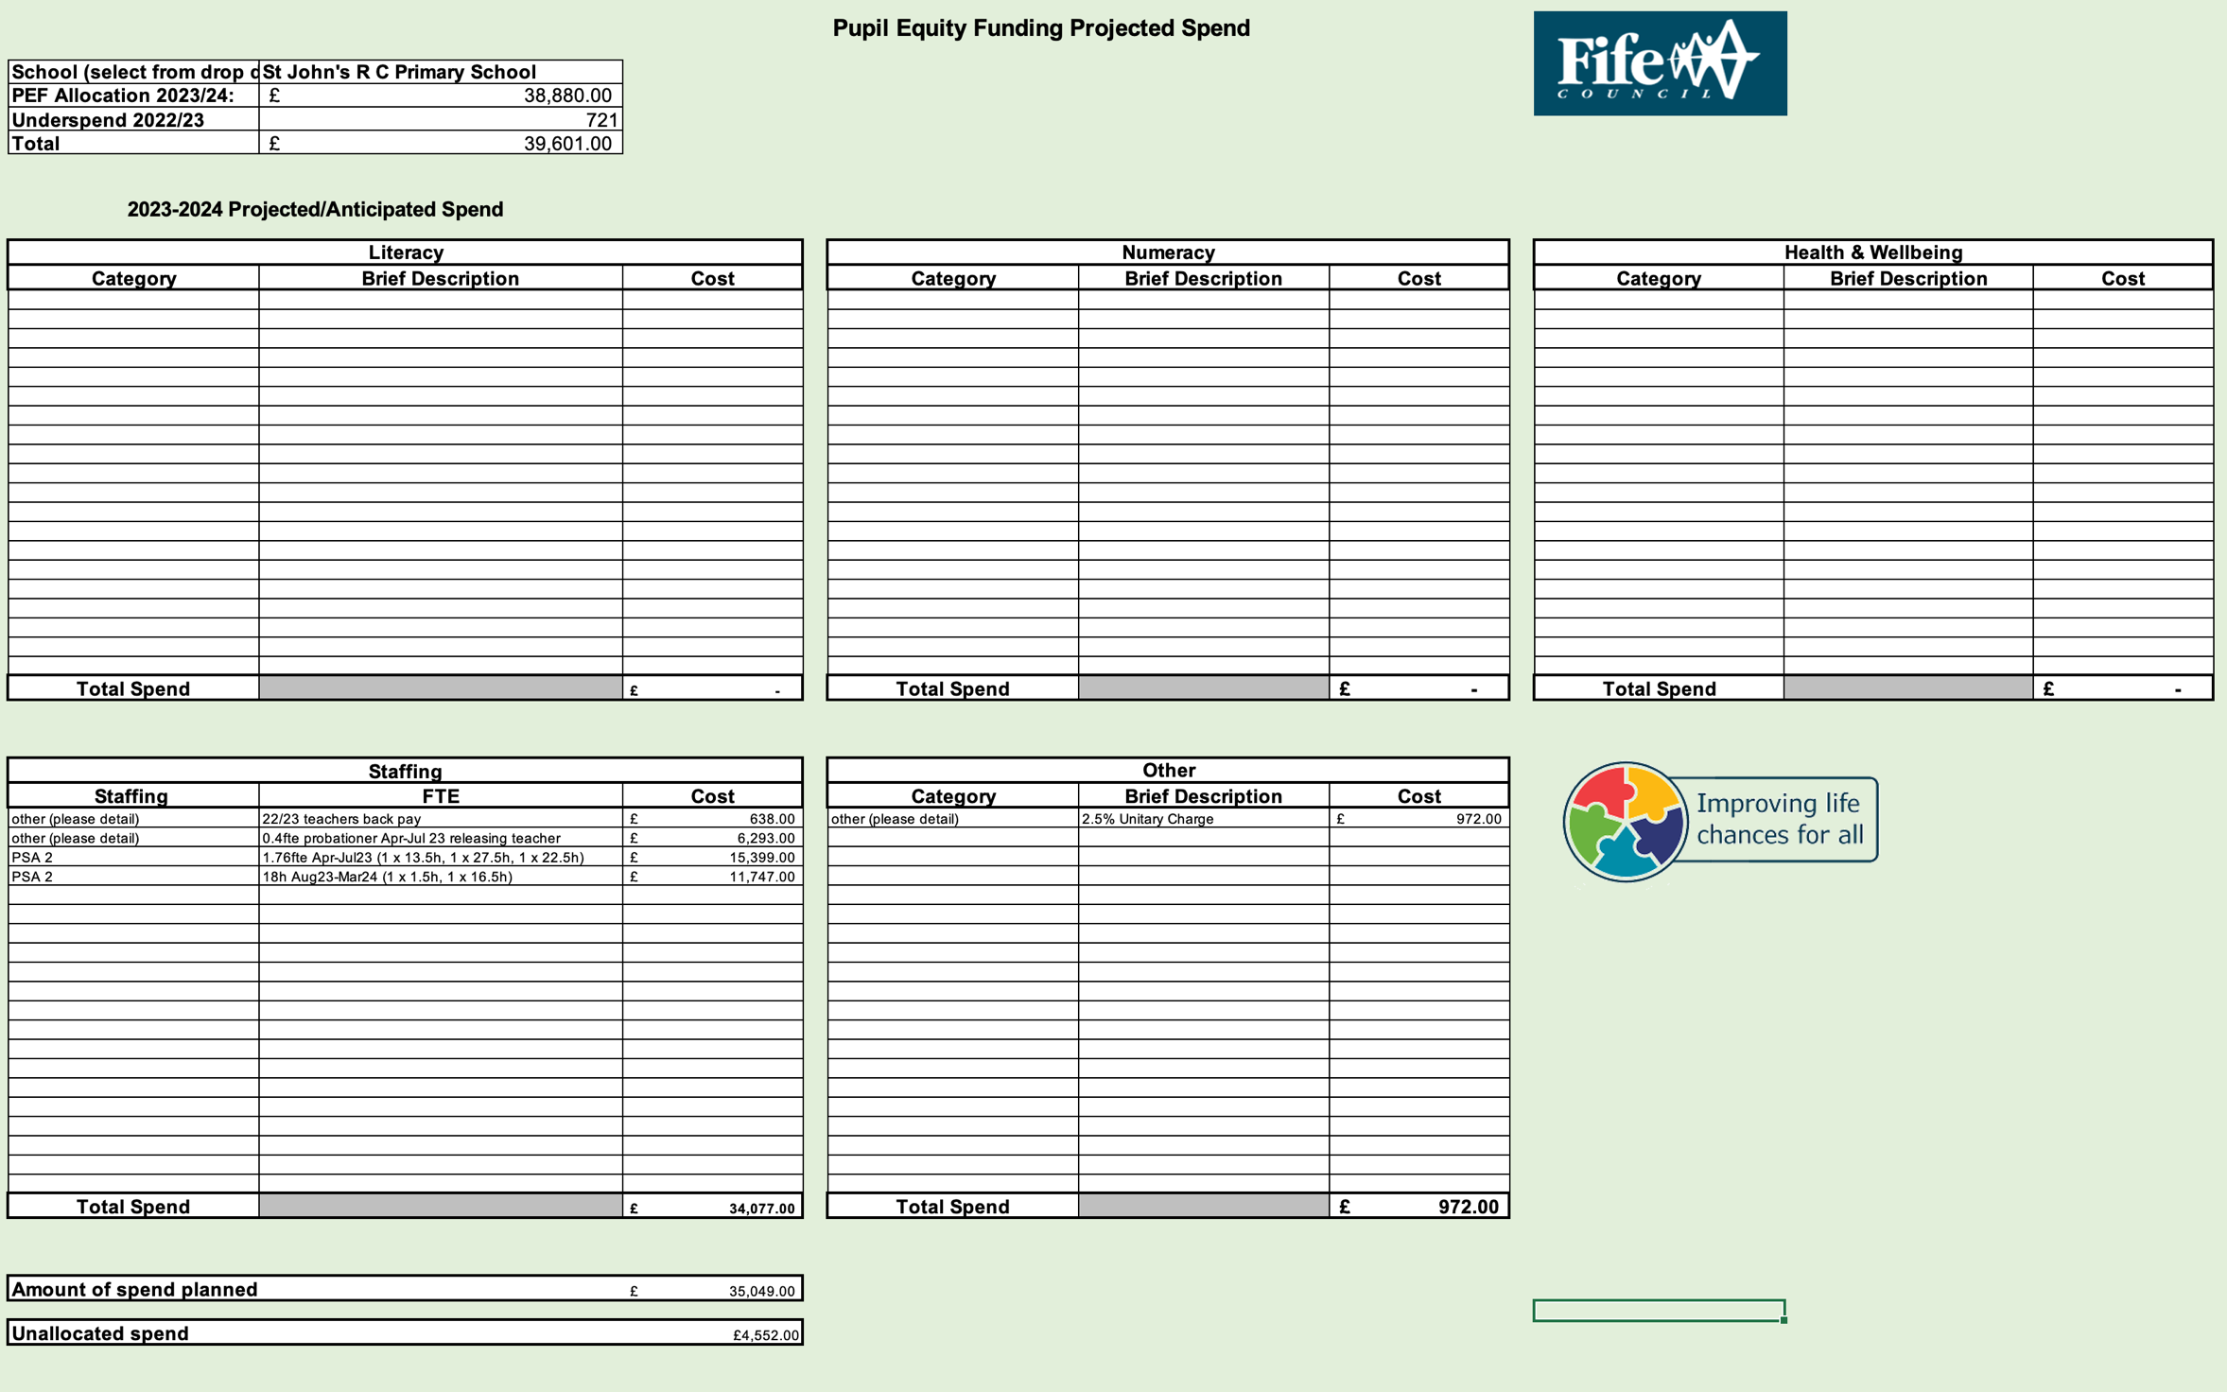

Appendix E
Name of Establishment

Name of Headteacher

Education Manager

Standards and Quality Report Session 2022-2023

 | Comments
Agreed format for SQR 2022- 2023 has been used
Context table completed
Shared vision and values shared
Improvement Work 2022 – 2023  Priority 1 | Fully Achieved |  | Partially Achieved |  | Continued next session
Progress

Clear progress been made with planned strategic actions
Clear impact shown for children and young people

- Quantitative or qualitative data to support this impact
- Written evaluatively
Limited number of next steps identified
Improvement Work 2022 – 2023  Priority 2 | Fully Achieved |  | Partially Achieved |  | Continued next session
Progress

Clear progress been made with planned strategic actions
Clear impact shown for children and young people

- Quantitative or qualitative data to support this impact
- Written evaluatively
Limited number of next steps identified
Attainment Overview Completed

Evaluative Statement about Attainment

Attainment overview/Achievement of a Level/Outcomes for Young People
- Successes and gaps identified
- Destination trends (secondary)
Wider achievement – impact on children and young people
(evidence of skills developed rather than a list of achievements/experiences, this can be linked to four capacities)
Feedback from External Scrutiny
- LP/ELP
- Education Scotland
- Care Inspectorate
PEF Evaluation (per priority)
Progress:
Detail given of work/action which had been undertaken towards this priority eg professional learning, consultation with all stakeholders, implementation of planning, use of resources etc
Impact
- Quantitative or qualitative data to support this impact
- Written evaluatively
NIF quality Indicators are evaluated using six point scale (School)
NIF quality Indicators are evaluated using six point scale (ELC)
Care Inspectorate Grades included (where relevant)

Improvement Plan Session 2023- 2024
Comments
Are priorities identified supporting recovery?
- Do they cover school, ELC and ASC?
Are relevant QI’s identified for priority identified?
Expected impact
- Is this focused on children and young people
- Is this written evaluatively
- Is this linked to data
Strategic Action/tasks identified:
- High level
- Realistic
Responsibilities
- Identified
- At all levels
Measure of Success (including Triangulation of evidence/QI Metholodgy)
- Is there evidence that evidence will be gathered from different stakeholders and through different ways
Timescales
- Realistic
PEF Plan
PEF Financial Plan

Appendix F

Measure of Success – QI Methodology

Quality improvement is about giving the people closest to issues affecting outcomes the time, permission, skills and resources they need to solve them. It involves a systematic and coordinated approach to solving a problem using specific methods and tools with the aim of bringing about a measurable improvement.

A few suggested approaches to consider are :

Approach | Description | Visual
Model for Improvement | Rapid cycle process involving Plan, Do Study, Act (PDSA) cycles to test the effects of small changes, make them and ultimately spread the effective changes through the system if they have the desired effect. | 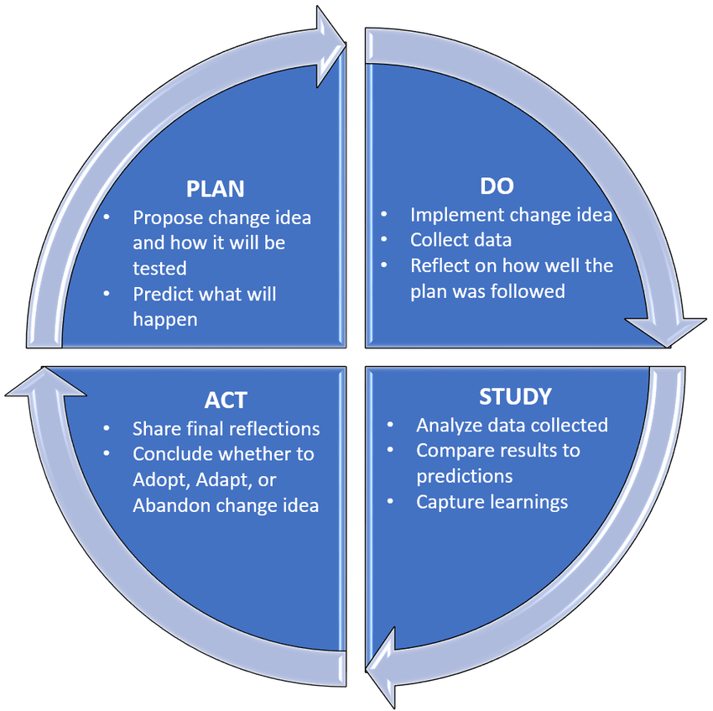
Visible Learning – Impact Cycle | Gather and consider/analyse evidence/data to determine a focus, introduce an idea or element to your practice and measure the impact that it has based on evidence. | 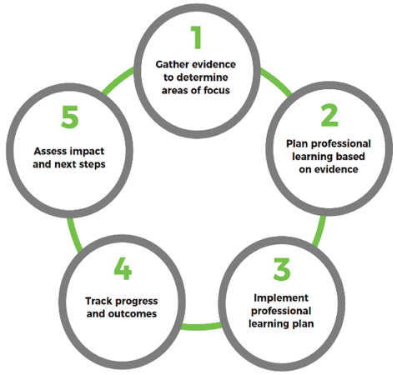
Practitioner Enquiry/professional Enquiry Process |  | 