
St columba’s RC primary
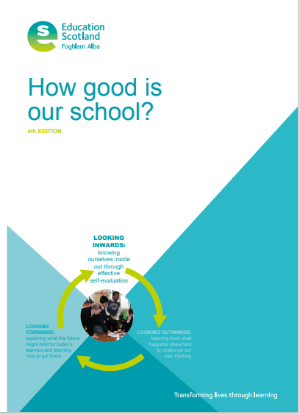
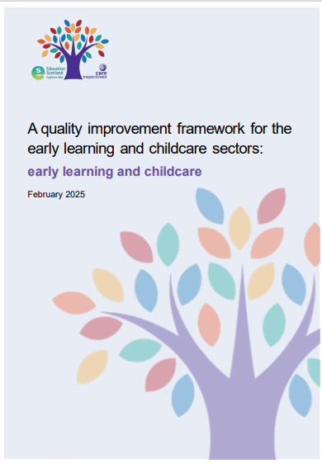
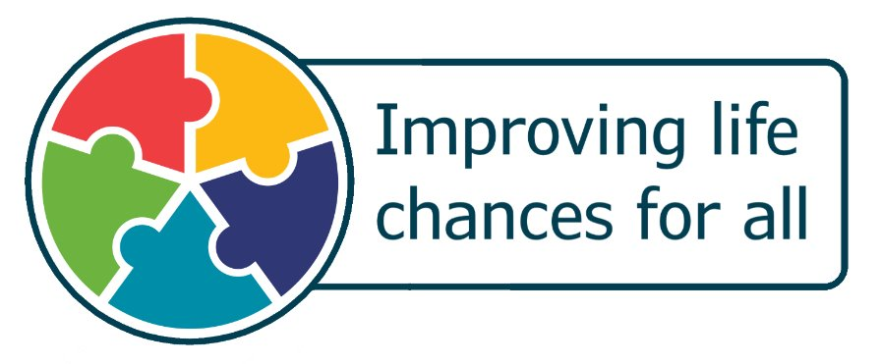
SUMMARY SELF-EVAlUATION
Date Published: 22/06/2026
Version: 2
Date to be reviewed: January 2027
St Columba’s RC Primary
1.3 LEADERSHIP OF CHANGE
How would you evaluate yourself using the six-point scale? |  |  | 2024/25 | 2025/26 |  | 2026/27
 |  |  | Level 4 - Good - important strengths with areas for improvement | Level 4 - Good - important strengths with areas for improvement |  | Level 4 - Good - important strengths with areas for improvement
Date last updated: 22/06/2026 | How well are we doing?  What is working well for our children? | How do you know?  What evidence do you have? |  |  | What are you going to do now?  What are your improvement priorities?
Developing a shared vision, values and aims relevant to the school and its community.  Strategic planning for continuous improvement  Implementing improvement and change | Developing a shared vision, values and aims relevant to the school and its community  Our vision and values were developed through collaboration with all pupils, staff and parents / carers in 2024 -2025. The shared ownership of our values: Ambition, Belief and Courage (ABC) create the conditions for everyone to empower their potential, build their character and shape their tomorrow.  Demographic  All staff have a good understanding of the social, economic and cultural context of our school, with 233 of our pupils living in SIMD Deciles 3-18. The average SIMD: 5.7; FME entitlement Primary 6 & 7 of 12.88%. Staff are supported by the Headteacher and Principal Teacher. This year, due to the absence of the HT & PT, Mrs S Gorman (HT St Ninians), led the school for 3 months.  At St Columba’s the percentage of pupils who have English as an additional language is 7.30%. The percentage of children with a recognized and recorded additional support needs: 29.61% 46 pupils with other ASN over and above disabled. The percentage of children having being declared disabled is 13.19%. We have  10.64% of children assessed as disabled. Our general level of attendance is 94%, which is 2.6% less than our stretch target. The percentage of the number of pupils with less than 90% attendance was 14.89%. The percentage authorised absence / unauthorised absence: 3159 sessions (am & pm) 6.96% / 1334 sessions (am & pm) 16.49%  Strategic planning for continuous improvement  Our assessment framework / calendar reflects our expectations. These include lesson observation, jotter monitoring, collated overviews of classroom observations and all the associated feedback.  Staff engage in Cluster Progressive Plan for Transforming learning and progress. Tracking & Monitoring Meetings – Progress (all curriculum areas) are carried out termly. We seek feedback in a variety of ways to ensure all stakeholders are given the opportunity to feedback on the school’s improvement activity and influence future decision making in the school.  Implementing improvement and change  Staff are supported to engage in and demonstrate their ongoing commitment to professional learning informed by annual PRD processes. We value staff CPD, professional dialogue and ensure the working time agreement allows teaching staff opportunities to develop their careers. The majority of staff members have responsibility for leading an aspect of school improvement which is supporting children to develop wider skills, regulation strategies and enhancing curricular pathways and the development of a culture of leadership at all levels.  We are increasing the opportunities for children to be involved in leading aspects of school improvement e.g. Fairtrade ambassadors, eco leaders, House Captains, Reading buddies, sports ambassadors, ICT leaders and within their own learning within classes. This is supporting them to develop an understanding of skills for life, learning and work.  We regularly provide opportunities for our children to feedback on their wellbeing at Feedback Fridays and during class times. We use this to inform our curriculum planning to ensure we are getting it right for all of our children across the Broad General Education. | Data:  Quality and assurance calendar  Directorate calendar  School behaviour & antibullying policy  Bronze Rights Respecting Schools award  Wellbeing web overview  Circle Classroom Inclusive Scale  Digital planning  Peoples Views  Parent Council, teaching staff, PSA & pupil focus groups  Attainment meeting overviews  High Quality feedback in classroom  Partnership Visits  Pupilwise, Parentwise & Staff surveys  Forms surveys  Observations:  Summative data  Feedback from Learning  Tracking from Progress / BASE / NSA  Planning documentation  Classrooms Observations |  |  | Developing a shared vision, values and aims relevant to the school and its community  Look at opportunities to develop the children’s involvement in the life and work of the school.  We aim to support this through:  Global Citizenship, Fairtrade, Eco Committee, Global goals, Rights Respecting and learning together groups  Strategic planning for continuous improvement  Embed new tracking system  Implementing improvement and change  Look for staff opportunities to develop their leadership skills by leading on SIP

St Columba’s RC Primary
2.3 LEARNING, TEACHING AND ASSESSMENT
How would you evaluate yourself using the six-point scale? |  |  |  | 2024/25 | 2025/26 | 2026/27
 |  |  |  | Level 4 - Good - important strengths with areas for improvement | Level 4 - Good - important strengths with areas for improvement | Level 4 - Good - important strengths with areas for improvement
Date last updated:  22/06/2026 | How well are we doing?  What is working well for our children? | How do you know?  What evidence do you have? | What are you going to do now?  What are your improvement priorities?
Learning and engagement  Quality of teaching  Effective use of assessment  Planning, tracking and monitoring | Learning and engagement  Our Gospel values underpin our school values Ambition, Belief and Courgae. We seek to promote postivie relation ships between pupils, parent / carers and staff. Our aim is to promote a positive social, healthy and emotional environment for learners to learn in, promote high quality learning and create opportunities for the children to be prepared for the world of work.  Quality of teaching  All staff experience classroom observations as part of quality assurance activities. We use these opportunities to provide individual feedback to support improvements in learning and teaching.  A collated overview of classroom visits is shared with all staff highlighting strengths and next steps for the school.  We use this evidence to inform teacher’s planning and ensure that leaners all meet their learning entitlement and develop their learning needs.  All staff incorporate the four-part model into their lessons, ensuring that children experience consistency in their learning and teaching. Staff give clear explanations and instructions, learning intentions are shared, success criteria are co-created and feedback is used effectively to support children to lead their learning.  In the majority of lessons, meta-skills progression is being shared by teaching staff to plan learning experiences and link to the children’s skills for life, learning and work.  Pupil tracking systems have been refreshed in line with Donnibristle Primary School’s model, providing a clearer overview of learners’ academic, social and emotional progress. These are reviewed and updated regularly during tracking meetings.  Effective use of assessments  In partnership with our Support for Learning Teacher all teaching staff use the CIRCLE Framework Inclusive Classroom audit tool to reflect on the universal and additional supports available within learning environments.  All staff plan for universal, additional and intensive supports for children. We identify children who require additional and / or intensive support. We then identify appropriate interventions and achievable targets. We regularly review these targets with parents / carers to ensure that children’s needs are being met.  At St Columbas a range of evidence to assess children’s progress in learning e.g. P1 BASE, NSA, formative and summative assessments as part of our agreed Assessment Calendar. This informs dialogue at Tracking & Monitoring Meetings and ensures that teaching staff are planning effectively for all children in their class. They ensure that this is ambitious for their children to allow them to make good progress in learning.  Approaches to moderation across the school and previously within the cluster are supporting teachers in their professional judgements and this is being used to ensure that children are receiving appropriate pace and challenge in learning.  Planning, tracking and monitoring  In Primary 1 approaches to play pedagogy are increasingly meaningful and purposeful and are giving children opportunities to develop curiosity, independence and creativity linked to the meta-skills. They are also being well supported to articulate their own learning and next steps as a result.  In Primary 6 and 7 children are making good use of the digital devices to support and enhance their learning. These devices give opportunities for children to access tools to support removal of barriers and allow for greater personalisation and choice across the curriculum.  All staff plan across all 8 curricular areas, using Fife’s Progression Pathways. This ensures children are receiving their entitlement to a BGE. | Data:  Wellbeing web overview  Circle Classroom Inclusive Scale  Quality and assurance calendar  Directorate calendar  Digital planning  Summative data – BASE, CfE & NSA’s  Consistent use of planning documentation  Peoples Views  Parent Council, teaching staff, PSA & pupil focus groups  Attainment meeting overviews  High Quality feedback in classroom  Partnership Visits  Pupilwise, Parentwise & Staffwise surveys (May 2026)  Forms surveys  Observations:  Summative data  Feedback from Learning  Tracking from Progress / BASE / NSA  Planning documentation  Classrooms Observations  Learning Partnership feedback | Learning and engagement  Increased priorities for all staff to collaborate with colleagues on moderation activities using the Learning & Teaching, Assessment Cycle.  Staff to develop the meta skills / play tracker  Quality of teaching  Embed transforming learning across Primary 5 & 6  Effective use of assessments  Use Hachette Teejay maths assessments to underpin high quality teaching and learning  Opportunities for moderation for Numeracy  Planning, tracking and monitoring  Embed new play / meta skills tracker across all classes

St Columba’s RC Primary
3.1 ENSURING WELLBEING, EQUALITY AND INCLUSION
How would you evaluate yourself using the six-point scale? |  |  |  | 2024/25 | 2025/26 | 2026/27
 |  |  |  | Level 4 - Good - important strengths with areas for improvement | Level 4 - Good - important strengths with areas for improvement | Level 4 - Good - important strengths with areas for improvement
Date last updated:  22/06/2026 | How well are we doing?  What is working well for our children? | How do you know?  What evidence do you have? | What are you going to do now?  What are your improvement priorities?
Wellbeing  Fulfilment of statutory duties  Inclusion and equality | Wellbeing  There is strong evidence that almost all learners feel safe in school and understand how adults can support them when needed. Relationships are a key strength.  There is clear evidence of sustained improvement in pupils’ perceptions of safety and support, with the majority reporting that they feel safe and know who to approach for help across a range of situations.  The data over time, increasing confidence is evident in pupils’ ability to manage their wellbeing, with more learners recognizing how school supports them to feel confident, respected and included.  The school has strengthened its inclusive ethos, reflected in improved pupil feedback around fairness, respect and positive relationships with staff.  Fulfilment of statutory duties  Most learners report that they are making progress in their learning and are supported effectively to understand their next steps. A consistent majority feel that learning is explained clearly and that they are motivated to engage.  Almost all learners report positive experiences of learning, particularly in relation to feeling supported, understanding success, and being encouraged to participate.  The data shows that most learners believe they receive support when they find learning difficult and that teachers help them improve. Where support is most targeted, almost all learners report that this support helps them succeed.  All staff have completed the mandatory Child Protection training and visitors are made aware of the CP and the DCP.  School has 4 trained first aid and emergency training.  Inclusion and equality  In relation to inclusion, most learners feel included and valued. Staff promote equality, diversity & inclusion  Opportunities to contribute to the life of the school are viewed positively, with the majority indicating that they can influence aspects of school life. | Data:  Wellbeing web overview  Circle Classroom Inclusive Scale  Oracle cloud mandatory e – learning overview  First Aid folder  Active school registers  Extracurricular clubs  Peoples Views  SMART Targets – Childs plans  Parent Council, teaching staff, PSA & pupil focus groups  Tracking meeting overviews  Pupilwise, Parentwise & Staffwise surveys (May 2026)  Forms surveys  Behaviour policy  Cost of the school day statement  Observations:  Summative data  Feedback from Learning  Tracking from Progress / BASE / NSA  Planning documentation  Classrooms Observations  Learning Partnership feedback | Wellbeing  Almost all learners feel safe and supported, with strong relationships across the school.  Most learners experience clear teaching and support, contributing to positive attainment.  Positive ethos and nurturing environment underpin learners’ readiness to learn.  Fulfilment of statutory duties  Strengthen learner participation to ensure all learners feel they have a voice in school improvement.  Further develop inclusive practices to ensure learners consistently feel included.  Enhance partnerships with parents to support their understanding of the positive aspects of digital learning.  Inclusion and equality  Strengthen pupil voice further, as less than half feel consistently involved in decision-making about improvements, indicating variability in participation opportunities.

St Columba’s RC Primary
3.2 RAISING ATTAINMENT AND ACHIEVEMENT
How would you evaluate yourself using the six-point scale? |  |  |  | 2024/25 | 2025/26 | 2026/27
 |  |  |  | Level 4 - Good - important strengths with areas for improvement | Level 4 - Good - important strengths with areas for improvement | Level 4 - Good - important strengths with areas for improvement
Date last updated:  22/06/2026 | How well are we doing?  What is working well for our children? | How do you know?  What evidence do you have? | What are you going to do now?  What are your improvement priorities?
Attainment in literacy and numeracy  Attainment over time  Overall quality of children’ achievements  Equity for all children | Attainment in literacy and numeracy  Robust tracking and analysis of data across the school shows attainment over time at key stages Primary 1, 4 & 7 Attainment in Literacy and Numeracy.  Consistent use of Fife Core Approaches across the school for Literacy & Numeracy.  Attainment over time  Attainment across Primary 1 is good, with most learners making appropriate progress within Early Level. The majority of children are on track to achieve First Level within expected timescales, demonstrating effective early learning and teaching approaches.  A minority of learners are working below expected levels; however, early interventions are having a positive impact on closing gaps.  Attainment at Primary 4 is consistently good across literacy and numeracy, with nearly all learners working within Second Level Early.  Learners demonstrate sustained progress across Literacy & Numeracy, reflecting increasingly effective classroom practice.  Attainment in literacy and numeracy in Primary 7 is good. Most learners are achieving Second Level and the majority are progressing into Third Level, indicating effective progression across the BGE.  The school provides a range of opportunities for personal and wider achievement, which have a positive impact on learner confidence and engagement.  Overall quality of children’ achievements  Learners can articulate their achievements and skills; however, this is not yet consistent across all stages. In partnership with Donnibristle and Dunnikier Primary Schools, an effective tracking system has been developed to celebrate wider achievements and support greater consistency  Equity for all children Pupil Equity Funding has been strategically used to support identified cohorts, addressing academic, social and emotional, and physical needs. It ensures financial barriers are minimised so that all learners can access planned opportunities. Attendance for targeted individuals has improved through effective partnership working with families to promote regular school attendance.  Pupils are well-supported at points of transition including our feeder nurseries to Primary 1 and for our Primary 7s, going to High School. | Data:  Attainment over time overview  Class trackers  Progress year trackers  Attendance  Peoples Views  Parent Council, teaching staff, PSA & pupil focus groups  Attainment meeting overviews  High Quality feedback in classroom  Partnership Visits  Pupilwise, Parentwise & Staffwise surveys (May 2026)  Forms surveys  Observations:  Summative data  Feedback from Learning  Planning documentation  Classrooms Observations  PEF Interventions | Attainment in literacy and numeracy  Develop approaches to measuring the impacts of improvements in learning, teaching and assessment.  Attainment over time  Improve attainment outcomes by increasing pace, challenge and differentiation in learning.  Embed robust moderation practices to ensure consistent and accurate teacher judgement.  Strengthen use of literacy data across staff to ensure attainment information drives timely interventions.  Evaluate interventions more rigorously, focusing on measurable improvements in attainment.  Overall quality of children’ achievements  Embed the new tracker developed in partnership with Donnibristle & Dunikier Primary Schools  Equity for all children  Ensure a fairness in equity across the school.

SQR TEMPLATE

St Columba’s Primary School
Context of the School
Demographic | St Columba’s RC Primary School is one of four schools in the former market town and Royal Burgh of Cupar in Fife.  There are currently 235 pupils in the school, including 4 care experienced children and 17 children who come from various countries around the world. There is a strong connection with the local parish, St Columba’s RC Church and the wider Cupar community.  St Columba’s RC Primary is a PPE school built in 2007 on the old Bell Baxter Junior School site. There are 10 classrooms available, currently 9 are used, and various other smaller rooms used as creative and nurturing spaces. There is a music room and library, dinner hall and large gym hall. There are smaller spaces for staff offices, two medical rooms and community lounge. The playground has a garden including outdoor prayer space, large playground and grass area. There is a trim trail and other outdoor equipment for playtime activities. The surrounding area supports topic and outdoor learning and PE opportunities.  For academic session 2025-26 there were 9 classes, consisting of 235 pupils across Primary 1 -7. The pupils at St Columba’s Primary reside within SIMD deciles 3 – 18 with an overall SIMD of 5.7%. As of September 2025, the free school meal entitlement for Primary 6 and 7 was 12.88%. 7.30% of children are registered as an additional language (EAL).  29.61 % of pupils have a recognized and recorded additional support need, with 13.19% of children having being declared disabled and another 10.64% assessed as disabled.  General levels of attendance are high with a school average of 93.92%. We did not achieve our stretch target of 94.0%. Percentage of the number of pupils with less than 90% was 14.89%.
Vision, values and aims   | School Aims:  Learners will be safe, happy and included, supported and challenged, and will achieve success while developing their faith.  School Values:  - Ambition - ambition to fulfil our potential  - Belief - in self and faith  - Courage - to face challenges  School Vision:  To engage the learning community to instill believe in themselves and give them every opportunity to achieve their very best
Attendance | Total | 93.92% | Authorised | 4.18% | Unauthorised | 1.9%
Exclusions % | 0%
Summary of consultation with stakeholders | - All parents / carers had the opportunity to feedback on specific improvement priority work through questionnaires from staff working parties  - Engaged with parents / carers on digital learning – held a workshop on Digital Literacy (invited councilors). Feedback will be used to create a school policy on digital lieracy / update social media policy / use of iPads. Regular updates to Parent Council.  - Shared information on IT at Open Mornings  - Engaged regularly with the SMART phone parent group  - A parent focus group was part of Learning Partnership  - LP feedback highlighted to continue to develop on our numeracy journey  - Parent Council meetings are held termly with a few small meetings held with office bearers when necessary – discussions regarding the SIP/children’s learning and other important aspects are discussed  - Pupil feedback is on-going throughout the year and gathered through regular pupil focus groups, and questionnaires  - Pupil / parent questionnaires  - Pupil, Parent and staff wise surveys (May 2026)
Attainment Scotland Fund Allocation (PEF) | £34,500
Cost of the School Day statement | At St Columba’s RC Primary School, we recognize the need to reduce the Cost of the School Day for all our young people and particularly for those who are already experiencing poverty. We examine the school day through the following headings:  Uniform  We promote the school clothing grant through our website, social media, school emails and at the Primary 1 transition meetings.  We have clean laundry available for pupils who need school uniforms. We share promotions run by our school uniform providers (e.g. 10-20% off) and promote uniform recycling opportunities at school events. Our school uniform is also on sale for a minimum price (e.g. 50p - £2) from Caring for Cupar, our church charity shop.  Travel, Residential and School trips  To support any costs connected to school excursions we try to use the Under 22s Free Travel Cards. We keep the cost of school trips to a minimum, only asking for donations of £5. We subsidize Primary 7s residential so all children can attend.  Eating  All children in Primary 1-5 have access to free school meals. Grants for free school meals and school milk are promoted. Fruit is available for all children who need snack. There is a breakfast Café available from 8:00am which is free for children and families. Café Inc runs from our school during the holidays which makes it a familiar venue for families to come for a daily meal. We also link with our partner agencies and local parish priest to support families in crisis for extra assistance.  Home Learning  As part of the Transforming Learning project digital devices have been rolled out to all primary 5 – 7 pupils.  Digital Devices are provided for children who do not have access to them at home. New pupils and those identified through Term 1 parent meetings are offered a device to support learning, on request.

Summary of Progress and Impact from last session’s Improvement Plan and Next Steps

ELC/School Improvement Priority 1 To improve numeracy outcomes for all students by fostering an inclusive classroom environment, implementing regular moderation of planning and assessments, and providing accessible, high-quality numeracy resources.
HGIOS4/ELC Quality Improvement Framework Quality Indicators:
QI 1.3 - Leadership of Change
QI 2.3 - Learning, Teaching and Assessment
QI 3.1 - Ensuring wellbeing, equality and inclusion
QI 3.2 Raising attainment and achievement
Has this priority been:  (please highlight) | Fully achieved |  | Partially achieved |  | Continued into next session
Progress of numeracy:
- Pupils’ BASE & CfE figures were investigated in August:
Most of the pupils in Primary 1 (84.6%) were on target. We targeted 3 pupils – (a potential increase of 9.0% to achieve early level in all areas of numeracy).
The majority of pupils in Primary 4 (77.3%) were on target. We targeted 2 pupils – (a potential increase of 6.7% to achieve first level in all areas of numeracy).
Half of pupils in Primary 7 (50.0%) were on target. We targeted 10 pupils (a potential increase of 30.0% to achieve second level in all areas of numeracy).
- All PSA staff received training in using the Conceptual Numeracy and used 5-minute boxes for targeted intervention. 4 pupils Primary 1 pupils were identified as being off target. 100% of the pupils achieved 1IE in their Numeracy
- Primary 4 and 7 NSA data was analysed by LIF Area PT, areas for improvement were identified and targeted by Primary 4 and Primary 7 teachers.
- All class teachers attended CPD session led by Cluster Raising Attainment teacher to learn how to use, record and track progress using new Fife Numeracy Assessments.

Impact:
In August 2025, most (84.6%) Primary 1 pupils were on target to achieve Early level in all areas of Numeracy by May 2026. 86.1% of pupils achieved Early Level in all areas of Numeracy, which was an increase of 1.5%.
Since the initial numeracy BASE assessment, Primary 1s have made an improvement overall. From their BASE scores 27% of pupils are showing 130 or above. Most pupils are 100 or above.
In August 2025, the majority (77.3%) Primary 4 pupils were on target to achieve First level in all areas of Numeracy. In May 2026, 83% (most) Primary 4 pupils achieved First Level in Numeracy - an increase of 5.7%.
In August 2025, majority of pupils in Primary 7 (59%) were on target to achieve Second level in all areas of Numeracy by May 2026. In May, 2026, 84.2% (most) of Primary 7 pupils achieved Second Level in Numeracy, which was an increase of 25.2%.
All staff use Fife Progression pathways, records of understanding and assessments with confidence.
Consistent teaching, leading to improvement in attainment (See above).
All maths environments in all classes were peer evaluated and a base line of displays and resources was discussed
Next Steps:
Learning Partnership feedback highlighted the continued need for targeted intervention in numeracy.
All staff to continue to monitor numeracy progress in termly tracking meetings.
All staff to have a consistent approach in their understanding and teaching of conceptual numeracy concepts.
All classes will use conceptual numeracy regularly to enhance learning experiences.

All stakeholders to discuss a consistent approach to homework.
All staff to develop a consistent approach to mental maths at all levels.
All staff to embed Teejay resource across the school.

Summary of Progress and Impact from last session’s Improvement Plan and Next Steps

SIP Priority 2 Support and enhance the delivery of high-quality learning, teaching and assessment through professional learning for all staff on the use of digital technology.
To support all staff through the use of digital technologies to effectively assess children’s progress, leading to a learning environment which ensures appropriate pace and challenge, leading to improved outcomes for children.
HGIOS 4 Quality Indicators
1.3 Leadership of Change
2.2 Curriculum
2.3 Learning, Teaching and Assessment
2.4 Personalised Support
2.6 Transition
3.2 Raising Attainment and achievement
3.3 Increasing creativity and employability
Has this priority been:  (please highlight) | Fully achieved |  | Partially achieved |  | Continued into next session
Progress of Numeracy:
All teaching staff have engaged in 7.5 hours professional learning for Transforming Learning.
All teaching staff personalize their learning using digital teaching platforms.
All teaching staff have had CPD to provide feedback to pupil via digital methods.
All staff have developed their understanding of professional learning through collegiate discussion and in-service training on the use of the iPad to enhance teaching and learning.
Impact
All staff use a range of creative pedagogical and digital tools.
All staff use a range of apps to enhance the learning outcomes for children.
All PSAs have engaged in use of Clicker on iPAds to support children with writing.
All Primary 6 and 7 pupils received Transforming Learning iPAds as well as continuous opportunities to enhance to enhance their knowledge and use of the iPad.
All children have personalized their iPAds with accessibility as a focus.
All Primary 5-7 children use Teams and Glow.
All Primary 1-4 pupils are using Seesaw and can upload their own work.
Targeted children in Primary 3-7 have used Nessy reading and spelling as part of a planned intervention to raise attainment in literacy.
All children use and access their digital portfolio on Seesaw.

All pupils have demonstrated an increased confidence in using a range of technology resources.
Next steps
Staff to engage with Apple Education Community. Improve variety of skills using iPad to share and model e.g. screen share.
Primary 6 and 7 teaching staff to provide high quality feedback, in particular numeracy lessons using digital tools.
We aim to use newly learned skills and confidence in pupils to track the impact – inform pupil understanding of numeracy concepts.
Change over from Seesaw to Showbie for all stages across the school.
Parent workshops to support transition to Showbie.

Summary of Progress and Impact from last session’s Improvement Plan and Next Steps

SIP Priority 3: Plan a progressive curriculum for all children across 8 curriculum areas ensuring that all children receive their entitlement to a broad general education.
Use benchmarks for all curriculum areas to measure children’s progress and achievement of a level across the broad general education using a range of assessment evidence to inform professional judgements.
HGIOS 4 Quality Indicators
1.2 – Leadership of Learning
1.3 – Leadership of Change
2.2 – Curriculum
2.3 – Learning, Teaching and Assessment
3.1 – Ensuring wellbeing, equality and inclusion
3.2 – Raising attainment and achievement
Has this priority been:  (please highlight) | Fully achieved |  | Partially achieved |  | Continued into next session
All children will experience planned, progressive learning experiences across the broad general education.
All staff will enhance their assessment skills through planned assessment and moderation activity; this will ensure all children are making progress across all areas of the curriculum
All staff will track children’s progress across the broad general education and use assessment evidence to support professional judgements to ensure children experience their entitlement to a broad general education.
Impact:
Led by Depute Head Teacher and Principal Teachers All staff have worked collegiately in expressive art to design and implement high-quality assessment approaches aligned to national benchmarks
All learners are beginning to experience greater consistency in learning expectations and progression across classes and stages.

All teaching staff use benchmarks
All teaching staff use progression pathways for literature and numeracy
All teaching staff use benchmarks used for assessing all other areas of the curriculum
All staff complete 4 tracking meetings throughout the year where, look at assessment data e.g. SNSA, BASE (Focusing on literature and numeracy & health and wellbeing)
Next steps
Next steps engage in professional dialogue on creating assessments in the remaining curricular areas.
All staff to engage in moderation across St Columbas Primary and with other schools.

Improving Outcomes

Attainment
Overall Attainment for 2025 - 2026
 | Literacy |  | Numeracy
 | Stretch | Actual | Stretch | Actual
P1 | 86.1% | 81.6% | 91.7% | 86.1%
P4 | 80.0% | 100% | 84.0% | 83%
P7 | 76.9% | 90.6% | 79.5% | 84.2%

Stage | Listening and Talking | Reading | Writing | Numeracy
 | Actual | Actual | Actual | Actual
P1 | 83.3% | 88.9% | 80.6% | 86.1%
P4 | 100% | 100% | 100% | 94.3%
P7 | 92.3% | 92.3% | 87.2% | 88.0%

Attainment Over Time Evaluative Statement (Primary/Secondary):
In Primary 4 numeracy, the majority (72%) were on track in September, by January this had increased to most (78.26%) and in May, this had increased again to most pupils (83%).
In Primary 4 reading, the most (81.8%) were on track in September, by January this had increased to most (82.6% because we gained a pupil) and in May, this had increased again to all pupils (100%).
In Primary 4 writing, the majority (72.7%) were on track in September, by January this had increased to most (73.91% because we gained a pupil) and in May, this had increased again to all pupils (100%).
In August 2025, majority of pupils in Primary 7 (59%) were on target to achieve Second level in all areas of numeracy by May 2026. In May 2026, 84.2% (most) of Primary 7 pupils achieved Second Level in numeracy, which was an increase of 25.2%.
In Primary 7 reading, the most (86.8%) were on track in September, by January this had increased to most (86.8%) and in May, this had increased again to almost all pupils (92.3%).
In Primary 7 writing, the majority (78.9%) were on track in September, by January this remained at most (78.9%) and in May, this had increased again to all pupils (87.2%).
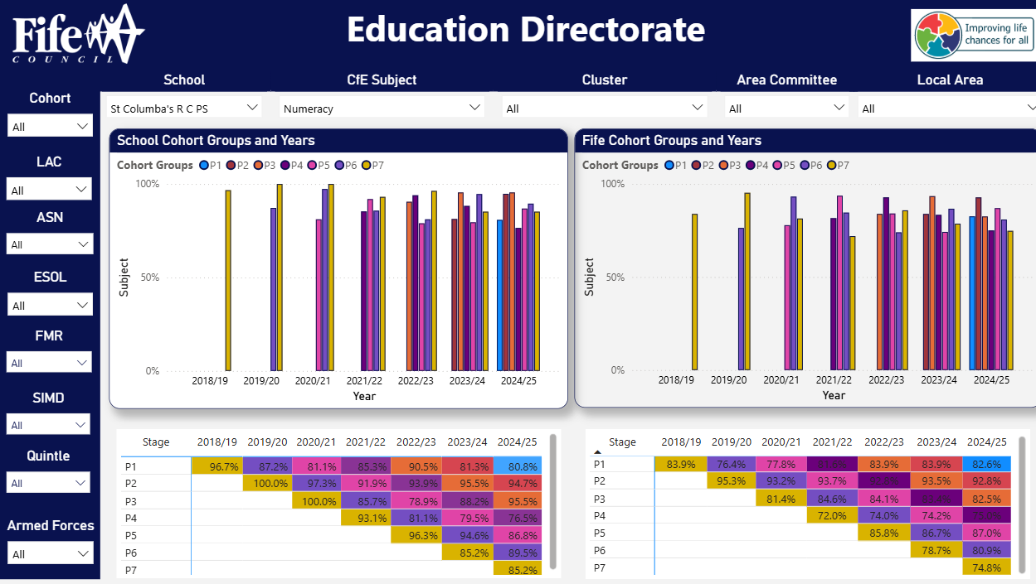
Screenshot taken from Cohort Tracker, PowerBI on 13/06/26
Impact of PEF on outcomes for children and young people:
Consistent use of Nessy resulted in the majority of targeted P2–P6 pupils making progress in reading, while a minority also demonstrated improvements in writing.

Attainment in writing across Primary 1 & 4 is 90.3% which is an increase from 72%.

Most pupils in the Read, Write, Inc raising attainment group can recognize and use sounds to support individual reading progress.

By using PM Benchmark Literacy Assessment, highlighted pupils engaged in 6-week interventions. Almost all pupils in the Primary 2 raising attainment group can now discriminate, blend and segment phonemes, as assessed using the Highland Council Tracker.

Participation in Kitbag has supported almost all P7 pupils and the majority of P5–P6 pupils to develop confidence in recognizing emotions and communicating their needs effectively

Most pupils in the Primary 2 – 4 nurture group have developed increased confidence in identifying emotions and are able to self-regulate.

All targeted Primary 1–P3 pupils developed social and emotional skills that support positive interactions with peers.

All pupils in the gross motor group are demonstrating an increased ability to remain calm, self-regulated and engage in learning.
Achievements
Curriculum Areas & Subjects
We promoted Belief in all our Primary 4 – 7 pupils. Learners were given the opportunity to participate in a variety of sports events: including basketball, badminton, (girls & boys) football, tennis and running festivals at local and cluster level promoting interpersonal and resilience skills. All children were involved with our Burns festival and experienced a series of drama workshops.

Interdisciplinary Learning
All Primary 6 & 7 pupils and parents / carers had the opportunity to be involved in rolling out the transforming learning program aimed at raising the Ambition of our learners.
Primary 4 engaged in the “Toadstool” project where we promoted the importance of the Health and Wellbeing of our leaners. Our pupils had the Courage to share their learning with our new Primary 1 pupils and parents / carers during our transition program.

Ethos and the life of the school
We are committed to our value of Belief. Our Faith journey included children celebrating the Sacrament of Reconciliation, Confirmation and Holy Communion.
We showed Ambition, Belief and Courage to become a Scottish Book trust reading accredited school.

Opportunities for learning
Almost all Primary 7 pupils attended the residential trip to Lendrickmuir in February. This built resilience, confidence, risk assessment skills and team work. All Primary 7 pupils attended Banardo’s substance abuse visit – February. This developed their life skills.
The Transforming learning program was rolled out following consultation with parents / carers.

Evaluations (School)
 | 2023-24 | 2024-25 | 2025-26 | Inspection Evaluations  (since August 2024)
1.3 Leadership of Change | Good | Good | Good
2.3 Learning, teaching and assessment | Good | Good | Good
3.1 Ensuring wellbeing, equity and inclusion | Good | Good | Very Good
3.2 Raising attainment and achievement | Good | Good | Good

Session 2026-2027 Improvement Plan

Education Directorate Improvement Plan: Improving Learning, Teaching & Assessment: Meeting Learner’s Needs: Curricular Pathways
Focused Priority: To develop a shared understanding of the continuum of support across the cluster (3-year plan)
HGIOS4 Quality Indicators |  |  | Quality Improvement Framework
2.3 Learning, teaching and assessment  3.2 Raising attainment and achievement. |  |  | National Improvement Framework Priority:  Closing the attainment gap between the most and least disadvantaged children and young people  Improvement in attainment, particularly in literacy and numeracy.  National Improvement Framework Driver  Teacher and practitioner professionalism  Curriculum and assessment  School and ELC improvement  Performance information
Expected Impact | Strategic Actions Planned | Responsibilities |  | Measure of Success  (Triangulation of Evidence/QI Methodology) | Timescales
There will be consistency of expectations and understanding of what constitutes universal, additional and intensive levels of support across the cluster.  Clarity of language around needs for staff, parents and partners  Transition programmes are reviewed to support effective transitions including enhanced transitions | Develop a base line standard of expectation for meeting needs across primary, secondary and early years settings. Gather data at cluster around training, good practice and signposting.  Create continuum of provision template (linked to BB continuum) detailing expectations at each level  Parent information created to support understanding of expectations and the continuum of support and roles in supporting transition  Transition events planned involving active schools, partners, St Andrews and Bell Baxter High along with our partner nurseries.  Transition planning created for universal, additional and intensive | SLF Teacher  All staff  SLF Teacher  All staff |  | Consistent Application of Support Frameworks  Across the cluster, staff confidently and consistently apply shared definitions of universal, additional and intensive support. Monitoring evidence (e.g. planning, staged intervention records and classroom practice) demonstrates increased consistency and reduced variation between settings.  Improved Clarity and Shared Language  Staff, parents and partners use a common, clearly understood language when discussing children’s needs and supports. Feedback from stakeholders (including parental engagement and partner collaboration) shows increased confidence and understanding of the levels of support and associated interventions.  Enhanced Quality and Impact of Transitions  Transition programmes, including enhanced transitions, are clearly structured, consistently implemented and responsive to individual needs. Evidence from pupil voice, parental feedback and tracking information demonstrates that children experience smoother transitions with reduced anxiety and improved continuity in learning and support.  Improved Outcomes for Learners Requiring Additional Support  Children receiving additional and intensive support demonstrate improved progress in learning, wellbeing and engagement over time. Tracking and monitoring data shows that targeted interventions are better matched to need and have increased impact across the cluster. | Nov 2026
Ongoing Evaluation
This should be updated as part of on-going cycle of self-evaluation

Education Directorate Improvement Plan: Improving Learning, Teaching & Assessment: Meeting Learner’s Needs: Curricular Pathways
Focused Priority: Moderation Cycle Increase attainment in numeracy across all classes.
Increase staff confidence in assessment and moderation of numeracy.
HGIOS4 Quality Indicators |  |  | Quality Improvement Framework
2.3 Learning, teaching and assessment  3.2 Raising attainment and achievement |  |  | National Improvement Framework Priority:  Closing the attainment gap between the most and least disadvantaged children and young people  Improvement in attainment, particularly in literacy and numeracy.  National Improvement Framework Driver  Teacher and practitioner professionalism  Curriculum and assessment  School and ELC improvement  Performance information
Expected Impact | Strategic Actions Planned | Responsibilities |  | Measure of Success  (Triangulation of Evidence/QI Methodology) | Timescales
All children will experience improved engagement and motivation in developing their conceptual maths knowledge.  All stakeholders to discuss a consistent approach to homework  All staff to develop a consistent approach to mental maths at all levels  All staff to embed Teejay resource across the school | Professional learning  As part of their WTA all staff will engage in targeted professional development in conceptual numeracy, focusing on mathematical thinking, problem solving and the use of multiple representations.  Staff will embed the Teejay Maths programme across all stages, ensuring consistent approaches to planning, delivery and assessment. Staff will collaborate to align Teejay resources with Curriculum for Excellence experiences and outcomes.  Enhance Digital Pedagogy:  Identify and embed high-quality numeracy apps on iPads. Staff will evaluate their impact to ensure digital tools support and deepen conceptual understanding rather than replace it. | SM, NY & KR  All staff  All staff  Led by KR  All staff |  | - Increased proportion of pupils achieving expected levels in numeracy.  - Learners demonstrate improved confidence, flexibility and depth in mathematical thinking.  - Staff have a shared understanding of standards and apply consistent approaches to assessment and moderation.  - Digital tools are used effectively to enhance engagement and support conceptual understanding. | November 2026  Staff development session led by professional learning team  Moderation with cluster at BBHS  May 2026
Ongoing Evaluation
This should be updated as part of on-going cycle of self-evaluation

Session 2026-2027 Improvement Plan – PEF Plan
Pupil Equity Fund allocation for session 2026/27 | £34,300
School Context (copied from SIP)
St Columba’s RC Primary School is one of four schools in the former market town and Royal Burgh of Cupar in Fife.
St Columba’s RC Primary is a PPE school built in 2007 on the old Bell Baxter Junior School site. There are 10 classrooms available, currently 9 are used, and various other smaller rooms used as creative and nurturing spaces. There are a music room and library, dinner hall and large gym hall. There are smaller spaces for staff offices, two medical rooms and community lounge. The playground has a garden including outdoor prayer space, large playground and grass area, a trim trail and other outdoor equipment for playtime activities. The surrounding area supports topic and outdoor learning and PE opportunities.
There is a strong connection with the local parish, St Columba’s RC Church and the wider Cupar community.
Currently there are 235 pupils in the school, including 4 care-experienced children. 7.30% of children are registered as an additional language (EAL). 29.61 % of pupils have a recognized and recorded additional support need, with 13.19% of children having been declared disabled and another 10.64% assessed as disabled. The pupils at St Columba’s Primary reside within SIMD deciles 3 – 18 with an overall SIMD of 5.7%. As of September 2025, the free school meal entitlement for Primary 6 and 7 was 12.88%.
General levels of attendance are high with a school average of 93.92%. We did not achieve our stretch target of 94.0%. Percentage of the number of pupils with less than 90% was 14.89%.
Cost of the School Day (In what key ways do you plan to mitigate against Costs within the School Day)
At St Columba’s RC Primary School, we recognise the need to reduce the Cost of the School Day for all our young people and particularly for our young people who are already experiencing poverty. We examine the school day through the following headings: Uniform, Travel, Learning, Breakfast, Community, Residential and School trips, Clubs and Home Learning. We subsidise residential and school trips, so all children can attend. We keep the cost of school trips to a minimum and ask for donations of £5. We have clean laundry available for pupils who need school uniform and offer swap opportunities at school events. Our school uniform is also on sale for a minimum price from Caring for Cupar, our church charity shop. There is a breakfast Café available from 8:00am which is free for children and families. Café Inc runs from our school during the holidays which makes it a familiar venue for families to come for a daily meal. We also link with our partner agencies and local parish priest to support families in crisis for extra assistance.

Stakeholder engagement  (in what ways have you engaged with your stakeholders – children/parents/community etc.) | Participatory Budgeting  (Are you using any of your PEF allocation to support participatory budgeting. If yes, what is the focus?)
In September SIP, SQR and PEF were shared with all parents/carers through our normal communication, e.g.: Parent Council meeting, SWAY via email website.  Termly newsletters shared with parents/carers to highlight and explain progress made throughout the session on various aspects of SIP/PEF along with other important school information regarding teaching and learning, staffing and events/celebrations.  At Parent Council meetings, parents/carers are given a progress update. This is then available for all parents/carers through PC minutes. | PEF allocation is not used to support participatory budgeting.

Rationale – Intervention 1 – Numeracy / Maths  Improve numeracy attainment, with increased confidence, accuracy, independence, and readiness for next stages, as informed by Learning Partnership. |  |  | Amount of Fund allocated (if appropriate) £253.30 for resources
Out of the identified group of pupils, 57% are at risk of experiencing child poverty and/or are receiving free school meals.
Expected Impact  (What is the expected impact on outcomes for children and young people)  If this links to a SIP priority, please reference | Interventions Planned  (What is the intervention? How will it be delivered? Who is responsible?) | Measure of Success  (Triangulation of Evidence/QI Methodology) |  | Impact on children  Ongoing evaluation ongoing throughout school session and final evaluation in June  (What has been the actual impact/outcome, in particular for the targeted group of children)  (What data/evidence shows the impact of the project/intervention? Refer to outcome statement. Did you achieve what you set out?)
By May 2027 identified pupils will have increased attainment in Numeracy/Maths.  This will be by 10% in P4 and 7.  P1 Almost all will develop confidence in early maths concepts.  P4, targeted pupils will improve accuracy and fluency in four operations.  • P7 targeted pupils will demonstrate increased confidence in applying numeracy skills and improve readiness for secondary transition.  • Across all stages, pupils will show greater engagement and confidence in numeracy and increased independence in learning. | Purchase class resources for universal support.  Use of Conceptual Numeracy approach to reinforce number processes in P4.  Focus on problem-solving, mental math and application of skills in P7.  Small group/targeted support focusing on key numeracy skills.  Use of 5 Minute Number Box, plan to do 3x a week with PSA  PSAs to engage with Fife Conceptual Numeracy training. | P1 BASE results  P4 and P7 SNSA results  CfE tracker  Ongoing assessment and tracking to inform next steps and ensure targeted support.  Termly planning / tracking meetings with SfL & SLT  Classroom observations  High quality feedback in jotters  Feedback from pupils |  | What has been the impact? Have you met your original expected impact?

Rationale: Intervention 2 – Literacy  ASN pupils will develop independence in their learning through supported access to the curriculum.  Learners not on track in literacy will receive targeted support to close gaps and improve attainment. |  |  | Amount of Fund allocated (if appropriate) £
Within the identified cohort, 28% are at risk of experiencing child poverty and/or are in receipt of free school meals, with a further proportion presenting with additional support needs.

Expected Impact  (What is the expected impact on outcomes for children and young people)  If this links to a SIP priority, please reference | Interventions Planned  (What is the intervention? How will it be delivered? Who is responsible?) | Measure of Success  (Triangulation of Evidence/QI Methodology) |  | Impact on children  Ongoing evaluation ongoing throughout school session and final evaluation in June  (What has been the actual impact/outcome, in particular for the targeted group of children)  (What data/evidence shows the impact of the project/intervention? Refer to outcome statement. Did you achieve what you set out?)
All identified ASN pupils will become familiar with sentence patterns, build confidence, and write independently by June 2027 through a targeted plan.  All identified learners (17 pupils in P2-6) will develop the confidence and skills to transfer learning into literacy tasks. | Use of CLICKER, 3-4x a week  Plan: sentence sets to build simple sentence, model - view & copy with guided order, view & copy with sentence order, supported by CT & PSA  Complete RWI baseline assessment  Intervention sessions, 30-minutes, twice a week  PSA engages with group.  PT/SfL/CT support PSA  Nessie used consistently | Baseline assessment in August  Termly assessments  Planning and tracking using CLICKER plan  Termly tracking meetings with SfL & SLT  Planning tracking meetings  Feedback from pupils  P1 BASE results at start and end of year  CfE results throughout the year  Termly RWI assessments  Completed RWI tracker.  Termly Nessie data collated.  CT teach agreed target.  Regular and termly tracking meeting with SLT, SfL, CT and PSA  Feedback from children
Rationale: Intervention 3 - Nurture  Prioritise HWB to remove barriers to learning, support inclusion and improve outcomes for all, through targeted nurture interventions |  |  | Amount of Fund allocated (if appropriate) £
Out of the identified pupils, 32% are identified as at risk of experiencing child poverty and/or receiving free school meals.

Expected Impact  (What is the expected impact on outcomes for children and young people)  If this links to a SIP priority, please reference | Interventions Planned  (What is the intervention? How will it be delivered? Who is responsible?) | Measure of Success  (Triangulation of Evidence/QI Methodology) |  | Impact on children  Ongoing evaluation ongoing throughout school session and final evaluation in June  (What has been the actual impact/outcome, in particular for the targeted group of children)  (What data/evidence shows the impact of the project/intervention? Refer to outcome statement. Did you achieve what you set out?)
By June all identified pupils will have improved HWB and reduced barriers to learning  Kitbag Groups –34 pupils in P2–P7  Gross Motor Group -16 pupils in P1/2 | Kitbag Groups – run by PSA and use of kitbag programme.  Targeted support to develop confidence in recognising and managing emotions, improving resilience, and promoting positive relationships.  Gross Motor Group – by PSA  Engaging, varied physical daily activities (ie: trikes/gymnastics)  Targeted support to improve self-regulation, coping strategies, increase calmness, readiness to learn, improved access to the curriculum | Attendance and engagement in target group  Individual pupil target created and monitored.  Pupil feedback  Regular review by PSA, CT, SfL

APPENDIX E – Pupil Equity Financial Plan Session 2026-2027 (to be completed with Business Manager)

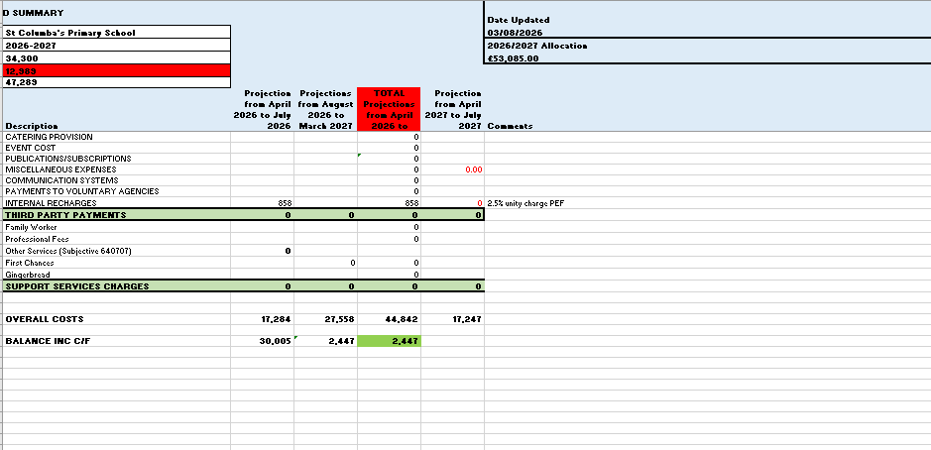

APPENDIX F – LOCAL AUTHORITY FEEDBACK
Name of Establishment:
Name of Headteacher:
Education Manager:
Standards and Quality Report Session 2025-2026
Context
Vision, values and aims | Completed |  |  | Still to be completed
Attendance | Completed |  |  | Still to be completed
Exclusions | Completed |  |  | Still to be completed
Summary of consultation with stakeholders | Completed |  |  | Still to be completed
Attainment Scotland Fund Allocation (PEF) | Completed |  |  | Still to be completed
Cost of the School Day statement | Completed |  |  | Still to be completed
Summary of consultations with stakeholders | Completed |  |  | Still to be completed
Progress and Impact
Priority 1 | Fully achieved |  | Partially achieved |  |  |  | Continued next session
Progress | Evidence of Progress e.g.  Professional learning  Curriculum development  Development of policy and processes  Involvement of stakeholders/gathering of triangulation of evidence  Resources |  | Comments (if required):
Impact | Evidence of Impact  Clear impact shown for children and young people |  | Comments (if required):
Next Steps | Appropriate strategic next steps |  | Comments (if required):
Priority 2 | Fully achieved |  | Partially achieved |  |  |  | Continued next session
Progress | Evidence of Progress e.g.  Professional learning  Curriculum development  Development of policy and processes  Involvement of stakeholders/gathering of triangulation of evidence  Resources |  | Comments (if required):
Impact | Evidence of Impact  Clear impact shown for children and young people |  | Comments (if required):
Next Steps | Appropriate strategic next steps |  | Comments (if required):
Priority 3 | Fully achieved |  | Partially achieved |  |  |  | Continued next session
Progress | Evidence of Progress e.g.  Professional learning  Curriculum development  Development of policy and processes  Involvement of stakeholders/gathering of triangulation of evidence  Resources |  | Comments (if required):
Impact | Evidence of Impact  Clear impact shown for children and young people |  | Comments (if required):
Next Steps | Appropriate strategic next steps |  | Comments (if required):
Improving Outcomes
Attainment Overview | Completed |  |  |  | More detail to be added (comment, if required)
Evaluative Statement about Attainment Over Time | Completed |  |  |  | More detail to be added (comment, if required)
PEF Progress and Impact reported | Completed |  |  |  | More detail to be added (comment, if required)
Wider achievement – impact on children and young people  Personalised for schools and significant events/achievements shared | Completed as per the guidance |  |  |  | More detail to be added (comment, if required)
Evaluations (6-point scale) | Completed |  |  |  | Comment, if required
External Feedback | Completed |  |  |  | Comment, if required

Improvement Plan Session 2026-2027
 | Feedback
Are priorities identified supporting improvement:  - Do they cover school, ELC and PEP/SEP?  - Are they linked to previous SQR and ongoing setting self-evaluations and identified next steps in SSE? | Yes | No |  | Comments, if required
Are relevant QI’s identified for priority identified? (including Early years if relevant) | Yes | No |  | Comments, if required
Expected impact  - Are these focused on children and young people?  - Are these written evaluatively?  - Are these linked to data? | Yes | No |  | Comments, if required
Strategic Action/tasks identified:  - High level  - Realistic | Yes | No |  | Comments, if required
Responsibilities  - Identified  - At all levels and across all settings, where appropriate | Yes | No |  | Comments, if required
Measure of Success (including Triangulation of Evidence)  - Will evidence be gathered from different stakeholders and in different ways throughout the session? | Yes | No |  | Comments, if required
Timescales  - Realistic  - Ongoing throughout the session | Yes | No |  | Comments, if required
PEF Plan (included) | Completed |  | Still to be completed
PEF Financial Plan (included) | Completed |  | Still to be completed
Overall Comment:

Feedback given by:
Feedback date: | August 2026

