
St Bride’s RC PS

Website: St Brides R C Primary School | Fife Council

Headteacher: Jo-Anne Angel

Site Traffic Management
Plan

August 2026
(Next review date August 2027)



Contents

Section

- Introduction
- Layout / Access
- Pedestrians
- Pupils
- Staff
- Visitors
- Cyclists
- Servicing / Deliveries
- School Buses
- Contract Hire Services
- Disabled Access
- Out with the School Grounds
- Management Practices
Appendix A

Introduction

This document has been prepared to inform and instruct employees, pupils, parents and others who come onto the site, including visitors (both pedestrians and people in vehicles), about the site rules concerning pedestrian and vehicle separation.

St Brides RC PS takes the health and safety of all site users very seriously. It is therefore, imperative that individuals take care, exercise caution when in the school grounds or within the vicinity of the school grounds and follow instructions to avoid risk of injury. If there are any concerns about traffic safety, they should be reported to any member of the school’s Senior Leadership Team.

We urge all site users to read this document carefully and act in accordance with the instructions contained therein. The instructions constitute site rules. Pupils in breach of the site rules may be subject to the school’s behaviour management policy.

St Bride’s RC PS is situated on a site with several areas which need to be given consideration for the site to operate safely.

Copies of this document will be made available to school staff, pupils, parents and carers. This document is available on the school website:
https://blogs.glowscotland.org.uk/fi/stbridesrcps/

The document will be reviewed annually and awareness raised regularly through parental events, pupil sub-groups, assemblies and school meetings.

For further information, please contact:

Bridget Barker, Business Manager on 03451 55 55 55 + ext. 474802 or bridget.barker-sc@fife.gov.uk

Jo-Anne Angel, Headteacher on 03451 55 55 55 + ext. 401568 or
joanne.angel@fife.gov.uk

School Layout / Access
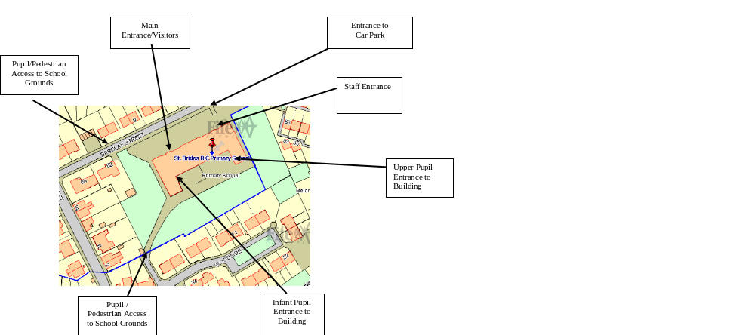

Pedestrians

There are pavements and designated walkways around the school. Pedestrians should make sure that they use these safely and avoid spilling onto the road. Pupils walking in groups should take this into account and allow other users to pass safely.

Pedestrians should only access the school from the designated entry points. Pedestrians need to recognise that these may be adjacent to vehicular access points that will be in use during peak times and should exercise caution.

Designated Entry Points

Pupils should only enter the school grounds by the front gate near the main entrance or by the rear gate from Woodside. Under no circumstances should unaccompanied children enter the school grounds by the car park entrance as vehicles use this narrow opening at all times of day. Adults entering the school on foot through the car park must exercise extreme caution and must be responsible for any children who may accompany them.

Pupils

It is very important that pupils set a good example to others, particularly in the spirit of being a safe school. There are a number of site related areas pupils should be aware of:
- Pupils should be particularly aware that unaccompanied entry into the school ground via the vehicular access points (school car park) is strictly forbidden. Whilst this may seem a quick way into the school, it is a breach of the site rules and compromises personal safety and the safety of others.
- Pupils found to be climbing over walls, not following staff instructions in relation to the site, or not adhering to the contents of this plan will be in breach of the site rules and may be subject to disciplinary action.
- Pupils who are not supervised by a responsible adult must not walk on the car park at any time.
- When using the footpaths – walk! This will avoid accidents and will make you more aware of what is happening around you.
- Pupils are supported in crossing the road before and after school.

Drop Off/Pick Up

Taxis or private cars may use the car park to drop off pupils who must then enter the school playground via the gate in the fence near the main entrance. Pupils being picked up by an adult or by taxi should be escorted out of the main entrance by an adult (usually the taxi driver). Children must not be allowed to walk through the car park unless supervised by a responsible adult.

The school bus/taxis will stop at the ide entrance to the playground for children to access in the morning. In the evening children are escorted to the buses.

Staff

The car park is within the school grounds and these are strictly for use by visitors and school staff. Drivers should proceed slowly within the car park at all times. Please bear in mind that some young people and some pupils with additional support needs may have little or no awareness of road safety and you should take account of this.

Staff are expected to act responsibly on the site when parking and accessing the school building. If you are aware of unauthorised use of parking bays, this should be reported via the school receptionist or to a member of the Senior Leadership Team who will inform/remind the offending driver of the correct use of the site. It would be helpful if staff could supply the school with your registration number so that you can be contacted if there is a need to do so (eg. if car lights are left on).

The main staff car park is situated on the right as you enter the car park, please use the dedicated parking bays as marked. When entering/leaving the car park, drivers should be aware that pedestrians may be crossing the car park access road.

The visitors and disabled car park nearest to the main school entrance is limited to short-term visitors only and has designated disabled parking bays for disabled blue badge holders only. These bays have been adopted and are subject to penalty charge notices for anyone parking without a blue badge.

Visitors

Visitors are welcome to park in the school grounds, but should only park in designated spaces in the visitor car park (on the left as you enter car park). Doing so will allow unrestricted movement of other vehicles during the school day or at peak times. Designated disabled parking bays are restricted to disabled badge holders only.

On street parking is strictly limited in the surrounding area, but if you are unfamiliar with the area, please make sure that you do not block residential driveways or park where this could cause obstruction.

Access into the school is only permitted from the main entrance on Barclay Street. All visitors must report to reception and sign in before going anywhere in the school. Visitors are required to leave a note of their registration number with staff. On departure, visitors should sign out at reception and leave the building by the main entrance door.

Disabled visitors are recommended to use the disabled space within the staff car park nearest to the main school entrance at the front of the building.

If visitors need any advice on access or parking before their visit, please call the school reception on 01383 602431.

Cyclists

Cycle stands are available for use by pupils, staff and visitors. Anyone choosing to cycle should ensure they do so in a safe manner for both themselves as cyclists and pedestrians who will be using the shared 3m wide paths which have been designed for dual use. These paths join the grounds from Barclay Street as part of the wider community cycle network. It would be good practice when entering the school site, in particular at busy times to dismount from your bike and wheel it to the cycle racks.

Servicing / Deliveries

Drivers of service vehicles (if they have not been on the site before or obtained instruction in advance) should report to the reception desk / janitor’s office in the main building to advise the nature of their visit and get clarification on where they can park. Drivers may be issued with a copy of this plan for reference or simply be advised of the site rules in relation to the area they are parking at the time.

Where the contractor is on site to carry out works by prior arrangement, please call the school reception on 01383 602431 in advance to agree the most suitable parking location.

Bus Park

This area is strictly for use by contracted buses. It is essential that this area is not used for a drop off point or parking.

Drivers should be aware that they are working within a school environment – exercise extreme caution and be vigilant when carrying out vehicle manoeuvres in any part of the school grounds.

School Buses

Buses that enter the site to collect mainstream pupils should only access the bus park from Barclay Street. The bus park is situated next to the steps as you enter the car park.

The Senior Leadership Team has designated the bus park for sole use of the buses.

3 buses use the bus park. All drivers should park in the designated bus stance and are instructed to drive in nose first.

The bus should be at a complete stop before allowing pupils to get on or off the bus with the engine switched off. Only when pupils are clear of the vicinity of the bus park (am) or all on board (pm), should drivers exit the bus park following the agreed departure sequence.

Pupils are reminded about good conduct around the bus park in section 4 of this plan, however if there are any other concerns about how this site is being used, they should be raised via the staff supervisors during the afternoon pick up.

Contract Hire Services

Contracted vehicle drivers (including taxis and minibuses) will have specific instructions given to them through Transportation & Environmental Services as part of the terms of the contract. However, there are some specific comments to make in relation to the site at St Brides RC PS.

Minibus and Taxis for mainstream pupils

These vehicles must use the visitor car park located to the front of the school building. Only by agreement with the Senior Leadership Team should the bus park be used out with pupil collection and drop off times.

Minibus and Taxis for ASN pupils

The accessible vehicles (those who use a tailgate to pick up / drop off wheelchair users and require 3 meters clearance at the rear for wheelchairs) or larger vehicles by prior arrangement are permitted to use the visitors / disabled car park between 8.20am and 9.00am and 2.30pm and 3.30pm.

- Drivers should reverse vehicles into place, making sure that it is safe to do so first.
- In the morning, pupils should only be permitted to leave the vehicle, if there are appropriate staff in place to accompany them immediately into the school building.
- At pick up in the afternoon, pupils must wait on the paved area in front of the visitor’s car park next to the main school entrance until and the vehicle they are to enter is in situ and ready for them.
- When vehicles are ready to leave the site, they should not do so unless there are no pupils or staff in the vicinity and it is safe to move off.
- There should be no parental collection/drop off without permission and pavement parking, parking on the grass verges and out of bay parking is strictly forbidden.

Disabled Access

Pedestrian access is primarily via the main front entrance for visitors. There is a ramp at the main entrance.

Parking
There are several disabled bays in the car park and are clearly marked out on the road surface. Access to the disabled parking bays can be found by entering the grounds via the vehicular access and taking a left turn into the visitors parking area.

If visitors, staff or pupils require information on access or any other considerations, they should contact the school reception in the first instance on 01383 602431.

Outwith the School Grounds

The school accepts that parking near the school is not easy. Barclay Street is a main traffic route, used by Service buses as well as car traffic into and out of the surrounding area. It is important that the school is a good neighbour to local residents. Barclay Street is a main thoroughfare and in constant use during the day. Parents/Carers are encouraged not to park near the school and allow their children to walk the remaining distance if they drop them off further away. There are a number of access points to the site within residential streets and we would ask that you respect the people who live in these areas by not using them as drop off / pick up points.

Parking indiscriminately, such as mounting pavements, double parking, stopping on any red / yellow lines, obstructing access points to streets and driveways and parking near junctions causes danger to pupils and other road users. Accidents can arise if views are obstructed or pedestrians have to negotiate between parked vehicles. In addition, the roads can become congested which results in frustration and delays to services and ongoing journeys.

Please act responsibly by parking as far away from the school as possible to keep the pupils at St Bride’s RC PS, local residents and other road users safe.

Management Practices

Key to the ongoing monitoring of the plan is the role of school managers and other staff. All staff have a responsibility to make sure that they are acting in such a way as to not compromise the health and safety of themselves or others.

Supervision

The Senior Leadership Team will carry out supervision / duties at the end of the school day.

Monitoring of compliance against this plan

In addition to the supervision arrangements in place, the Senior Leadership Team will carry out weekly site inspections to view practices. These inspections will be recorded on the ‘weekly site monitoring form’ (see appendix A). These records will be retained for 6 months.

Where issues arise with vehicular access, taxi/minibus drivers and staffing, these will be dealt with or escalated by the school Business Manager. The Senior Leadership Team will be responsible for addressing the conduct of all pupils where this is not consistent with the requirements and expectations of this plan.

Non-compliance

If there are concerns or incidents that constitute non-compliance these will be recorded on the form by those monitoring the site and appropriate action will be taken. This includes possible disciplinary action and reports going to Contractor or Service management which may result in investigative action. On days where there is no monitoring carried out and there is an instance of non-compliance, these should be escalated immediately to the Senior Leadership Team who will make a record on the form and take appropriate action.

Appendix A

OHS-C-23.F5 Site Traffic Management Checklist March 2021.docx

