

St. Bride’s RCPS
Food and Nutrition
Policy

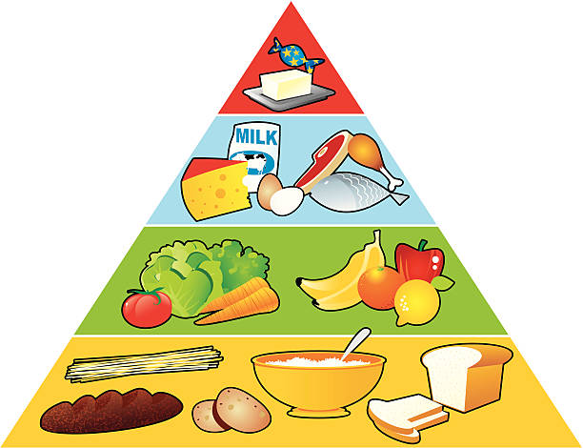

Policy Rationale and Vision, Values & Aims
At St. Bride’s RCPS we strive to promote the health and wellbeing of all children, ensuring that food and drink provided across the school day supports learning, growth and healthy lifestyles.
Our overarching Vision is “Learning Together in Love” through the Values of “Respect, Achieve, Believe.”

Food and Nutrition play an important role in achieving our Vision, Values and Aims and have a positive contribution to the health and wellbeing of children, young people, families, staff, and the wider school community. This includes accommodating all dietary requirements, including cultural, religious, and medical needs, ensuring all children feel included and respected.

Policy Aims
In St. Bride’s RCPS, we aim to:
- Provide our children/young people with nutritious food.
- Build knowledge and skills enabling our children/young people to make well informed food choices in school and beyond.
- Promote good food choices in an environment that supports all children and young people’s health, wellbeing and participation in decision making.
We will achieve this by taking a whole school approach to food provision, food education and the food experience of children and young people attending St. Bride’s Primary School by:
- Providing food choices throughout the school day that meet the requirements of the Nutritional Regulations (2020) in The Schools (Health Promotion and Nutrition) (Scotland) Act 2007 ('the Act').
- Ensuring that everyone involved in the provision of food at school, or educating children/young people about food, is presenting a consistent whole school, health promoting approach.
- Working together with school food providers, pupils, families and partners.
- Ensuring that our approach is based on current dietary advice to support children/young people to have the knowledge and skills required to make well informed dietary choices.
Our whole school food policy is based on a partnership approach that reflects the views of children/young people, parents, school food providers and school staff.

Guidance for the Primary School (5–12 years)

Provision will follow Healthy Eating in Schools 2020 Regulations:
- Breakfast club: Supported by Magic Breakfast and provides nutritious options in line with Fife Council guidance.
- Morning and other break times: Fruit and vegetables: Free fruit will be available for children requiring a snack during break times.
- School Lunches: School lunches will meet nutrient standards, offering increased fruit and vegetables, wholegrains, and reduced sugar, salt, and processed meat.
- Packed lunches from home: Parents will be made fully aware of our food policy at the time of enrolment. This includes samples of lunch/snack menus
- Drinks: Drinking water will be accessible across the school.
- School day trips: A nutritionally balanced packed lunch can be provided via our kitchen or children/young people can bring their own from home
- Other aspects of school life:
- Social, cultural or recreation events: Celebrations will prioritise healthier choices or non-food alternatives. Where treats are offered, frequency will be managed
- School clubs and activities: Standards apply not only at lunchtime but at Breakfast Club and school events, with the exception of events run by the Parent Council such as Halloween Disco.
- Celebrations & Special Occasions: Birthdays are celebrated in school in a variety of ways which do not always involve birthday cakes as we are mindful of the number of sweet treats children may be consuming in a day.
- Learning and teaching/food education: Practical cookery, growing projects, and classroom learning will reinforce key messages (Better Eating, Better Learning). Healthy eating will be embedded through Curriculum for Excellence experiences and outcomes
- Consulting with Stakeholders/Parental engagement: Parents/carers will be consulted regularly about menus, policies, and approaches to ensure consistency between home and school.

Guidance for the Nursery (LSPS Nursery, 3–5 years)
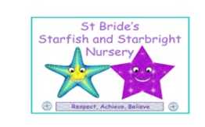
In nursery, all staff use Setting the Table and Fife’s Fabolous Food Guidance, following these standards to ensure all food is healthy and nutritious. We work closely with our families to support this, offering a range of balanced snacks and meals at snack and mealtimes.

Specific Dietary Requirements
Children who are allergic or intolerant to certain foods have a Health Care Plan in place which will be reviewed annually. Staff working with a child who has allergic reactions, or when allergic reactions may be suspected, are aware of their Health Care Plan and any associated care/medication needs.
A photograph of any child with a special dietary requirement or allergy will be displayed in the food preparation area to ensure that permanent and supply staff are aware of each individual child’s needs.

Provision of cultural or dietary preferences
Families and children may choose to exclude, include, or prepare foods in a particular way according to their religious faith and beliefs. Staff follow the council guidance and take account of individual differences and varying levels of adherence to religious laws which would be discussed for each child with his or her parent or guardian regularly and updated on Seemis, as necessary.
Children with special dietary requirements will be included alongside all children at meal times as much as possible.

Responsibility for the Food Policy
In St. Bride’s RCPS this policy is relevant to everyone involved with food and drink on our school premises. Everyone has a role to play in supporting our policy and ensuring compliance with the required Nutritional Regulations.
This includes our school catering team, who provide lunch and breakfast club; and wider school staff who provide food connected through the Curriculum for Excellence and at school events.
The food policy applies to the following times across the school day:

- Breakfast Club
- Morning and other break times
- School lunches
- Packed lunches from home
- Food brought into school
- Drinks
- School day trips

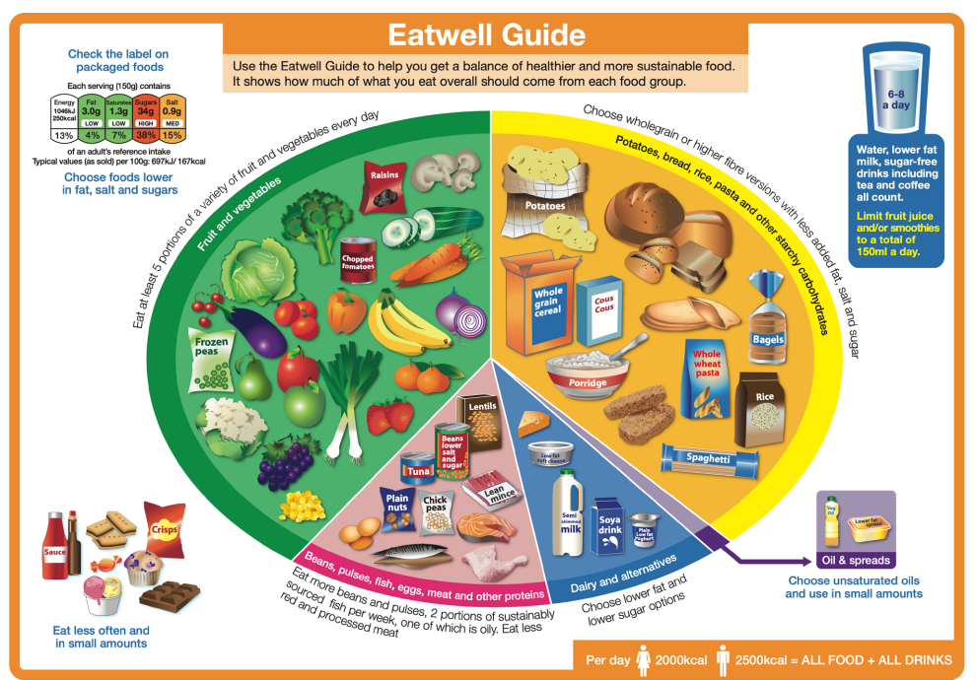

The school Catering Team undertake necessary training in Food Hygiene and follow Fife Council Facilities Management “Cook Safe – Food Safety Assurance System (February 2025).

Monitoring and Review
Compliance with Healthy Eating in Schools Regulations 2020 will be monitored through Fife Council catering services and Education Scotland inspections. Care Inspectorate will monitor nursery compliance with Setting the Table guidance.
This policy will be formally reviewed every three years, with annual interim updates, or sooner if required by legislative or local authority changes.

Date written: September 2025
Review date: September 2028
Member of SLT responsible - Jo-Anne Angel Sep 25

Reference material
This policy is underpinned by the following national and local frameworks:
- Healthy Eating in Schools: Guidance for Implementing the Nutritional Requirements for Food and Drink in Schools (Scotland) Regulations 2020
- Hungry for Success and the Fife Food in Schools Action Plan
- Scottish Dietary Goals (2016) and Scotland’s Diet and Healthy Weight Delivery Plan (2018)
- Curriculum for Excellence and Realising the Ambition: Being Me
- Getting It Right For Every Child (GIRFEC)
- Fife’s Fabulous Food: Fifes-Fabulous-Food.pdf
- Setting The Table: Setting the Table
- UNCRC (Article 24 – right to health, including nutrition).
- Food in schools across Scotland: A self-evaluation resource
- PDF file: Food in Schools sketchnote: Connections (1.4 MB)
- Health Promotion Guidance: Nutritional Guidance for Children and Young People in Residential Care Settings - gov.scot (www.gov.scot)
- Schools (Health Promotion and Nutrition) Scotland Act: Health promotion guidance for local authorities and schools - gov.scot (www.gov.scot)

