

St Bride’s RC Primary
and Nursery


Attendance Policy



Policy Rationale and Vision, Values & Aims


Why Attendance Matters
Positive, sustained attendance is essential for every child’s learning, wellbeing, and success. Regular attendance ensures continuity in education, builds strong relationships, and supports children to thrive in all aspects of school life.

Our Values in Action
- Respect
We respect every child and family by listening, understanding, and working together to remove barriers to attendance. We value diversity and create an inclusive environment where everyone feels safe and supported.
- Achieve
Consistent attendance is key to achievement. Every day in school matters for progress, attainment, and personal growth. We aim to help every child reach their full potential by promoting and celebrating good attendance.
- Believe
We believe in every child’s ability to succeed. By fostering confidence and resilience, we encourage children to believe in the importance of education and their own capacity to overcome challenges.

Our Commitment
We will work closely with parents/carers, partners, and our children to ensure attendance is prioritised and barriers are reduced or removed. Together, we will create a culture where being in school every day is valued and supported

Policy Aims

At St. Bride’s RCPS, we aim to:
- Improve pupils’ attainment by setting high expectations for attendance and punctuality
- Achieve a minimum attendance of 90% for every child
- Create an ethos where positive attendances habits are the norm
- Understand the common barriers to good attendance within the context of our school
- Raise awareness amongst parents/carers and pupils of the importance of positive attendance habits and the impact poor attendance can have on pupils’ attainment, relationships with others and their overall Wellbeing
- Raise awareness amongst parents/carers of their responsibilities in ensuring positive attendance habits for their children
- Recognise the roles played by members of school staff in helping build relationships and encourage positive attendance habits.

Impact of Poor Attendance

Children who are regularly absent from, or late to school will fall behind in their learning. They will also develop gaps in their knowledge and gaps in the development of key skills for learning, life and work.
  - Did you know?


Positive Approaches to Promoting School Attendance

At St. Bride’s RCPS, we are a nurturing school with a warm and inclusive school ethos and culture. We strive to build positive, supportive relationships between staff, children and their families. We have strong working partnerships with parents/carers and we welcome them as part of the life of our school as often as possible. For example, at Sharing the Learning, assemblies, transition events, policy consultation, Parent Council and coffee mornings. As well as this, we have an open-door policy, should parents/carers wish to speak to the school about any concerns.
Staff are supportive in meeting the needs of our children, in identifying additional support needs and other protected characteristics that may link to a barrier to attendance. This includes:
- Care Experience
- Free School Meal Registered (or entitled)
- Caring responsibilities
- Support from Children’s services including on the Child Protection Register
- Health Care needs
- Socioeconomic deprivation

Responsibility of School

Fife Council have clear protocols and procedures in place to support schools with the recording and management of attendance using SEEMiS.
The schools Senior Management team can authorise absence when they are satisfied by a legitimate reason for the request. Reasons for authorised absence can include:
• Illness
• Medical and dental appointments
• Meetings prior to, and during court appearances and other legal processes
• Attendance at, or in connection with, a Children’s Hearing or Care Review, or appointment with another service provider, e.g. social worker
• Religious observance
• Bereavement
• Weddings or funerals of close friends and family
• Participation in non-school debates, sports, musical or drama activities agreed by the school
• Lack of transport – including due to bad weather
• Family recovery from exceptional domestic circumstances or trauma
• Period of exclusion to be recorded in a separate category
• Extended leave with parental/carer consent including some young carer activities
• Family holidays – in exceptional circumstances, usually related to the profession of a parent/carer

  - Absence
If a child is absent from school, without explanation, the school office will send a text alert to parents/carers requesting information regarding absence. Office staff will update the school’s attendance records following a response from parents/carers.
If no response is received after 1 day, a reminder text alert will be sent and if no response is received after 3 days SLT will follow up.

Responsibility of Parents/Carers
Absence
Parents/carers should:
- Inform the school that their child will be absent from school and the reason for this absence, as soon as reasonably possible. Parents/Carers can do this by:
  - Responding to the absence text alerts
  - Phoning the school reception (01592 583444)
- Ensure that medical and dental appointments are made for outwith school hours, as far as is practically possible. When this is not possible, parents/carers should inform the school office of any planned appointments.
- Ensure their child is present in school before and after scheduled appointments.
- Monitor attendance information shared with them in respect of their child, and contact the school to update on any unauthorised absences.
  - Punctuality
Parents/Carers should:
- Ensure that their child arrives in school on time.
- Ensure their child, when late, attends at the school office to sign in and order lunch.
  - Absence for Holidays
Parents/Carers are expected to take their child on holiday during the designated school holiday periods. This is to ensure that there is no impact on attainment or progress. Only those children whose parents work for the armed or emergency services are entitled to have authorised holidays during term time. All other absence due to holidays will be recorded as unauthorised and will directly affect a pupil’s attendance percentage for the session.
  - Absence for Other Reasons
We recognise that there are many reasons why a child may be absent from school and will apply discretion accordingly, based on the information provided. Parents/Carers should discuss this with their child’s class teacher or a member of the school leadership team in the first instance.
If a child is missing from school for 5 consecutive days without explanation, he/she will be subject to Child Protection measures and school staff may refer to Police Scotland to undertake a Welfare Check.

Monitoring and Review
Robust monitoring of attendance is carried out in school, with weekly attendance figures tracked and monitored by SLT.
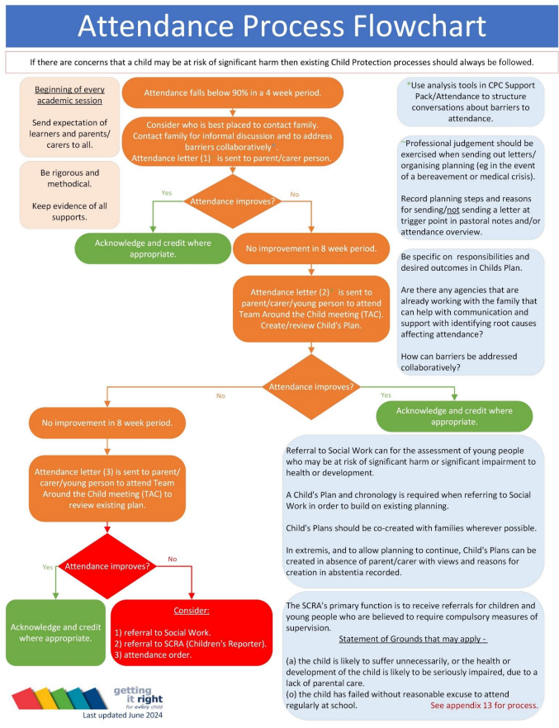
When a child or young person’s attendance falls below 90% in a four-week period and there are no mitigating factors schools, exercising professional judgement, the school should instigate a process of intervention and associated supports as outlined in Attendance Procedure flowchart.

Reference material
This policy is underpinned by the following national and local frameworks:
- Getting it Right for Every Child (GIRFEC)


- Fife Attendance Policy

