
Respect, Achieve, Believe


St Bride’s RCPS
And
Nurseries

Mobile Phone Policy

August 2024

2nd Edition
Revision Log (Every Two Years)

Review Date | Revisions Made | Actions
Jan 2022
Jan 2024 | JA/MB | Updated parent letter
Jan 2026

St. Bride’s RC Primary School

Whole School Mobile Phone Policy

Rationale:

At St Bride’s Primary School and Nursery we are committed to ensuring the safety of children in our care. We recognise that mobile phones in the school and nursery have a role to play for the purpose of communication, but we are aware that casual or inappropriate use of mobile phones could pose a risk to children and adults. The enhanced functions of many mobile phones are of most concern and are most susceptible to misuse. Misuse includes the taking and distribution of images, exploitation and bullying. Mobile phones can cause an unnecessary distraction during the school day and can be intrusive when used in the company of others.

When mobile phones are misused, it can impact on an individual’s dignity, privacy and right to confidentiality. Such concerns are not exclusive to children and young people; hence there is a duty to protect the needs and vulnerabilities of everyone. It can be difficult to detect when such devices are present or being used, particularly in relation to enhanced functions, such as cameras. The use of all mobile phones is, therefore, limited, regardless of their capabilities.

The aim is to avoid distraction and disruption of the school day. Please note that for the purposes of this policy, the term ‘mobile phone’ also covers any electronic device with the capacity to be used as a form of communication eg Smartwatch, either through the device itself or any applications stored on the device.

As a school we are committed to equip our children with appropriate skills for safe online behaviour. We work closely with our local community police and Fife Internet Safety officers.

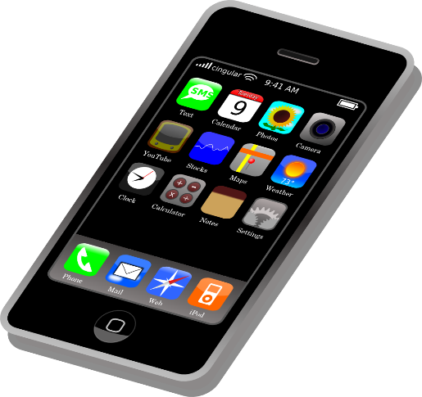
Children/Young People

• Children who walk to and from school without an accompanying adult may need to carry a mobile phone for safety. In addition, children may require to carry a phone to school as returning to a difference home address or for childcare reasons. In these cases, children may bring a mobile phone on to the school building but must hand it to the class teacher at the start of the day and collect it at the end of the day. We take no responsibility for phones in school and children should be encouraged to not routinely bring a phone to school.

• Parents and carers need to be aware that whilst there are obvious benefits to pupils having a mobile phone in terms of personal safety there are also some associated risks such as potential for theft, bullying and inappropriate contact, including grooming by unsuitable persons.

• We would also like to alert parents and carers to the risks that using a mobile phone has while walking to and from school. Children who are concentrating on using their phone can have reduced general safety awareness which may result in road accidents and/or injury if a child is not paying attention to their surroundings.

• Mobile phones given to the class teacher will be kept safely in a locked box. Whilst the school will take every reasonable care, it accepts no responsibility whatsoever for theft, loss, damage or health effects (potential or actual) relating to mobile phones. It is the responsibility of parents and carers to ensure mobile phones are properly insured. It is recommended that pupil’s phones are security marked and password protected.

• Children are not allowed to bring mobile phones into any other areas of the school, and all other out of hours school activities.

• Any mobile phones discovered to have been brought into the school and not handed to the class teacher will be placed in the office. Parents or carers will be asked to collect the mobile phone.

• Children are not allowed to carry mobile phones on any school trips.

• If a member of the staff has any suspicion that a mobile phone brought into school by a pupil has unsuitable material stored on it, the pupil will be asked to hand over the phone immediately to a member of staff and parents or carers will be asked to collect it from a member of the senior leadership team.

Visitors, Parents and Carers

•It is recognised that many parents and carers use their mobile phone as a camera/video device to record their child at special performances e.g. class assemblies, concerts, sports day, etc. On these occasions the use of a phone is permitted for photographing/videoing only; images should only be taken by parents and carers if they only include their own child and that the use of these images is for their own personal use and must not be uploaded for any internet use including Facebook or any other social networking sites or used in any form of publication. Failure to follow this can raise Child Protection issues for children on our school family.

. • We recognise that children may inadvertently be included in photographs by another phones on trips can help to ensure safety for all members of the school or centre party. However, it is important that the following guidance is adhered to in order to keep children safe and protect parents and volunteers from accusations of inappropriate use.

School trip helpers

• The party leader should carry the office mobile phone for use in contacting other staff members or volunteers on the trip, contacting the school or contacting the emergency number.

• Members of staff and volunteers may carry their own, personal mobile phones within the following guidelines:

Personal phones should only be used to contact staff members or volunteers on the trip, the campus or emergency services. If possible, these calls should be made away from children.

• Personal phones should not be used for any purpose other than school business for the duration of a trip. This means that personal calls or texts should not be made or accepted.

• If it becomes necessary for a member of staff or volunteer to make a personal call or text, then the party leader or another member of staff should be informed and take responsibility for the pupils in the group while the call or text is made away from sight and sound of any pupils.

• Parent mobile phones must not be used under any circumstances to take photographs or videos of pupils.

• Volunteers are acting role models for the duration of the trip and therefore must not take photos or videos of any pupils, including their own child, using a mobile phone or any other mobile device, e.g. camera or tablet, without the express permission of the party leader. Volunteers may be asked to take photographs of their group using a school or centre device – this must be passed back to the party leader at the end of the trip.

• The party leader may ask volunteers to provide them with their mobile phone number for the duration of the trip so that they can be contacted in case of emergency. The party leader undertakes to ensure that these numbers or not held on any mobile device or in any written form after the end of the trip.

• It is advised that if the party leader is using his or her own mobile phone, then if they need to contact anyone during the trip they do so by pre-dialling 141 (some mobile providers use a different prefix – staff are advised to check this with their provider) before the number so that their own number remains protected. Appendix 1 provides guidance for volunteers on trips.

Jan 2024

Appendix One

Dear Parent/Carer

Use of mobile phones - guidance for volunteers on school trips

Thank you for volunteering to help on our trip. During the trip we ask that you follow the guidelines below in accordance with the school’s mobile phone policy:

• Personal phones should only be used to contact staff members or volunteers on the trip, the school/nursery or emergency services. If possible these calls should be made away from pupils. Personal phones should not be used for any purpose other than school business for the duration of a day trip.

. • If it becomes necessary for a volunteer to make a personal call, then the party leader or another member of staff should be informed and take responsibility for the pupils in the group while the call or text is made away from sight and sound of any pupils.

• Personal mobile phones must not be used under any circumstance to take photographs or videos of pupils. Volunteers are asked to set an example for the duration of the trip and therefore should not take photos or videos of any pupils, including their own child, using a mobile phone or any other mobile device, e.g. cameras or ipads.

• Volunteers may be asked to take photographs of their group using a school or centre device – this must be passed back to the party leader at the end of the trip.

• The party leader may ask volunteers to provide them with their mobile phone number for the duration of the trip so that they can be contacted in case of emergency. The party leader undertakes to ensure that these numbers or not held on any mobile device or in any written form after the end of the trip.

• It is advised that if the party leader is using her or his own mobile phone, then if they need to contact anyone during the trip they do so by pre-dialling 141 (some mobile providers use a different prefix – volunteers are advised to check this with their provider) before the number so that their own number remains protected.

If you have any questions regarding these guidelines please speak to the party leader. Thank you for your support and co-operation to ensure the safety of all the pupils.

Jo-Anne Angel
Head Teacher

