

St Bride’s RC Primary School
and Nursery


Play Policy

What is play?
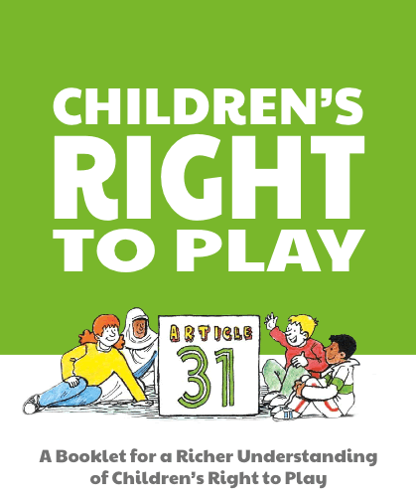
The UNCRC Handbook (2007) describes play as:
“Possibly the most interesting (of the group of concepts) in terms of childhood in that it includes activities of children which are not controlled by adults.”
Article 31 of the United Nations Convention on the Rights of the Child states:
“The right of the child to rest and leisure, to engage in play and recreational activities appropriate to the age of the children and to participate freely in cultural life and the arts.”
The UNICEF Children’s version simplifies this beautifully:
“Every child has the right to rest, relax, play and to take part in cultural and creative activities.”
And as Kay Jamison reminds us:
“Children need the freedom and time to play. Play is not a luxury. Play is a necessity.”
What are the benefits of play?
In Play Scotland’s Play Types Toolkit: Bringing more play into the school day (2012) it has been noted that: “The benefits of play are broad, encompassing: Health and wellbeing; Early childhood development; Cognitive development; Physical activity; Mental health; Emotional wellbeing; Social development; Learning about risk and challenge; Play as therapy.”
To a child, play is about having fun, but to society it is much more. Play is essential to healthy development from birth to adulthood, contributing to capacity for learning, resilience and the development of physical, cognitive, social and emotional skills (Play Strategy for Scotland: Our Vision).

At St Bride’s Primary and Nursery, we place high value on play as a cornerstone of children's growth and wellbeing in early years. Play is not simply a break from learning—it is a powerful form of learning in itself. Through play, children develop essential skills, build relationships, and gain confidence in navigating the world around them. We recognise the importance of play in the following ways:
- It supports brain development, enhancing adaptability and laying the foundation for future learning.
- It nurtures curiosity, independence, creativity, and imagination.
- It contributes to physical health and encourages active lifestyles.
- It helps children understand boundaries and develop the ability to assess and manage risk.
- It enables children to explore their own interests, strengths, and identities within a social context.
- It fosters a positive attitude towards learning and builds skills that last a lifetime.
- It provides emotional support, helping children process challenges and build resilience.
- It strengthens social bonds and helps children form meaningful connections with others.

What does this look like in St Bride’s?
“When children pretend, they’re using their imagination to move beyond the bounds of reality. A stick can be a magic wand. A sock can be a puppet. A small child can be a superhero.” – Fred Rogers
At St Bride’s Primary School, we are dedicated to creating an environment where play is recognised as a powerful and purposeful part of learning in the early years of primary school. Our approach is rooted in the belief that children thrive when they are given space, time, and trust to explore through play. Here's how this commitment is reflected in practice:
- Child-led learning: We place children’s interests and ideas at the heart of our planning. Through regular observation, we gather insights into what engages them and use this to shape meaningful learning experiences and provocations.
- Flexible curriculum design: Our curriculum is designed to be responsive and adaptable. Teachers are empowered to collaborate across classes, enabling more efficient use of space and resources.
- Varied daily experiences: Children engage in a balanced mix of whole-class teaching, small group work, and free-flow protected play. Outdoor learning is offered at various points during the year.
- Thoughtfully prepared environments: Our classrooms are calm, inviting, and rich with opportunities for open-ended play. Areas include construction, roleplay, expressive arts, reading, writing, numeracy, fine motor activities, and sand play.
- Sustained provocations: Play areas are maintained for at least a week to allow children to fully immerse themselves and for educators to observe and extend learning meaningfully.
- Protected free-flow play: We ensure that children are genuinely leading their play, rather than completing teacher-directed tasks disguised as play.
- Focused observation and assessment: Staff use observations, focusing on individual children regularly. A range of assessment methods supports ongoing understanding of each child’s development.
- Active adult involvement: Staff participate in play to build relationships, enrich vocabulary, and support learning in the moment.
- Commitment to professional learning: Staff regularly engage in authority offerings to deepen their understanding of play-based pedagogy and refine their practice.

High-Quality Play Spaces
Across early level, we are committed to providing environments that inspire curiosity, creativity, and independence. High-quality spaces are the foundation for meaningful play experiences. Staff refer to the High Quality Spaces Core Provision Document to ensure consistency across nursery and P1 settings. Please click the link below for more information:
📂 Core Provision Guidance:
High-Quality-Spaces-A-Core-Provision-Interactive.pdf
This guidance helps us design spaces that:
✅ Offer a balance of indoor and outdoor play
✅ Include open-ended resources for exploration
✅ Support all areas of development
✅ Reflect children’s interests and cultural diversity
“When children play they are engaging in a complex process that affects all aspects of their development. The role of the adult in play is equally complex, because the adult must develop a repertoire of responses that are appropriate to each individual play situation, appropriate for children at different points in their development and responsive to a range of individual needs.” And: “From their very early days, babies and toddlers need opportunities to play freely. Adults should respond to their playful responses and be proactive in initiating these too.” (Free Play in Early Childhood). “The role of the playworker is to support all children and young people in the creation of a space in which they can play…Playworkers choose an intervention style that enables children and young people to extend their play. All playworker interventions must balance risk with the developmental benefit and wellbeing of children.” (Extracts from the Playwork Principles).

Continuous Improvement Through Quality Audits
To ensure our play environments remain engaging and inclusive, we regularly review and improve our provision using audit tools. These tools allow us to:
- Assess the quality and accessibility of resources
- Identify gaps and plan enhancements
- Align practice with national guidance and children’s rights
📋 Audit Tool:
High-Quality-Spaces-Audit-Tool.pdf
By using these audits, we maintain a cycle of reflection and improvement, ensuring every child experiences play that is safe, stimulating, and developmentally appropriate.
Staff use their own planning documents to plan for and record children’s play. These can be found in the nursery planning folder for Nursery Children or on OneNote for Primary Children. An example template for school can be found below:
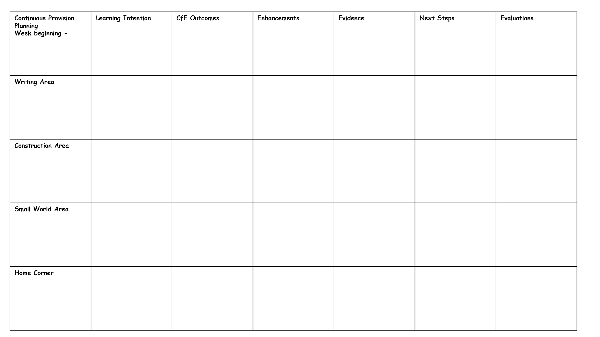
Risk Benefit Assessments
Striking the right balance between protecting children from the most serious risks and allowing them to reap the benefits of play is not about eliminating risk. Nor is it about complicated methods of calculating risks or benefits. In essence, play is a safe and beneficial activity. Sensible adult judgements are all that is generally required to derive the best benefits to children whilst ensuring that they are not exposed to unnecessary risk. All children both need and want to take risks in order to explore limits, venture into new experiences and develop their capacities, from a very young age and from their earliest play experiences. Children would never learn to walk, climb stairs or ride a bicycle unless they were strongly motivated to respond to challenges involving a risk of injury.
The Care Inspectorate supports care service providers taking a positive approach to risk in order to achieve the best outcomes for children. This means moving away from a traditional deficit model that takes a risk averse approach, which can unnecessarily restrict children’s experiences attending registered services, to a more holistic risk benefit model.
At St. Bride’s we consider the benefits and meta skills that children can develop through play experiences, as well as assess the risks involved. These can be found in the risk assessment folder within our nursery.
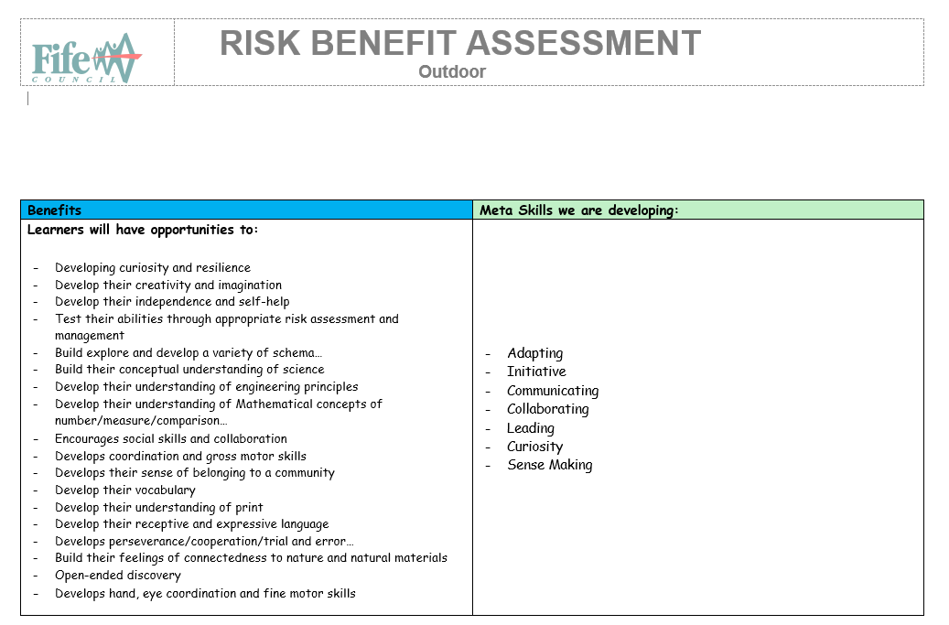

Observing Children’s Play
Staff will record children’s play achievements in lots of different ways, most notably through Seesaw, PLJs, Floorbooks and Observation records. Examples of observation templates can be found below:
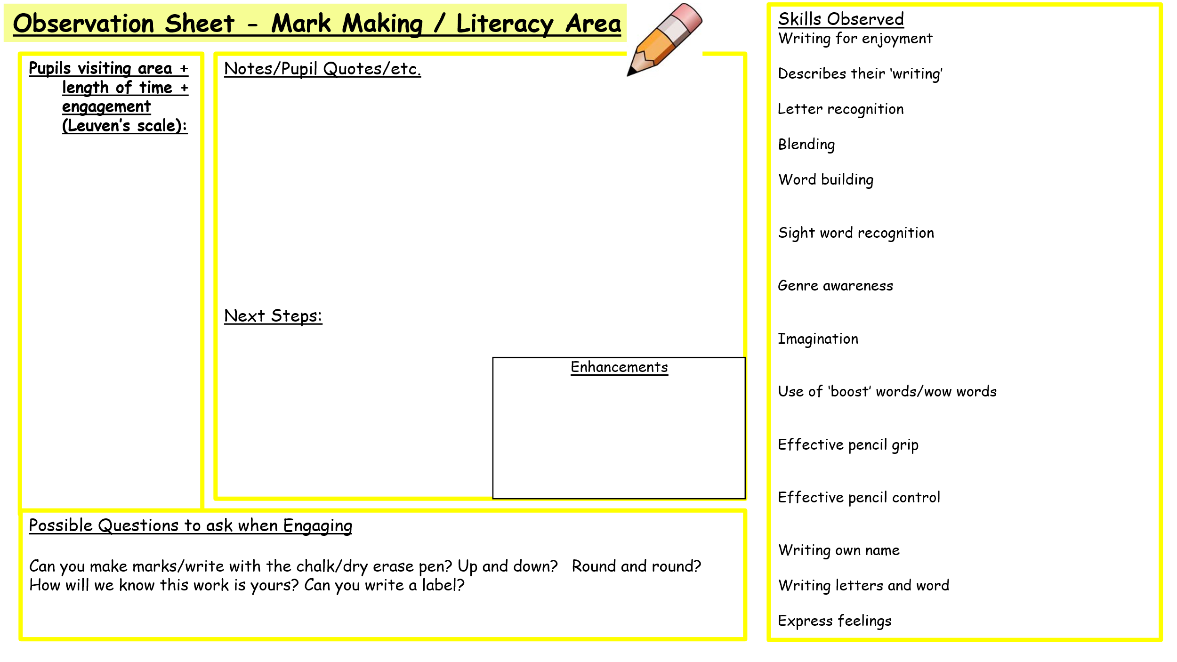
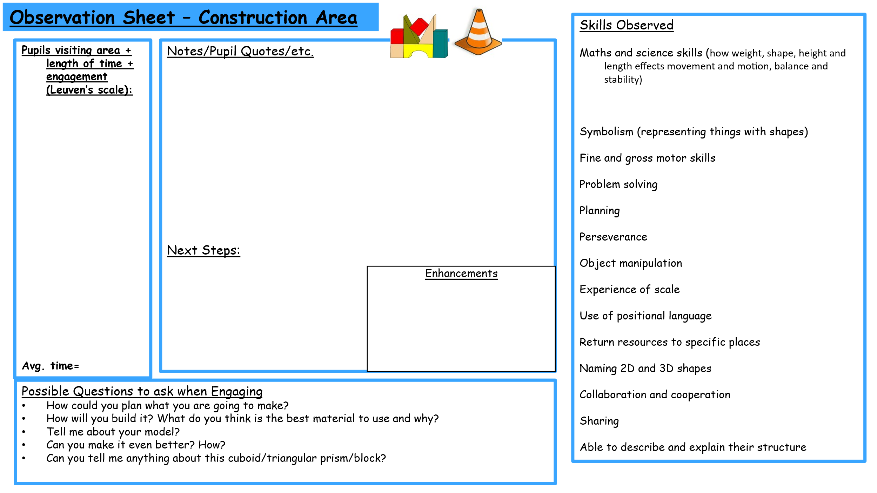
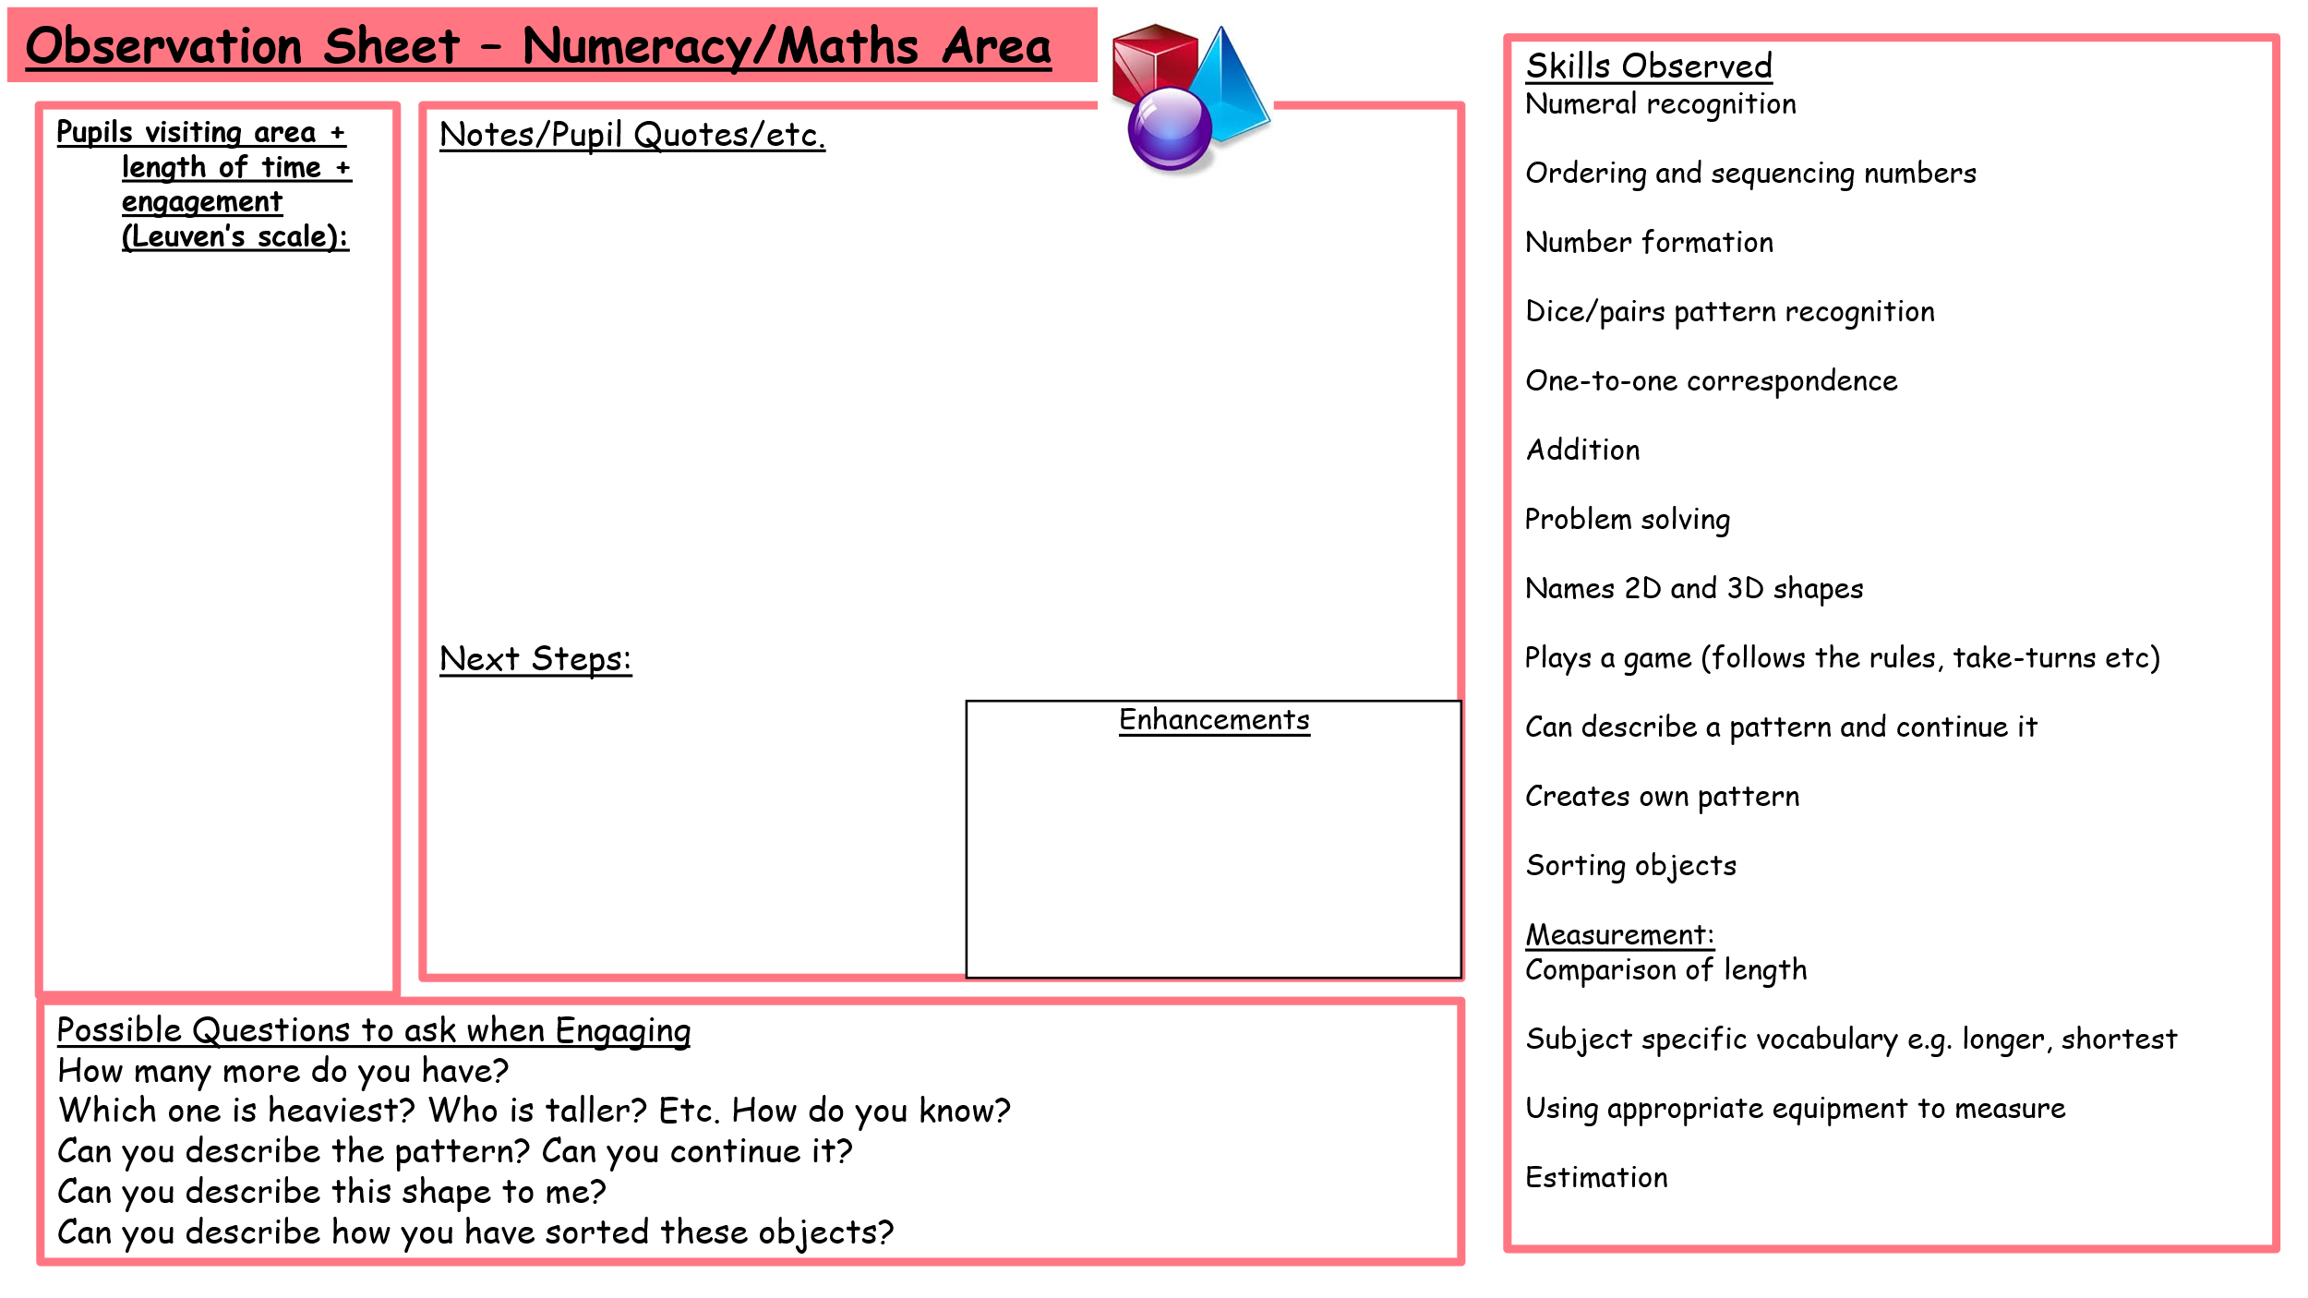
More examples of these are held centrally in our Play Policy folder.

