# Generated image

**Fresh Air Frankie’s**

**School Travel Plan**

School: St Bride’s RC Primary School

Headteacher: Joanne Angel

School address: Barclay Street, Cowdenbeath, KY4 9LD

Telephone No: 01383 602431

Social Media/Website: [Website](https://blogs.glowscotland.org.uk/fi/stbridesrcps/)

**Contents Page**

**3: 1.0 WHY HAVE A SCHOOL TRAVEL PLAN**

**3.: 2.0 BENEFITS OF HAVING A SCHOOL TRAVEL PLAN**

**4: 3.0 Current Travel Habits**

**3.1 Family Questionnaire Data**

**10:** **4.0** **ROUTE AUDIT OF KEY ROUTES TO SCHOOL**

**4.1 Access Arrangements**

**11:** **5.0** **ACTION PLAN**

**12:** **6.0** **MONITORING AND EVALUATION**

**12:** **7.0** **DISTRIBUTION OF SCHOOL TRAVEL PLAN**

**1.0 Why have a school travel plan**

School-related traffic congestion and the risks congestion pose to the safety of the pupils, teachers, parents, residents, and motorists in and around school locations is a significant problem in communities around Fife.

The most obvious cause of traffic congestion around our schools is vehicles, and the biggest source of those vehicles is parents’ dropping off and picking up their children from school.

Statistics highlight that 1 in 4 cars during the hours of 8:30 to 9:15 and 2:30 to 3:15 is primary school traffic.

Encouraging active travel—such as walking, cycling, or scooting to school—offers children a healthier, more energising start to their day. It helps improve physical fitness, boosts mood and concentration, and reduces traffic congestion and pollution around school gates, making the environment safer for everyone.

Fife Council’s Road and Transportation Service are working with schools in Fife to develop School Travel Plans; a practical framework to promote sustainable travel and address barriers families may face by supporting Frankies Active Campaigners Team (FACT) to lead activities, raise awareness, and celebrate progress. These initiatives empower children to take pride in their choices and inspire others to get moving – making active travel a positive part of everyday school life.

**2.0** **BENEFITS OF HAVING A SCHOOL TRAVEL PLAN?**

The benefits of encouraging active travel are clear and a school travel plan can ensure that your school has a long–term vision with aid to support your FACT group with delivering campaigns that will;-

* Improve health and well-being by reducing harmful emissions and increasing activity levels.
* Improve safety through engineering measures and increasing road safety education.
* Improve access and opportunity by developing pupils’ skills for safe and independent travel.
* Improve the environment by reducing pollution and CO2 emissions.
* Gain school accreditations such as Fresh Air Frankie STP Awards, Active School Award and Eco Schools.

All work associated with School Travel Planning has been designed to fit into the Curriculum for Excellence.

**3.0**  **CURRENT TRAVEL HABITS**

Each year all Fife schools undertake the hands up survey which gives a true reflection of how pupils are travelling to school, and the 2024/25 results show that 48% of pupils are actively travelling to school. However, with over 34% still being driven to school the school must remind parents of their responsibilities around the school gate.

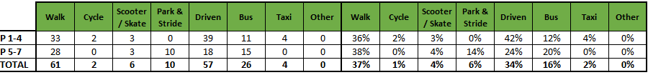

**3.1 Family Questionnaire**

43 families answered the online questionnaire, and the results are as follows.

**What year group is your child/children in?**

**How far do you live from the School?** 30 of the families that completed the questionnaire said that they live within a 1-mile radius from the school.

**How long does your journey usually take?** 30 families live within 10 minutes from the school. Now let’s break this down further to see how they travel!

**How many families who live within 1 mile and travel less than 10 minutes take the car?**

13 out of the 30 families who live within 1 mile and whose journey takes less than 10 minutes travel by car.

**Breaking the data down to those who live within the shortest distance to school with the shortest travel time and travel by car, these are the reason for using this mode of transport.**

**Here are some tips to overcome these concerns:**

**Journey combined with another trip (e.g., commuting to work)**

* Consider parking a little away from school and walking the last 5 minutes together—your child still gets the benefit of active travel even if you need to drive on to work.

**2. Concerns about child safety**

* Join or start a ‘walking bus’ or buddy system so children travel together with adult supervision.

**Bikeability is offered to all schools in Fife. Would you be interested in undertaking cycle training to help with the delivery of Bikeability within the school?**

* There are a lot of parents who try to get as close to the school as possible which makes it harder being on foot as there are so many cars at the back and at the front of the school. Cars continue to park on the pavement at the back of the school meaning sometimes at 3pm you’re having to go into the middle of the road to get past them it isn't ideal and it's a bit selfish of road users.
* It is well and smooth
* Need more parking options
* My little one currently gets a school taxi/bus to school, she enjoys it and it’s very helpful given I have another very young child at home. The only part I would bring to attention is the need for supervision upon dropping off at the school - the part between children getting off the bus/taxi and the school bell ringing. At the moment children (young children p1-7) are unsupervised during that time.
* No apart from the dog poos on the pavement all the time
* The problem with where we walk from is all the cars parking on the pavement at top of school exit at Moss Side rd. /woodside mostly bad at night
* I drop my child at a childminder who lives more than 2 miles away and due to the children she childminder has to drive to school.
* My son gets picked up from Lumphinnans and dropped off in Cowdenbeath for school, via school taxi (bus), and gets dropped off when it's home time. Traffic is usually alright and steady, comes home within the half hour of school finishing as there is other bairns to get dropped off around the area.
* Having more than just the school carpark to park our cars would be great. Especially now that we are getting fined for parking on the pavement at the top of the school gate
* Feel the school could make a safe gated pathway from mosside road to the school so children aren’t near the cars
* The parking is rather tricky and quite dangerous. Parents are parking in the staff car park, and I have witnessed very close near misses of children almost getting hit.
* Sometimes cars are parked on the pavement and also often block the middle of the path near the rear gate. Some parents need to drive because they go to work after dropping off their children, but there isn’t a safe public car park near the school.

**3.2** **Staff Questionnaire**

**How far do you travel to work?**

**How do you travel to work?**

**Number of Staff who live under 2 miles and travel by car.**

**What would encourage you to consider an alternative mode of transport to work?**

* I live in Dunfermline so my car is essential for my job, especially when I have to move around from other education establishments.
* I would only drive to work
* Don't feel I have time for public transport and too many resources to carry.
* Need car for job i.e going to the bank and post office
* As I must drop my young children off with Grandparents on my way to work I am unfortunately unable to use an alternative mode of transport.
* When I don't need to drop my daughter off.
* Car share
* Safe place to keep bike
* Reliable, frequent, inexpensive public transport.
* As a teacher it is difficult to consider another mode of transport to work as I often have many things to carry or bring in and particularly in the winter months, I do not wish to walk in the dark myself.
* Working closer to home
* I have considered cycling

**Are there any improvements you could make to your journey to ensure the routes to school are less congested?**

* I drive early and use the dual carriageway.
* I arrive early, so no congestion.
* Walk more
* My Start and finish time aren't at congested times.
* No as long is there is a lollipop person to keep children safe.

**Is there anything else you would like to tell us about your journey to work?**

* Being safe in the dark mornings and evenings walking home.
* The car is quicker and easier. I don’t want to increase my travel time by 15mins at least by getting the bus which would probably cost me more money.
* I travel to work daily on the bus, and it takes 15 mins of travel time.
* I have considered cycling, however I just need to look at where to safely store my bike while at school.
* No, I was quite a nervous driver and I stay in Kirkcaldy so it has forced me to become more confident driving longer journeys.

**4.0 MAPPING WORK AND ROUTE AUDIT**

By analysing the geographic distribution of pupil residences, we identified key clusters and common travel corridors that assisted in creating a strategic map of routes that prioritise safety, accessibility and connectivity to the school using existing infrastructure.

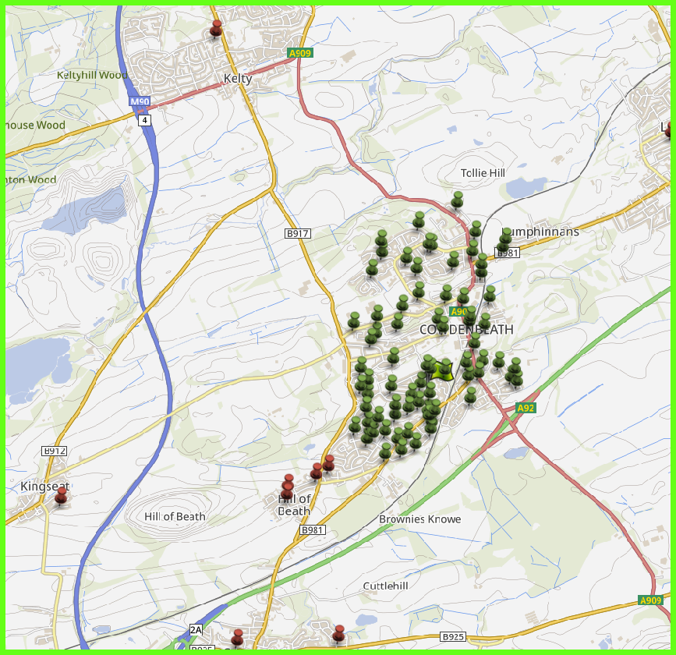

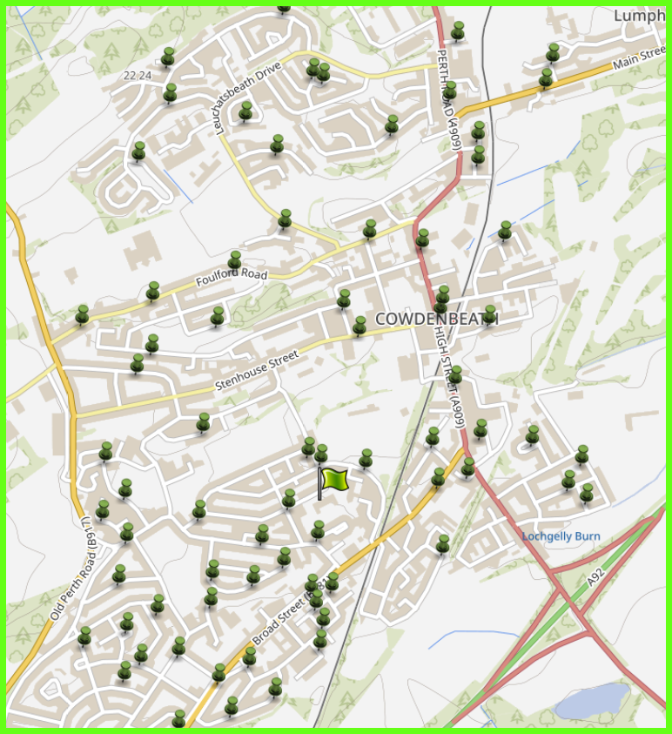

**4.1 Access Arrangements**

There are 2 pedestrian entrances to the school building. The main school entrance is located on Barclay Street and the other is accessed from Woodside and leads directly into the school playground.

All cars, including staff and visitors, can park at the front of the school accessed from Barclay

Street. This area has been fenced off from the children’s playground and is out of bounds to

children for safety reasons. Delivery lorries and vans use this parking area to drop off to the

kitchen and bring orders into the school by the main entrance. Parents also park here

temporarily when picking up or dropping off children or when visiting the school.

**Route Audit Report: Catchment Area**

**Overview:**   
This audit assesses the pedestrian infrastructure and safety features along key routes to school within the residential area of the school. The area benefits from wide pavements, adequate dropped kerbs, and traffic calming measures including 20 mph speed zones.

**Key Findings:**

1. **Pavement Quality and Width:**

* Pavements throughout the area are consistently wide, allowing for safe passage of children, parents, and mobility aid users.
* Surfaces are generally smooth and well-maintained, with minimal trip hazards or obstructions.

1. **Dropped Kerbs and Crossing Points:**

* Dropped kerbs are present at all major junctions and crossing points, supporting accessibility for wheelchairs, pushchairs, and visually impaired pedestrians.
* Tactile paving is in place at most crossings, enhancing safety for visually impaired users.

1. **Traffic Calming and Speed Limits:**

* The 20 mph speed limit is clearly signposted and contributes to a safer environment for school children.
* Residential streets show evidence of traffic calming features such as speed humps and narrowed carriageways.

1. **Visibility and Lighting:**

* Street lighting is adequate along main routes, ensuring visibility during early morning and late afternoon travel times.
* Sightlines at junctions and crossings are generally clear, reducing the risk of vehicle-pedestrian conflict.

1. **Transition to Main Distributor Road (30 mph):**

* Exit from the 20 mph residential zone joins a main distributor road with a 30 mph speed limit.
* This road experiences higher traffic volumes and speeds, presenting increased risk to pedestrians.
* Pavement width remains adequate and although crossing points are less frequent they are managed by signalised crossing points.
* Visibility at junctions and crossing points are good.

1. **Signage and Wayfinding:**

* School Patrol signage is visible on Broad Street, there is also a part time 20 mph restriction during school drop off and pick up times.

1. **School Car Park**

The school car park has a very narrow entrance and at times can be very busy. Parent parking should be discouraged as access is required for school transport.

**Conclusion:**

While the main distributor road is a necessary part of the school route network, it does not present significant safety and comfort concerns for families. The main issued raised by parents who actively travel to school is that of parent parking behaviours.

The school could look at setting up an official park & stride site or look at creating a drop off zone on Chapel Street where pupils could walk the last few minutes of the journey through the off-street routes to school.

As the school has opted to complete their travel plan this year without setting up a FACT group to work with the school travel plan team it is suggested that the school should try to take part in the actions set out in section 5 and send out social media posts created by the school travel plan team for each term.

**5.0** **ACTION PLAN**

|  |  |  |
| --- | --- | --- |
| **Action** | **Solution** | **Action Owner** |
| Promote School Travel Plan | * Upload plan to website and social media pages. * Create a FACT notice board. * Upload generic social media posts throughout each term. * Keep the school travel plan team updated on all work carried out by completing your FACT floor book. | School |
| Fresh Air Frankie Awards Campaigns | **Term 1**  Hands up Survey Active Travel  FACT Assembly about Active Travel Month  Send out generic Social Media Posts  Active Travel Month (distribute and collect Fresh Air Frankie  Travel Passports)    T**erm 2**  Launch #dontparkhere Campaign  FACT Assembly  Send out generic Social Media Posts  Road Safety Week  T**erm 3**  Frankie’s Step into Spring Campaign  FACT Assembly  Big Walk and Wheel    T**erm 4**  FACT Assembly about Active Travel Month  Send out generic Social Media Posts  Active Travel Month (distribute and collect Fresh Air Frankie  Travel Passports) | School – full details held within your FACT folder |
| Reduce congestion | Consider developing the following:-  Parking Pledge  Walking Bus  Campaigns to increase active travel to school. | School – full details held within your FACT folder |
| Bikeability | Deliver Level 2 Bikeability and apply for Cycle Friendly School Award | School/Bikeability |
|  |  |  |
| Annual Active Travel Award | Top 3 schools that can showcase the largest increase in Active Travel to School will be crowned champions. Data will be collated from the HUSS and our own travel tracker. | School/Travel Plan Team |

**6.0 MONITORING & EVALUATION**

The FACT will continue to meet periodically to monitor progress and amend strategies to comply with the actions set out in this plan. Specific progress will be monitored by participation in the “Hands Up Travel Tally” each year and a repeat of the full travel survey will take place in 2031/32.

The school’s ongoing commitment to travel planning will be publicised in the school handbook, the school newsletters, the Parent’s notice board and through assemblies.

**7.0 DISTRIBUTION OF SCHOOL TRAVEL PLAN**

The following bodies will receive a copy of the School Travel Plan:

• Fife Council Sustainable Transport and Travel via the Travel Plan Team

• Fife Council Education Service

• Parent Partnership

• Copies will also be made available to the parents from the School Office and via

the school information sites.