REGISTER YOUR ACCOUNT
To use the online payment service, you will need to register with mygov.scot for a myaccount.

- Go to www.fifedirect.org.uk/schoolpayments

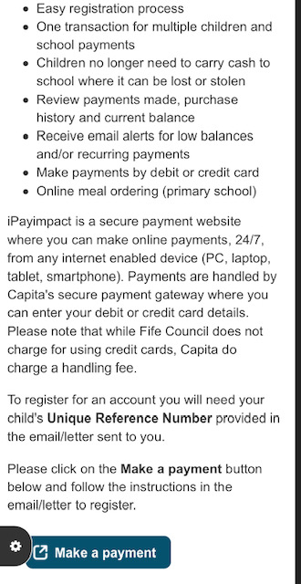

- Click on Make a Payment which then takes you to the login screen.
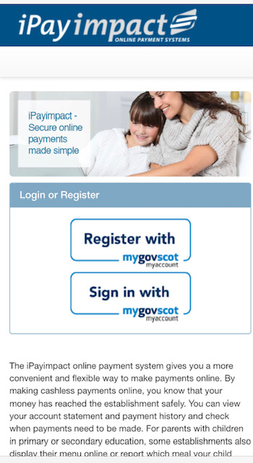

- Click on Register with Mygovscot.

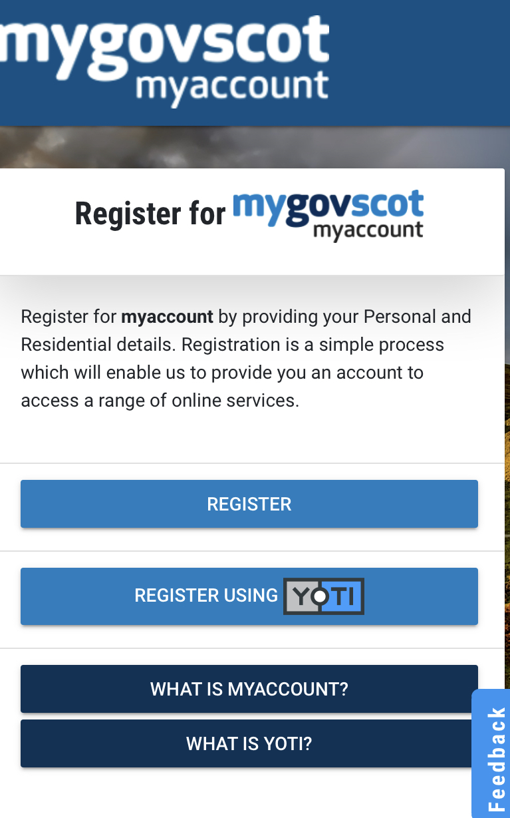
- Click on Register to create a new account
- Follow the instructions to register your account (please use YOUR DETAILS and not your childs).
- Once registered, you will be sent two emails; one with your username and another with a one-time-use password.
- To ACTIVATE your account you need to;
- click on the link provided in the email
- log in with your username and one-time-use password (you will be prompted to create a new password)
- enter your child’s unique account Reference Number (above).
- If you have more than one child at the school, you can add them to your account (you will receive an individual email / letter for each child with their unique account Reference number)

More information about our online payment system including how to pre-order meals, can be found on our web page www.fifedirect.org.uk/schoolpayments.

