Welcome to School!

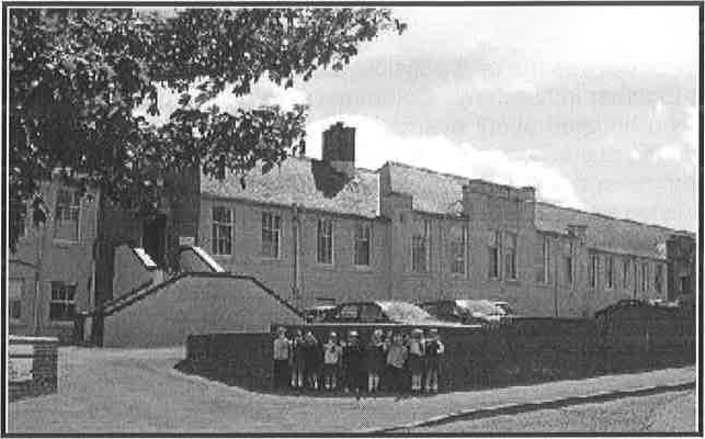

A Guide to Primary 1

St. Bride's R C Primary School

2024-2025



# School Information

Thank you for choosing St. Bride's RC Primary School.

The information in this booklet will help you to prepare your child for starting School in August.

## Partnership

To ensure that your child receives the best possible education, it is essential that school and parents /carers at home, work together in harmony. Communication is an important part of any relationship. The school will keep you updated about events and key dates in our school calendar through our newsletters. We also use our school app to send text messages and emails as reminders of up-coming events. Our school app is free to download and a leaflet with how to do this is included! I would also ask parents/carers to keep school staff updated with any changes at home that may affect the work of your child at school. In this way we can work together to ensure your child is successfully supported here at St. Bride's.

To read our school booklet, please visit - <https://www.fife.gov.uk/kb/docs/articles/education2/schools-in-fife/primary-schools/primary-school-booklets/st-brides-r-c-primary-school>

## Preparing for School

It is important to build up your child's independence and self-confidence and a good deal of work has already been started at home and in the Nursery in relation to this!

* Children will need to learn how to change for gym and back again within a set period of time.

 Please make sure that your child can use a knife and fork (help is always on hand to cut things like fish or pizza etc.)

* Please encourage your child to recognise their own name — which should be written on all their belongings e.g. P.E. items, bag, clothing etc. Remember that one school sweatshirt is identical to the next!
* Please make sure that your child is able to use the toilet unaided and knows to wash his/her hands afterwards. If you have any concerns please talk to a member of staff.

# School Lunches

Pupils can choose for your child to have a school lunch or can bring their own packed lunch from home. The lunchtime break for P1 is from 12.35 — 1.20pm. School menus are on the new online payment system (IPAY). Parents will need to login to this system. Pupils can choose their meal with you at home or each day in school. IPAY registration letters will be given to all parents and carers.

**Special Diets**

Should your child have a specific dietary requirement e.g. a specific food that they cannot eat for health or religious reasons, please complete the online [**Specific Dietary Requirement Form**](https://www.fife.gov.uk/__data/assets/word_doc/0022/502924/SDR-Form-2023-V6.docx). The school cook and manager will arrange to meet with you to discuss how best to fulfil your child’s needs.

If your child prefers a vegetarian diet there is a selection of suitable dishes on the menu every day and you don’t need to complete a Specific Dietary form.

Fife school meals do not use any ingredients containing nuts, but some products may be made in a non-nut-free environment. You can [**check the recipes online**](https://fifecouncil.mysaffronportal.com/).

**Free Meals**

* **All children in Primary One to Primary Five are entitled to a Free School Meal**.  Children in Primary Six and Seven that are not eligible for the [**Free School Meal Entitlement program**](https://www.fife.gov.uk/kb/docs/articles/education2/schools-in-fife/free-school-meals-and-school-clothing-grants) can also enjoy the same Two Course Meal choices for just £2.50 per day.
* Pupils can have soup **or** dessert with the main meal as part of a two-course lunch, this also includes a drink of either milk or water. They are also entitled to a piece of fresh fruit.
* For our main meal options, we always have a vegetarian option and plated salad or filled roll/sandwich options with a choice of fillings.

## **Milk**

Milk is paid termly, this can be paid via IpayImpact or by cash at the main office. Updates regarding milk payments will be communicated on the school app.

## Uniform

Children will be given a school tie before they begin Primary 1. Our uniform consists of black, grey or navy trousers/skirts and cardigans/sweatshirts, white polo shirt or shirt. Uniform can also be purchased from [www.alansantryschoolwear.co.uk](http://www.alansantryschoolwear.co.uk).

Parents/carers can also apply for a clothing grant if they are on low income, for more info, please visit <https://www.fife.gov.uk/kb/docs/articles/education2/schools-in-fife/free-school-meals-and-school-clothing-grants>.

Classroom Arrangements

When starting School, each child will have a peg and a tray with their name.

It would be helpful if you could provide your child with the following:

* Velcro fastening shoes unless your child is able to tie their own laces.
* 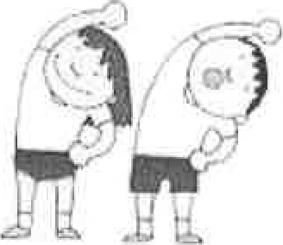Gym bag with T-shirt, shorts and gym shoes (all named).

This is hung up on their peg or put into their tray.

* A school bag — big enough to hold books.
* Children should have a water bottle and are encouraged to drink water throughout the school day.
* A healthy snack, for example a piece of fruit or a cereal bar may be brought from home to eat at morning break.

## Home & School Link

Children will bring home a "shared reading" book and homework jotter for parents to comment. The emphasis here is to encourage you to spend time enjoying a book with your child — a simple comment relating to how your child responded to the story is requested.

At a later date, children will also bring home a word bank of common words, taught in School, to be reinforced at home. This type of partnership in your child's education is greatly valued.

# The Big Day 21st August 2024

At this point, we intend that all Primary 1 children will start this day **at 9.10a.m and end at 2.50pm.** Please bring your child to the infant playground for 8:50am. You and your child will then be brought to the P1 classroom by our staff. We encourage parents to leave as soon as their child is settled — this stage can often be more traumatic for parents and guardians than for the child!

# The Playground

Our Playground is supervised by our Pupil Support Assistants. Our primary 7 playground buddies assist the adults in organising games and activities for our children in Primary 1-3.

# P7 Buddies

Our P7 pupils will act as buddies to the P1 children. The P7 's will help the children get ready for breaktimes, and gym, help with lunches, and also at various events during the first term in school.

# Calling into School

When calling into School we would be grateful if you would always report to the School Office where Miss Mannarn or Mrs Jack will be there to help.

If you have any concerns about your child, please do not hesitate to telephone or call in and discuss them. If the class teacher or Headteacher Mrs Angel/ Depute Headteacher Ms Burke are unable to see you immediately, you will always be offered an appointment at another time.

Please avoid discussing your child's progress with classroom teachers when they are bringing the children into class in the morning — remember that they have a large active group of eager learners, ready to face the challenges of another new day!!

I hope that this information will be useful. If there are any further questions regarding starting Primary 1, please contact us. See you soon!

St. Bride's Telephone Number: 01383 602431

Email: stbridesrcps.enquiries@fife.gov.uk