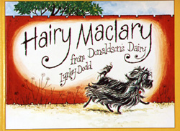

https://www.booktrust.org.uk/books-and-reading/have-some-fun/storybooks-and-games/hairy-maclary/

Hairy Maclary from Donaldson’s Dairy by Lynley Dodd

Here are some suggestions to use with this story.

Literacy

- Talk about any new words the children are hearing to develop their vocabulary.
- Can you join in with the line ‘and Hairy Maclary from Donaldson’s Dairy’ every time you hear it?
- Look at the pictures. Can you describe what each character looks like?
- Try and retell the story in your own words.
- Draw your favourite part of the story.
- Act out parts of the story. For example, the dogs all walking along…and then they meet Scarface Claw!
- Pick out and talk about the rhyming words. Can you think of other rhyming words?
- Try saying the dog’s names and clapping the syllables in them.

Numeracy/Maths

- How many dogs are there altogether?
- Which dog does Hairy Maclary meet first? Which dog does her meet next?
- Which dog does he meet last?
- Look for the door numbers. Which number does each dog live at?
- Are the numbers getting bigger or smaller as the story goes on?
- Which dog is the biggest? Which dog is the smallest?

Health and Wellbeing

- In the story, how did the dogs feel when they met Scarface Claw?
- How do you think Scarface Claw was feeling?
- Have you ever felt like that? What happened to make you feel like that?
- How does Hairy Maclary feel at the end of the story?

Puppy Dog, Puppy Dog

Puppy dog, puppy dog,

Wag your tail.

Puppy dog, puppy dog,

Let out a wail.

Puppy dog, puppy dog,

Jump for a bone.

Puppy dog, puppy dog,

Run on home!

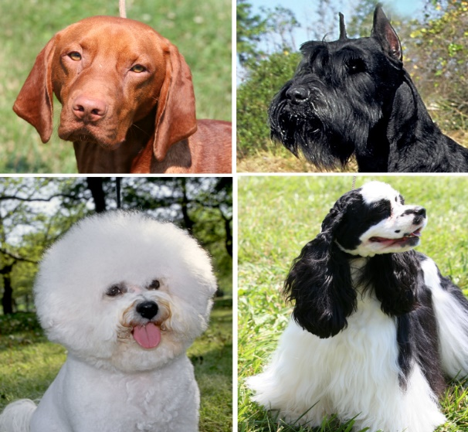

Can you say the rhyme together?

Which words rhyme in the poem?

Can you act the rhyme out?

