ST ANDREWS NURSERY

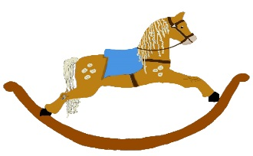

HOME LEARNING ADVICE

Issue 23

Over the coming weeks we wish to support you with ideas on how you can support your child’s continued learning at home.

In this bulletin the team have produced some suggestions on how to keep learning going at home.

THE IMPORTANCE OF PLAY
Play is how our youngest children’s learning and development. It will be very important that time is made within a day for quality play experiences.

Playing alongside your child at times during the day is going to have the maximum impact. This will provide them with the security and comfort that they will require over the coming weeks, but it will also help you have fun together.

Play enables children to develop a range of skills including communication, problem solving, imagination, co-operation etc.

It can take place indoors or outdoors.

The following web links may provide further information and practical ideas.

https://www.playscotland.org/parents-families/

https://education.gov.scot/parentzone/learning-at-home/learning-through-play/

ONLINE RESOURCES
Suggested resources and links have been included below to support learning and development.

As with any online resource, parental guidance and supervision is recommended to ensure children are accessing these in a safe and appropriate manner.

Manfred the Baddie
by John Fardell

With your child watch and listen to the following story being read aloud on.

https://www.youtube.com/watch?v=F1buXrttOCc

Here are some suggestions to use with this story.

Literacy
- Design your own crazy machine, describe what it is for and label all the different parts. Would your machine be for good or bad?
- Write a recipe for your favourite sandwich, get an adult to help you.
- Try to retell the story in your own words.
- Draw your favourite part of the story.

Numeracy/Maths
- Get an adult to help you to create a series of instructions for making the sandwich.
- When sharing out the sandwiches how many bits does everyone get. Do they all get the same?

Health and Wellbeing
- Would you be Manfred’s friend if he was this bad? Why?
- Talk about why Manfred was bad and how he became good.
- Make your favourite sandwich for you and your family to have at lunch time.
- Who looks after you when you have a cold?

RHYME TIME

Polly put the kettle on
Polly put the kettle on,
Polly put the kettle on,
Polly put the kettle on,
We’ll all have tea.
Sukey take it off again,
Sukey take it off again,
Sukey take it off again,
They’ve all gone away.
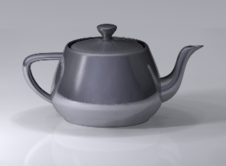
I'm a Little Tea Pot
I’m a little teapot, short and stout
Here’s my handle (place hand on hip)
Here’s my spout (stick your other arm out straight)
When I get all steamed up, hear me shout
Just tip me over and pour me out (lean over with your spout arm)

Don’t forget to share your home learning times with us.

Take a photo and email it to us at:
standrewsnur.enquiries@fife.gov.uk

By sending us in your photos you are agreeing that we can then post them on our website or social media page to help you keep connected with your friends.

