ST ANDREWS
NURSERY

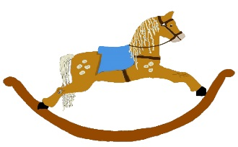

HOME LEARNING ADVICE

Issue 22

Over the coming weeks we wish to support you with ideas on how you can support your child’s continued learning at home.

In this bulletin the Treetop Team have produced some suggestions on how to keep learning going at home.

THE IMPORTANCE OF PLAY
Play is how our youngest children’s learning and development. It will be very important that time is made within a day for quality play experiences.

Playing alongside your child at times during the day is going to have the maximum impact. This will provide them with the security and comfort that they will require over the coming weeks, but it will also help you have fun together.

Play enables children to develop a range of skills including communication, problem solving, imagination, co-operation etc.

It can take place indoors or outdoors.

The following web links may provide further information and practical ideas.

https://www.playscotland.org/parents-families/

https://education.gov.scot/parentzone/learning-at-home/learning-through-play/

ONLINE RESOURCES
Suggested resources and links have been included below to support learning and development.

As with any online resource, parental guidance and supervision is recommended to ensure children are accessing these in a safe and appropriate manner.

What the Ladybird Heard Next by
Julia Donaldson

With your child watch and listen to the following story being read aloud on.

https://www.youtube.com/watch?v=lWhwAFHAuwI

Here are some suggestions to use with this story.

Literacy
- Can you spot the rhyming words?
- Try to retell the story in your own words.
- How many words can you spot that rhyme with ‘hen’.
- Join in with the animal noises when reading the story.
- Draw a picture of your version of the Snuggly Snerd, does your version look the same as the one in the story.

Numeracy/Maths
- How many bees chased after the two bad men?
- Compare the size of eggs, are they all the same size? Find something smaller and bigger than an egg.
- Get an adult to give you some coins, sort them by colour and size, do you know what the coins values are?

Health and Wellbeing
- Do you think that the ladybird is a good friend?
- What would you do if you were the ladybird?
- Who would you speak to if you needed help?

RHYME TIME
This Photo by Unknown Author is licensed under CC BY-SA

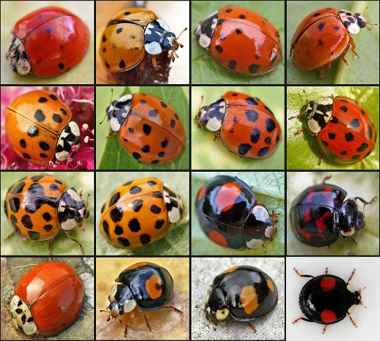
Ladybird Ladybird
Ladybird, Ladybird, fly away home
the field mouse is gone to her nest
the daisies have shut up their sleepy red eyes
and the birds and the bees are at rest
Ladybird, Ladybird, fly away home
the glow worm is lighting her lamp
the dew’s falling fast, and your fine speckled wings
will flag with the close clinging damp
Ladybird, Ladybird, fly away home
the fairy bells tinkle afar
make haste or they’ll catch you and harness you fast
with a cobweb to Oberon’s star.
Rhyme From 1957

Ladybird Ladybird
Ladybird, ladybird fly away home,
Your house is on fire and your children are gone,
All except one,
And her name is Ann,
And she hid under the baking pan

Modern version

- Which version do you prefer?

Don’t forget to share your home learning times with us.

Take a photo and email it to us at:
standrewsnur.enquiries@fife.gov.uk

By sending us in your photos you are agreeing that we can then post them on our website or social media page to help you keep connected with your friends.

