ST ANDREWS
NURSERY

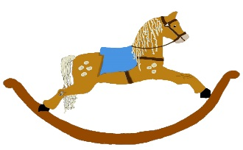

HOME LEARNING ADVICE

Issue 21

Over the coming weeks we wish to support you with ideas on how you can support your child’s continued learning at home.

In this bulletin our team have produced some suggestions on how to keep learning going at home.

THE IMPORTANCE OF PLAY
Play is how our youngest children’s learning and development. It will be very important that time is made within a day for quality play experiences.

Playing alongside your child at times during the day is going to have the maximum impact. This will provide them with the security and comfort that they will require over the coming weeks, but it will also help you have fun together.

Play enables children to develop a range of skills including communication, problem solving, imagination, co-operation etc.

It can take place indoors or outdoors.

The following web links may provide further information and practical ideas.

https://www.playscotland.org/parents-families/

https://education.gov.scot/parentzone/learning-at-home/learning-through-play/

ONLINE RESOURCES
Suggested resources and links have been included below to support learning and development.

As with any online resource, parental guidance and supervision is recommended to ensure children are accessing these in a safe and appropriate manner.

Wonky Donkey by Craig Smith

With your child watch and listen to the following story being read aloud on.

https://www.youtube.com/watch?v=InuQD8-as1w

Here are some suggestions to use with this story.

Literacy
- Can you identify the rhyming words, for example wonky donkey, cranky and lanky.
- Do you know what the descriptive words mean? For example lanky, stinky, wonky, mischief.
- Can you guess what happens next in the story?
- Can you remember the list of words in the story?
- Can you pretend to be the wonky donkey? Make the noise of a donkey

Maths/Numeracy
- How many legs does the wonky donkey have? How many legs does a donkey normally have?
- How many words can you identify that rhyme?
- Count pages, looking at the numbers.

Health and Wellbeing
- How do you think the wonky donkey was feeling?
- What does it mean to feel cranky?
- Have you ever felt this way?

RHYME TIME

Donkey, Donkey, Old and Gray

Donkey, Donkey,
Old and gray,
Open your mouth
And gently bray.

Lift your ears,
And blow your horn
To wake up the world
This sleepy morn.
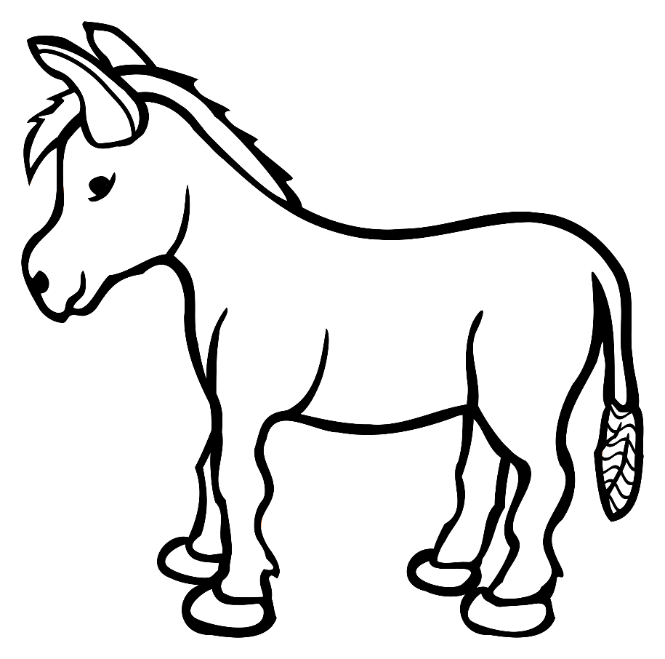
Don’t forget to share your home learning times with us.

Take a photo and email it to us at:
standrewsnur.enquiries@fife.gov.uk

By sending us in your photos you are agreeing that we can then post them on our website or social media page to help you keep connected with your friends.

