ST ANDREWS NURSERY

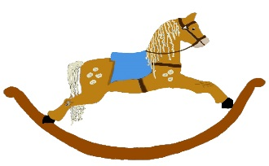

HOME LEARNING ADVICE

Issue 20

Over the coming weeks we wish to support you with ideas on how you can support your child’s continued learning at home.

In this bulletin our team have produced some suggestions on how to keep learning going at home.

THE IMPORTANCE OF PLAY
Play is how our youngest children’s learning and development. It will be very important that time is made within a day for quality play experiences.

Playing alongside your child at times during the day is going to have the maximum impact. This will provide them with the security and comfort that they will require over the coming weeks, but it will also help you have fun together.

Play enables children to develop a range of skills including communication, problem solving, imagination, co-operation etc.

It can take place indoors or outdoors.

The following web links may provide further information and practical ideas.

https://www.playscotland.org/parents-families/

https://education.gov.scot/parentzone/learning-at-home/learning-through-play/

ONLINE RESOURCES
Suggested resources and links have been included below to support learning and development.

As with any online resource, parental guidance and supervision is recommended to ensure children are accessing these in a safe and appropriate manner.

Guess How Much I Love You
by Sam McBratney

With your child watch and listen to the following story being read aloud on.

www.guesshowmuchiloveyou.com/

Here are some suggestions to use with this story.

Literacy
- Awareness of turning pages- left-right
- Retell part of the story using fabric to place their feet into the puddle.
- Discover words that convey thoughts and feelings.

Numeracy/Maths
- Talk about size huge, big small
- Count page numbers
- Awareness of routines? Daytime, nigh time?

Health and Wellbeing
- Talk about emotions and feelings? How do you feel today?
- Use actions when reading. Holding ears, stretching arms out/up
- Can you hop like little hare?

RHYME TIME

Little Peter Rabbit
Little Peter Rabbit has a fly upon his nose
Little Peter Rabbit has a fly upon his nose
Little Peter Rabbit has a fly upon his nose
And he flipped it and flapped it and it flew away

Chorus
Floppy ears and curly whiskers
Floppy ears and curly whiskers
Floppy ears and curly whiskers
And he flipped it and flapped it and it flew away

Let the fly fall onto different parts of your body, ear, knees, toes

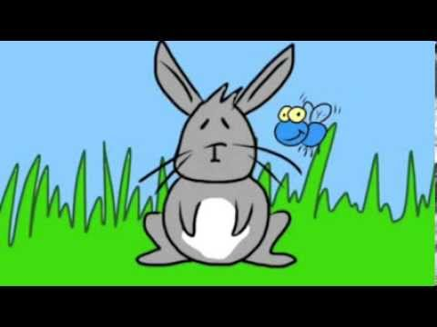

Don’t forget to share your home learning times with us.

Take a photo and email it to us at:
standrewsnur.enquiries@fife.gov.uk

By sending us in your photos you are agreeing that we can then post them on our website or social media page to help you keep connected with your friends.

