ST ANDREWS
NURSERY

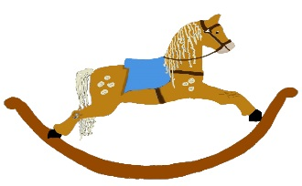

HOME LEARNING ADVICE

Issue 19

Over the coming weeks we wish to support you with ideas on how you can support your child’s continued learning at home.

In this bulletin our team have produced some suggestions on how to keep learning going at home.

THE IMPORTANCE OF PLAY
Play is how our youngest children’s learning and development. It will be very important that time is made within a day for quality play experiences.

Playing alongside your child at times during the day is going to have the maximum impact. This will provide them with the security and comfort that they will require over the coming weeks, but it will also help you have fun together.

Play enables children to develop a range of skills including communication, problem solving, imagination, co-operation etc.

It can take place indoors or outdoors.

The following web links may provide further information and practical ideas.

https://www.playscotland.org/parents-families/

https://education.gov.scot/parentzone/learning-at-home/learning-through-play/

ONLINE RESOURCES
Suggested resources and links have been included below to support learning and development.

As with any online resource, parental guidance and supervision is recommended to ensure children are accessing these in a safe and appropriate manner.

Aliens Love Underpants
by Claire Freedman and Ben Cort

With your child watch and listen to the following story being read aloud on Youtube.

https://www.booktrust.org.uk/books-and-reading/have-some-fun/storybooks-and-games/hairy-maclary/

Here are some suggestions to use with this story.

Literacy
- Draw some underpants and give them a cool pattern. When you are finished you could cut them out and hang them up.
- Underpants and bloomers are funny words, listen for other funny words and talk about what you think they mean?
- The Aliens use radar. What do you think radar is? You could look it up if you are connected to the internet.
- The aliens are leaving, can you spot the one they left behind?
- Talk about the story, re-tell your favourite parts.

Numeracy/Maths
- On the first page, how many arms does the alien have? Can you count his spots?
- As you turn the pages look for a stripy pattern on each page?
- How many underpants are hanging on the washing line? Which pair is your favourite?
- There is a dog chasing the aliens, can you count his teeth?

Health and Wellbeing
- Aliens live in space, what planet do we live on?
- Underpants make the aliens happy. Talk about what makes you happy.
- “Upside down pants races” sound like fun. Can you walk on your hands? Give it a try.
- At the end of the story there is a boy how do you think the boy is feeling? Is he happy, sad, worried, frightened?

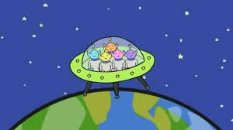
RHYME TIME

5 Little Men in a Flying Saucer
FIVE little men in a flying saucer
flew round the world one day.
They looked left and right but they didn't like the sight
So one man flew away.
WOOOSH

FOUR little men in a flying saucer
flew round the world one day.
They looked left and right but they didn't like the sight
So one man flew away.
WOOOSH

THREE little men in a flying saucer
flew round the world one day.
They looked left and right but they didn't like the sight
So one man flew away.
WOOOSH

TWO little men in a flying saucer
flew round the world one day.
They looked left and right but they didn't like the sight
So one man flew away.
WOOOSH

ONE little man in a flying saucer
flew round the world one day.
He looked left and right but he didn't like the sight
So one man flew away.
WOOOSH

Don’t forget to share your home learning times with us.
Take a photo and email it to us at:
standrewsnur.enquiries@fife.gov.uk
By sending us in your photos you are agreeing that we can then post them on our website or social media page to help you keep connected with your friends.

