ST ANDREWS
NURSERY

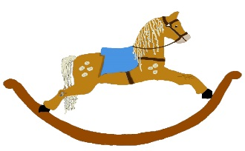

HOME LEARNING ADVICE

Issue 16

Over the coming weeks we wish to support you with ideas on how you can support your child’s continued learning at home.

In this bulletin our team have produced some suggestions on how to keep learning going at home.

THE IMPORTANCE OF PLAY
Play is how our youngest children’s learning and development. It will be very important that time is made within a day for quality play experiences.

Playing alongside your child at times during the day is going to have the maximum impact. This will provide them with the security and comfort that they will require over the coming weeks, but it will also help you have fun together.

Play enables children to develop a range of skills including communication, problem solving, imagination, co-operation etc.

It can take place indoors or outdoors.

The following web links may provide further information and practical ideas.

https://www.playscotland.org/parents-families/

https://education.gov.scot/parentzone/learning-at-home/learning-through-play/

ONLINE RESOURCES
Suggested resources and links have been included below to support learning and development.

As with any online resource, parental guidance and supervision is recommended to ensure children are accessing these in a safe and appropriate manner.

Giraffes Can’t Dance by Giles Andreae & Guy Parker-Rees

With your child watch and listen to the following story being read aloud on YouTube.

https://www.youtube.com/watch?v=0Bp2wiMu9xU

Here are some suggestions to use with this story.

Literacy
- Listen carefully, can you hear what words rhyme?
- Can you name the different animals you see in the story?
- What emotion words do you hear? Talk about different emotions in the story.
- Draw your favourite part of the story, you can send them to us to see!
- See if you can recall the story, acting out your favourite bits.

Numeracy/Maths
- How many different animals can you spot?
- Can you count how many Monkeys, Chimps, Elephants and Lions there are?
- Can you find something that’s Tall, Long, Thin?
- Can you measure how Tall you are?
- What shape did Gerald’s hoof make as he started to dance?

Health and Wellbeing
- How do you think Gerald felt when he was told Giraffes can’t dance?
- Using your body, pop on some music and have a little dance? How did this make you feel?
- Discuss feelings and emotions throughout the story. What would you do to make Gerald feel Happy?

RHYME TIME

That Tall Giraffe

That tall giraffe, sure makes me laugh.
His legs are so tall, why doesn’t he fall?
His neck is so long, is he very strong?
What does he eat, does he eat meat?
That tall giraffe, sure makes me laugh.

- Can you say the rhyme together?
- Which words rhyme in the poem?
- Can you use the story to see if you can answer the questions in the rhyme?
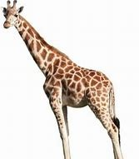

Don’t forget to share your home learning times with us.

Take a photo and email it to us at:
standrewsnur.enquiries@fife.gov.uk

By sending us in your photos you are agreeing that we can then post them on our website or social media page to help you keep connected with your friends.

