ST ANDREWS NURSERY

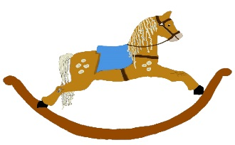

HOME LEARNING ADVICE

Issue 13

Over the coming weeks we wish to support you with ideas on how you can support your child’s continued learning at home.

In this bulletin our team have produced some suggestions on how to keep learning going at home.

THE IMPORTANCE OF PLAY
Play is how our youngest children’s learning and development. It will be very important that time is made within a day for quality play experiences.

Playing alongside your child at times during the day is going to have the maximum impact. This will provide them with the security and comfort that they will require over the coming weeks, but it will also help you have fun together.

Play enables children to develop a range of skills including communication, problem solving, imagination, co-operation etc.

It can take place indoors or outdoors.

The following web links may provide further information and practical ideas.

https://www.playscotland.org/parents-families/

https://education.gov.scot/parentzone/learning-at-home/learning-through-play/

ONLINE RESOURCES
Suggested resources and links have been included below to support learning and development.

As with any online resource, parental guidance and supervision is recommended to ensure children are accessing these in a safe and appropriate manner.

Eat Your Peas
by Kes Gray & Nick Sharratt

With your child watch and listen to the following story being read aloud on Youtube.

www.youtube.com/watch?v=Rab3Iw0qT1U

Here are some suggestions to use with this story.

LITERACY
- Talk about the foods you have in your house: Where do they come from? How are they made?
- Draw pictures of foods on pretend plates.
- Make up combinations of favourite foods to see if you would eat them i.e. broccoli ice-cream (Yuck).
- Think of different foods that begin with the different letters of the alphabet, or foods that have the same first letter.

MATHS / NUMERACY
- Using plasticine / playdough foods correspond to no’s 1-10.
- Using food available in the house put into size order small – large, or large - small.
- Look at shapes of the foods and their packaging, model correct names.
- Encourage child to cut up fruit using simple fraction names as they work.

HEALTH AND WELLBEING
- Talk about what foods are good for us and why we need to eat a healthy diet.
- Using foods in the cupboards put into groups of foods we should eat regularly, sometimes and a treat. Traffic light system.
- Prepare a snack or food together, encourage use of kitchen equipment to cut, spread and mix their own food.
- Use playdough / plasticine to make fruits and vegetables.
- Plant some seeds in pots to grow together.

RHYMETIME

One potato, two potatoes, three potatoes - four
Five potatoes, six potatoes, seven potatoes - more
Eight potatoes, nine potatoes, ten potatoes - all
One, two, three, four, five, six, seven, eight, nine, ten
One potato, two potatoes, three potatoes - four
Five potatoes, six potatoes, seven potatoes - more
Eight potatoes, nine potatoes, ten potatoes - all

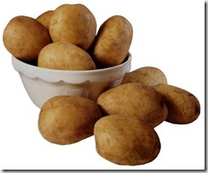

Don’t forget to share your home learning times with us.

Take a photo and email it to us at:
standrewsnur.enquiries@fife.gov.uk

By sending us in your photos you are agreeing that we can then post them on our website or social media page to help you keep connected with your friends.

