ST ANDREWS NURSERY

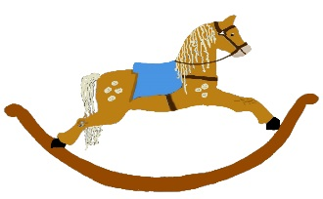

HOME LEARNING ADVICE

Issue 12

Over the coming weeks we wish to support you with ideas on how you can support your child’s continued learning at home.

In this bulletin our team have produced some suggestions on how to keep learning going at home.

THE IMPORTANCE OF PLAY
Play is how our youngest children’s learning and development. It will be very important that time is made within a day for quality play experiences.

Playing alongside your child at times during the day is going to have the maximum impact. This will provide them with the security and comfort that they will require over the coming weeks, but it will also help you have fun together.

Play enables children to develop a range of skills including communication, problem solving, imagination, co-operation etc.

It can take place indoors or outdoors.

The following web links may provide further information and practical ideas.

https://www.playscotland.org/parents-families/

https://education.gov.scot/parentzone/learning-at-home/learning-through-play/

ONLINE RESOURCES
Suggested resources and links have been included below to support learning and development.

As with any online resource, parental guidance and supervision is recommended to ensure children are accessing these in a safe and appropriate manner.

Owl Babies
by Martin Waddell and Patrick Benson

With your child watch and listen to the following story being read aloud on Youtube.

https://www.youtube.com/watch?v=GyiBDPJCDFY

Here are some suggestions to use with this story.

Literacy
- Talk about any new words the children are hearing to help develop vocabulary.
- What are the baby names?
- Where do the babies live?
- Where do we live?
- Why did the mummy go away?
- Who goes out for our food?
- Where do we get our food from?
- Look at the pictures. What do you think the babies are feeling?
- How do we know how they’re feeling?
- Why are they feeling like this?
- Pick out rhyming words e.g. mice/nice. Can you think of other rhyming words?
- Encourage your child to discuss/retell their favourite part of the story.
- Encourage your child to draw their favourite part of the story.

Numeracy
- How many baby owls are there?
- Can you count them, can you show me how many fingers that is?
- What length are the branches they sit on? (big/small)
- When we go shopping how do we get there, is it on the bus, what number of bus do we get?

Health and Wellbeing
- Discuss how the babies feel when their mummy flies away?
- How do you know? Discuss their facial expression and what they’re doing.
- Have you ever felt like that? When?
- What made you feel better?
- How do the babies feel when their mummy comes back? How do we know how they feel? Again discuss their facial expression and what they’re doing.

Rhyme time
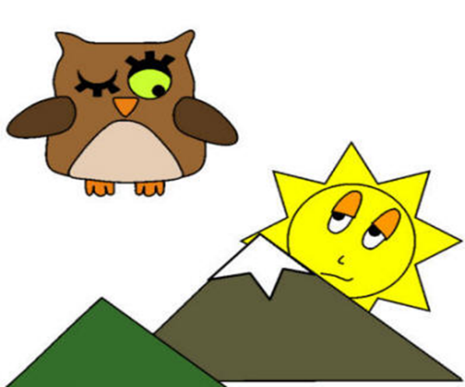
Five little owls,
On a branch by the shore,
A squirrel scampered by,
And then there were four.
Four little owls,
Perched high up in a tree,
The wind shook one off,
And then there were three.
Three little owls,
With nothing fun to do,
One got very bored,
And then there were two.
Two little owls,
Just having some fun,
A bear came along,
And then there was one.
One little owl,
Winked at the setting sun,
Flew into the forest,
And then there were none.

- Can you say the rhyme together?
- Which words rhyme?
- How many owls were there?
- Can you show how many owls there are (using your fingers)
- What happened to them?

Don’t forget to share your home learning times with us.

Take a photo and email it to us at:
standrewsnur.enquiries@fife.gov.uk

By sending us in your photos you are agreeing that we can then post them on our website or social media page to help you keep connected with your friends.

