ST ANDREWS
NURSERY

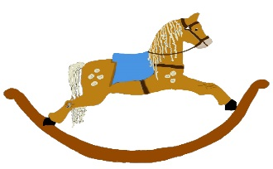

HOME LEARNING ADVICE

Issue 11

Over the coming weeks we wish to support you with ideas on how you can support your child’s continued learning at home.

In this bulletin our team have produced some suggestions on how to keep learning going at home.

THE IMPORTANCE OF PLAY
Play is how our youngest children’s learning and development. It will be very important that time is made within a day for quality play experiences.

Playing alongside your child at times during the day is going to have the maximum impact. This will provide them with the security and comfort that they will require over the coming weeks, but it will also help you have fun together.

Play enables children to develop a range of skills including communication, problem solving, imagination, co-operation etc.

It can take place indoors or outdoors.

The following web links may provide further information and practical ideas.

https://www.playscotland.org/parents-families/

https://education.gov.scot/parentzone/learning-at-home/learning-through-play/

ONLINE RESOURCES
Suggested resources and links have been included below to support learning and development.

As with any online resource, parental guidance and supervision is recommended to ensure children are accessing these in a safe and appropriate manner.

Five Minutes Peace by Jill Murphy

With your child watch and listen to the following story being read aloud on Youtube.

https://www.youtube.com/watch?v=EzR6BZFizII

Here are some suggestions to use with this story.

Literacy
- What was your favourite part of the story? Can you draw a picture of it?
- Can you retell the story in your own words?
- What did Mrs Large want to eat for breakfast? What do you like for breakfast?
- Where did Mrs Large want to eat her breakfast? Why did she want to do this?

Numeracy
- How many items did Mrs Large have on her breakfast tray?
- Who is the biggest elephant and who is the smallest elephant?
- Who is taller than Laura?
- How many elephants are in this story? How many people are in your house?
- What time of the day would you have a bath? In the morning like Mrs Large or in the evening before bed?

Health and Wellbeing
- How does Mrs Large feel when the children join her in the bath?
- If someone wasn’t listening to how you felt, how would you feel?
- Mrs Large had a big breakfast, was it healthy? What healthy breakfast would you like to eat?
- It seems like a noisy house, what sounds can you hear around your house? Do you like loud noises or quiet noises?
- Can you act out your favourite parts of the story and maybe use some sound effects?

Rhyme Time

Twinkle, twinkle, little star,
How I wonder what you are,
Up above the world so high,
Like a diamond in the sky,
twinkle, twinkle, little star,
How I wonder what you are.

- Can you say the rhyme out loud and do some actions?
- Can you play any musical instruments, like Lester in the story, to the tune of Twinkle, Twinkle?

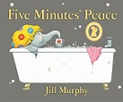

Don’t forget to share your home learning times with us.

Take a photo and email it to us at:
standrewsnur.enquiries@fife.gov.uk

By sending us in your photos you are agreeing that we can then post them on our website or social media page to help you keep connected with your friends.

