Element of Pedagogy | Specific Area of Focus
Strong start to learning | Using a consistent framework to ensure a strong start to all lessons that emphasise consistency, establish routines and set high expectations for learners.
Trusted Technique | Key Features of Focus
5 Step Framework for ensuring a strong start to learning | I have been using this framework in my lesson planning and preparation to ensure that my lessons deliver a strong start to learning. The 5-step framework incorporates the following steps: Entry, Retrieval, Circulation, Feedback & Transition. I want to use this to monitor pupil engagement, establish consistent routines and communicate the importance of a strong start to learning to learners.
A relevant and engaging starter task that incorporates recall/retrieval | I have been using the framework with all my classes as it is relevant to both BGE and senior phase. For example, S2 ICT, I have been using starter tasks in their Economics unit to recall key terms and concepts that we have been learning. The purpose of this is to help retrieve key terms and their meanings as some pupils may require more support and understanding of what they mean.
Reflection and Impact
I have found that using the framework with all classes has helped to establish consistent routines with my classes and helps to set the tone for the rest of the lesson. It has improved learner engagement a from the outset which helps ensure they are ready to learn from when they enter the classroom. It has also further enhanced my classroom management and the overall learning environment. Going forward, I plan to continue refining this framework and share effective strategies with colleagues to promote consistency across the whole school.

Pupil voice questions:
- Do you enjoy starter tasks like this?
- Do you feel a strong start to learning helps you for the rest of the lesson?

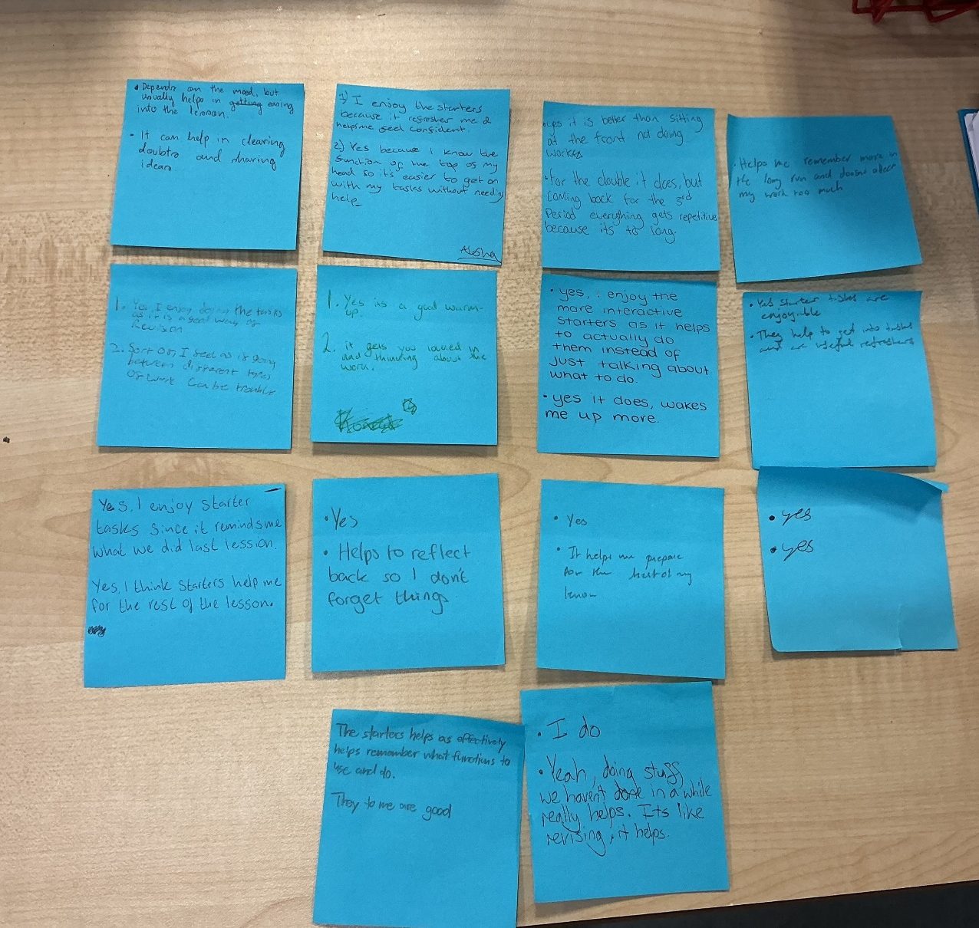

Pupil voice

