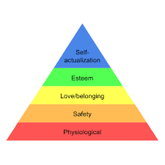

**Self-Esteem Guidelines**

Our self-esteem guidelines underpin how we support our learners and ensure their rights are at the centre of our practice. The following articles are a focus for us at Rosslyn:

**Article 15**

**Freedom of association**

* Let me see my friends and join groups

**Article 13**

**Freedom of expression**

* Respond to me when I am communicating with you
* Give me plenty time to respond
* Support and validate my emotions and help me regulate them

**Article 12**

**Respect the views of the child**

* Encourage me to make good choices
* Include me in the conversations/messages
* Introduce people to me
* Tell me what’s happening now and next
* Be aware of my personal space
* Support me with changes
* Help me to take pride in how I look

**Article 3**

**Best Interests of the Child**

* Ensure the pace of activities is right for me
* Praise and encourage me
* Be consistent in agreed strategies and approaches
* Tell me what you want me to do and not what you don’t want me to do
* Talk about things that are relevant to my learning

**Article 23**

**Children with a disability**

* Let me help
* Let me have a go and help me when I get stuck
* Check that I am comfortable
* Be discreet when discussing my personal care needs
* Make me aware that you are going to touch or move me

**Article 31**

**Leisure, play and culture**

* Give me meaningful, relevant and motivating tasks that are fun and engaging
* Give me opportunities to experience and learn things in different places

**Article 28 & 29**

**Right to Education & Goals of education**

* Give me achievable goals
* Ensure my activities are age appropriate and match my needs and level of understanding
* Personalise the resources I use
* Interact with me in a way that is personalised to me
* Give me opportunities to develop my personality
* Give me plenty opportunities to experience new things more than once

**Article 24**

**Health and health services**

* Plan to meet my health needs throughout the day
* Show me you care for me