Minute of Parent Forum – 02/10/2024

In attendance; Jackie Urquhart, Amanda Beveridge, Lynne, John and Callum Hailstones, Karyn Rodgers
Apologies; Dave Lynch
Discussion points: | Action Points:
Welcome and apologies | N/A
Staff/pupils updates | New staff and pupils all settled well.  We welcomed Harley at the start of term and managed to place him with no impact on other classes.  No vacant posts – no changes  Jordan finishes on Friday for maternity leave. We will have nursing cover full time in school with staff who are familiar with pupils. We wish Jordan all the happiness in the world, and look forward to hearing her news soon!
Active Schools update – Rachael   | Email: Kalia.dair@fife.gov.uk  New Active School’s Coordinator for Viewforth cluster.  How can they support families and young people this year?  - Holiday clubs  - Focus on the summer  - JU to meet with Kalia and parent council to discuss plans next term  - Looking to develop a summer provision with paid staff, PAMIS etc.
School Improvement and PEF   | 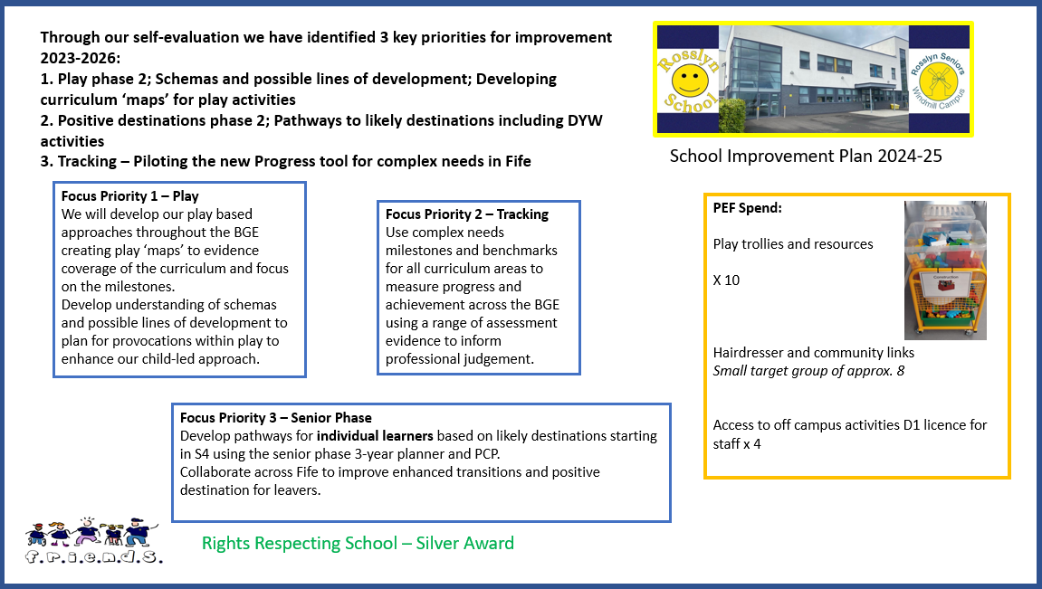  Full Version on the website:  https://blogs.glowscotland.org.uk/fi/rosslynschool/
  Rights Respecting Schools | Helen Mead is leading on this and looking for parent forum members.  We are looking for approximately 3 more volunteers. Currently on the group we have:  Lynne Hailstones  Amanda Beveridge  Sharon Veelenturf  Helen will be in touch next term with meeting dates.
Home – School Communication | Current system is working well.  Agreement with teachers:  Messenger part of SeeSaw used daily for communication  Learning Log information shared at least once a week.  School App – You should be able to set notifications on. This is used regularly to share news and information.  Authority may be moving to another provider next year, so not going to make any changes to comms till next year.  Termly newsletter – no change to this.
Fundraising  School funds | We discussed fundraising ideas for school funds and have proposed to do the following:  Party Night – Theme to be agreed  Scratch Cards  Amazon wish list – Renata, Karyn Rodgers and Eve Earnshaw  The Amazon wish list is a list of school resources (like a wedding list). This will be shared next term with the idea that anyone will be able to buy a resource chosen by school staff and it will be posted out directly to Rosslyn. Great Christmas idea for folks who want to donate a gift!
Friends of Rosslyn update   | Currently £1000 in the bank.  Plan is to raise another £3,000 to pay for a summer provision in the Rosslyn garden.  2 days for 5 weeks.  10 days with 3 or 4 staff.  £100 daily rate for staff (regardless of band)  Potential costs for staffing - £3,000 - £4,000  Resources £100  PAMIS support  Active Schools support  Ideas for fund raising:  Application to Cash for Kids
The Big House   | Family resources  Going to set out a table on Family Fun Fridays – 1st Friday of every month.
SAPC | Please read the leaflet above for information.  There is no specified deadline for return of application but you are encouraged to express interest as soon as possible.  Friends of Rosslyn committee:  Chair – TBC  Secretary – Lindsay Charnley  Treasurer – John Hailstones  Thanks to everyone who has been part of the committee over the past few years.  Julie Paisley  Sharon Veelenturf  Sandra Galloway
Parking | Due to Viewforth HS change of times, things seem to have eased in the car park for Rosslyn families at pick up and drop off.  Reminder to please watch your speed when driving in to the campus.  Bus transport has settled down.  Any outstanding concerns please call school.
Reports and Reviews | Start again after the October break.  Families will be asked to identify outcomes within the 4 capacities.  This will be used within the ‘wider achievement’ part of reporting.  More information will come to you prior to your review.  Sticking with the annual SWAY format for now.  Updates should be weekly through SeeSaw learning journal.
Upcoming dates | Odd Socks Day - 12th November £1 to wear odd socks for school funds Inservice Day - 15th November  Tempest Photography - 19th November
AOB | No other business
Next Parent Forum meeting | Wednesday 27th November  1:30pm session  6:30pm session  I have decided to run 2 sessions on Parent Forum/Friends of Rosslyn days to capture as many families as possible.  Reminders will come a week in advance of meetings.  Save the date!  Agenda items will always include the topics on the left of this minute.  Jackie Urquhart – HT

