Rimbleton Primary School

Anti-Bullying Policy

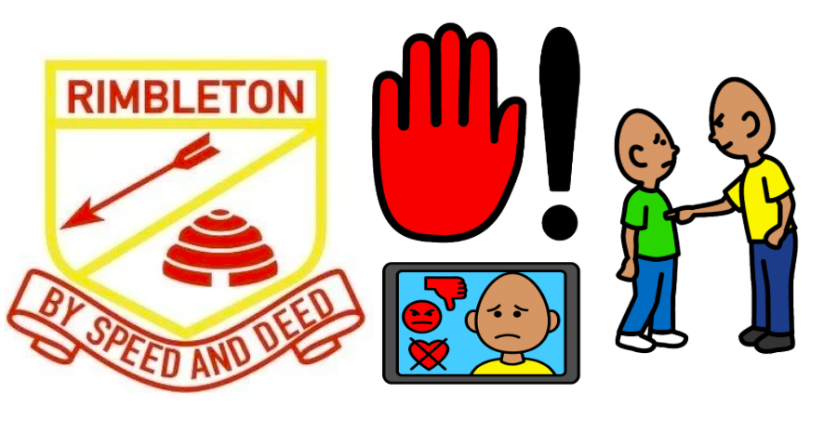

Date: January 2026

Opening Statement/context

1.The Agreed National Definition of bullying as set in ‘Respect for All’

Bullying should never be seen as a normal or inevitable part of growing up. Just as adults should not accept abuse from others, the same standard applies to children and young people.

Rimbleton Primary School adopts the national definition of bullying outlined in Respect for All: The National Approach to Anti-Bullying for Scotland’s Children and Young People (RfA).

“Bullying is face-to-face and/or online behaviour which impacts on a person’s sense of physical and emotional safety, their capacity to feel in control of their life and their ability to respond effectively to the situation they are in.” “The behaviour does not need to be repeated, or intended to cause harm, for it to have an impact. Bullying behaviour can be physical, emotional or verbal and can cause people to feel hurt, threatened, frightened and left out.”

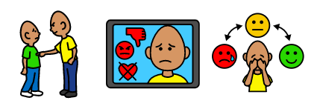

2.Organisational stance/policy scope and aims

At Rimbleton Primary School, we believe that bullying behaviour is never acceptable. Every child has the right to feel safe, valued, respected, and included in a nurturing learning environment. We are committed to fostering a school culture where kindness, respect, ambition, and safety are at the heart of everything we do.
We recognise and celebrate the diversity of our school community, including our learners with Additional Support Needs (ASN). Our approach is inclusive and responsive, ensuring that all children and young people are supported to thrive.
This policy applies to all staff, learners, families and partners working within Rimbleton Primary School and is aligned with the national definition of bullying. It covers all instances of bullying, racism, prejudice, and discrimination – whether they occur in person or online – and especially where they impact a child’s attendance, engagement, or wellbeing.
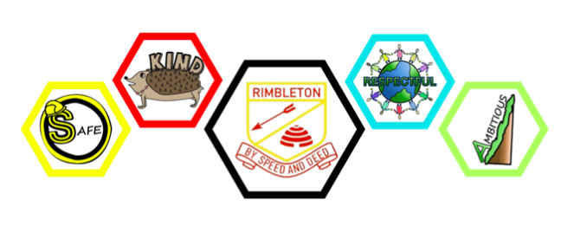

We aim to:
- Create a safe, respectful, and nurturing environment where all children can learn and grow free from fear or harm.
- Respond to bullying behaviour promptly and effectively, making it clear that it is unacceptable and will not be tolerated.
- Promote kindness and ambition, encouraging all learners to support one another and strive to be their best selves.
- Work in Partnership with pupils, parents/carers, and staff to develop and uphold a shared understanding of anti-bullying practices.
- Reflect our inclusive ethos within the daily life of our school including daily communication within the community.
Together, we are building a school where every person feels safe, supported, and empowered to achieve their full potential.
3. Preventing and Responding to Bullying
In line with Getting It Right for Every Child (GIRFEC), Rimbleton Primary School promotes a safe, inclusive environment where bullying is not tolerated.
Prevention strategies include effective supervision in shared areas, proactive anti-bullying activities, and learning through the curriculum to help children understand bullying, respectful relationships and the impact bullying behaviour can have on others.
All pupils are also expected to follow the school’s Acceptable Use of Technology Policy, which outlines the safe and responsible use of digital devices and online platforms. Pupils are required to read, agree to and sign this policy. It clearly states that technology must never be used to bully, harm or upset others.
When bullying occurs, staff will take a child-centred approach, considering the behaviour, its impact on wellbeing, and the actions needed to resolve the situation. Any underlying attitudes or prejudice will also be addressed in order to support positive relationships, inclusion and wellbeing for all children.

4. Children’s rights (and supporting legislation)

Bullying is a violation of children’s rights and is incompatible with the United Nations Convention on the Rights of the Child (UNCRC), which has been fully incorporated into Scots law. At Rimbleton Primary School, we are committed to upholding these rights and ensuring all children learn in a safe, respectful, and supportive environment.

5.Equality duties

Our Commitment to Equality and Respect at Rimbleton Primary School Reflects the Equality Act (2010)
At Rimbleton Primary, we believe that everyone deserves to feel safe, respected, and included – no matter who they are or what their background is. We are proud of our diverse school community and are committed to making sure every person feels welcome and supported.
We do not tolerate any form of bullying, including those relating to the protected characteristics listed in the Equality Act (2010):-
- Disability or additional support needs
- Race, skin colour, or where someone comes from
- Religion or beliefs
- Gender or gender identity
- Who someone loves (sexual orientation)
- How someone looks or dresses
- Family circumstances or money worries

Our school follows the law to make sure we:
- Treat everyone fairly
- Give everyone the same chances to succeed
- Help children build good relationships with others

We also support children’s health and wellbeing – physically, emotionally, and socially – so they can grow up to be responsible citizens, confident individuals, effective contributors and successful learners.

If bullying happens, we take it seriously. We listen, we act, and we work together with families to make things better. Every child at Rimbleton has the right to learn in a place where they feel safe to be the best they can be.

6.Expectations and responsibilities of children and young people, staff/volunteers and parent/carers.

This policy sets out the expectations and responsibilities of children and young people, staff, volunteers and parents/carers. It has been developed with input from all members of our school community to ensure that everyone understands their role in preventing and responding to bullying.

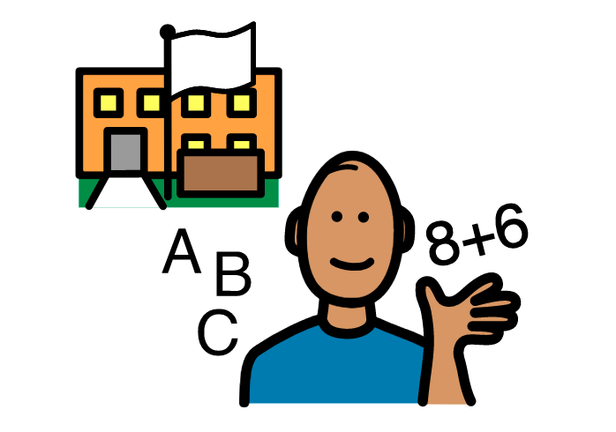
School staff and volunteers
- Provide a safe environment where all children are listened to.
- Respond quickly and fairly to bullying concerns.
- Speak to all parties without bias.
- Use appropriate support services when needed.
- Communicate clearly with parents.
- Take action and follow up to resolve issues.


Children and Young People
- Ask for help and tell a trusted adult.
- Recognise when behaviour is unacceptable.
- Take responsibility for their actions.
- Speak up for others and include everyone.
- Play kindly and ensure no one is left out.

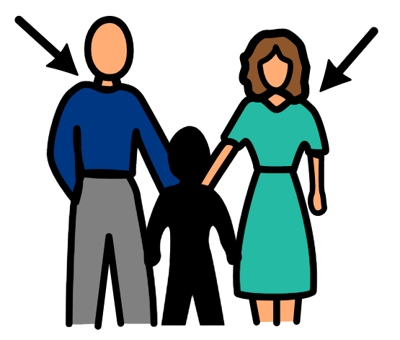
Parents/Carers
- Listen to their child and communicate regularly.
- Monitor online activity and phone use.
- Inform the school promptly if bullying is suspected.
- Act as positive role models
- Work collaboratively with the school to keep children safe.

7.Respectful behaviour

At Rimbleton Primary School, being respectful is one of our core values and is central to everything we do. We are committed to:
- Adults consistently modelling respectful behaviour for children and young people.
- Encouraging positive relationships between pupils, staff, parents, and the wider community.
- Creating a safe and welcoming environment where all children feel valued, listened to, and supported.
- Ensuring children have trusted adults they can turn to for guidance or help, supporting their wellbeing and confidence.



By embedding respect across the school, we foster a positive ethos where everyone can learn, grow, and feel secure.

8.Labelling

At Rimbleton Primary School, we avoid labelling children as ‘bullies’, ‘victims’ or ‘perpetrators’, as this can be disempowering and unhelpful. Instead, we focus on the behaviour and its impact, helping children understand what was wrong and what positive behaviour is expected. Using terms such as ‘children displaying bullying behaviour’ or ‘children experiencing bullying behaviour’ supports learning, encourages reflection, and reinforces positive relationships while guiding recovery and behaviour change.
To support this approach, staff make use of Emotion Works to help children recognise and understand their emotions, develop empathy and build strategies for managing feelings. Fix It Folders are also used to support restorative conversations and reflection, helping children think about the impact of their behaviour and how relationships can be repaired.

9.Reporting, recording and monitoring

Rimbleton Primary School records and monitors all bullying incidents using SEEMiS, in line with Fife Council guidance and the Data Protection Act 2018. Information is recorded securely, ensuring a consistent, monitored, and evidence-based approach to tackling bullying.

10.Evidence of children and young people’s involvement

Pupils at Rimbleton Primary have been able to express their views on matters that affect them, and these have been considered in developing our Anti-Bullying Policy. During Anti-Bullying Week, each class took part in activities exploring kindness, respect, and inclusion through discussions, posters, and interactive projects. Pupils’ views on bullying were also welcomed and noted during discussions at parents’ evenings. Feedback from all these activities has helped shape the approaches and strategies included in the policy.

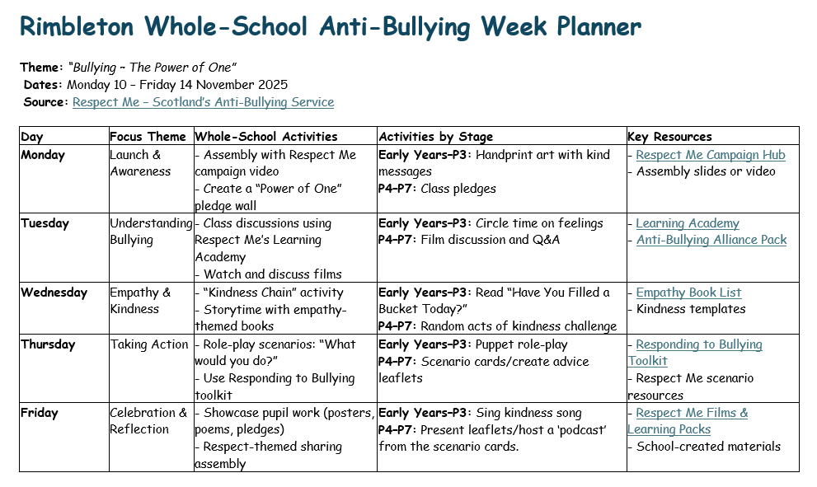

11.Evidence that parent/carers have, in line with their rights, been included and consulted in the policy development process.

In line with their rights, parents and carers were actively involved in developing our Anti-Bullying Policy. A form was emailed to all parents/carers to gather their thoughts on bullying, complemented by a parents’ evening where responses were recorded. Feedback from both methods has directly informed the policy, ensuring it reflects the views and needs of our whole school community.

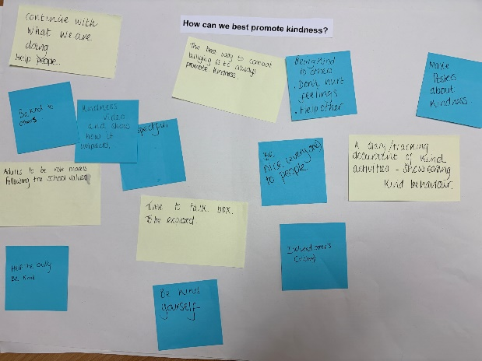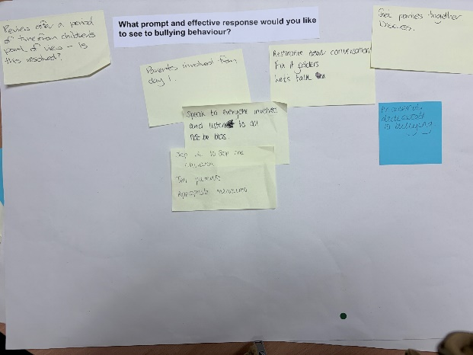

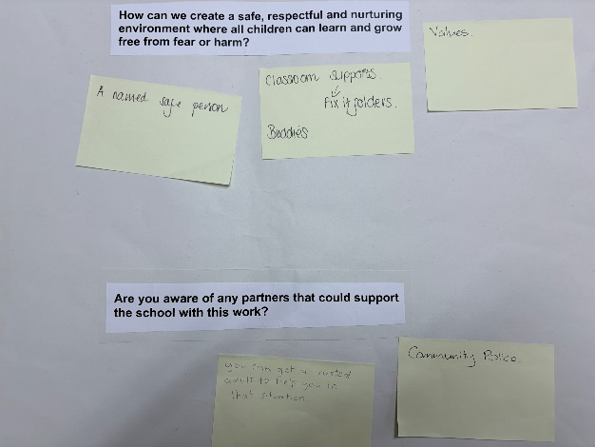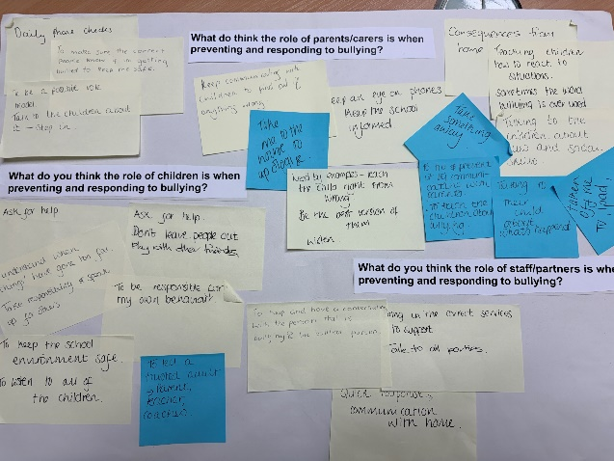

12.Evidence that staff/volunteers have been included and consulted in the policy development process.

13.Policy review and communication plan/process

This policy will be reviewed no more than 3 years after its implementation date and thereafter at intervals of no more than 3 years. This is in line with national guidance.
Reviews will involve consultation with all relevant stakeholders to ensure the policy remains effective, up to date, and reflects the needs of our school community.

14. Commitment to training and supporting staff and volunteers

Collated information from Parent’s Evening – Post-it notes (delete if not required for evidence)

Role of Parents/Carers (as identified by parents/carers and pupils)
Parents and carers believe their role is to:
- Communicate regularly with their child and listen to concerns
- Monitor online activity and phone use
- Inform the school promptly if bullying is suspected
- Act as positive role models and teach right from wrong
- Help children understand social cues and appropriate behaviour
- Support consequences at home where appropriate
- Work collaboratively with the school to keep children safe

Role of Children (as identified by parents/carers and pupils)
Pupils feel children should:
- Ask for help and tell a trusted adult
- Understand when behaviour has gone too far
- Take responsibility for their own actions
- Speak up for others and include everyone
- Not leave others out and play kindly

School Responsibilities (as identified by parents and pupils)
The school should:
- Provide a safe environment where all children are listened to
- Respond quickly and fairly to bullying concerns
- Speak to all parties involved without bias
- Use appropriate support services where needed
- Communicate clearly with parents
- Take appropriate action and follow up to ensure issues are resolved

Preferred Responses to Bullying
Parents and pupils would like:
- Parents to be involved from the start
- Restorative conversations between those involved
- Opportunities to review whether issues have been resolved
- Use of tools such as “Fix It” folders and structured discussions
- Assemblies focused on bullying awareness

Creating a Safe and Nurturing Environment
Suggestions include:
- Promoting clear school values
- Having a named safe adult for children
- Classroom support strategies (e.g. Fix It folders)
- Buddy systems to support inclusion

External Support
Suggested partners include:
- Community police
- Trusted adults within and beyond school

Promoting Kindness
Parents and School
- Adults modelling kindness and school values
- Continuing current positive practices
- Providing opportunities to talk and reflect (e.g. time-to-talk boxes)
- Tracking and celebrating kind behaviour
Pupil Ideas
- Be kind and include others
- Help others and avoid hurting feelings
- Create posters and videos about kindness
- Show how kindness positively impacts others

